Name: Date:________________

Lichens as Bioindicators
Steps to evaluating air quality at Crescent Valley using lichens

We have talked briefly about lichens and how they are important to the environment. They are the main source of food for many animals during the winter and a crucial part of the foodweb. Lichens are also good indicators of air quality. It has been found that they are sensitive to many common pollutants that are released into the air. These pollutants can be a result of natural sources such as volcanoes, but the main source is result of human activities. These include automobile exhaust, the burning of fossil fuels and industrial processes.
A sensitivity rating has been developed to help explain why many of lichen species are disappearing. Certain species tend to become damaged or even die due to the pollutants. Sulphur dioxide mixed with the moisture in the air creates acid rain. Some lichens can tolerate some amounts of acid rain, where others cannot.

Objectives
- Learn the different characteristics of many lichen species.
- Discover the tolerance levels of different species of lichens.
- Understand how ecosystems change in response to disturbances and interactions.

Answer these questions FIRST. – You may answer the questions on the computer or write on your own piece of paper.

We will be bringing samples of lichens into the classroom to identify them and verify their sensitivity rating.

Answer the questions below before you collect your samples. Check with me before going out.

Question 1. As stated above lichens are indicators of air quality. Certain species are more sensitive to common pollutants than others. What do you think it means if you find only highly tolerant species on your sample? __________________________________________________________________________________________________________________________________________________________________________________________________________________________________________________________________________

Question #2. What types of lichens do you think you will find on your sample. High tolerance lichens or low tolerance lichens? Why?
______________________________________________________________________________________________________________________________________________________________________________________

Step 1: Collecting Samples

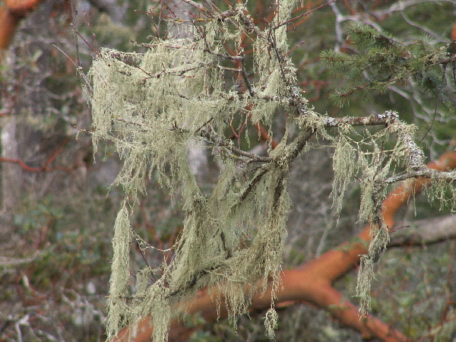
Go outside and find a place where lichens are abundant.(behind gymnasium??). Locate 3 to 4 branches that are at least 10 in. long and covered with several species of lichens.

Identify the species of lichens on your branch using the links below, as well as document their air pollution sensitivity rating to.
Make a list in the space below of the different types of lichens. Draw a small picture to aid you later when you use this information again.
http://gis.nacse.org/lichenair/?page=photos
http://www.fs.fed.us/r6/aq/lichen/images.htm#Aleims (also shows tolerance)
*You may also use the identification keys, book and identification slides on the class website.

Table 1.
Branch Number | Scientific Name | Common Name | Sensitivity Rating | Sketch or photo
Example 1 | Alectoria sarmentosa | Witch's hair | Sensitive | 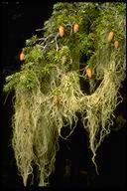

Question 3. How many different types of lichens are on your branch? What do think influences the type and amount of lichens present? Why? _________________________________________________________________________________________________________________________________________________________________________________________________________________________________________________________________________________

Question 4. Was your prediction of the tolerance level of lichens present accurate? Why or why not?
_________________________________________________________________________________________________________________________________________________________________________________________________________________________________________________________________________________

Step 2. FINDING PERCENT COVER OF YOUR LICHENS
Now let’s take a look at what percentage of the branch each of these types is covering by using methods described below and demonstrated in class.

Measure a 20 cm. section of your branch. Determine the amount of area each species covers using a 1cm block or square piece of paper. See the example in the table below to understand how to record your data.

5. Record your data in the table below: Column B,C,D are to aid you with calculations. This should be done for each species and each branch.

Table 2: Note: you will need to add more rows or use your own paper
Branch # | Species | Column A  # of 1 cm sections out of 20 | Column B  Length of sample area | Column C  Column A divided by Column B  Or A/B | Column D Percent Cover= Column C*100
1 | EXAMPLE:  Usnea fillipendula (fishbone lichen) | 5 | 20 | .25 | 25%

Question 6. What two species of lichen on the branch had the highest percent cover?
___________________________________________________________________________________________

Question 7. What is the percent cover of these two species?
___________________________________________________________________________________________
Question 8. What is their sensitivity rating?
___________________________________________________________________________________________

Question 9. What does your data tell you about the environment the lichens are living in?
___________________________________________________________________________________________

Step 3 – Determining the abundance and the air quality class rating.
Table 3
 | Percent cover – See step 1 below, 0,√,+ |  |  |  | See Step 2 below | See step 1
Species | Branch #1 | Branch #2 | Branch #3 | Branch #4 | Is it Abundant (yes or no) | Class Rating
Lobaria pulmonaria |  |  |  |  |  | 4
Evernia prunastri |  |  |  |  |  | 3
Usnea subfloridana |  |  |  |  |  | 3
Ramalina faranacea |  |  |  |  |  | 2
Ramalina menziesii |  |  |  |  |  | 2
Parmelia sulcata |  |  |  |  |  | 1

- Using the percent cover you found in table 2, In each space you will record only a 0 for less than 5%, a √ for 5 to 25% and a + for greater than 25% cover.
- Determine whether the lichen is abundant. The lichen is found to be abundant if it has either two √ or one + .
- Continue this method for each species. If the abundance is yes then record the class rating from the adjacent column below.(highest only)
The highest class rating for this site is Class _________
Class 4 = Very clean air
Class 3 = Typical rural air
Class 2 = Typical urban air
Class 1 = Polluted air
Class 0 = More polluted air

Question 10. What is the class rating that you found? What is the type of air according to this method? Do think this is an accurate representation of the air quality? Why or why not?
________________________________________________________________________________________________________________________________________________________________________________________________________________________________________________________________________

Question 11. Looking at table three, what might be some lichen species that would be present near a major freeway? Which ones might be absent? (2 for each)
________________________________________________________________________________________________________________________________________________________________________________

