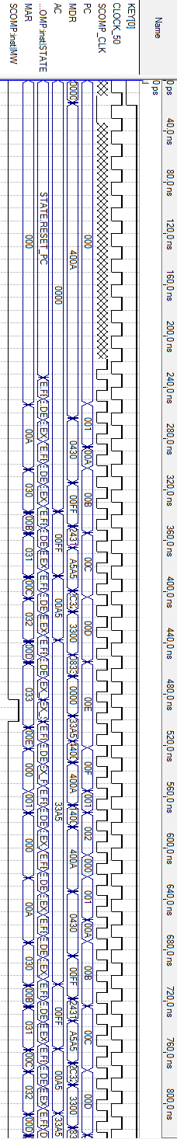
-- Altera Memory Initialization File (MIF)

DEPTH = 1024;
WIDTH = 16;

ADDRESS_RADIX = HEX;
DATA_RADIX = HEX;

CONTENT
BEGIN
[000..3FF] : 0000; -- Default to NOP

000 : 400A; -- CALL CALC
001 : 1400; -- JUMP0
00A : 0430; -- CALC: LOAD A ;Load value stored in A
00B : 2431; -- AND B ;AND with value stored in B
00C : 2C32; -- XOR C ;XOR with value stored in C
00D : 0833; -- STORE D ;Store value in D
00E : 4400; -- RETURN
030 : 00FF; -- A: DW &H00FF
031 : A5A5; -- B: DW &HA5A5
032 : 3300; -- C: DW &H3300
033 : 0000; -- D: DW &H0000
END;
-- Altera Memory Initialization File (MIF)

DEPTH = 1024;
WIDTH = 16;

ADDRESS_RADIX = HEX;
DATA_RADIX = HEX;

CONTENT
BEGIN
[000..3FF] : 0000; -- Default to NOP

000 : 400A; -- CALL CALC
001 : 1400; -- JUMP0
00A : 0430; -- CALC: LOAD A ;Load value stored in A
00B : 2431; -- AND B ;AND with value stored in B
00C : 2C32; -- XOR C ;XOR with value stored in C
00D : 0833; -- STORE D ;Store value in D
00E : 4400; -- RETURN
030 : 00FF; -- A: DW &H00FF
031 : A5A5; -- B: DW &HA5A5
032 : 3300; -- C: DW &H3300
033 : 0000; -- D: DW &H0000
END;

