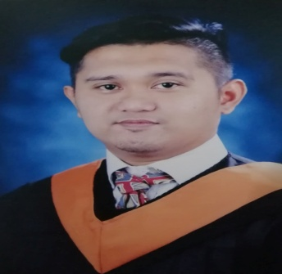Dan Carlo L. Canua  
#110 Purok 2 Marinig, 4025, Cabuyao Laguna

0929-591-4658 | [dancanua@gmail.com](mailto:dancanua@gmail.com)   
**Data Analyst** | **Freelance Website Developer**

# profile

Passionate on creating websites, who loves to deal with webpages both backend and designing. Computer Literate.

# OBJECTIVES

To apply all of my knowledge, learning tasks with dedication and most importantly I want to be part of the success in an environment of growth and excellence.

# Experience

NEDA Calabarzon **Calamba City**

On Job Training **Feb 2015 – May 2015**

* Encoding datas on Excel
* Basic troubleshooting of system unit

TELETECH Sta. Rosa City  
  
*Chat Support Specialist* **Oct 2019 – Feb 2020** - Assisting customers and answering queries about product

# Education

Saint Matthew Montessori and Science High School **Cabuyao City**  
Don Bosco Institute of Arts and Sciences **Cabuyao City** Associate in Information Technology 2013-2015

**CITI Global College Cabuyao City**

Bachelor of Science in Computer Science 2015-2019

# Seminars and Certificates

*SAP Business One*  October 2017

*Freelancing & Website Design/Development Seminar* March 2019

*Free Employment Seminar* May 2019

# **SKILLS**

* Knowledgeable in few programming languages. Backend: PHP; Cliendside: Javascript;

Frontend Frameworks: W3.CSS, Bootstrap series; Databases: MySQL

* Knowledgeable in basic computer troubleshooting
* Knowledgeable in Excel Functions. (e.g. V-Lookup, Pivot Table, Basic Computations)
* Self-motivation

# **CharacTER REFERENCES**

Jett Rey Nuval from IBM 0956-593-6205

MY WEBSITE / PORTFOLIO / THESIS

*http://cgcelarning.com/index*

**I solemnly declare that all the above information is correct to the best of my knowledge and belief.**

_______________  
Applicant Signature