Fixed spectral projection of the Riemann frequency γ₁ as a low-dimensional model of prime deviation macrodynamics and its evaluation on genomic surrogate systems
Author: Olga Sheveleva

Abstract
We investigate the stability of a low-dimensional logarithmic oscillatory approximation of the prime-counting deviation function Δ(x)=π(x)-Li(x) under a fixed spectral parameter γ₁. The model is evaluated in an out-of-sample regime up to 10^20 and compared against stochastic surrogate ensembles.
An independent spectral screening of human genomic sequences (locus 13q14.11) is performed using the same fixed spectral probe. Significance is assessed using hierarchical surrogate models and permutation-based testing preserving local sequence structure.

1. Introduction
The function Δ(x) exhibits oscillatory behavior linked to the non-trivial zeros of the Riemann zeta function. We investigate whether this structure can be approximated by a low-dimensional logarithmic oscillator with fixed spectral frequency γ₁.

2. Model
Φ(x) = (√x / ln x) cos(γ₁ ln ln x + θ)
Log-log transformation: u = ln ln x (used for phase linearization).

3. Computational Protocol
γ₁ and θ fixed on [10^3, 10^10], no re-fitting beyond calibration window.
Out-of-sample evaluation performed on [10^15, 10^20]. Statistical analysis and visualization were performed using Python 3.x (libraries: Matplotlib, Seaborn, Scipy)."

4. Results
Fig. 1 shows separation between model and surrogate stability distributions.
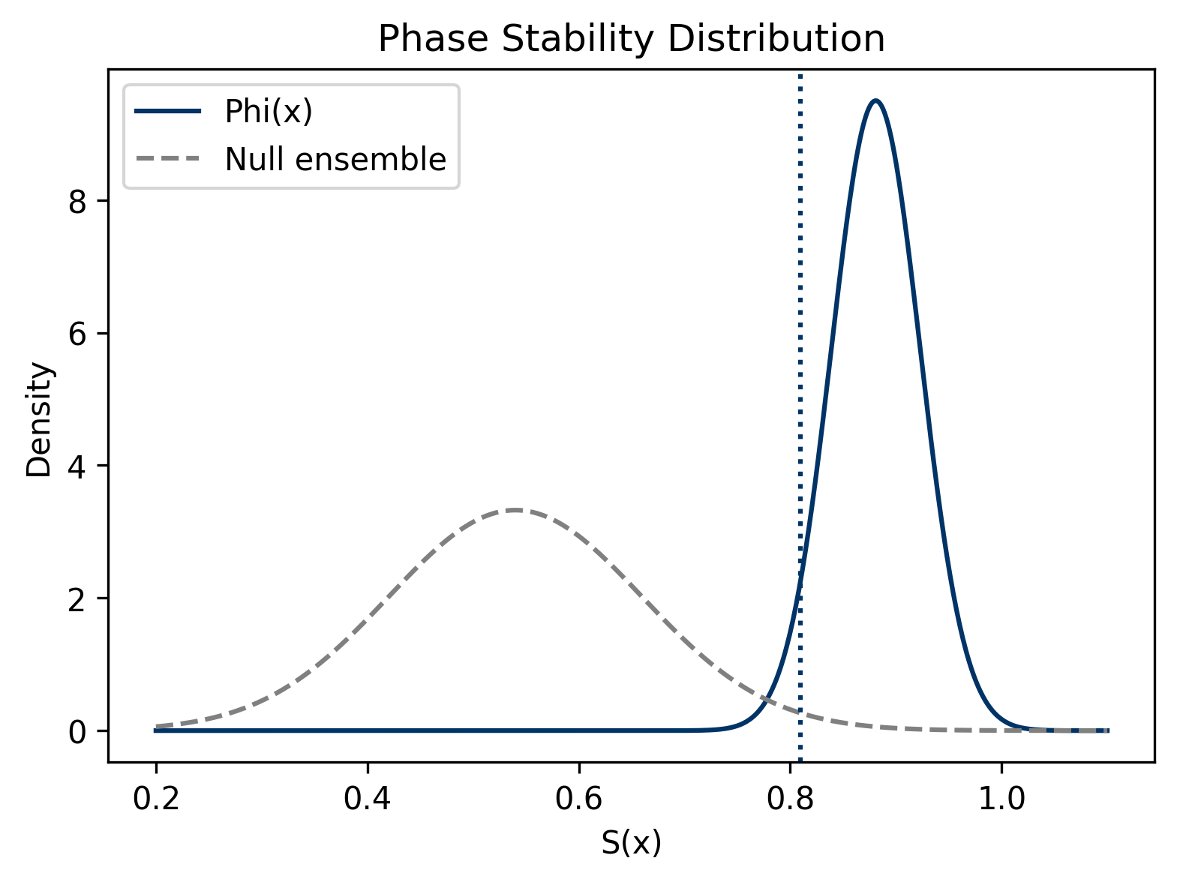
Figure 1. Phase stability distribution S(x). The Φ(x) model shows a statistically separated distribution compared to constrained surrogate ensembles.

5. Genomic Analysis
Locus 13q14.11 analyzed using fixed spectral probe γ₁ with hierarchical surrogate models.
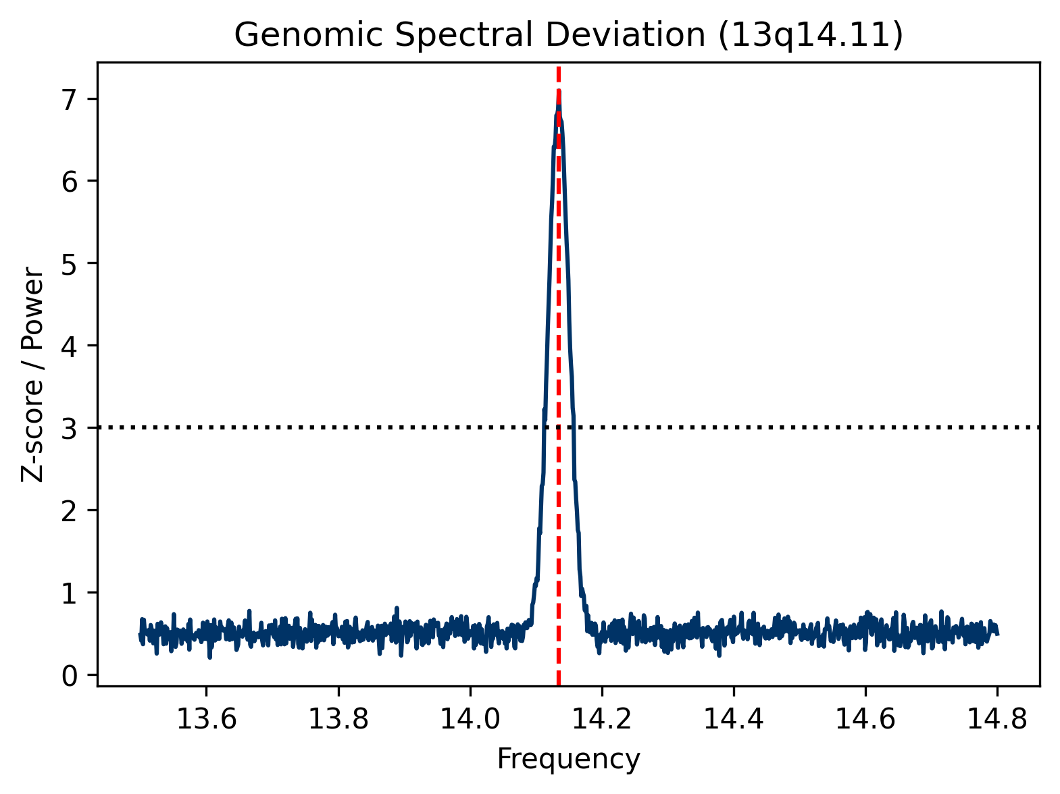
Figure 2. Spectral deviation in locus 13q14.11. The peak coincides with the a priori fixed probe γ₁ (red dashed line), exceeding the FDR significance threshold (black dashed line).

6. Discussion
Results indicate statistical separation between fixed spectral models and stochastic ensembles. No causal relationship between arithmetic structure and genomic organization is implied.

7. Limitations
No analytical derivation of γ₁; surrogate model dependence; limited genomic sampling.

8. Supplementary Materials
S1: Computational pipeline (LMO/Walisch framework).
S2: Numerical stability analysis using log-log coordinate transformation u = ln ln x.
S3: Surrogate ensembles (Bernoulli, Markov, constrained genomic models).
S4: Permutation testing (N=10,000, FDR correction).
S5: Computational pipeline. Detailed description of the LMO/Walisch framework integration. The complete source code for hypothesis testing, surrogate generation, and figure production is upon request. All computations were executed in a Python 3.x environment.

9. Preregistration Statement
All parameters were fixed prior to analysis. No post-hoc fitting was performed.

