API TEST

Dev IDE : Spring tool suite 3.9.5.RELEASE(<https://spring.io/tools3/sts/all>)

1. **How to Import Register Project to Spring tool suite**
   1. **Open Spring tool suite > File > Import…**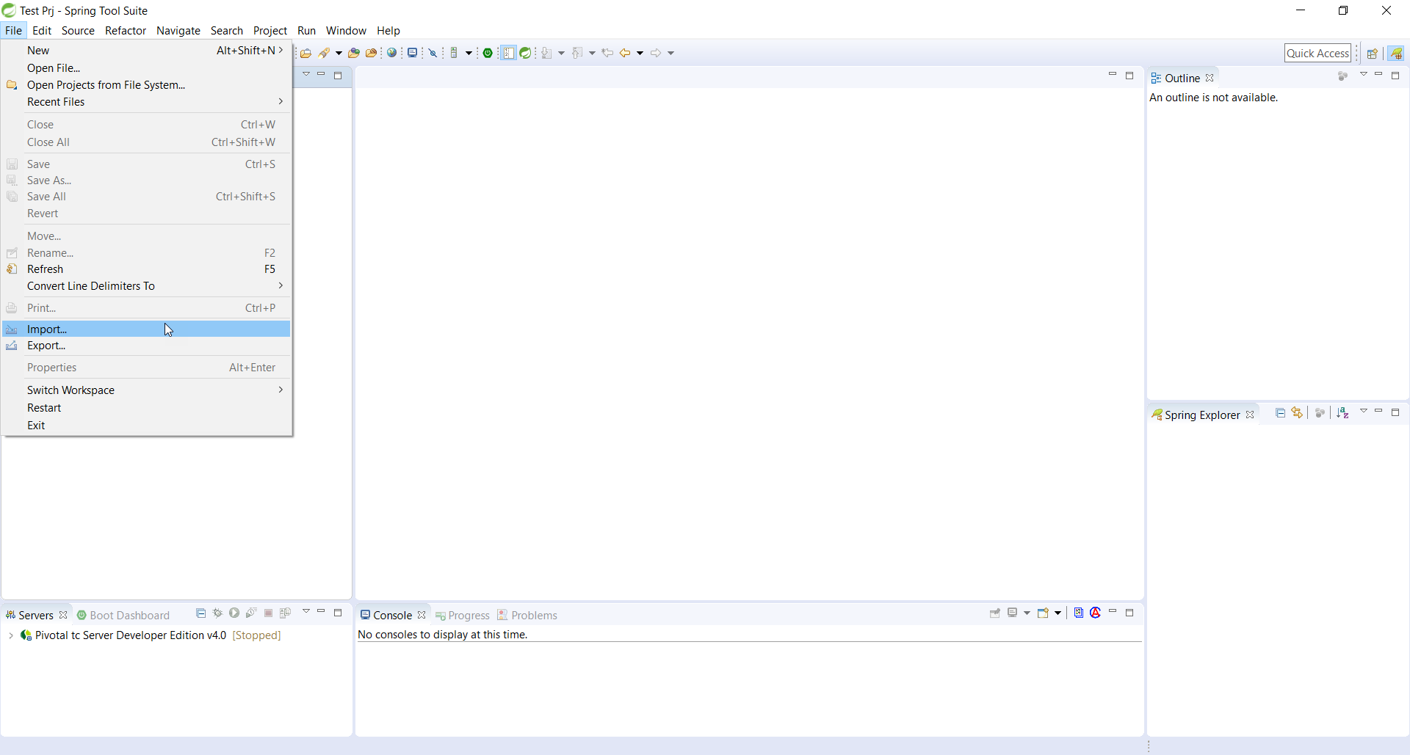
   2. **Select “Project from Folder or Archive”** 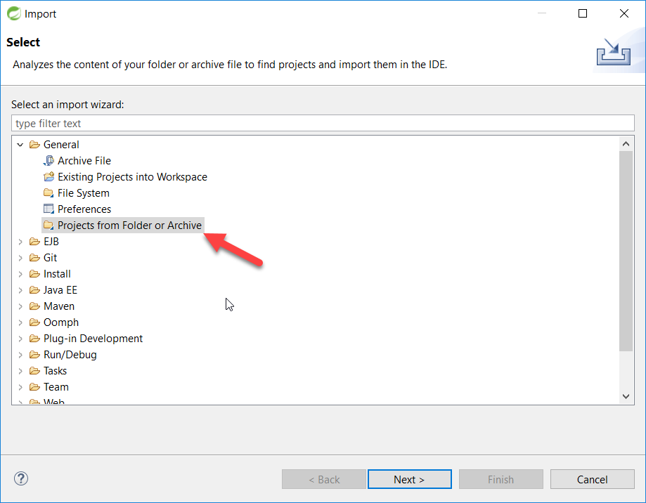
   3. **Select register folder then click finish. Project will be build auto.** 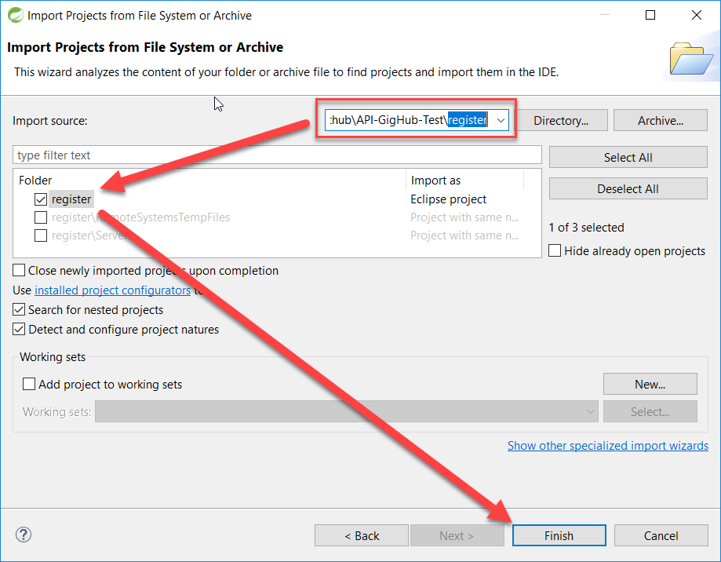
2. **How to run Project**
   1. **Right click on register project and select Run As > Spring Boot App**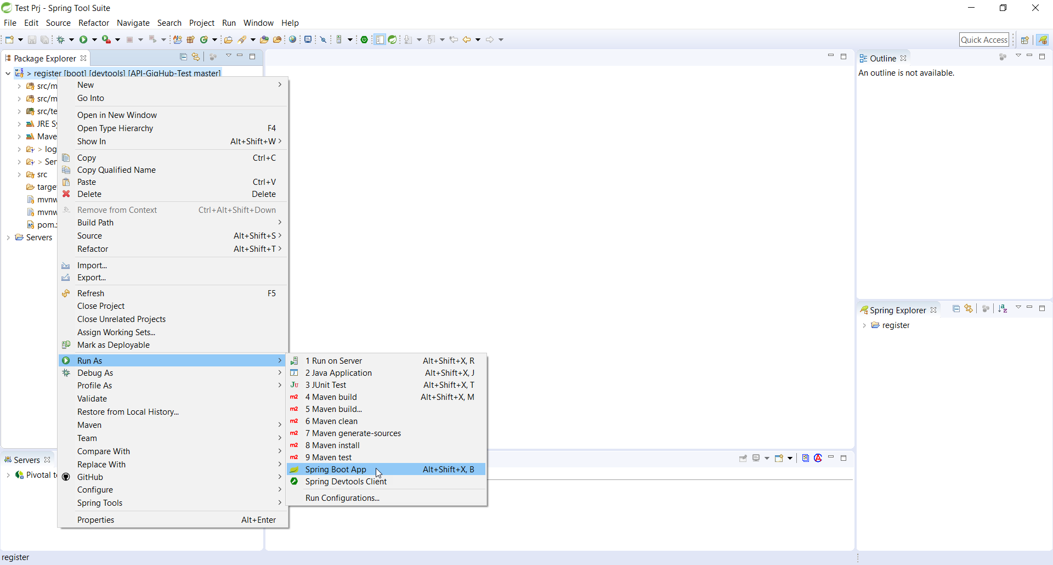

**H2 link:** [**http://localhost:8080/h2/**](http://localhost:8080/h2/)

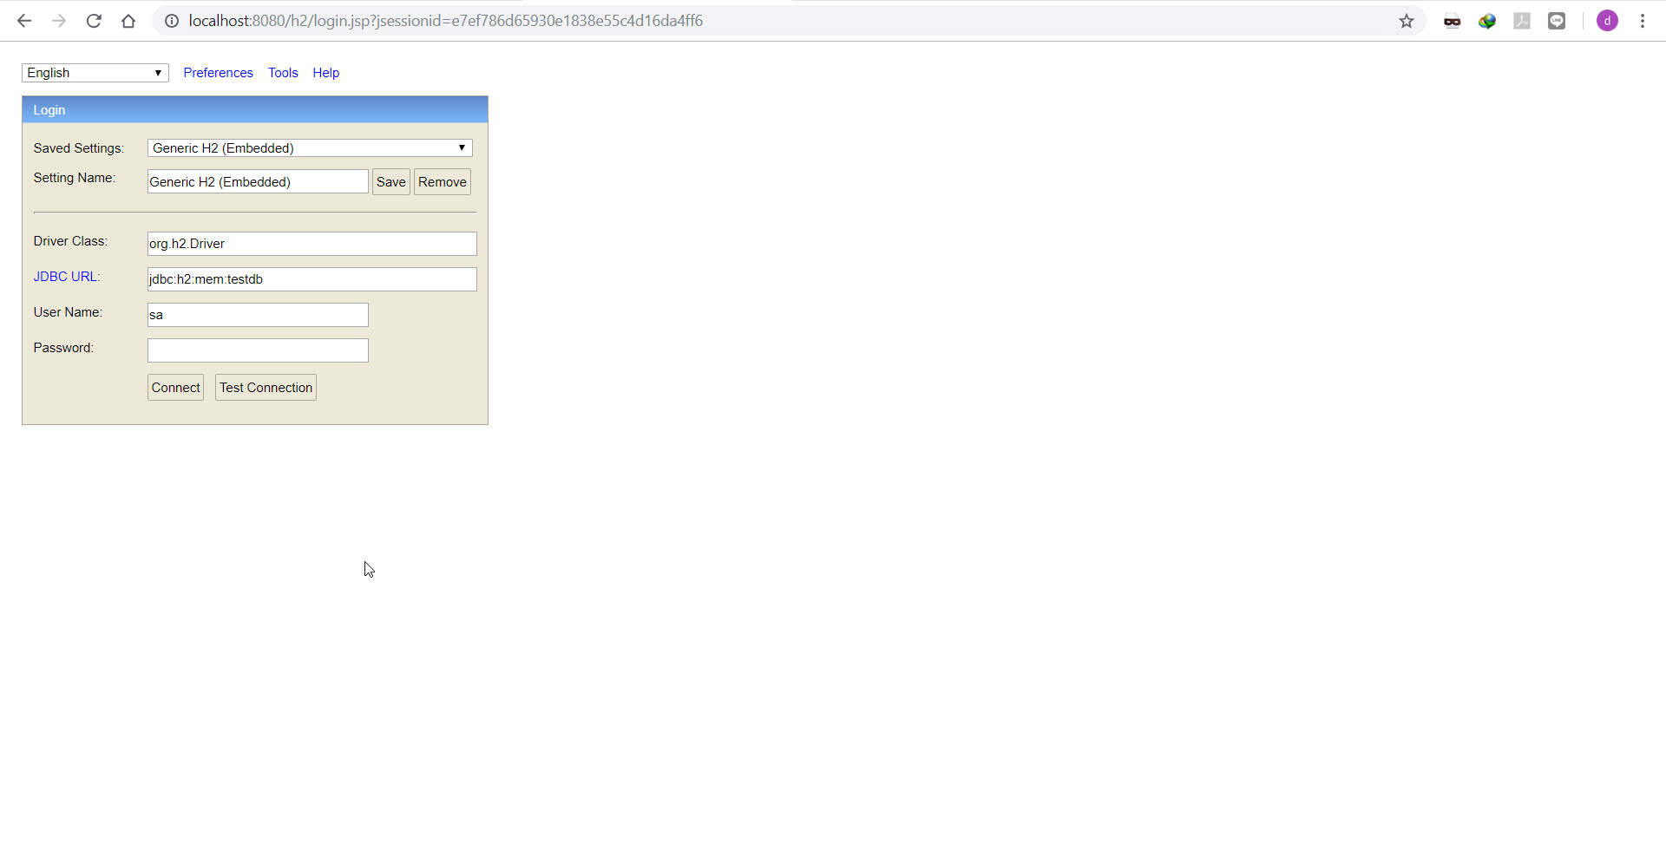

**Swagger link:** [**http://localhost:8080/swagger-ui.html#/**](http://localhost:8080/swagger-ui.html#/)

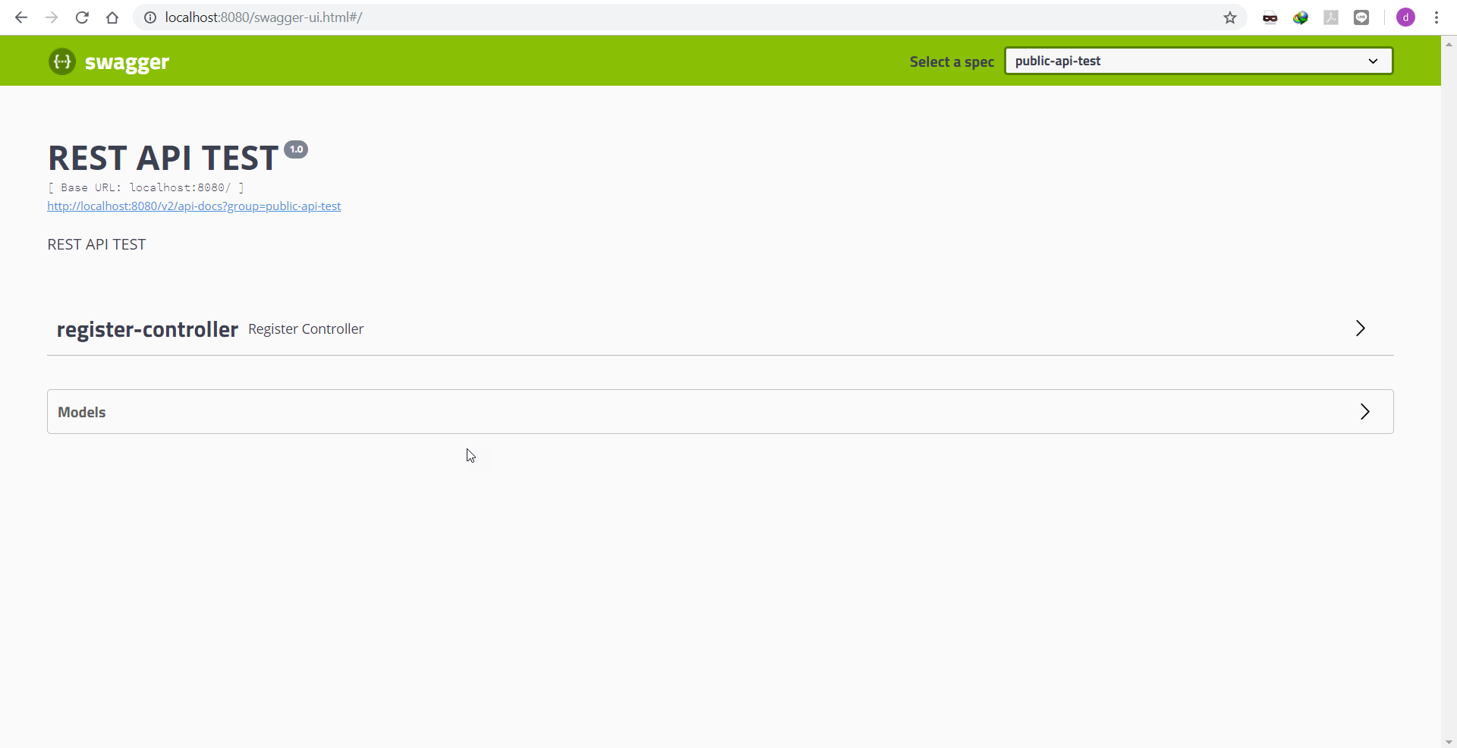

**Junit Test**

