SPATIAL WATER STRUCTURE OF THE TARTAR STRAIT
Danchenkov M.A.
Far Eastern Regional Hydrometeorological Research Institute

ABSTRACT
Spatial water structure of the Tartar strait is described on the base of historical (1950-1993) and modern (1995-2003) oceanographic data. 8 water masses were picked up. Their typical characteristics were determined.
Key words: Tartar strait, temperature, salinity, water masses.

INTRODUCTION
The strait, connecting the Japan Sea and the Okhotsk sea, is divided into three parts having own names: Nevelskogo strait, Amurskiy Liman and Tartar strait- Fig.1.
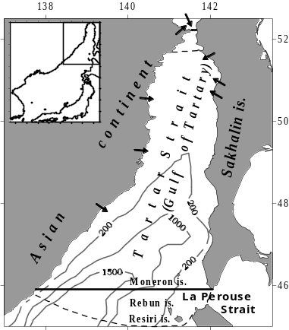
Fig.1. Borders of the Tartar strait and its bottom relief.
The arrows designate the places of basic river estuaries.

Nevelskogo strait (in Japan and in Russia before revolution- Mamiya strait or Mamiya-Rinzo)- its narrowest part.
Now inside its 3 kms length “Lazarev passage” is allocated also (no other passages exist).
Before revolution northern limit of the Japan Sea was defined on Mamiya strait (Sailing directions, 1914).

Estuary of Amur river (Amurskiy Liman) belongs to the Okhotsk Sea.
Soviet hydrography (Sailing directions, 1970) in "Amurskiy Liman" (i.e. into the Okhotsk Sea) the large area to the south of Nevelskogo strait has included also- Fig.2.

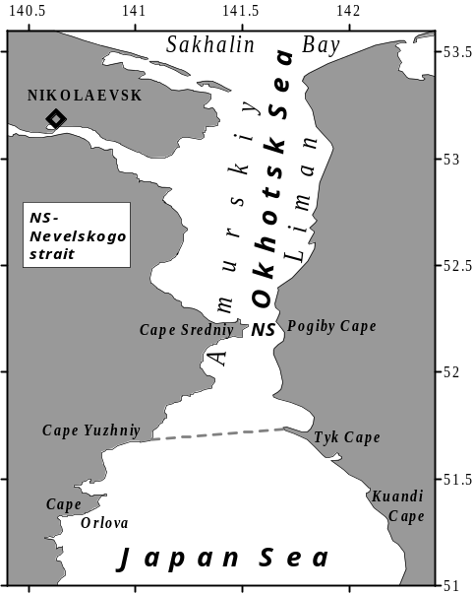
Fig.2. Amurskiy Liman and northern part of the Tartar strait.
Official northern limit of the Tartar strait is designates by dotted line.

Such northern border of the Japan Sea was approved (Spec.paper, N23) by IHB in 1953 only (Hidaka, 1966).
The transfer of a part of the Japan Sea to the Okhotsk Sea, probably, is convenient for the description of navigating conditions, as they are very close in shallow areas to the north and to the south of Nevelskogo strait.
But such northern border (not on the narrowness) does not correspond to usual practice and results in contradictions in area of the sea and its mean depth.

The coasts of Asian continent *) and Sakhalin island are western and eastern borders of the Tartar strait.
*) Centuries ago this northeast part of Asia referred to as Tartary (Tartarie), i.e. wild area. It was shared (on belonging) to the Russian and Chinese Tartaries.
LaPerouse has named the waters between Sakhalin and Tartary as “Golfe de Tartarie”. This part of the sea was named “gulf” because known (Hahn, 1996) strait between Sakhalin and continent was recognized by LaPerouse too shallow for navigation. Till now in English navigating charts this name (" Gulf of Tartary ") is kept for area to the south of 51.4N (and only narrowness between 51.4 N and 53.7N is named “strait” (" Strait of Tartary ").
During hydrographic description of this area the Russian hydrographers have opened this strait anew (because known publications were inconsistent) and have described it in details. But Russian name (“Tatarskiy strait” or “Tatar strait”) became completely different from initial one and amusing- tatars never lived in these places.

Southern border of the Tartar strait is defined (Sailing directions, 1970) unusually also: not on southern latitude of extensive shelf (49N), not on latitude of extreme southwest point of Sakhalin- Krillion Cape (45.9N).
It is bent from it far on the south- to include Rebun and Resiri islands. Thus in Russian Tartar strait the area under Japanese jurisdiction is included.
Tartar strait has the sizes like some seas: width in southern part about 170 miles, in northern- 4 miles, extent (from Krillion Cape to Nevelskogo strait- about 320 miles. Taking into account the sizes, this area should refer to the Tartar Sea or the Tartar Gulf. Nevelskogo strait has to be considered as its northern limit, and Krillion Cape- as its southern limit.

This area is most difficult in oceanographic description part of the Japan Sea and, probably, whole Pacific ocean.
During an year the water temperature changes from -1.8ºС up to 22ºС, salinity- from 24.0 psu up to 34.2 psu.
In winter the waters of Amur river flows out into the strait. In the strait fresh waters of numerous rivers (Fig.1) flow down also. The discharge of the majority of them never was measured. During an year the Tsushima current (to be more precise, its anonymous branch) transfers warm subtropical waters here. In spite of volume of these waters is neglected (for example, Yoon, 1991), it is great enough. For example, its heating action is sufficient to keep 100 km channel free of ice during every winter. Within whole year the cold water of the Okhotsk Sea penetrates here from LaPerouse strait. Because of large number of the influencing factors the vertical water structure in Tartar strait reminds a puff pie. Besides the water characteristics considerably change both within year and from year to year.
On bottom relief features the strait it is possible to divide into two parts: shelf (approximately to the north of 49 N) and deep basin (to the south 48 N).
The Japan Sea is considered as the World ocean in a miniature (Ichiye, 1984). Tartar strait can be considered as the Japan Sea in a miniature- it contains all its basic elements (warm and cold currents, thermal front, basic water masses. Tartar strait is coldest part of the Japan Sea. On its surface 90 % of sea ice is formed every winter.

At complexity of its spatial water structure and essential temporal variability the number of published papers devoted to waters of the strait is dramatically small (Danchenkov, Aubrey, Hong, 2000, Danchenkov, 1998; Riser, Warner, Yurasov, 1999). Among them the publications on biology and fishery oceanography (Shelegova, Uranov, 1964 prevail; Kozlov, Shelegova, 1961; Piskunov, 1952) prevail. The most valuable information on waters of area contains in TINRO reports.
Among known oceanographic atlases of the sea only two (Atlas of water temperature, 1983; Pischalnik, Arkhipkin, 2000) describe oceanography of the strait. Last one contains a complete set of the accurately prepared schemes of spatial distribution of water characteristics (except of sound velocity, ice, tides and currents). The information on sound velocity in the strait was not published at all. The published information about tides and tidal currents is very poor. The publications about sea ice in the strait is limited to the description of position of its edge (Yakunin, 1987) usually. The information on currents in the strait is more numerous (Ponomarev, Yurasov, 1994; Yurasov, Yarichin, 1991, Supranovich, 1989), though is inconsistent.
In the present work the spatial (horizontal and vertical) distribution of water temperature and salinity, mainly in the upper 200- meter layer, is analyzed.

THE DATA
The parameters of waters Tartar strait were measured in more than 350 expeditions. However data of their measurements are allocated on agency’s archives till now. Because of it even the catalogue (Pischalnik, Klimov, 1991) of oceanographic data of the area is incomplete and contains errors. For example, non-existent climatic section of R/V “Volna” on 47.3N was given (it was out of the strait) and some of TINRO expeditions were not shown.
In the present work the data of 43 Soviet (FERHRI, TINRO, Institute of Oceanology) expeditions of 1960-1993, data of 3 Russian expeditions of 1993, 1995 and 1999 were used.
Data of four (194, 223, 224, 225) floats-profillers (Danchenkov, Riser, 2000) in 1999-2003 were used also.
15 shipping surveys (with data of comparatively good quality) covered the strait (from 46.3N to 51.5N) by stations (Table 1).
Table 1. Surveys in the Tartar strait, used in present paper.
Year | Period | N of stations | R/V
1960 | May 4-16 | 122 | Dalnevostochnik
1975 | May 16-31 | 065 | Dalnevostochnik
1976 | May 23- June 22 | 044 | Vikhr
1977 | May 24-31 | 067 | Uryvaev
1978 | May 18-25 | 125 | Dalnevostochnik
1981 | May 16-20 | 052 | Trubchevsk
1985 | November 9-22 | 072 | Uryvaev
1986 | September 26-October 2 | 053 | Uryvaev
1987 | May 4-14 | 052 | Valentin
1988 | May 1-9 | 065 | Levanidov
1989 | August 18-25 | 086 | Maximov
1990 | August 9-24 | 088 | Uryvaev
1991 | September 5-12 | 114 | Frolov
1993 | September 21-28 | 085 | Khromov
1994 | June 4-12 | 090 | Gordienko

Typical position of oceanographic stations and sections of FERHRI R/V (on example of R/V “Gordienko” cruise in June of 1994) are given on Fig.3.
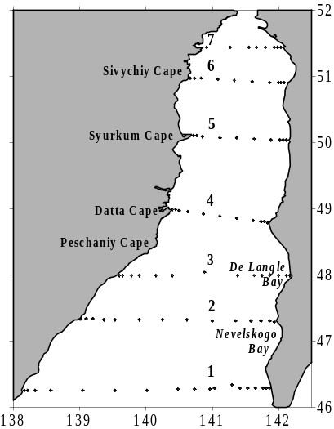
Fig.3. Typical position of oceanographic sections of FERHRI research vessels in the Tartar strait.

Here the following sections with repeating measurements are designated by figures:
- Olimpiady Cape- Pereputie (46.3N),
- Zolotoy Cape- Slepikovskogo Cape (47.3N)- “century” section,
- Grossevichi- Illinskiy Cape (48.0N),
- Krasniy Partizan- Lamanon Cape (49.0N),
- Syurkum Cape- Korsakov Cape (50.0N),
- Sivuchiy Cape- Jonkier Cape (50.9N),
- Orlova Cape- Quandi Cape (51.4N).
The most often measurements of FERHRI research vessels were carried out on “century” section (2).
39 of them, have passed our quality control and were used in the further work.

The measurements of TINRO research vessels in the Tartar strait were carried out on 6 sections in the northern part of the strait (Fig.4) usually.

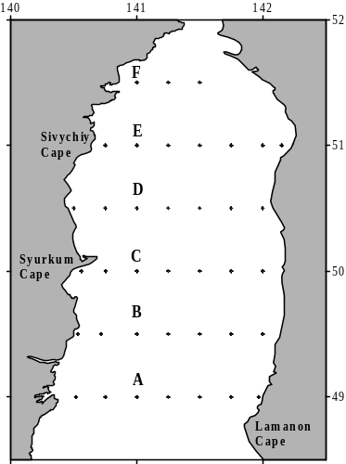
Fig.4. Typical position of oceanographic sections of TINRO research vessels.

In the present work the data of 8 TINRO surveys, have passed quality control, were used.
Research vessels of TINRO worked in the strait only since April till November. In winter, even during intensive thawing of ice, usual oceanographic vessels could not work in the Tartar strait (famous by abrupt change of wind strength). Due to it, till now there are no winter measurements to the north of 47N. Let's notice, that suitable for such work research vessels (ice class) of FERHRI were used at the same time, basically, in tropical areas of the Pacific ocean.
Main problem of the data in the Tartar strait is their quality. The numerous data of measurements, with rare exception (data of Sakhalin branch of TINRO), were not published. In Vladivostok the largest in the world (more than 30 large-tonnage vessels) research fleet was concentrated. But there was not any manufacturing of scientific equipment and materials. They were delivered from western part of the country (distance of 10000 kms). Water samplers (of terrible quality) were manufactured in Georgia, thermometers- in DDR, normal water- in Moscow. They were delivered out of schedule too often. The salary of research crew worked in domestic waters (Tartar strait) was much less than salary for work in expedition far from them. Usual number of station per day (3-4) was too big (with the taking into account the local weather) and not much time was given for data control in expeditions. These did not promote quality of measurements.
Due to large flow of data (for example, 10 large research vessels of FERHRI produced about 10,000 every year), weak delayed control and not publishing of them, their quality was dissatisfied. All 1-meter CTD data were throw out.
Quality of salinity measurements was especially low. It is possible to appreciate the quality of salinity on its values for deep layer. 30 years ago (Gamo, Horibe, 1976) it was known, that salinity of deep waters Japan Sea changes in very narrow limits (34.05 psu- 34.08 psu). However Soviet measurements showed overestimated and underestimated values till 1993 (year of first international expedition in the Japan Sea). For example, salinity values of 33.96 psu and 34.20 psu at 1000 m level were admitted as authentic (Pokudov, Manko, Khlusov, 1976).
The similar erroneous values (from 33.8 psu up to 34.2 psu) are given as characteristic for waters below halocline (Yarichin, 1982). The erroneous values of salinity (34.16 psu on 1000 m horizon) measured by R/V “Vityaz” were published (Report of “Vityaz”, 1954). The erroneous values of salinity are characteristic also for measurements of TINRO vessels. For example, in 10-th cruise of R/V “Krym” on 50N the salinity of more 34.6 psu were pointed.
Because of it even on climatic (averaged for many years) schemes (Fig.4) obviously incorrect (more than 34.2 psu) values of salinity occur- Fig.5.

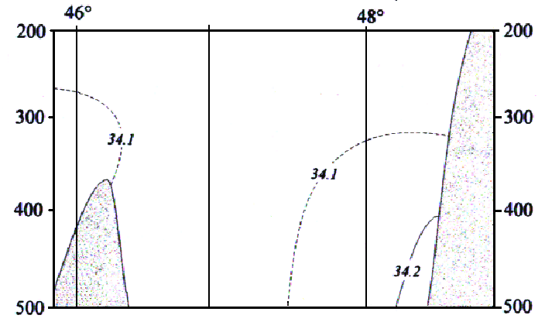
Fig.5. Fragment of salinity distribution on 141E in an autumn (Pischalnik, Arkhipkin, 2000).

The intermediate layers of low and high salinity were found in northern part of the Japan Sea recently(Kim, Kim, 1999). By Soviet CTD data (1980-1990) such layers did not traced. Quality problem begun to discuss only after in FERHRI Regional Data Center was established. But even now in Vladivostok is not the equipment to justify the CTD gauges. Expeditions with participation of foreign scientists in Tartar strait are forbidden till now too.
Therefore qualitative salinity data in the Tartar strait are not numerous.
To them it is possible to attribute the measurements of few international expeditions (R/V “Akademik Lavrentiev” , May of 1995; R/V “Professor Khromov”, July of 1999 and July of 2002) and data of floats-profillers (August of 1999-July of 2000).

WATER MASSES OF THE JAPAN SEA AND TARTAR STRAIT
Waters of World Ocean or its parts (sea or gulf) can be divided into some water masses (WM),
in which temperature and salinity are rather close and are constant. Generally, the quantity of ranges of temperature and salinity can be any, but even for wast parts of ocean are usually limited by 5-7.
By general definition (Dobrovolskiy, 1961) “water mass” is “the rather BIG volumes of waters having for a LONG TIME CONSTANT distribution of characteristics”. Combination of water masses on a vertical is named a structure. The allocation of water masses is carried out sometimes by claster method (Luchin, 2003), EOF (Yasui et al., 1967) or on the change of vertical gradients of parameters (Radzikhovskaya, 1961).
Usually it was made by TS-analysis (Mamaev, 1987). By claster or EOF methods it is difficult to distinguish water masses with close values of temperature and salinity of different origin.
For identification of WM, except for two basic parameters, concentration of the dissolved oxygen (different for waters of subtropical and subarctic origin) are sometimes used.

On Fig.6 the TS-curve typical of subtropical waters of the Japan Sea (and values of temperature and salinity in cores and borders of water masses) is submitted.

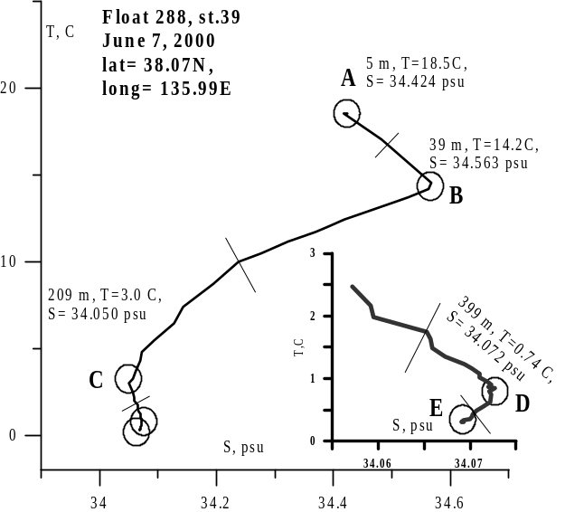
Fig.6. TS-curve for station 39 of float-profiler 288.
Lowest its part is presented separately.

Except for cores (points of extremal values on the curve) indexes of water masses- values in points formed by tangent of TS-curve- are used. It is considered, that indexes should characterize water in a place of WM formation. On Fig.6 indexes of WM B and D are very close to values in their cores. WM C has index (5ºC, 34.0 psu) which is distinct from parameters of WM in core (209 m, 3ºC, 34.05 psu). WM “A” – surface one; WM “B” - subsurface of high salinity; WM “C”- intermediate of low salinity; WM “D”- intermediate of increased salinity; WM “E”- deep. In deep areas just below deep WM it is possible to allocate and bottom WM (usually it is warmer than deep one).

The values of deep WM core in Figure 6 are not shown- its core is located below lowest (807 m) horizon of float- profiler measurements. It is clear, that the parameters of deep WM and bottom WM are different in shallow and deep parts of the sea. Depending on a place of station and time of year, the values of temperature and salinity in core of WM are different also. However indexes of water masses and their attributes (high either low salinity) have to be constant.
Up to middle of the last century in the Japan Sea (except for surface and bottom water masses) only two basic water masses were allocated (Suda, 1932; Uda, 1934):
Deep (or proper water, occupying the sea lower 200 m, with temperature 0ºC- 1ºC and salinity 34.0 psu-34.1 psu) and subtropical (or pacific, with high- more 10ºC- temperature and high- up to 34.5 psu- salinity) WM.
In middle of century two new WM were found: intermediate WM of low salinity (Miyazaki, 1953) and cold subsurface WM (Leonov, 1958). At the end of century (Kim, Kim, 1999) two another WM- intermediate of high salinity and intermediate of low salinity- were described.
Except for them, numerous WM of small volume and small duration of existence (Zuenko, Yurasov, 1995) were allocated in small parts of the sea. However, the allocation of such water masses contradicts the given definition.

Tartar strait contains all known in the Japan Sea water masses.
On a vertical, water column in Tartar strait can be divided on features water distribution into: the upper layer (most heated), thermocline (layer of the greatest vertical gradients), layer of minimal temperature (cold subsurface) and deep layers. On features of salinity distribution on a vertical there are different layers: upper (with fresh water), layer of high salinity, layer(s) of low salinity, intermediate layer of high (increased) salinity and deep layer. It is necessary to explain that in Tartar strait, subtropical waters of high salinity occupy other (in relation to a southern part of the sea) position- near the surface usually. Therefore in the present work the upper layer of high salinity will refer to surface layer (not intermediate).
The water characteristics in the strait very strongly change both within one year, and in different parts of the strait. As will be shown further, the strait is divided by thermal and salinity front into two parts, in which the water masses and their combination on a vertical are various.

The vertical structure of waters in the strait is a combination of layers representing various water masses.
In total in the Tartar strait 8 basic water masses are allocated. Between them are:
two surface WM- subtropical of high salinity and subarctic of low salinity, two water masses of low salinity (subsurface and intermediate) cold subsurface WM, intermediate WM of high salinity and proper (deep) WM.
Eighth WM (bottom), distinct from deep WM by higher temperature, was allocated only in area of a deep basin.
Subsurface layer of low salinity and intermediate layers of high and low salinity are allocated only with the use of qualitative CTD data.
The examples of TS-curves of waters of the strait are submitted on Fig.7a, 7b and 7c (the characteristics of numerous stations of June 1994 best are submitted as TS-diagram).

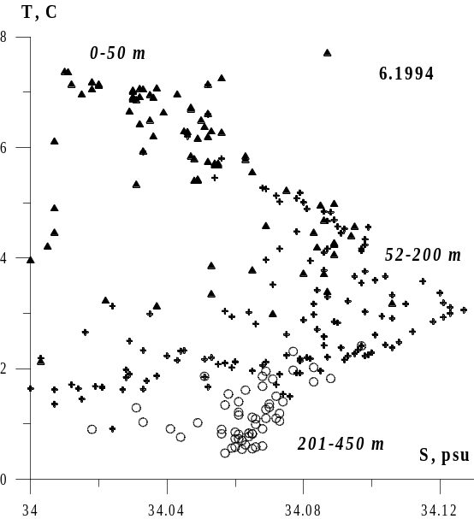
Fig.7a. TS-diagram for stations in June of 1994.
Measurements in a layer 0-50 m are designated by triangle, in a layer 52-200 m- by cross, in a layer 201-450 m- by circles.

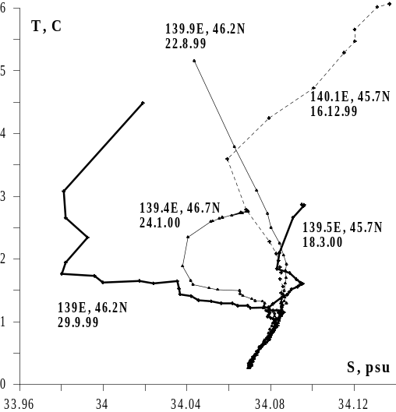
Fig.7b. TS-curve for stations with low salinity layer (thick curves- float 223,
Thin curves- float 225, dotted line- float 224).

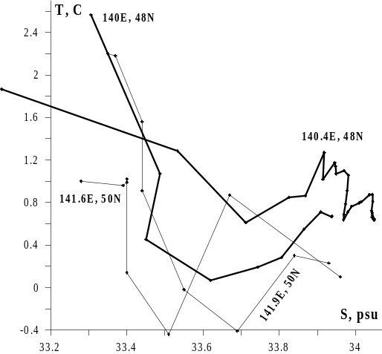
Fig.7c. TS-curve for stations with cold subsurface WM
(thin curves- May of 1977, thick curves- July, 1999).

Let's note the features of water masses of the Tartar strait.
Surface water masses.
At a wide range of water temperature variations of surface WM, their constant features are: extremely high (for subtropical WM) and low (subarctic WM) salinity. Core of surface WM of high salinity is situated near horizon 50 m (Fig.7a). This WM becomes subsurface one only when fresh water layer appear at the surface (for example, in area of Krillion Cape).
Subsurface WM of low salinity (in fig.7 is not shown).
The thin layer of this WM is usually existed in the summer under thin surface layer of higher salinity.
Intermediate WM of low salinity (Fig.7b).
It differs from subsurface WM by its depth (near 100 m horizon) and value of salinity (more 34 psu).
Intermediate WM of high salinity.
I is separated from surface WM of high salinity by layer of intermediate WM of low salinity. The core of this WM is situated near horizon 300 m.
Cold subsurface WM (Fig.7c).
Water temperature of this water mass is less 1.5 ºC. Salinity changes over a wide range.
Proper (deep) WM.
Is usually exists on the lowest horizons of measurements.
The parameters of Proper water mass below 250 m in the Tartar strait (0.12ºC-1.2ºC, 34.05 psu- 34.08 psu) are similar known for other areas of the Japan Sea.

FEATURES OF VERTICAL WATER STRUCTURE OF SOUTHERN PART OF THE TARTAR STRAIT
The vertical water structure of southern part of the strait is formed by a combination of layers of different WM. Between them are fresh surface WM, surface and intermediate WM of high salinity, subsurface and intermediate WM of low salinity and Proper WM.
Some of them have subtropical origin, some- subarctic origin. Origin of one of them is unclear now.
By the basic features southern (to the south 48N) part of the sea are thick surface layers of subtropical (high salinity) and subarctic (low salinity) waters- Fig.8.
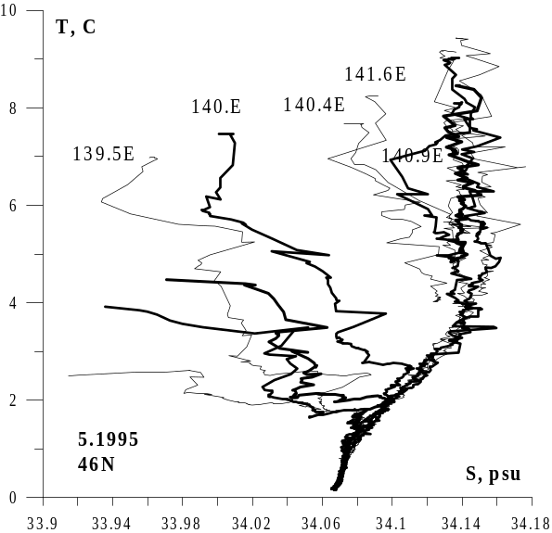
Fig.8. TS-curves of stations at 46N (May of 1995).

Surface layer of warm and high salinity waters corresponds to a branch of Tsushima current (Miyazaki, 1953). We use for it the abbreviation of HSL or HSL-1 (with the taking into account the existence of second-intermediate- layer of high salinity).
For 600-mile travel from the Tsushima strait to the Tartar strait these waters are transformed- temperature and salinity are lowered.
In spite of it their basic features (high temperature and high salinity) remain constant.
Temperature of subtropical waters even in May exceeds 6ºС, and salinity exceeds 34.1 psu. However values of salinity, higher 34.2 psu, in the strait are rather rare.
The thickness of HSL in the spring seldom exceeds 120 m.
The depth of core of HSL changes within one year. In April and, probably, during previous winter it is below than horizon 50 m (in the LaPerouse strait- near bottom).
At the end of May (and during the following summer) the core of high salinity layer is located at a surface. In the winter and spring these waters are marked only near Sakhalin coast- between 140.6E and 141.7E. Their core usually is traced near Moneron island (141.1E-141.2E).
Warm subtropical waters in a southeast part of the strait do not approach to the coast. Along the coast (from LaPerouse strait up to 47N) the strip of cold and fresh waters from the Okhotsk Sea exists. Their characteristics (temperature less 2ºС, and salinity- less than 33.5 psu) sharply differ from characteristics of local waters (as surface as deep ones).

Subsurface the layer of cold water (LCW) to the south 48N exists only near continental coast and, basically, only in spring.
The layer of low salinity (LSL) deserves the special attention, as in the Tartar strait it is marked for the first time (but existed, certainly, always).
Earlier it was known only in western part of the sea (Kim, Chung, 1984), where is formed (Danchenkov, Aubrey, Feldman, 2003) annually between subarctic and Northwest fronts.
This layer is presented in southern part of the Tartar strait almost everywhere, except for shallow areas.
In May the core of low salinity layer is located just under the surface thermocline- between horizons 10 m and 20 m.
Near continental coast the low salinity layer comes on the surface.
The values of salinity in a core of this layer and its depth in southwest and in southeast parts of the strait differ essentially: near continent water salinity is much lower, and the depth of its core- is much less.
Sometimes (for example, on 139.5E in May of 1995) on a vertical it is possible to find out at once two layers of low salinity: thin subsurface (core- on horizons 10-20 m) and more thick intermediate (which core is between 100 and 200 m).
These differences allow to divide layer of low salinity into two: subsurface layer of low salinity (LSL-1) and intermediate layer (LSL-2).
Sometimes (it is usual in the middle of the strait) there is one LSL.
In east part of the strait two LSL are easily distinct: LSL inclines intolayer of high salinity and LSL-2 is situated just under it.
However LSL-2 was met and outside of area of subtropical waters of high salinity.
It was presented in the Tartar strait during the most part of a year (even at the beginning of winter).
The value of salinity in its core varied from greatest (34.07 psu) in March (Fig.9) down to the least (33.96 psu) at the end of April.

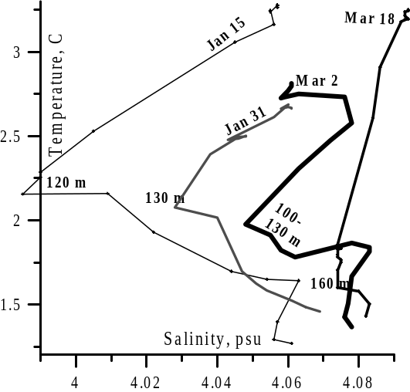
Fig.9. TS-curve of stations of float-profiler 194 since January till March, 2000.
The labels designate horizons. On horizontal axis- anomaly (S- 30.) of salinity.
The trajectory of float drift is submitted on Fig. 10.

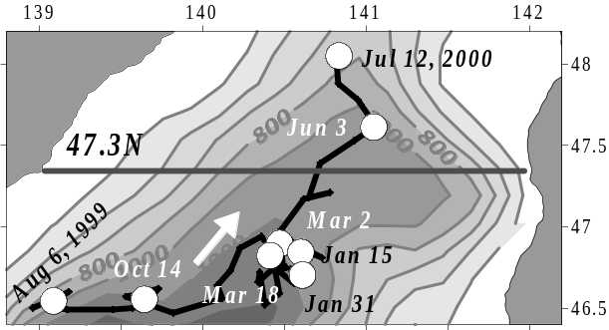
Fig.10. Trajectory of float 194 drift at 800 m level since July of 1999 till July of 2000.
By thick line a location of “century” section is shown.

In the summer (July of 1999) LSL was allocated only on 46N (between 60 m and 120 m). On 48N it was absent.
Water temperature in its core was 3ºC-4ºС, and salinity- 34.00 psu- 34.04 psu.

In southern part of the strait intermediate high salinity layer (HSL-2) was allocated. It differs from surface high salinity layer (HSL-1) by value of temperature (much less), by depth its core (near 300 m usually) and area of distribution (in area of deep basin only).
There, where HSL-1 and HSL-2 were presented together, they are divided by layer low salinity (LSL-2).
By high dissolved oxygen concentration (more than 6.5 ml/l in July of 1999 and in July of 2002), HSL-2 is not simple part of HSL-1.
Probably it is formed by transformation of surface high salinity water mass in zone of deep convection.
In summer of 1999 (Figure 11) HSL-1 (temperature 5ºC- 10ºС, salinity- 34.11 psu- 34.18 psu) was located, basically, on shelf of Sakhalin (141.7E, 35 m- 60 m,), and HSL-2 (temperature - 1ºС- 2ºС, salinity- more than 34.075 psu) occupied almost whole strait (139E-141E, 200 m- 400 m).

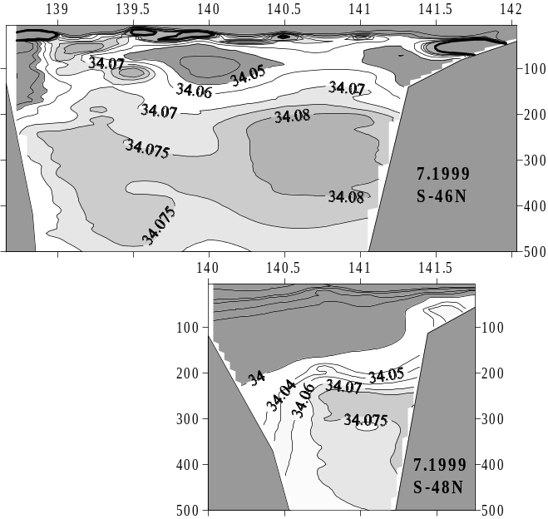

Fig. 11. Intermediate layer of high salinity in July, 1999.

On northern (48N) section the thickness and area of distribution of HSL-2 has decreased essentially in relation to its situation on southern section. Because of it, it is possible to assume, that HSL-2 was distributed from the south to the north.

FEATURES OF VERTICAL WATER STRUCTURE IN NORTHERN PART OF THE TARTAR STRAIT
The vertical water structure in northern (to the north 48N) part of the strait is more simple, than in southern its part.
Distinctive feature of vertical water structure in northern part of the strait is subsurface layer of cold water (LCW).
Its water temperature on some degrees is more cold than temperature of waters, lied above it and under it.
In different time this layer was found out at all latitudes of the strait and during the most part of year.
LCW was traced (since May till November) in “domainе of cold water” - between 48N and 51N usually.
In the winter, during ice formation, water are cooled from the surface and by convection cold waters are distributed down to levels of 150 m- 200 m (in deep basin area) or to the bottom (on the shelf).
In winter (since January till March) the measurements from the ice cover in the strait were not carried out.
Because of it is not clear, where the core of cold water locates in winter- near bottom (where new formed dense waters should accumulate)
or at the surface (where their cooling is highest). In the spring (in April) the coldest waters are traced at a surface, and rather warm waters are settled down near bottom.
In the beginning of April LCW thermocline is absent. The homogeneous waters, cooled in the winter, occupy whole water column- from the surface to the bottom. But in May surface waters get heat enough to form thin surface layer of comparatively high temperature. As the result, thermocline and LCW were traced. The core of LCW settles down at a continental coast on horizon of 30 m (under the thermocline) and depth of the core increased eastward- Fig.12.

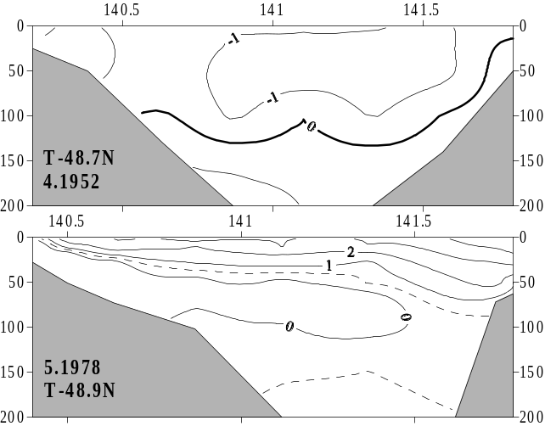
Fig.12. Distribution of water temperature at sections in northern part of the strait in April 12, 1952 and May 23-24, 1978.

In the Okhotsk Sea this layer is limited by isotherm 0^{о}С. In the Tartar strait, where water temperature in LCW changes both in limits of the strait and within one year, the LCW limits can be determined different (from -1.5^{о}С up to 1.5^{о}С) isotherm.
Let's notice, that low (less -1.5^{о}С) water temperature in LCW core was observed enough often. For example, in May of 1977 and in May of 1978.
At the heating of LCW waters from the surface and from bottom layer the thickness of LCW decreases during one summer. In western part of the strait it is thicker and water temperature in its core is lower. High surface water temperature is explained by their solar heating. Relatively high near-bottom water temperatures could be explained by inflow of warm water from the south only. It is confirmed by the increasing (within an year) of temperature and salinity of near-bottom water and their higher values in east part of the strait.
-.the inflow of warm water is insignificant there.
The influence of warm water is different on 47N and on 51N. On southern section (except for the special area to north from Krillion Cape) warm waters are situated close to the coast and LCW along the coast is absent. To the north of thermal front (48N-49N) warm waters usually pass on middle strait and LCW is usually broken off- Fig.13.

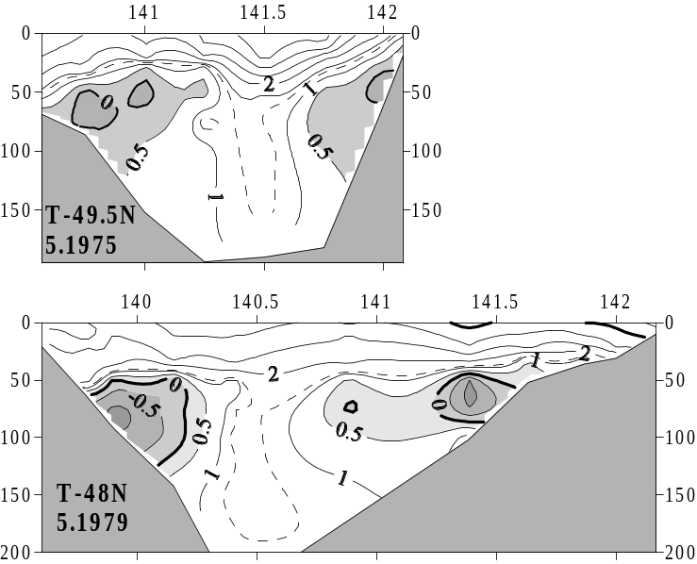
Fig.13. LCW in northern part of the strait (May 21,1975 and May 31, 1979).

Waters lying above and below of LCW have different origin. The different origin cause their different salinity.
Above the thermocline salinity is very low (less 33.2 psu in northern part of the strait and less 33.8- psu- in its southern part).
Especially (less 30 psu) low salinity was typical for surface waters along continental coast. Probably (any measurements were not conducted) rivers discharge there is more than in eastern part of the strait.
Because of it surface water in northwest part of the strait can be considered as special WM.
Salinity at Sakhalin coast is higher. It shows the existence of surface (subsurface) current of high salinity.
Below LCW water salinity is much higher (from 33.9 psu in northern part of the strait to 34.05 psu- in its southern part) than at the surface.
Because depth of LCW core increases from the west to the east, water salinity in LCW increases from the west to the east too.
For example, water salinity in LCW at 50N (limited by isotherm 0.5С) increased from less 33.0 psu (at continent) up to more than 33.8 psu (at Sakhalin) - Fig.14.

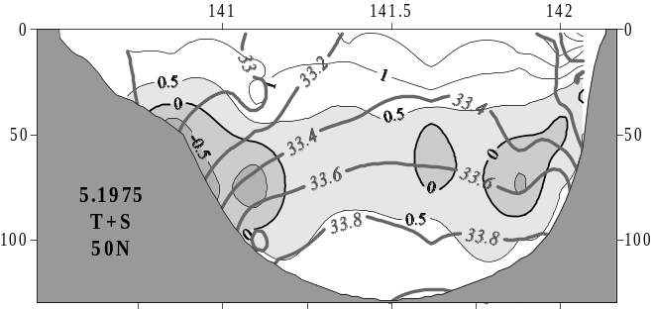
Fig.14. Water temperature and salinity at 50N, May 17-18, 1975.

Sometimes (July of 1999) two LCW were allocated. One of them (with core on horizon of 50 m) was located in halocline and its salinity
changed in wide (from 32.9 psu up to 33.9 psu) limits. Another LCW (with core situated on horizon of 160 m) was characterized by almost constant (33.98 psu-34.01 psu) salinity- Fig.15.

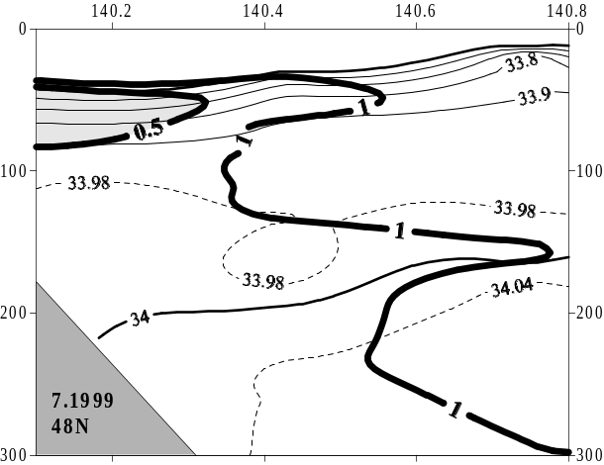
Fig. 15. Two layers of cold water on 48N (July of 1999).
Isotherms are designated by thick lines.

The main feature of waters of northern part of the strait in summer is strong freshening of surface waters. Decreasing of salinity values depends from river discharge and volume of salty waters inflow. Now there are not any special measurements, suitable for an estimation of northward salty waters inflow (for example, series of surface drifters). The run-off of most of numerous rivers of northern part of the strait also never was measured. It is possible only to assume that basic influent factor (river discharge or northward inflow) is different in different part of the northern Tartar strait.
The warming up of surface waters is resulted in increase with thickness of upper layer. In shallow (for example, on 51.4N) areas of the strait the LCW disappears completely in summer- Fig.16.

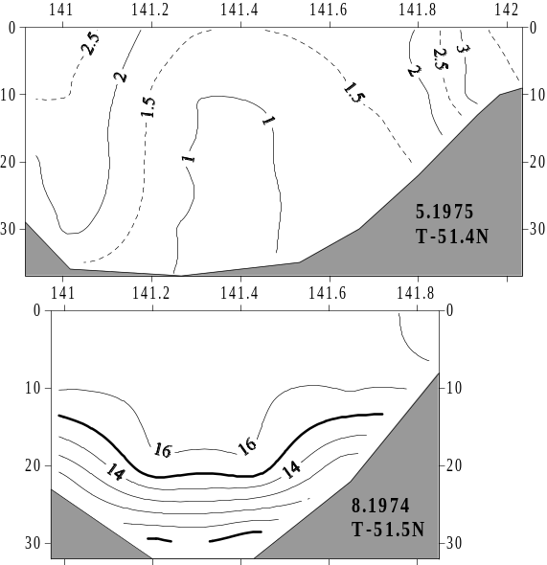
Fig. 16. Distribution of water temperature on section along по 51.4N in May (above) and in August (below).

Water temperature in LCW grows up in summer (from -1ºC in May up to 1.5ºC in August) - Fig.17.

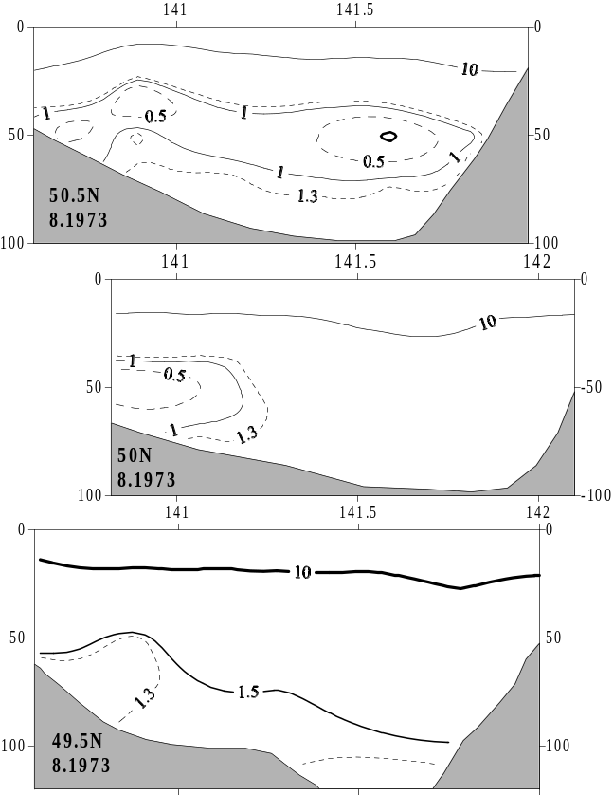
Fig. 17. Distribution of water temperature in northern part of the Tartar strait in August, 1973.

Характеристики вод слоёв в течение года меняются. Особенно изменчивы характеристики воды верхнего слоя. Менее всего изменчивы характеристики глубинного слоя. Характеристики придонного слоя, возможно, изменяются после каждой зимы, однако в настоящей статье они не рассматриваются из-за недостатка качественных данных.

INTERYEAR VARIABILITY OF VERTICAL WATER STRUCTURE
Water characteristics of layers in the Tartar strait vary within one year. Characteristic of water of the upper layer are variable especially. Characteristic of deep layer are almost constant during whole year. The characteristics
of bottom layer, probably, change after each (cold or warm) winter. However now there are not the quality data to investigate such variations.
Typical values of water temperature, salinity and density of some (subsurface and intermediate) layers are presented in Table 2. Note that typical values of water parameters of LSL-1 and LCW are very close.
The Table 2. Water characteristics of some layers of the Tartar strait.

Layer | Season | Depth of core, m | Temperature, С | Salinity, psu | Density
LSL-1 | Spring | 10- 70 | 1.8-4.0 | < 33.95 | 27.0-27.1
LSL-1,  LSL-2 | Summer | 10- 40  70-140 | >10.0  1.5-2.0 | < 33.90  < 34.02 | <26.1  >27.2
LSL-2 | Autumn | 50-140 | 1.5-3.0 | < 34.00 | >27.2
LSL-2 | Winter | 100-150 | 1.8-2.2 | < 34.03 | >27.2
LHS-2 | Summer | 330 | 0.9 | 34.075 | 27.3
LHS-2 | Autumn | 380 | 0.9 | 34.078 | 27.3
LHS-2 | Winter | 300 | 0.9 | 34.083 | 27.3
LCW | Spring | 40-100 | < 0.5 | 33.5- 33.8 | 26.9-27.1
LCW | Summer | 30- 70 | < 1.0 | 33.6- 33.8 | 26.9-27.1

Therefore the updating of LSL-1 could be occur within summer along south-western continental coast at the expense of LCW.
Thickness and water temperature of LCW within a year varies significantly.
It is possible to trace the change of LCW thickness on the variation of its boundary isotherms. If to accept for
Its boundary isotherm of 1ºC, its distribution (Fig.18) shows the following.

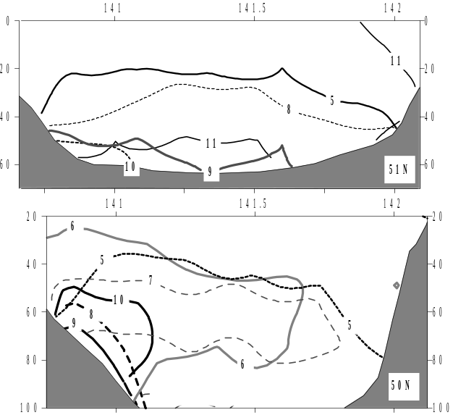
Fig. 18. Distribution of isotherm of 1ºС on 51N (above) and
on 50N (below) in different months (labels are months of year).

In September- October LCW occupies the least area and in May- greatest one.
Since November the formation of the new cold waters begins in east part of the strait. Despite of small
distance between 50N and 51N, 50N and 51.4N, temperature and salinity spatial distribution on these
sections is essentially different. In the beginning of a summer on 50N under LCW the rather warm water is situated. And on 51N and on 51.4N- LCW lies just near the bottom. At the end of one summer on 50N and 51N LCW exists and on 51N- disappears at all.
Depth of seasonal variations there is much more, than it was considered earlier (200 m). For example,
The increasing of water temperature in layer of 0-50 m, in area with the centre on 46.8N, 140.3E, was accompanied by the same warning of layer of 500-800 m (Fig.19).

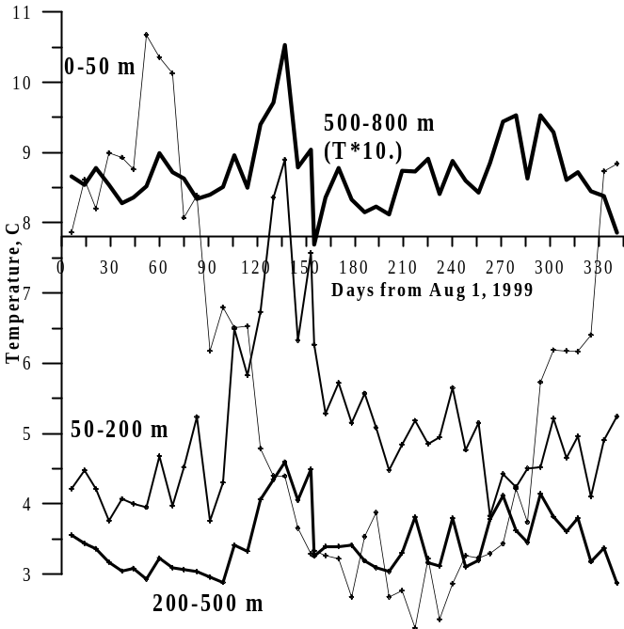
Fig. 19. Temporal variation of average temperature of layers 0-50 m, 50-200 m, 200-500 m, 500-800 m (temperature of last layer is given with a multiplier) since August 1999 till July, 2000. Data of float-profiler 194. Trajectory of its drift was shown at Fig.10.

By the spatial movings of floats in period from December of 1999 till March of 2000 it is possible to neglect.
Most measurements were made in area with the center in point with coordinates 46.7N, 140.5E.
Temporal variation of water temperature and salinity is presented on Fig.20.

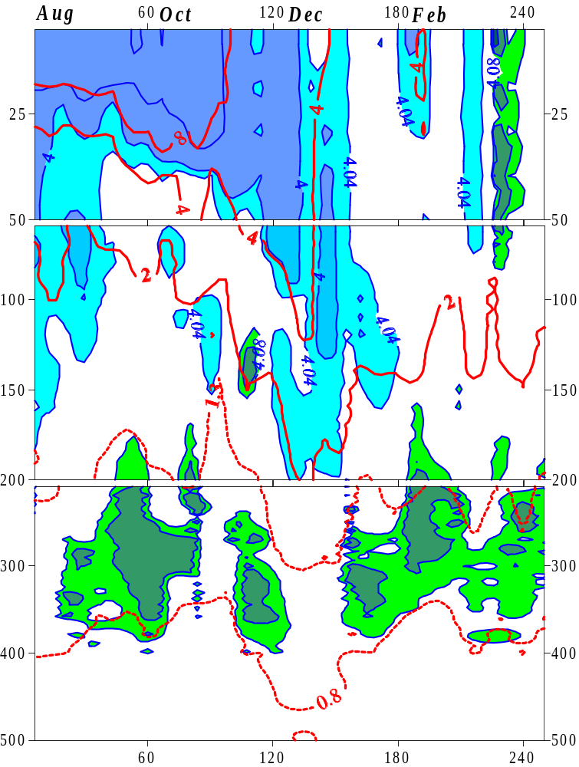
Fig.20. Temporal variation of temperature and salinity of float-profiler 194.
On horizontal axis the days from August 1, 1999 are shown.
The distribution of fresh water (down to horizon of 100 m- 140 m occurs gradually since October till December.
The stability of waters in this period is positive. At the end of winter (in March)
salty (more than 34.078 psu) waters reaches the horizon of 230 m. Stability of this water is negative or is close to 0. In vertical column the temperature of homogeneous on salinity water changes in
small limits- from 2.0ºC- 2.5ºC at the surface up to 0.8ºC- 1.0ºC at horizon of 300 m. The depth of water mixing in the winter was different for different floats (in spite they were on small distance from each other: float 223 in point with coordinates 45.8N, 139.3E; float 224- in point with coordinates 45.5N, 140.2E)- Fig.21.

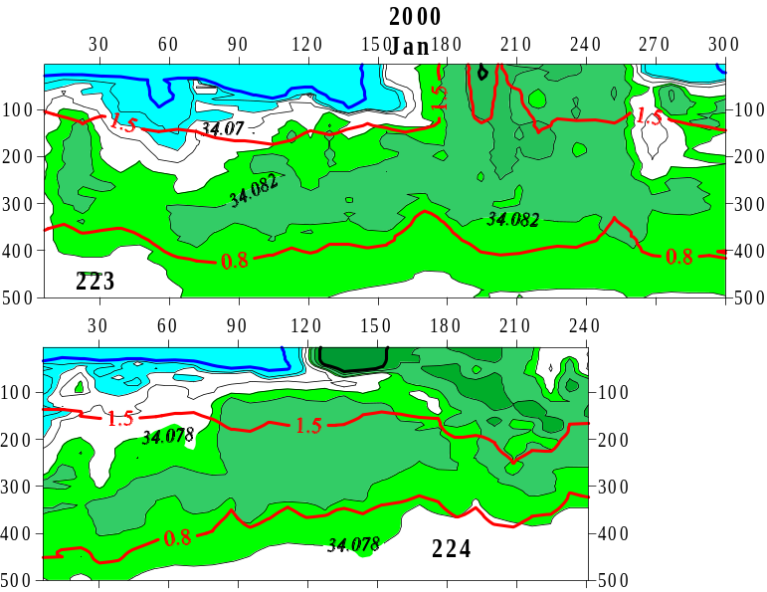
Fig.21. Temporal variation of water temperature and salinity of floats 223 and 224.
On horizontal axis the days from August 1, 1999 are shown.

Greatest (300 m) depth of water mixing in winter was marked in area of float 223 drift.
In spite of sharp change of water temperature in the strait begins from the end of November,
The heating by Tsushima current waters was traced even in winter.
Due to the influence of warm waters the ice cover distributes differently in western and in eastern parts of the strait. In east part of the strait the channel of free of ice water reaches 48N (Stolyarova, 1963).
In western part of the strait the ice cover distributed to the southern limit of the strait.
During one year the spatial distribution of water temperature and salinity vary very much.

HORIZONTAL WATER STRUCTURE OF THE TARTAR STRAIT
The basic features of horizontal distribution of temperature and salinity on a surface strait are thermal (Fig.22) and salinity fronts, separating cold and low salinity water of northwest part of the strait from warm and more salty waters of southeast part.
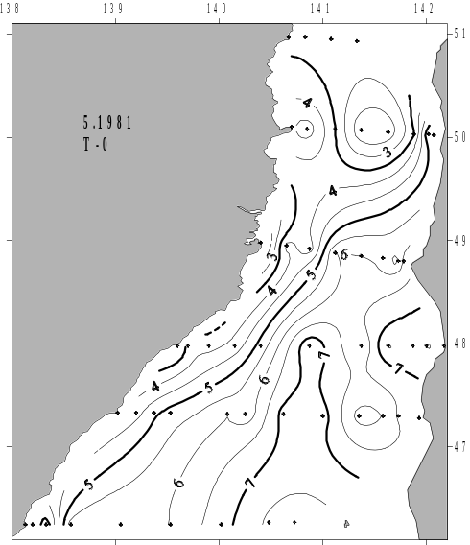
Fig.22. Distribution of surface water temperature of the Tartar strait in May 3-20, 1981

The positions of thermal and salinity fronts are close to each one in the most part of the strait (southern part).
Northern part of the strait is an exception, where water temperature and salinity changes in the large limits.
Basic front (“Tartar front”) is a branch of Subarctic front, dividing the subarctic and subtropical waters of the sea (Belkin, Cornillion, 2003). In the strait it passes by a complex line: from a continental coast on 46.5N up to 48-49N, where follows on the latitude to the east up to 141.5E. There front is divided.
One of its branch passes to the north along western coast of Sakhalin (“ Northern front”), and another one follows southeastward -to Krillion Cape (“Krillion front”). To the north of Tartar front there is extensive (47.5N-51.4N, 141E-142E) area of cold water- “cold domain of the Tartar strait”. Its width is maximal between 50N and 51N, and to the south of 49.5N its width sharply are down. To the south of Tartar front the extensive area of warm water (“warm domain of the Tartar strait”) is located. It was formed by meander of Tsushima current.
Its center is located near Moneron island.
On the borders of cold and warm domains the gradients of water temperature are higher, than outside of them.
Therefore it is possible to speak not about one Tartar front, but about two fronts (cold and warm ones) and about a zone between them.
The greatest gradients of water temperature water across the front (up to 5ºC/mile) are characteristic for two parts of the strait- the strip between 48N and 49N and, especially, coastal area of southwest Sakhalin (“Krillion front”).
Below the surface (Fig.23) the position of Tartar front is kept or is displaced to the east.
The border between cold and warm domains is non-zonal on all levels.
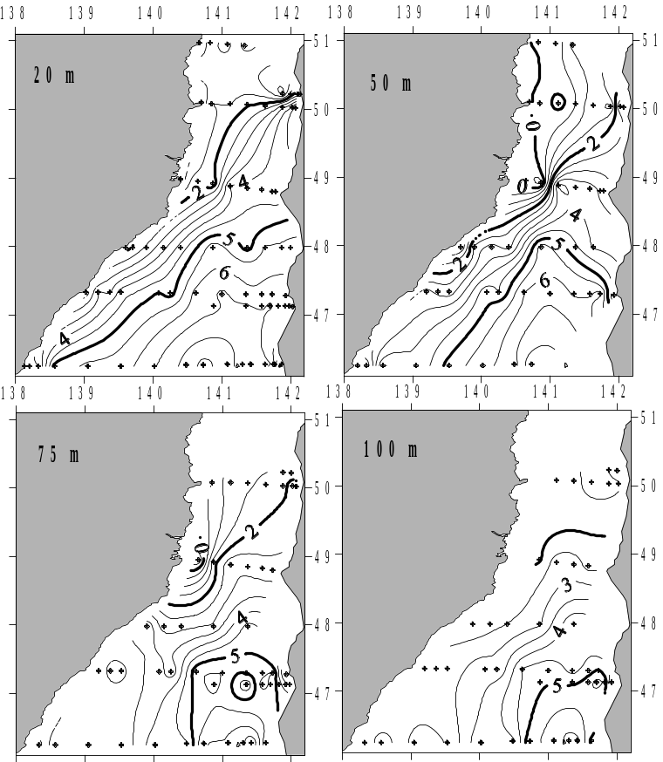
Fig.23. Distribution of water temperature on different levels in May 3-20, 1981
In the spring, surface salinity inside the warm domain exceeds 33.9 psu, and inside cold domain is less than 33.5 psu. The horizontal distribution of water temperature and salinity in the summer (Fig.24) essentially does not differ from spring one.
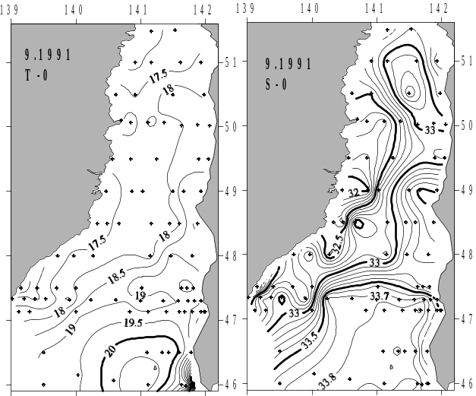
Fig.24. Distribution of surface water temperature and salinity in summer

On the surface it is possible to allocate two fronts and interfrontal area between them. Warm front limits the transformed subtropical (warm and of high salinity) waters. Cold front limits the cold and low salinity water.
The center of warm domain is located near Moneron island, and center of cold domain is situated near continental coast between 50N and 51N.
In spite of surface water temperature and salinity strongly vary within one year, it is possible to note the constant features of their distribution. Water temperature is maximal in warm domain, and it is minimal in the different (usually divided) places along continental coast. Salinity is maximal in warm domain and it is minimal along continental coast in northern part of the strait.
It is not easy to specify the typical isotherms, limiting warm and cold domains due to strong interannual variability of water parameters.
The border of warm domain on the surface a little bit differs from its border on 100 m level.
But the border of cold domain on the surface usually does not corresponds to its borders on depths- Fig.25.
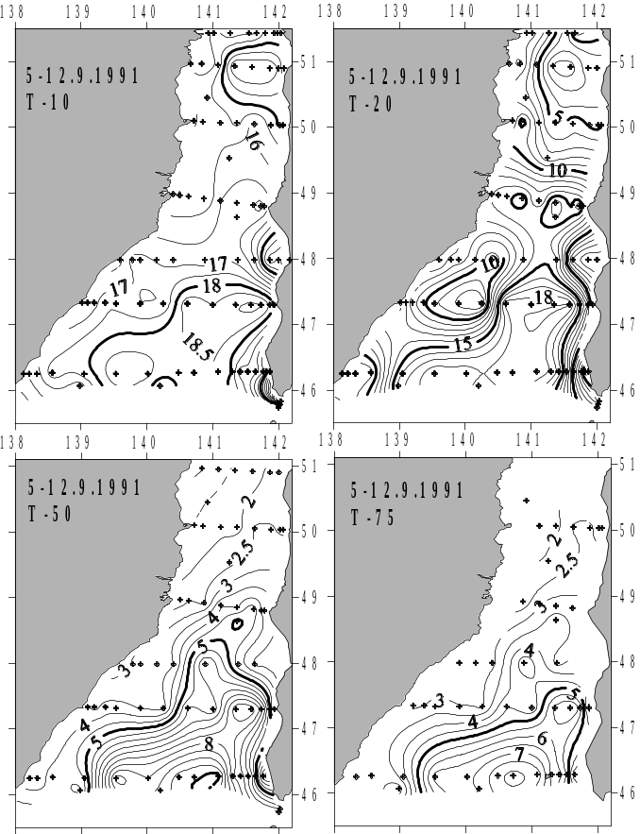
Fig.25. Distribution of water temperature in the summer on levels 10 m- 75 m.

On horizons of 20-30 m (in thermocline) and below the spatial gradients of water temperature are maximal. Thermal front is picked out well.
September is the month of greatest heating of waters of the Tartar strait.
Warm domain in September, 1991 on horizons 10-75 m was limited by isotherms of 18ºC, 15ºC, 5ºC and 3.5ºC accordingly. Warm water was distributed from Moneron island in two directions: to the north- along 141E, and to the west- toward continental coast (between 46N and 47N).
Warm water approaches to Sakhalin coast between 47N and 48N only.
Warm domain is limited not only by basic front (between 48N and 49N).
From the west and from the east it is limited by coastal fronys.

Front of cold domain on the specified horizons was limited by isotherms of 15ºC, 10ºC, 3.5ºC and 3ºC.
By the different characteristics (temperature, salinity and dissolved oxygen) cold waters in different parts strait have a different origin. In northwest part of the strait cold waters distributed to the south by narrowed strip. Only in area at 48N, the space engaged by them, was increased. Probably, it is at the expense of local upwelling.
In southeast part of the strait, water between Krillion Cape and 46.5N differs by lower temperature and salinity from waters of Nevelskogo (47N) and DeLangle (48N) bays. Temperature and salinity in coastal strip between Krillion Cape and 46.5N grew and width of coastal cold strip decreases.
It specifies a direction of cold and low salinity water distribution (from LaPerouse strait into the Japan Sea).
Cold waters in Nevelskogo and DeLangle bays, probably is the result of local upwelling.

DIVIDING OF THE TARTAR STRAIT
The position of typical surface isotherms in different years allowed to pick up the mean position of frontal lines in the Tartar strait (Fig.26).

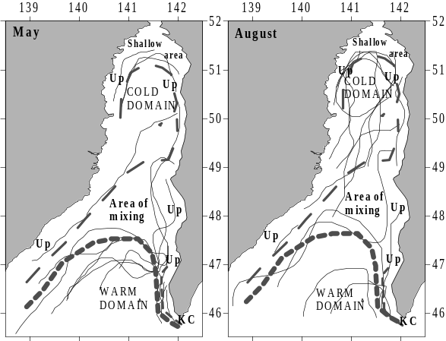
Fig.26. Distribution of typical isotherm (thin lines), fronts (dashed lines) and zones of the strait in May (left) and August (right) of 1960-1989. Up- Zone of the upwelling. KC- cold waters of Krillion current.

The Tartar strait is divided by fronts on some zones, in each of them special water mass prevails:
-warm domain;
-cold domain;
-belt of the Okhotsk Sea waters (KC);
-interfrontal zone;
-areas of coastal upwelling (Up);
-northern shallow area.

WARM DOMAIN AND SUBTROPICAL WATERS
At the end of summer, temperature of surface waters in northern part of the strait was close to surface water temperature surface of waters in its southern part. However warm domain does not reach to the nortnern limit of the strait. Isotherm of 3ºC was considered (Probatov, Shelegova, 1968) as the border of subtropical waters penetration in the strait. According to it, warm domain border lies to the south of 48N. Waters of east part of the strait were divided (Piskunov, 1952) on three parts (Pogibi Cape- Jonkier Cape- Lamanon Cape-Krillion Cape) according to the influence of warm subtropical waters. It was considered, that subtropical waters did not penetrate in northern (to north of 50.9N) part of the strait absolutely; area between 49N and 50.9N “was under weak influence of warm current”; the area between 46N and 47N “was under the action of cold East-Sakhalin current”.
At western coast of the Tartar strait (within the limits of 100 m isobath) transformed subtropical waters were not found out, though the upper layer gets the heat more, than at east coast of the strait (Fig.27).
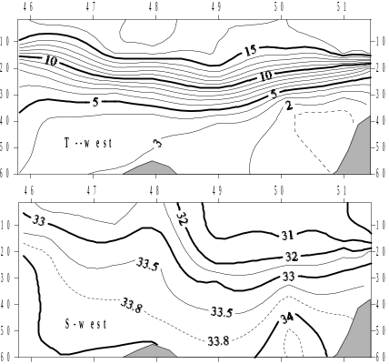
Fig.27. Distribution of temperature and salinity along continental coast of the Tartar strait in September 7-11, 1991

At east coast of the strait warm and salty waters are transported by nameless branch of the Tsushima current further to the north (up to 51N), than in central parts of the strait. Penetration of warm and salty waters
it is possible to explain the increase of temperature and salinity in bottom (under LCW) layer in cold domain.
Subtropical waters penetrate up to 47 N even in the winter, that explains not zonal distribution of ice cover in strait (up to 47.5N in east part of the strait).

The influence of warm water on the ice cover of the Tartar strait is especially appreciable in March. In this month the LaPerouse strait is blocked by the Okhotsk Sea ice and warm water moves into the Tartar strait mainly. For example, in March 21, 1961 the inflow of warm water from the south has connected some polyniyas together and the corridor of free of ice water was formed (to 49.5 N). At March 26, 1961 this corridor was distributed up to 50.5 N. At April 11 east part of the strait was cleared of ice up.

COLD DOMAIN AND LCW
Cold domain occupies the greatest area at the end of winter (in April). Its border on the surface does not correspond to its borders on the levels. In the summer border of LCW is traces better on 50 m horizon. To the surface cold water rises in upwelling areas (Fig.26).
In spite of LCW was shown for the first time in A.K.Leonov (1958) paper, it is described recently only (Pogodin, Shatilina, 1994; Zuenko, 1994). However given (Zuenko, 1994) information (“LCW is observed on 20 m- 100 m horizons”; “depth of minimum of temperature varies from 60 m- 90 m at the centre to 20-30 m in the northern Tartar strait, where water temperature is the lowest”; “between 45N and 52N the characteristics (temperature 0ºC-2ºC, salinity- 33-34 psu) of LCW are kept within summer”) do not coincide with results of our investigation.
For example, 100-meter thickness of LCW was shown in area, where depth is much less than 100 m. It is difficult to check up the calculation of cited thickness (dates of survey, name of research vessel did not presented). So, we shall note the discrepancies only.

“LCW is observed on horizons of 20- 100 m”.
In the spring LCW is absent- cold homogeneous water is distributed from the surface to the bottom.
As surface layer, LCW exists in April and, sometimes, in May.
In August – September the horizon of 20 m crosses the thermocline (Fig.28).

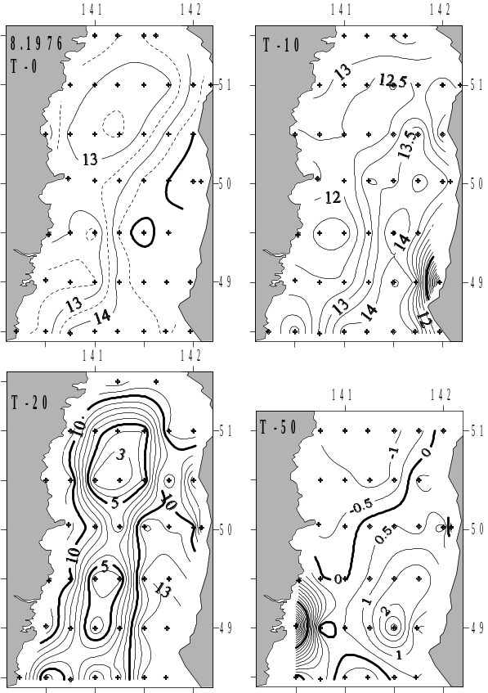
Fig.28. Distribution of water temperature on different horizons in August 8-23, 1976

LCW occupies the horizon of 100 m in the spring only. In summer on this horizon there are rather warm and salty water of deep layer.
“The depth of temperature minimum varies from 60-90 m in the center of the strait to 20-30 m at the north of the Tartar strait, where water temperature is the lowest”.
“Between 45N and 52N, the characteristics (temperature 0ºC- 2ºC, salinity- 33-34 psu) of LCW are kept within whole summer.”
The core of LCW is located on horizon 50 m usually (Fig.13-15,17,18).
The depth of LCW core grows from the west to the east.
On shallow “north of the strait” (51.4N) LCW existed during a short time (May). In June (Fig.29) it is absent.

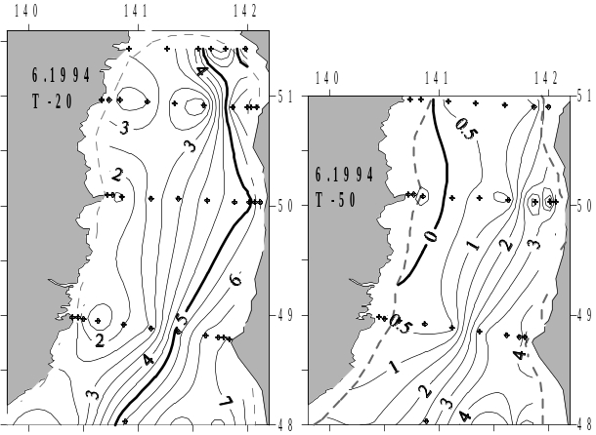
Fig.29. Distribution of water temperature on 20 m and 50 m levels ìn June 4-12, 1994
The coldest water in LCW was marked not “at the north of strait”, but between 50N and 51N.
The characteristics (temperature and salinity) of LCW waters do not remain constant. They grow during summer.
Within the limits of the large area (“between 45N and 52N”) they, naturally, are various (Fig. 30).

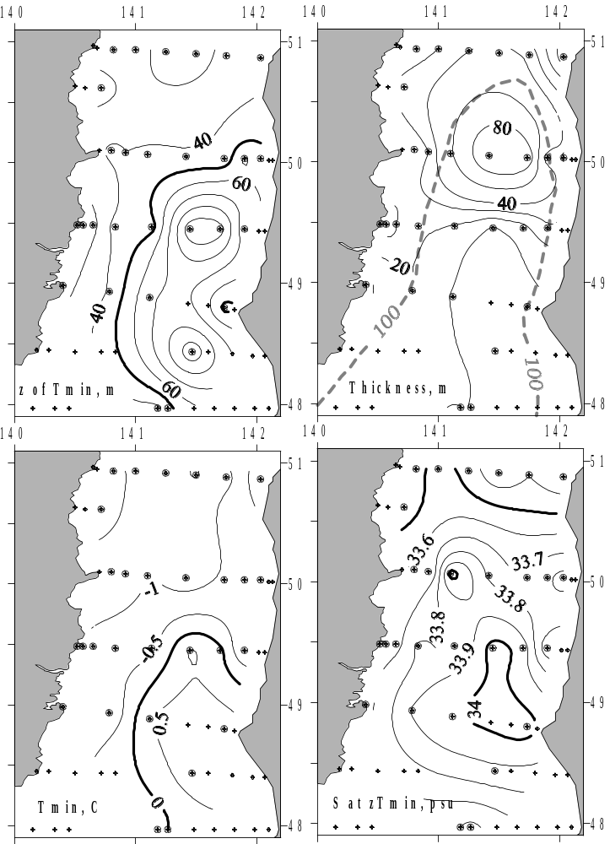
Fig.30. Depth of core, thickness, water temperature and salinity in core of LCW in summer (May 29- June 22, 1976). Stations, where LCW was absent are designated by points
In summer LCW was not present on 46N and on 51.4N usually; on 47N it was found out seldom; on 48N- frequently; in cold domain (between 49N and 51N) it was found almost always.

Areas of water upwelling
Homogeneous (on temperature) water occupies almost whole upper 100-meter layer in “warm domain”. Because of it is impossible to trace water upwelling in “warm domain” usually. In a winter the difference of water temperature between the surface and 100 m level is insignificant almost everywhere. Sometimes subsurface water even is warmer, than surface one.
The upwelling is traced well in cold domain and in coastal areas of the strait usually. In northern part of the strait, subsurface cold waters strongly differ from surface one and occupy the large area. But summer upwelling in northern part of the strait is rare. More dense subsurface waters could not penetrate at the surface through strong picnocline, which exists in a summer. The water upwelling is usual in Autumn (Fig.31).

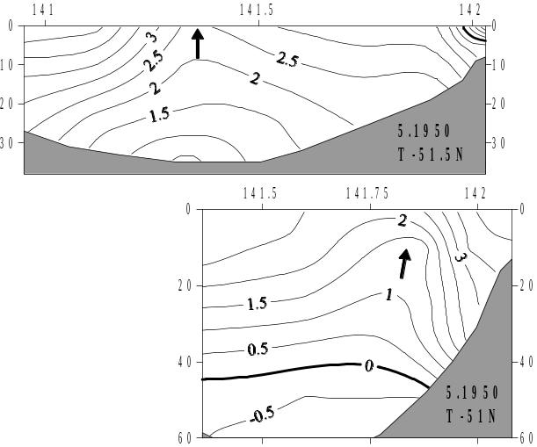
Fig.31. An example of water upwelling in northern part of the strait.
Off the coast the upwelling of cold waters is traced not on the surface, but below the thermocline frequently (Fig.32).
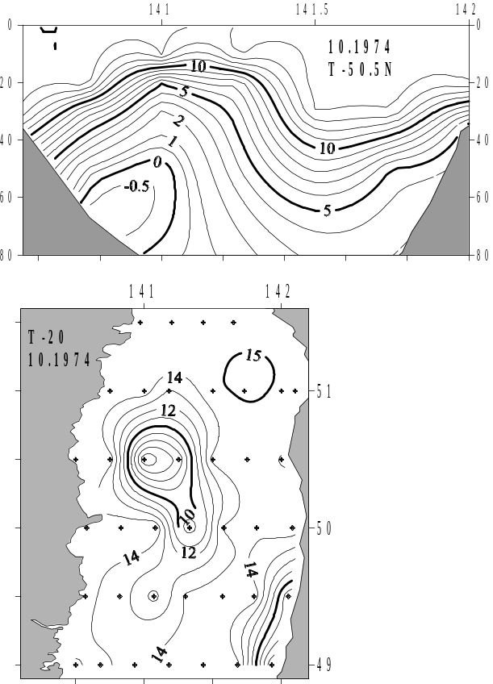
Fig.32. The upwelling of cold waters in October 3-7, 1974.
In coastal areas of the strait the output on the surface of colder subsurface waters is traced near capes. There is long-time strong off-shore winds (for example, at Syurkum Cape on 50N). Besides there is the upwelling in places of a divergence of currents (for example, in Nevelskogo and in DeLangle bays (between 46.5 and 48.5 N).

Belt of the Okhotsk Sea waters at Krillion Cape
Within whole year between Krillion Cape and Lopatin Cape (46.5N) the strip of cold water from the Okhotsk Sea exists. It is filled up with inflow from the LaPerouse strait (Fig.33) regularly.

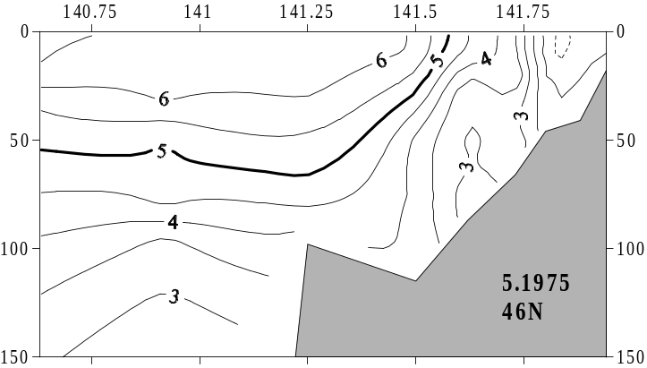
Fig.33. Distribution of water temperature on 46N section in May 16, 1975.
Its existence was noticed in 19 century (Maidel, 1879; Zuev, 1887): « along a southern part of western coast Sakhalin up narrow (5-8 miles) coastal strip of cold water goes up to 46.7N.”
Cold waters are distributed to the north by thin (20-30 м) layer and narrowed between Krillion Cape and 46N strip. Their temperature in winter is more (on 0.5ºС-1.5ºС), and in spring and in summer- less than temperature of coastal water in Nevelskogo bay (Fig.34).
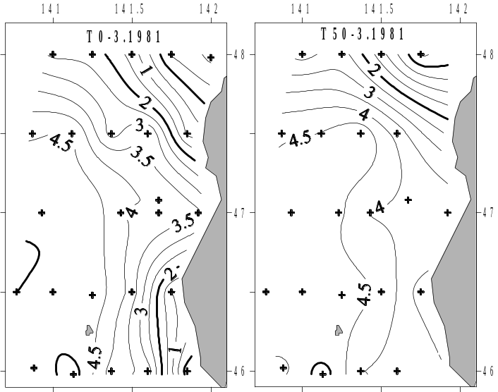
Fig. 34. Water temperature at the surface and at 50 м level in March 9-11, 1981.
For example, in summer of 1986 the water inside the strip (0-30 m) were much more (on 10ºC-12ºС) colder waters of Nevelskogo bay (Fig.35).

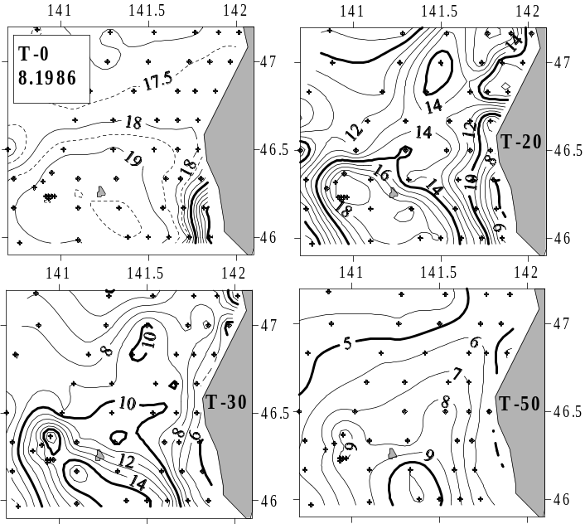
Fig.35. Water temperature in southeast part of the strait in August 1-25, 1986.
As well as winter, the penetration of waters from the Okhotsk Sea, basically, is limited by 46.5N. Only in some years with the combination of favorable winds (Probatov, Shelegova, 1968; Shelegova, 1960) these waters are distributed to Kholmsk (47N) and even far to the north.
The existence of this strip was explained by local upwelling along southwest Sakhalin coast and their transport to the south: «cold waters through LaPerouse strait penetrate into the Okhotsk Sea » (Zhabin, Gramm-Osipova, Yurasov, 1993); «at a southwest extremity of Sakhalin island the steady flow directed to the south into the LaPerouse strait is observed» (Yarichin, 1980); "West Sakhalin Current flowing southward along the west coast of Sakhalin … and directly flowing into La Perouse Strait " (Tanaka et al., 1996).

However, low temperature and salinity of waters inside the strip can not be a consequence of local upwelling (Danchenkov, Aubrey, Riser, 1999). Within whole year (even in the winter) waters inside the strip on 1ºС -1.5ºС are colder than subsurface waters of this area. Salinity of local subsurface water is on 0.2-0.4 psu higher than water salinity inside of cold strip.
The origin of cold water of low salinity is connected with water transport from area between Krillion Cape and the Stone of Danger island. The average level of the Okhotsk Sea on 40 cm is less than averaged water level of the Japan Sea. But this difference is various as in different (northern and southern) parts of the LaPerouse strait, as within a day.
In LaPerouse strait between Stone of Danger island and Krillion Cape the cold intermediate layer is supported by a branch of cold East-Sakhalin current (Krillion current- Maidel, 1879) - Fig.36.

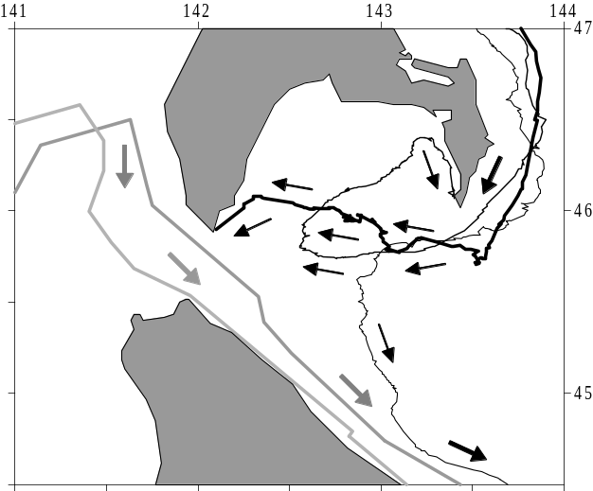
Fig.36. Trajectories of surface floats drift in LaPerouse strait vicinity (1999-2000). Their drift by warm Soya current is designated by light lines and arrows. Drift by cold East-Sakhalin current and cold Krillion current is designated by black lines and arrows.
Special «like by a plough» (Makarov, 1894) bottom relief between the Stone of Danger island (45.8N, 142.2E) and Krillion Cape promotes a upwelling of waters moving from the east to the west. Their temperature (less on 2ºC- 5ºС) and salinity (less on 0.5-1.0 psu) sharply differ (Fig.37) from the characteristics of surface waters of the Japan Sea.
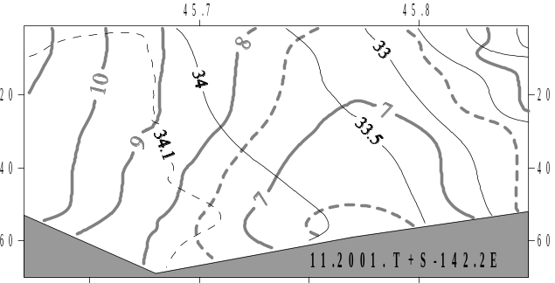
Fig.37. Water temperature and salinity in area between the Stone of Danger island and Krillion Cape ( November 5, 2001).
With daily tide (Biryulin, 1954) or, sometimes, under the action of special wind system the cold waters penetrate into the Japan Sea. «After penetration into the Japan Sea the flow of cold water under Coriolis force action turns to the right and follows along Sakhalin coast to the north » (Veselova, 1963). During low-tide the part of them comes back and, seized by Soya current, is distributed southeastward, far from the Stone of Danger island.
Width of the strip is about 8 miles near Krillion Cape and 5 miles at 46.8N (Zuev, 1887). Its thickness is 10-20 m, local temperature gradients is up to 5ºС/mile (Veselova, 1963).
The greatest water transport into the Japan Sea from the Okhotsk Sea was measured during a winter, least one- in summer. From the end of April up to middle of May, 1963 the water transport into the Japan Sea has decreased from 6 km3/hour to 1.4 km3/hour, and water transport into the Okhotsk Sea has increased in the same period up to 3.4 km3/hour (Shelegova, 1963). In summer (Shelegova, Uranov, 1964) the water transport into the Japan Sea is smaller (from 0 in July 17, 1965 to 0.26 km3/hour in July 14, 1964).
Water salinity of the Okhots Sea (less than 33.8 psu) is essentially less than salinity of local (as surface as subsurface) waters of the Japan Sea. Due to it the hypothesis (Zhabin, Gramm-Osipova, Yurasov, 1993) of local (in the Japan Sea) origin of cold waters in the strip is easily denied by the analysis of salinity spatial distribution.

WATER MASS ORIGIN
Four water masses (both surface, cold subsurface, subsurface of low salinity) of 8 are formed in the Tartar strait.
Tartar strait is considered (Martin, Munoz, Drucker, 1992) as a place of proper (deep) water mass formation (temperature 0.2ºС -0.5ºС, salinity- 34.05-34.08 psu). The basis for this is the duration and severity of winter conditions, and the existence of polynias. However, as a result of winter cooling and mixture of fresh (surface) and salt (deep) waters LCW is formed. Its salinity (from 33.5 up to 33.8 psu) and density vary from year to year not so much (Fig.38). And they differ from the characteristics of proper Japan Sea water mass.
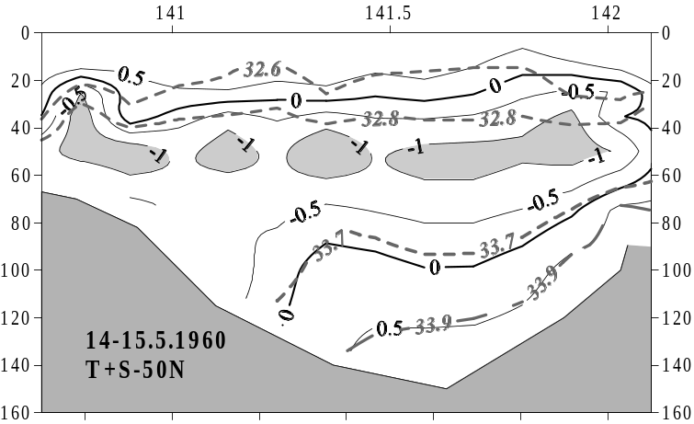
Fig.38. Temperature and salinity of LCW waters in 1960.
The formation of LCW waters occurs in the spring not only in cold domainе (as it was shown above), but, probably, and in a narrow strip along continental coast. Its salinity (33.8-34.04 psu) here (August of 1976) was much higher than salinity of LCW waters in cold domain (water temperature was very close in both areas).
Surface salinity in southern part of the strait is higher than in cold domain. Ice formation here could produce the cold and salty water. However, averaged (for a layer of 0-50 m) surface water density (up to 27.2) in winter (150-240 days, considering from August 1, 1999) do not achieve here the values (27.33-27.34), characteristic for deep water of the Japan Sea (Fig.39).
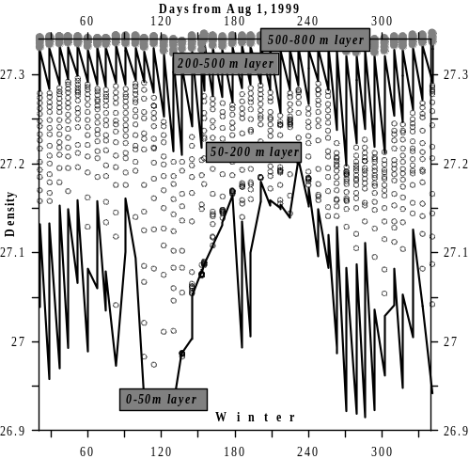
Fig.39. Variation of averaged density of float-profiler 194.
The trajectory of float drift is submitted on Fig.10.
Near 300 m level within an year the intermediate layer of high salinity (temperature 0.9С, salinity- 34.08). exists. It is formed probably in area (areas), where surface layer of high salinity distributes to deep (more than 300 m) horizons and where LSL-2 (capable to break off such thick layer) exists. The strong vertical mixture and is traced by data of float-profilers in area of «East eddy» (Danchenkov, Riser, Yoon, 2003) only. Low salinity water penetrate there (west of the Bogorov Rise) during whole year.
Surface waters in different parts of the strait are formed within year by mixture of waters of a different origin. Therefore their characteristics strongly differ. In general, salinity of surface waters decreases from the south to the north and from the east to the west. The exceptions is the strip near Krillion Cape (salinity is less than 32.5 psu) and northern shallow area (salinity less than 32.0 psu). Water temperature there varies within an year in wide interval (from 2ºС up to 10ºС).
Without qualitative measurements it is not clear, where LSL-2 (below the thermocline) is formed. The layer is not found out to the north of 47N. However on 46N it is present everywhere. Its characteristics in the spring (2ºС, 33.9-34.0 psu, density- 27.15) are close to the characteristics of surface waters and LCW waters in southwest part of the strait (temperature is less than 1.5ºС, salinity- 33.5-33.8 psu, density – about 27.15). Probably, it is formed there in the spring.
Water temperature and salinity at the surface (above the low temperature layer) and in bottom layer (under the low temperature layer, between 70 m and 120 m levels) in cold domain vary within an year. The increase of temperature and reduction of surface water salinity (Fig.40-41) is explained easy by solar radiation and river discharge. But the increasing of near-bottom water temperature and salinity in cold domain cannot be explained without the thaking into account of inflow of warm and salty waters from the south. But for detailed analysis there are not qualitative measurements of salinity.

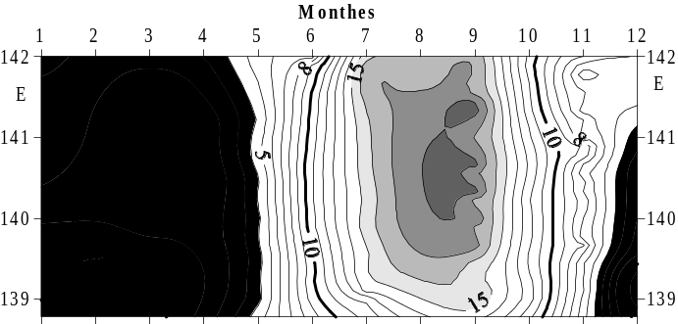
Fig.40. Change of surface water temperature within year on 47.3N.

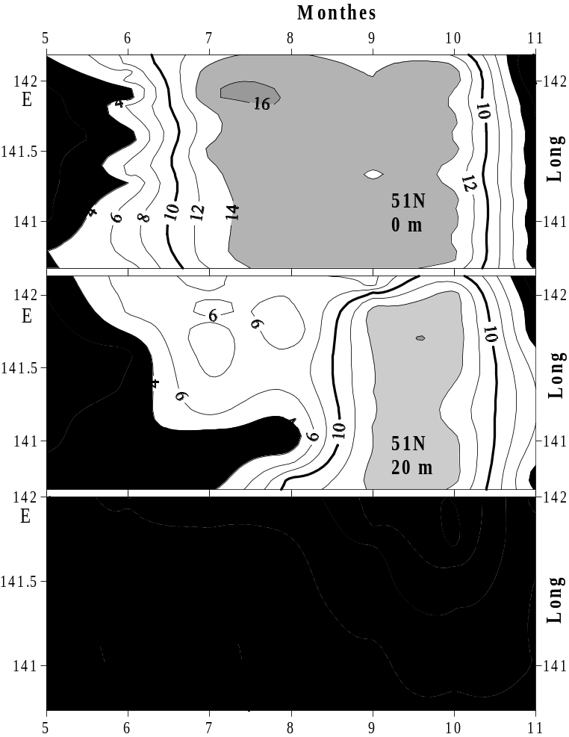
Fig.41. Variations of water temperature on 51N.

CONCLUSIONS
1. The basic water layers are allocated and their characteristics are determined.
2. The division of the Tartar strait was carried out.
ACKNOWLEDGEMENTS
Author is grateful to A.G.Pogodin and N.A.Rykov for presented historical data.

REFERENCES
Atlas of water temperature of the northern Japan Sea by airplane surveys (1983): Yuzhno-Sakhalinsk. 39 pp.
Belkin I., Cornillion P.(2003). SST fronts of the Pacific coastal and marginal seas. Pacific Oceanography, v.1, N2, p.90-113.
Biryulin G.M.(1954): Hydrometeorological characteristics of fishery areas of Southern Sakhalin. In: "Works of Kuril-Sakhalin Cooperative ZIN-TINRO Expedition in 1947-1949”. Moscow, USSR Academy of Sciences, v.1, p.167-303.
Danchenkov M.A.(1998). Oceanography of the Tartar strait. Vladivostok. Manuscript. 48 pp.
Danchenkov M.A., Aubrey D.G., Feldman K.L. (2003). Oceanography of area close to the Tumannaya river mouth (the Sea of Japan). Pacific Oceanography, v.1, N1, p.61-69.
Danchenkov M.A., Aubrey D.G., Hong G.-H. (2000). Bibliography of the oceanography of the Japan/East Sea. PICES Sci.Report N13, 99 pp.
Danchenkov M.A., Aubrey D.G., Riser S.C. (1999). Oceanographic features of LaPerouse strait. PICES Sci.Report, N12, p.159-171.
Danchenkov M.A., Riser S.C. (2000) Observations of currents, temperature and salinity in the Japan Sea in 1999- 2000 by PALACE floats. “Oceanography of the Japan Sea”. Vladivostok. Ed. Danchenkov M.A., p.33-40.
Danchenkov M.A., Riser S.C., Yoon J.-H. (2003). Deep currents of the Japan Sea central part. Pacific Oceanography, v.1, N1, p.6-15.
Dobrovolskiy A.D.(1961). On the water masses definitions. Okeanologiya, v.1, N1, p.
Gamo T., Horibe Y. (1983). Abyssal circulation in the Japan Sea. J.Oceanographical Society of Japan, v.39, N 2, p.220-230.
Hahn S.D. (1996). Chart of the Pacific ocean of Josef de Mendoza, published in 1798 by A.Arrowsmith. 1 p.
Hidaka K. (1966). Japan Sea/ Oceanographical Encyclopedy. Reinolds Publ., N.-Y., p.417-424.
Ichiye T. (1984). Some problems of circulation and hydrography of the Japan Sea and the Tsushima Current. “Ocean hydrodynamics of the Japan and East China Seas”. Ed. Ichiye T. Tokyo, Elsevier, p.15-54.
Kim K., Chung J.Y. (1984). On the salinity minimum and dissolved oxygen maximum layer in the East Sea (Sea of Japan). “Ocean Hydrodynamics of the Japan and East China seas”. Tokyo, Ed. Ichiye T., p.55-65.
Kim Y.-G., Kim K.(1999). Intermediate waters in the East/Japan Sea. J.Oceanography, v.55, N2, p.123-132.
Kozlov B.M., Shelegova E.K. (1961). The influenced conditions of the fishery in the northern Tartar strait. Rybnoye khozyaistvo, N7, p.9-11.
Leonov A.K.(1958). On the peculiarities of thermal structure and the currents of the Japan Sea. Works of USSR Geographical Society, v.90, N 3, p.244-264.
Luchin V.A., Manko A.N.(2003). Water masses (of the Japan Sea). “Hydrometeorology and hydrochemistry of Russian Seas. V.8. The Japan Sea.”. Saint-Petersburg, Gidrometeoizdat, p.243-256.
Maidel E.V.(1879). Extra notes on the cold current in LaPerouse strait. Morskoy sbornik, v.171, N 4, p.47-53.
Makarov S.O.(1894). "Vityaz" and the Pacific Ocean. Sankt-Petersburg. V.2. 511 pp.
Mamaev O.I.(1987). T,S-analysis of world ocean waters. Leningrad, Gidrometeoizdat, 296 pp.
Martin S., Munoz E., Drucker R. (1992). The effect of severe storms on the ice cover of the northern Tatarskiy Strait. J.Geophys.Research, v.97, N 11, p.17753-17769.
Miyazaki M.(1953). On the water masses of Japan Sea. B.Hokkaido Reg. Fish. Res. Laboratory, N7, p.1-65.
Reports of composite oceanographic expeditions on R/V “Vitayz” (1954). Moscow, USSR Academy of sciences, v.3, 350 pp.
Piskunov I.A.(1952). Spring herring of the west Sakhalin coast. Izvestiya TINRO, v.37, p.3-67.
Pischalnik, Arkhipkin (2000). Oceanographic atlas of Sakhalin shelf. Part 1. SakhTINRO, 173 pp.
Pischalnik V.M., Klimov S.M.(1991). Catalogue of oceanographic expeditions at the shelf of Sakhalin (1948- 1987). Yuzhno-Sakhalinsk, 166 pp.
Pogodin A.G., Shatilina T.A.(1994). On seasonal and year-to-year water temperature variability in the northern Japan Sea. Manuscript. TINRO, 78 pp.
Pokudov V.V., Manko A.N., Khlusov A.N. (1976). A pecularities of hydrological conditions of the Japan Sea regime in a winter. FERHRI Works, N60, p.74-115.
Probatov A.N., Shelegova E.K.(1968). Distribution of catches of spawning herring at southern Sakhalin. Izvestiya TINRO, v. 65, p.35-41.
Ponomaryev V.I, Yurasov G.I. (1994). The Tatar (Mamiya) strait currents. J.Korean Soc.Oceanography, v.6, N 4, p.335-339.
Radzikhovskaya M.A.(1961). Water masses of the Japan Sea. " Basic features of geology and hydrology of the Japan Sea”. Ed.Stepanov V.N. Moscow, USSR Academy of sciences, p.108-121.
Riser S.C., Warner M.J., Yurasov G.I.(1999). Circulation and mixing of water masses of Tatar Strait and the northwestern boundary region of the Japan Sea. J.Oceanography, v.55, N2, p.133-156.
Sailing directions of the north-west East Ocean (1914). Part 2. Saint Petersburg.
Sailing directions of the north-west East Ocean (1970). Part 2. Leningrad.
Stolyarova G.A.(1963). On forms and unity of ice of the Tartar strait. FERHRI Works, N13, p.129-138.
Shelegova E.K.(1960): The case of abrupt cooling in a summer at the South-Western Sakhalin coast. Izvestiya TINRO, v.46, p.249-251.
Shelegova E.K.(1963). Oceanographical conditions of fishery areas of Sakhalin and south-west Kamchatka in 1963. TINRO Report, N 8706, 34 pp.
Shelegova E.K., Uranov E.N.(1964). Oceanographical conditions in the Tartar strait and south-west Okhotsk Sea. TINRO Report, N 9279, 75 pp.
Suda K. (1932). On the bottom water of the Japan Sea. J.Oceanography,v.4, N 1, p.221-240.
Supranovich T.I.(1989). Maximal and mean ve;ocity of surface current in the Tartar strait. FERHRI Works, N39, p.34-36.
Tanaka I., Nakata A., Yagi H., Samatov A.D., Kantakov G.A.(1996): Result of direct current measurements in La Perouse Strait (the Soya Strait), 1993-1996. Manuscript, 13 pp.
Uda M. (1934). The results of simultaneous oceanographical investigations in the Japan Sea and its adjacent waters in May and June 1932. J.Imp.Fish.Exp.Station, v.5, p.57-190.
Veselova L.E. (1963). Some peculiarities of thermal conditions of waters along south-western Sakhalin coast. FERHRI Works, N13, p.42-63.
Yakunin L.P. (1987). Atlas of ice in Far Eastern seas of USSR. Vladivostok, 79 pp.
Yarichin V.G.(1980). Condition of the researches of the Japan Sea water circulation. FERHRI Works, N80, p.46-61.
Yarichin V.G.(1982). Some peculiarities of horizontal Japan Sea water movements to the north of 40N. FERHRI Works, N96, p.111-120.
Yasui M., Yasuoka T., Tanioka K., Shiota O. (1967). Oceanographic studies of the Japan Sea. 1. Water characteristics. The Oceanogr.Magazine, v.19, N 2, p.177-192.
Yoon J.H. (1991). The branching of the Tsushima Current. Rep.RIAM, Kyushu University, v.38, N 108, p.1-21.
Yurasov G.I., Yarichin V.G.(1991): Currents of the Japan Sea. Vladivostok, 176 pp.
Zhabin I.A., Gramm-Osipova O.L., Yurasov G.I.(1993). Wind upwelling at the north-west Japan Sea coast. Meteorologiya i gidrologiya, N10, p.82-86.
Zuenko Yu.I.(1994). Cold subsurface layer in the Japan Sea. "Complex study of marine resources and their environments". Vladivostok, p.40-45.
Zuenko Y.I., Yurasov G.I.(1995). Water masses of the north-western Japan Sea. Meteorologiya i Gidrologiya, N8, p.50-57.
Zuev A.(1887). Observations of water temperature in the northern Japan Sea. Notes on hydrography, N2, p.53-59.

