OCEANOGRAPHY OF AREA CLOSE TO THE TUMANNAYA RIVER MOUTH (THE JAPAN SEA)
Danchenkov M.A.¹, Aubrey D.G.², Feldman K.L.³
¹ FERHRI, Russia
E-mail: danchenk@vladivostok.ru
² Woods Hole Group, USA
³ Institute of Marine Biology, Russia

Tumannaya river mouth is frontier area between PRC, North Korea and Russia. Marine area close to it is investigated on the base of unic field measurements. Northwest thermal front from this area to the Yamato Rise was found. To the south of it southeastward current was traced by salinity distribution and surface floats drift.
Key words: Japan Sea, Peter the Great bay, Tumannaya river, currents, front, intermediate water.

INTRODUCTION
The Tumannaya river (Tumangang, Tumenzyan) represents a prospective way for transport of the Chinese goods to the east. Now, because of low depth the river is not navigable, though under deepening of the waterway it can become navigable, similarly to majority of the area rivers. At the intensive industrial development of river bed, its waters will transport pollutants to the Japan Sea area directly contiguous to the sea reserve (around Furugelm island). Research of problem “where the river drains after flowing into the sea would be transported to” is interesting as from the scientific as from applied science points of view.
The river runs into the Japan Sea (Figure 1) between Gashkevich Bay (Choson Bay) in the south and Possiet Bay in the north.

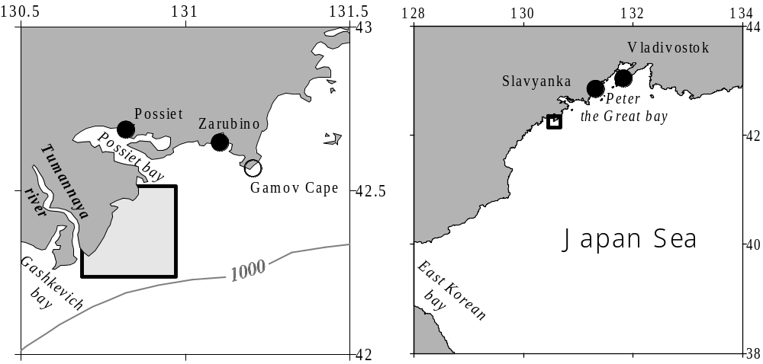
Figure 1. Tumannaya river mouth (left) and north-western Japan Sea (right)

In present paper waters of the Japan Sea, close to the Tumannaya river mouth are investigated.
A few papers are devoted to physical oceanography of the area (Vanin et al., 1999; Vinokurova and Skokleneva, 1980; Grigorieva et al., 1998; Podorvanova et al., 1989; Rodionov, 1984). Relatively detailed analysis of oceanographic conditions of small area, close to the Tumannaya river mouth from the north, was published just recently (Moschenko et al., 2000). There the conclusion on northward transport of polluted water from the Tumannaya river mouth to the north was made.
But here is another source of contamination – not rectified waters of ports and cities (near the river mouth there are four seaports: Possiet, Zarubino, Slavyanka and Vladivostok). Ships coming into the ports can pollute the waters of local marine reserve as well.
Over primary water transport from the river mouth to the north (Moschenko et al., 2000) the basic source of marine reserve water pollution would be river run-off (from China). Under the primary water transport from the north into the area of marine reserve the basic source of water pollution would be the Russian industrial and household drains.
To estimate possible ways of distribution of water pollution it is necessary to know prevailing currents, and due to small number of their measurements it is logical to attract comprehensive meteorological and oceanographic characteristics of the area.
DATA
In this work accessible oceanographic surveys for the last 15 years are used. The oceanographic data in researched area were received during the following periods: January 11-12, 1986; July 27-28, 1989; March 1-7, 1995; August 28-31, 1996; September 27-30, 1996; April 4-6, 1997; July 26-29, 1997; August 21-26, 1997; September 20-23, 1997; October 12-15, 1997; May 28-31, 1998; July 4-5, 1998; August 23-26, 1998; April 14-16, 1999; November 23 – December 3, 1999; March 4-12, 2000.
Among them 10 surveys were executed by Institute of Marine Biology in small area between the Tumannaya river mouth and Furugelma is. (marked by square at Figure 1).
METEOROLOGICAL CHARACTERISTICS OF AREA
In a number of papers (Vanin et al., 1999; Moschenko et al., 2000; Moschenko et al., 2001) the calculations of wind currents are carried out with wind speed not characteristic for considered area. To be convinced of it, the monthly average characteristics of wind are necessary to be researched.
Within the limits of Peter the Great Bay the direction and speed of wind are measured only at three coastal meteorological stations. One of them (Vladivostok) is located far from the considered area. Another station (Possiet) is situated inside the bay. Only one station (“Gamov Cape”) could be counted as typical for this area. There westwardwind prevails in winter and eastwardwind prevails in summer. Meridional component of speed is rather insignificant (in cited papers meridional component is essential). And monthly averaged wind speed is not more than 5 m/s within year.
Comparatevely big discharge of Tumannaya river (5.7 km³ per year) was calculated (Vyshkvartsev, Lebedev, 1997) indirectly only (measurements of the river speed, as well as river level, have never been carried out) – on the base of volume of precipitation only.
WATER MASSES
Water Mass (Water) is homogeneous water, being characteristic for the large area and existing enough long time. Sea waters, close to the Tumannaya river mouth from the north, were divided recently (Moschenko et al., 2000) into the next types:
- Surface Water (temperature in core is 16.8°С, salinity – 33.17‰),
- Subsurface Water (16.3°С, 33.36‰, in August only),
- Deep Water (3.2°С, 33.95‰),
- Bottom Water (0.9°С, 34.03‰).
Let’s note that parameters of so defined Subsurface Water are too close to parameters of Surface Water and pointed parameters of Bottom Water are not typical. And Water of low (33.4‰) salinity could not call “Subsurface” (typical feature of Subsurface Water is high salinity).
T(S) – indices constructed on the data the same as in cited work, give absolutely other values of Waters cores indices (Figure 2):
- Surface Water (21°С, less than 33.0‰),
- Intermediate Water (17°С, 33.5-33.6‰),
- Deep Water (1-2°С, 33.96-34.07‰).

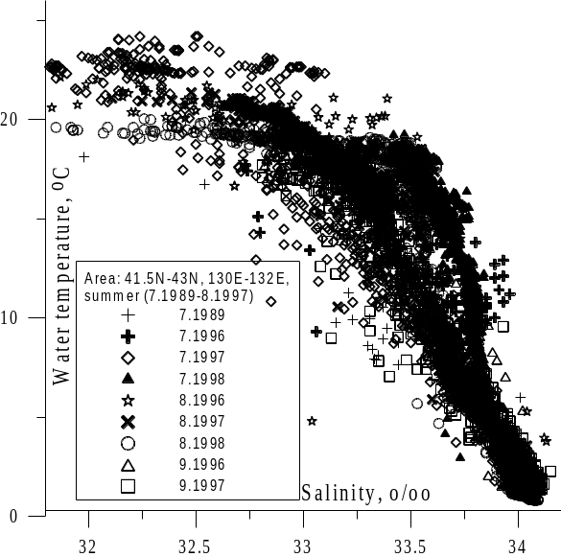
Figure 2. T(S) – indices of waters in the northwest part of the Japan Sea in summer

Because of rather small depths at these stations, water parameters near bottom in the summer essentially did not differ from the characteristics of waters lay above, therefore Bottom Water was not distinguished in summer. Water with comparatively low salinity is named as Intermediate Water.
The core of Surface Water was positioned on the surface, core of Intermediate Water was at 10-20 m depth and Deep Water spreads near bottom. Salinity of Surface Waters augmented with the increasing of distance from coast up to values, typical for Intermediate Water. From this the distance of restricting distribution of Surface coastal Water was determined as 12 miles. Behind this limit the surface layer and intermediate layer merged.
There was similar vertical structure of waters in the area to the east from the mouth of Tumannaya river in summer of 1989 (Tkalin, 1999): below heated surface layer on coastal (A – st. 82-85) and offcoastal (B – st. 86) stations the Intermediate Water of low salinity (С) was observed, which core (temperature 7°С-10°С, salinity less than 33.5‰) was situated at 10 m depth (Figure 3).

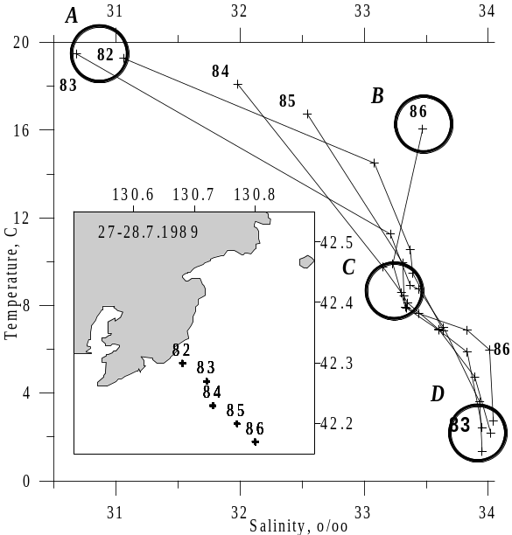
Figure 3. T(S) – curves for section near the Tumannaya river mouse in summer of 1989.
By digit the number of station is designated, by circles – Water core position

The deep layer was occupied by Japan Sea Proper Water (D), its temperature was less than 2°С, and salinity was 33.95-34.08‰. The further station was located off the coast, the salinity of deep waters was higher.
SEASONAL VARIATIONS OF WATER STRUCTURE
The water structure of considered area vertically changes strongly within a year. At the surface (on example of the section off Gamov Cape) it is possible to determine the Surface Coastal Water of low salinity (-0.6°С, 33.96‰) and Surface Offshore Water of increased temperature and high salinity (0.2°С, 34.08‰). Offshore water is characterized by the high uniformity from the surface to the bottom (to 120 m depth). Rather warm water is transported here from the east by large-scale gyre (Danchenkov et al., 2000). It is interesting that within the considered area in spring the Cold Water of low temperature (characteristic for the areas with ice formation – for example, the Okhotsk Sea) was not found absolutely (in spite of ice here is formed every winter). The reason of its absence is the influence of warm subtropical water penetrating into Peter the Great Bay from the east.
In winter in upper 100 m layer (Figure 4) it is possible to locate three Waters:
- Surface Water (water temperature is more than 0ºС, water salinity is 34.05-34.15‰), which core is located far from coast;
- fresh Intermediate Water (water temperature is less than 0°С, salinity – 33.7-33.9‰) with a core located at the surface ;
- Deep Water (temperature is less than 0°С, salinity is more than 34.1‰), which core is situated near the bottom.

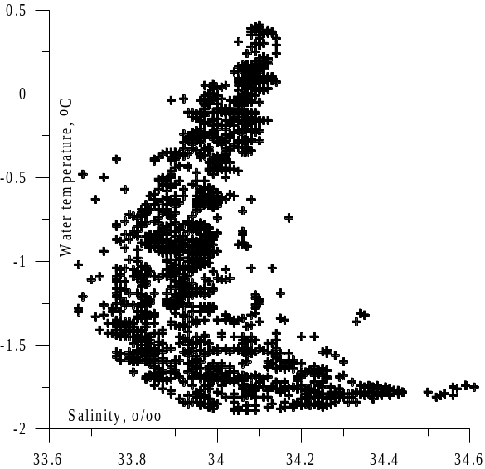
Figure 4. Т(S) – indices of Peter the Great bay waters in winter (March of 2000)

Salinity of Deep Water achieves very high values (up to 34.6‰).
In March the Surface Water was homogeneous by temperature (about 1°С), and in April the surface layer was warmed up to 3°С. Salinity of Surface Water in April has increased by 0.02-0.08‰ comparing with March values.
Intermediate Water became considerable in spring. This Water is known at least since 1953 (Miyazaki, 1953). But in Russian publications (Leonov, 1960; The basic features..., 1961; Yakunin, 1989) it was not mentioned prior to recent time. There was supposition, that Intermediate Water is formed by the downwelling of Surface Water at the Subarctic front (Miyazaki, 1953) and that it was transported from there to the south by North-Korean current ( Kim and Kim, 1983).
In April of 1999 core of Intermediate Water lied close to the surface, its salinity did not exceed 33.98‰, and temperature was between 0.2°С and 3.5°С. In May of 1998 its core lowered, temperature increased, and salinity reduced. This Water requires the special attention, as it is formed in the researched area between Northwest and Subarctic fronts.
The signs of influence of warm subtropical waters in researched area were described more than once. " In Peter the Great Bay there is significant quantity of subtropical and boreal benthos. However, hydrological observations do not point to the direct indications of any branch of warm current influx into the bay" (Biryilin at al., 1970). Near Possiet thermophilic fishes were met usually in the end of August – beginning of September. The found species were: sharks, tuna, fish – saber and moonfish (Shmidt and Taranets, 1934; Taranets, 1938; Gorodnichii, 1949; Rumyantsev, 1951; Novikov, 1957a; Novikov, 1957b). The constant congestions of flounder in winter near Gamov Cape and in the vicinity of Askold island were remarked (Moiseev, 1937).
But subtropical waters of high temperature and high salinity (more than 34.05‰) also were not found here in 1989-1998. Water salinity in upper 200-meter layer in summer did not exceed 34.00‰. Only in August of 1996 the water of high salinity (34.12‰ at the depth of 45 m) was remarked, but it temperature was rather low (4°C).
The way of subtropical waters penetration into Peter the Great Bay was identified for the first time recently (Danchenkov et al., 1997a). Warm waters transport occurs like a chain of warm eddies running along 131.5°E. But such northward water transport never was traced to the north off Possiet. The existance of warm waters to the north off Possiet (in Ussuri bay and near Askold is.) is caused by their transport from the east by westward flow of subtropical waters from Hokkaido (Danchenkov et al., 2000).
SPATIAL WATER STRUCTURE
Proceeding traditional concepts, accordingly which the Subarctic front in the Japan Sea runs along latitude of 40°N, it is impossible to explain penetration of warm waters into the Possiet area. But lately (Danchenkov et al., 1997b) alongside with known thermal front along 40°N there was discovered another large-scale and non-zonal Northwest front (Figure 5, 6).

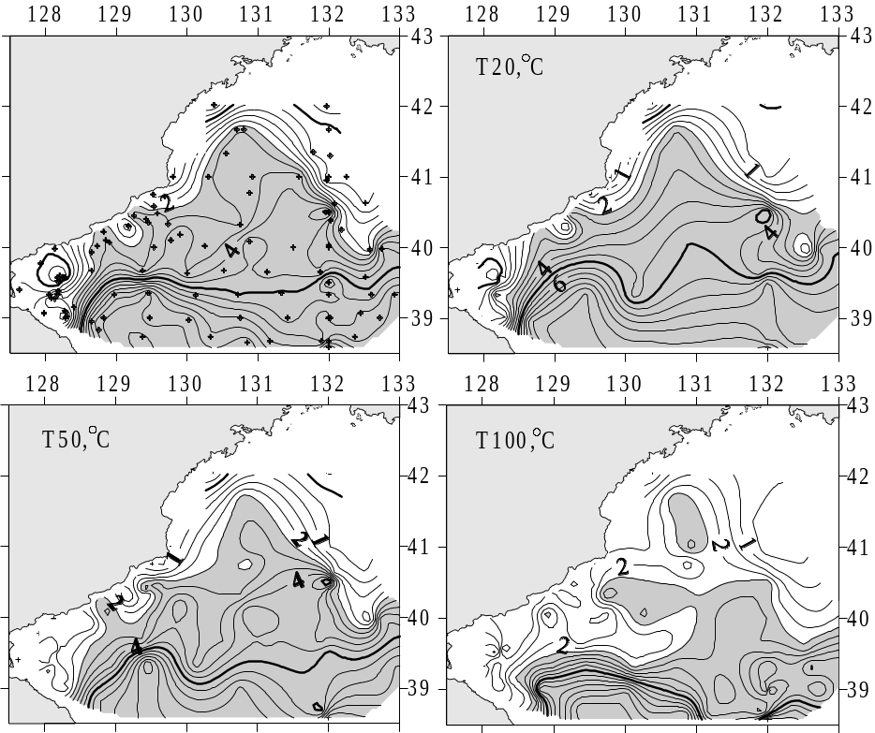
Figure 5. Water temperature at the surface and 50 m depth in winter of 1986

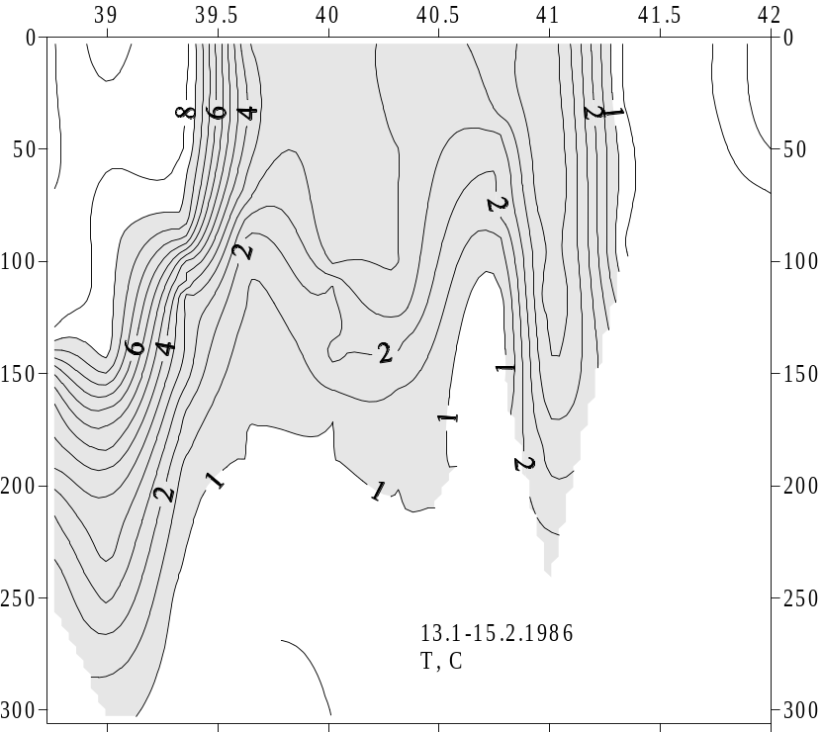
Figure 6. Water temperature at the section across two fronts in winter of 1986

This front passes from the Tumannaya river mouth to southeast also separating cold subarctic water from transphormed subtropical one. The shift of temperature through the front equals 3°С-6°С. Between fronts interfrontal area is sitiated. The temperature gradients across the Subarctic front is more than cross Northwest front. Non-zonality of this front is caused by transport of subtropical origin water into the investigated area from the south. Due to it the farthest border between warm (from the south) and cold (from the north) waters removed to north in western part of the Sea – size of interfrontal area decreases from the west to the east. Northwest thermal front is noticeable down to 100 m depth. Together with thermal shift across the Northwest front there are gradients of salinity. So, this front is traced by salinity gradients as well.
To the south from the Northwest front in winter the belt of fresh water is situated (Danchenkov et al., 2000). The formation of this Water is well visible, for example, on section along 130.5°E (Figure 7) and on the distribution of surface salinity in March of 1997 (Figure 8).

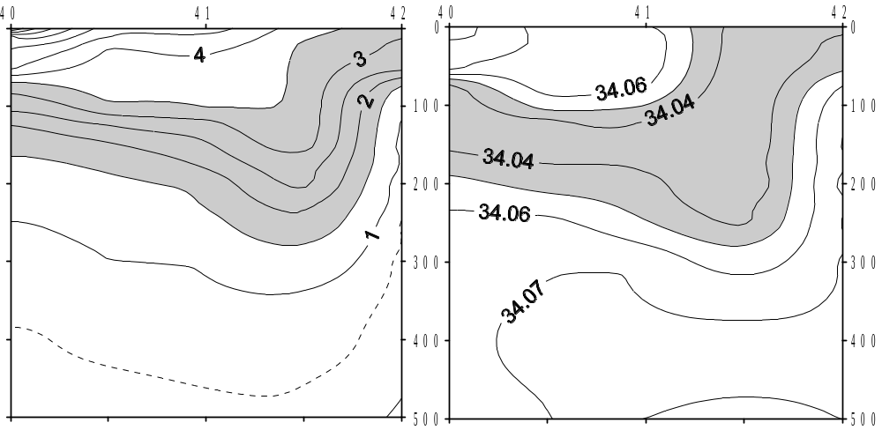
Figure 7. Vertical distribution of temperature and salinity along 130.5°E in March, 1997

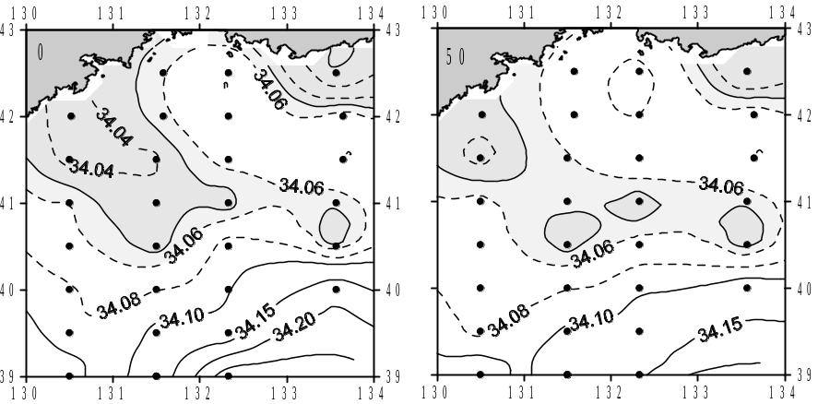

Figure 8. Distribution of salinity at the surface and 50 m depth in March of 1997

When surface waters begin to get warm, the tongue of cold fresh water on the surface disappears, but water of low salinity does not disappear at all. Its presence in the intermediate layer in summer is remarked on wide water space from Possiet to the coast of southern Korea. It is possible to assume, that it is distributed in that intermediate layer from the place of its formation (between two fronts) to the south. Not only water of the river Tumannaya and rivers flowing into the Peter the Great Bay, but also coastal waters of Southern Primorye participate in its formation on the surface in winter.
SEASONAL AND INTERANNUAL VARIATIONS OF NORTHWEST FRONT
The significant changes in oceanographic fields of northwest part of the Japan Sea take place during a year. Though the Northwest front exists within whole year, in summer the spatial gradients across the front on the surface are considerably weakened. Along 131°E there is steady water transport to the north along a chain of eddies. As result in autumn near Possiet the extensive area of warm water appears. In October south of Vladivostok the steady northern winds cause the upwelling of cold subsurface water and their futher quick (in one month) cooling. Cold waters are spread to the south and southwest, blocking area of warm water at Possiet. The cooling of this area takes two monthes. After that Northwest front is promptly displaced to the south till 40°N. Subarctic front is strengthened. Together with it a new Northwest front is formed between Tumannaya river estuary and Yamato Rise.
Transport of comparatively warm and salty waters from Hokkaido to the west along 42°N creates the obstacle to the ice spreading to the south.
Such winter structure is kept till April. Accordingly degree of cooling and formation of dense water not February, but March can be supposed as the most typical winter month (Danchenkov et al., 1994). In April the Subarctic front in the western Japan Sea collapses and again the chain of eddies is restored.
Beyond seasonal variations the year-to-year ones are significant as well. Disastrous sardine stock abundance in the 1930s is the only example of interannual changes. Despite the fact that temperature of air continuously grew in 20-th century, oceanographic conditions exhibited the periods of the warming and cooling. So, till 1913 the heat-loved sardine and saury didn’t inhabit the coastal Primorye waters. And from the end of 1930s the arriving of sardine to Russian coast constantly was late, and in 1942 the sardine practically disappeared (Gorodnichiy, 1949). On the contrary, catches of cryophilic herring in southern Primorye in the 1930s were sharply reduced and again increased in the beginning of the 1940s. The next warming displayed in detection of the heat-loved fishes near Possiet (Коs, 1969), began in 1949, and the next cooling happens in 1962.
DISCUSSION ON THE SOURCE OF WATER POLLUTION
Recently (Vyshkvartsev, Lebedev, 1997) it was declared about new current directed to the north from the river Tumannaya mouth: “On the shelf of the Possiet bay besides Primorye current the current of opposite direction exists. It flows near the river Tumannaya mouth with speed of 0.2-0.5 knots and is included in anti-cyclonic circulation in open part of the Possiet bay. It testifies to transport of polluting substances from China to Russia....”. Any proofs of new current existence were not given. The desire of the authors is clear to show, that the contamination of marine reserve waters (near Furugelma is.) occurs not from the wastes drain of Vladivostok or Zarubino, but from Tumannaya river.
In one paper (Grigorieva et al., 1998) two maps of sea currents were published (“appropriate to tidal inflow and tide outflow“). It is unclear the method of such division – recognized opinion is (Sailing directions of the Japan Sea, 1972), that tidal currents in this area almost are not registered at all. The authors of cited paper for some reason used to reference the data on sea level in the narrow Possiet bay, where tide level variations strongly differ from area of investigation. The data of measurements of currents from 6 buoy stations were not analyzed, probably, due to “the measurements of currents have isolated and casual character and do not give the complete picture of coastal water circulation” (Moschenko et al., 2000).
In line of papers northward drift current was got from calculations based on possible strong northward wind. The results of the same calculations (with the conclusions about water transport from the river mouth to the north) were published four times (Vanin et al., 1999; Vanin et al., 2000; Moschenko et al., 2000; Moschenko et al., 2001). The representations of currents are made concerningly results of calculations of wind currents by the assumption, that depth of area everywhere is small, and that “the wind was homogeneous in time and space”.
But water depth just in investigated area is very different (depth in southeastern part is more than 500 m), in a summer the wind has different direction and northward wind is not prevails. Any essential drift current could be appears in case of long-term wind action only and it could be seen at averaged speed values. Strong (with speed of 10 m/s and 20 m/s) wind is not typical for this area in a summer at all (monthly averaged speed is about 5 m/s).
Let’s look at the results of observation of currents in investigated area. For the first time some strong (about 50 сm/s) flow, transporting sea grass and wood from the Tumannaya river mouth to southwest, was noticed in 1797 during English round-the-world expedition. The transport of cold waters to the south along western coast of the sea further (Shrenk, 1874) was described under the name of Liman current. Then (Uda, 1934) instead of one continuous current along the continent the three were distinguished: Liman, Sibirian and North-Korean. Later Sibirian current was renamed to Primorye current. One coastal cold current is torn to two pices (Primorye current and North-korean current) just near Tumannaya river mouth. The southwestward current between Vladivostok and Possiet Gulf was remarked by drift of vessels and bottles many times, for example in May – June of 1939 (Istoshin, 1950).
Results of observation of surface drift of ARGOS floats in 1993-1997 and PALACE floats in 1999-2000 did not show any northward drift north of Tumannaya river mouth.
In the summer in investigated area southwestward current just near the coast was traced (Lee et al., 1997) usually (Figure 9). In late fall current in opposite direction was traced many times as curve of the chain of warm eddies (right).

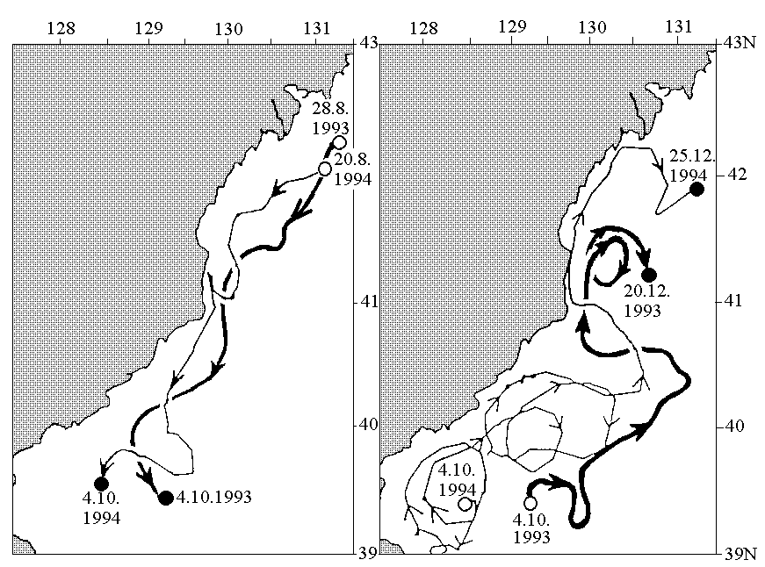
Figure 9. Drift of surface ARGOS floats in 1993-1994

But this current (and warm eddies) never penetrate north than Tumannaya river mouth.
In autumn (August – October of 1993 and August – October of 1994) the surface southwestward drift of floats took place near the coast (with average velocity of 10 сm/s). Surface drift of floats in the opposite direction in October – December of 1993 and in 1994 passed with smaller velocity (up to 4 cm/s). In last case the floats have not passed to the north further than the Tumannaya river mouth and turn to the south-east without approaching to the river mouth area.
Sometimes (July of 1997) the drift of float to the west along 42°N was marked. In a winter water from river mouse area is transported to the southeast usually.
More interesting and stable feature of water circulation is southeastward current along Northwest front. It is evident not only for the surface layer (Figure 10), but also for 300°m (Taira, 1997) and 800 m depth (Danchenkov et al., 2000). The analysis of a number of drifting floats showed that from southwestern Peter the Great Bay the water is transported to southeast along above described (Figure 10) Northwest thermal front. And the drift in southeast direction from area of Tumannaya river mouse to the Yamato Rise was traced by drift of floats more often than to the northeast or southwest.

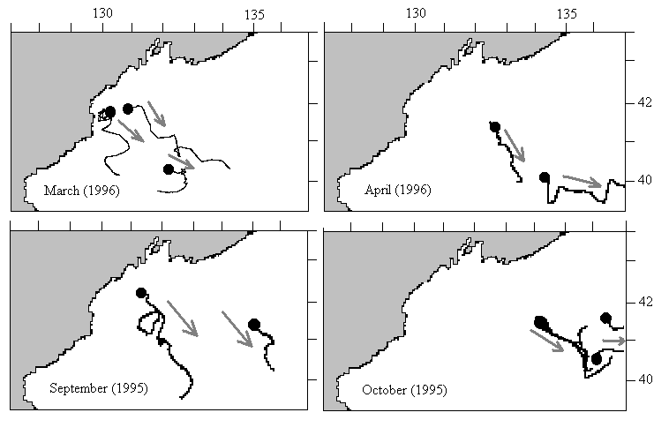
Figure 10. Drift of surface buoys to the southeast in 1995-1996 (Lee et al., 1997)

So it is possible to conclude that current measurements doesn’t show any northward water transport from Tumannaya river mouth.
Any influence of the river run-off is traced not far from river mouth (Sailing directions, 1972) with very rare exception. Usually the distribution of fresh water is limited by narrow area close to the river mouth – Figure 11.

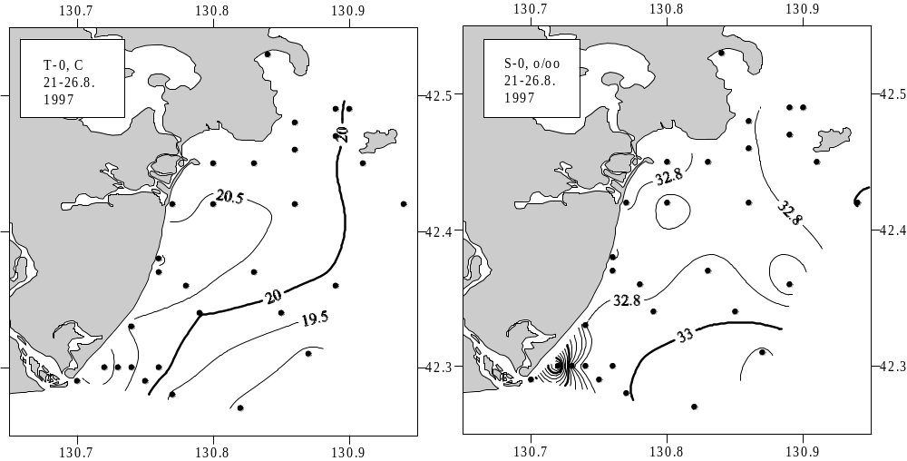
Figure 11. Typical temperature and salinity distribution at the surface to the north of Tumannaya river mouth

Except polluted flow of Tumannaya river there is another source of contamination – waste from numerous ships and from sea ports. In ports there are not any facilities for collection of oil-contaminated waters. There is not any control of ships by which waste the sea bottom is covered in the Peter the Great bay. Polluted waters (as urban as industrial) are not purified. Any waste from Vladivostok, Slavyanka and Zarubino could be transported by prevailed current (southwestward) into the investigated area. Concentration of organic matter between Vladivostok and Zarubino is enough high: 120-130 mkg/l – in water and 20-30 mg/100 g – in sediments (Rodionov, 1984). Volume of oil-contained waste – about 18000 t per year (Rodionov, 1984) and urbane polluted waters – about 13000 t per year is comparative with discharge of Tumannaya river.
CONCLUSIONS
- Basic feature of oceanographic water structure of investigated area is Northwest thermal front situated between Tumannaya river estuary and Yamato Rise. Intermediate water of low salinity is formed in winter at the surface of coastal area close to Tumannaya river estuary.
- According to floats drift and salinity distribution any polluted water from Tumannaya river mouth could be transported mainly to the southeast.
REFERENCES
The basic features of geology and hysrology of the Japan Sea. Moscow, USSR Academy of Sciences. 1961, 218 pp.
Danchenkov M.A., Aubrey D.G., Lobanov V.B. 2000. Spatial water structure of the northwest Japan Sea in winter. FERHRI Special Issue, 3, 92-105.
Danchenkov M.A., Goncharenko I.A. 1994. Variation of hydrological characteristics along 132°E in the Japan Sea. CREAMS Proceedings, Seoul, 19-22.
Danchenkov M.A., Lobanov V.B., Nikitin A.A. 1997a. Mesoscale eddies in the Japan Sea, their role in circulation and heat transport. CREAMS Proceedings, Fukuoka, 81-84.
Danchenkov M.A., Nikitin A.A., Volkov Yu.N. Goncharenko I.A. 1997b. Surface thermal fronts of the Japan Sea. CREAMS Proceedings, Fukuoka, 75-79.
Gorodnichii A.E. 1949. The variations of some Primorye fishes stocks in connection to oceanographic conditions. Rybnoye khozyaistvo, 1, 36-40.
Grigorieva N.I., Moschenko A.V., Propp L.N., Feldman K.L. 1998. The study of water transport and oceanographic conditions of an area to the north of Tumannaya river estuary. TINRO Proceedings, v. 123, 423-430.
Istoshin Yu.V. 1950. Currents of the Japan Sea by bottle drift. Transactions of Central Institute of weather forecasts, 1950, p. 88-131.
Kim C.H., Kim K. 1983. Characteristics and origin of the cold water mass along the east coast of Korea. J.Oceanol. Soc. Korea, v. 18, 1, 73-83.
Kos M.S. 1969. The decreasing of heat-loved elements in plankton of the Possiet bay (the Japan Sea). Reports of USSR Academy of Sciences, v. 184, 4, 951-954.
Lee D.K., Lee J.C., Lee S.R., Lie H.J. 1997. A circulation study of the East Sea using satellite-tracked drifters. 1. Tsushima Current. J.Korean Fish. Society, v. 30, 6, 1021-1032.
Leonov A.K. 1960. The Japan Sea. Regional oceanography. Part 1. 291-463 pp.
Miyazaki M. 1953. On the water masses of the Japan Sea. B. Hokkaido Reg.Fish.Res.Laboratory, 7, 1-65.
Moiseev P.A. 1937. Fishery of flounders by small-sizes ships in Ussuri bay in spring of 1935. Izvestiya TINRO, v. 12, 125-158.
Moschenko A.V., Vanin N.S., Lamykina A.E. 2000. Bottom relief, bottom sediments and oceanographic conditions of Tumannaya river estuary (Russian EEZ). Ecological conditions and biota of southwestern part of Peter the Great bay and Tumannaya river estuary, 42-75.
Moschenko A.V., Feldman K.L., Vanin N.S., Yurasov G.I. 2001. Solid run-off and contaminants distribution as a tracer of wind currents in the area north of the Tumen river mouth (Peter the Great bay, Sea of Japan). Rep. Int.Workshop on the Global change studies in the Far East. Part 1., 72-86.
Novikov N.P. 1957a. The case of catching of Xesurus scalprum in Primorye waters. Izvestiya TINRO, v. 44, 245-246.
Novikov N.P. 1957b. Diodon holocanthus in the Amurskii bay (the Japan Sea). Izvestiya TINRO, v. 44, 246-247.
Podorvanova N.F., Ivashinnikova T.S., Petrenko V.S., Homichuk L.S. 1989. Basic features of hydrochemistry of the Peter the Great bay (the Japan Sea). 201 pp.
Rodionov N.P. 1984. The Japan Sea. The forecast of pollution in the USSR seas. 118-150.
Rumyantsev A.I. 1951. New cases of the finding of rare specimen of fishes. Izvestiya TINRO, v. 35, 185-186.
Sailing directions of the Japan Sea. Part 1. 1972. 288 pp.
Shmidt P.Yu., Taranets A.Ya. 1934. On new elements in ichtiofauna of the northern Japan Sea. Reports of the USSR Academy of Sciences, v. 2, 9, 591-593.
Shrenk L.I. 1874. On the currents of the Okhotsk, Japan and adjacent seas. Notes of Russian Academy of Sciences. Supplement to v. 23, 3. 112 pp.
Taira K. 1997. Application of the ARGOS system to NEAR-GOOS. ARGOS Newsletter, 52, 13-15.
Taranets A.Ya. 1938. On new findings of southern fishes of the northwestern Japan Sea. B. Far Eastern branch of USSR Academy of Science, v. 28, 1, 113-126.
Tkalin A.V. 1999. Marine environment contamination near Tumangang (Tumen) river mouth. Ocean Research, v. 21, 1, 81-86.
Uda M. 1934. Hydrographical studies based on simultaneous oceanographical survey made in the Japan Sea and its adjacent waters during May-June 1932. Rec.Oceanogr.Works in Japan, v. 6, 1, 19-107.
Vanin N.S., Moschenko A.V., Feldman K.L. 1999. The modeling of wind currents to the north of Tumannaya river estuary (Peter the Great bay of the Japan Sea). Biologiya morya, v. 25, 2, 93-94.
Vanin N.S., Moschenko A.V., Feldman K.L., Yurasov G.I. 2000. Simplified model of the wind-driven circulation with emphasis on distribution of the Tuman river solid run-off. Ocean Research, v. 22, 2, 81-90.
Vinokurova T.T., Skokleneva N.M. 1980. Temporal variability of the oceanographic conditions in the Possiet bay. TINRO Proceedings, v. 104, 29-35.
Vyshkvartsev D.I., Lebedev E.B. 1997. The project of economic development of the Tumangan river – a danger for shallow water bay ecosystem of Posyeta bay, Sea of Japan. Biologiya morya, v. 23, 1, 51-55.
Yakunin L.P. 1989. On the water masses of the Japan Sea. Abstracts of International Conference on the Japan and the Okhotsk Seas, Nakhodka, 12-13.

