Spatial Structure of the Tartar Strait Waters
M.A. Danchenkov
Far Eastern Regional Hydrometeorological Research Institute (FERHRI), Russia
Email: danchenk@vladivostok.ru

Horizontal and vertical structure of the Tartar Strait waters is studied from the most complete set of quality-controlled oceanographic data, both historical (1950–1993) and modern (1993–2003). Seasonal variability of the horizontal and vertical water structure is analyzed. Seven water masses and ten layers are distinguished and described. Two fronts are identified, thermal and haline, that are close to each other over most of the Strait, except for its northern part. The main front, termed the Tartar Front, is a branch of the Subarctic Front that divides subarctic and subtropical waters of the Japan Sea. The Tartar Front splits into the Northern Front extending along Sakhalin and the Kril’on Front extending SE to Cape Kril’on. These fronts divide the Tartar Strait into six zones: warm domain, cold domain, belt of the Okhotsk Sea waters, inter-frontal zone, areas of coastal upwelling, and northern shallow area. Basic characteristics of these zones are determined and their seasonal variability is analyzed.

INTRODUCTION
The Japan/East Sea connects to the Okhotsk Sea by a channel that consists of three parts, namely, south to north, Tartar/Mamiya Strait (Tatarskiy Proliv in Russian), Nevelskoy Strait (Proliv Nevel’skogo in Russian), and Amurskiy Liman, the latter being the Amur River estuary (Figure 1). It is common in the literature to refer to the entire channel as the Tartar/Mamiya Strait.
The Asian continent and Sakhalin Island constitutes, respectively, the western and eastern boundaries of the Tartar Strait. Centuries ago northeast Asia was referred to as Tartary (Tartarie), i.e. a wild area, and it was shared by the Russian and Chinese Tartaries, a group of people of Mongolian descent, presently called Tatars. La Perouse has named the waters between Sakhalin and Tartary “Golfe de Tartarie”. This part of the sea was named “gulf” because the strait between Sakhalin Island and the continent was considered by La Perouse to be too shallow for navigation. Even now some English-language navigation charts use the name "Gulf of Tartary" for the area south of 51.4°N, and only the narrowest part between 51.4°N and 53.7°N is called the Strait of Tartary. Russian hydrographers essentially discovered this strait anew (since available publications were inconsistent) and described it in details. However, the Russian name “Tatarskiy Proliv” (“Tatar Strait“in English) is different from the original one given by La Perouse and is improper for the Tatars never lived in these places.
The narrowest (minimum width, 7 km) and shallowest (maximum depth, 10 m) part of the Tartar Strait is Nevelskoy Strait (named after Russian admiral Gennadi Nevelskoy who explored this area in 1849), which is also known as Mamiya Strait after Japanese explorer Mamiya Rinzo who, together with Matsuda Denjyuro, surveyed the Sakhalin coast in 1808-1809 and discovered that Sakhalin is an island.
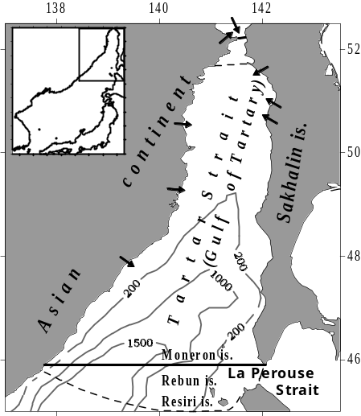

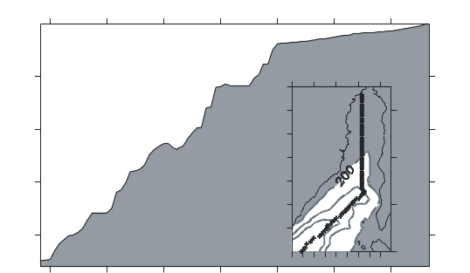
Figure 1. Base map (top) and longitudinal bathymetric profile (bottom) of the Tartar Strait.
Solid thick lines along 45.9°N and 52.2°N are the Tartar Strait boundaries adopted in this study.
Dashed lines are the Tartar Strait boundaries
from Russia’s official hydrographic source
(Sailing Directions…, 1970). Thin solid lines are isobaths. Top insert shows the location of the base map. Bottom insert shows the location of the bathymetric profile. All depths are in meters. Arrows show mouths of main rivers that empty
into the Tartar Strait.
Within Nevelskoy Strait, Lazarev Channel (Prokhod Lazareva) is distinguished, named after a Russian admiral.
Amurskiy Liman belongs to the Okhotsk Sea. Soviet hydrographers (Sailing Directions…, 1970) included a large shallow area south of Nevelskoy Strait into Amurskiy Liman, i.e. into the Okhotsk Sea, as well (Figure 2).
The above broad definition of Amurskiy Liman is probably convenient for navigation purposes since hydrographic conditions north and south of Nevelskoy Strait are similar. However, this definition does not correspond to international practice and leads to confusion in area calculations.
The official definition of the southern boundary of the Tatar Strait (Sailing Directions…, 1970) is also unusual: It does not coincide either with the shelf break at 49°N or with the southernmost point of Sakhalin at 45.9°N but deviates far south of the latter to include hydrographic conditions around Rishiri and Rebun Islands, thus including these Japanese Islands into the Russian Tartar Strait.
Defined by its natural geographical boundaries, Cape Sredniy at 52.2°N, and the southernmost point of Sakhalin, Cape Kril’on at 45.9°N, the Tartar Strait meridional extent is 378 nm or 700 km. Over this span, the Tartar Strait widens southward from 7 km to 342 km. Considering its sheer size, the Tartar Strait should be called the Tartar Sea.
This region is perhaps the most complex and variable part of the Japan Sea and probably of the entire Pacific Ocean. During the year, water temperature in the Strait changes from -1.8°С to 22°С, while salinity varies between 24.0–34.2 psu. Warm subtropical
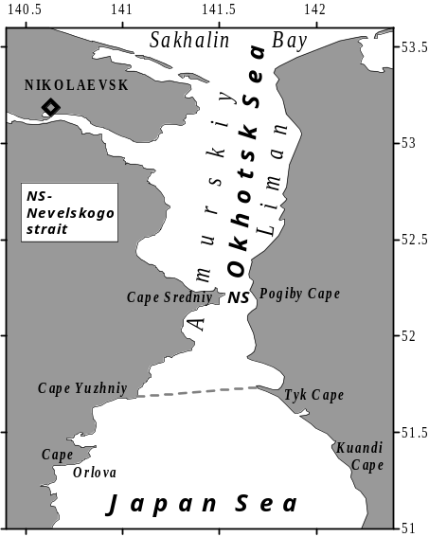
Figure 2. Northern Tartar Strait and Amurskiy Liman. Dashed line, the official northern boundary of the Strait
waters penetrate this area year round with an unnamed branch of the Tsushima Current. Its transport is sometimes neglected (e.g. Yoon, 1991), although it might be substantial; it is the warm subtropical waters that help maintain the Strait ice-free in the middle of winter. Cold waters of the Okhotsk Sea flow into the Strait year-round with the Kril’on Current via La Perouse/Soya Strait. In winter the Amur River discharge flows into the Strait. Besides the Amur River with a mean annual discharge of 350 km³/year, other numerous rivers contribute to a relatively low salinity of the Strait; most river runoffs, however, have never been gauged. Various factors influence the Strait’s vertical structure that consists of several well-defined layers, whose characteristics change seasonally and inter-annually.
Geomorphologically, the Strait can be divided into two major parts, namely, the shelf area (<200 m) north of 49ºN, and the rest of the strait, with a deep basin south of 48ºN. The Japan Sea is considered to be a small-scale World Ocean (Ichiye, 1984), and the Tartar Strait can be considered to be the Japan Sea in miniature. It contains all its basic elements, such as warm and cold currents, thermal front, and basic water masses. The Tartar Strait is the coldest part of the Japan Sea: 90% of the Strait’s surface is ice-covered in winter.
Notwithstanding the complexity and strong temporal variability of the spatial structure of the Strait’s waters, few papers have been published on the Tartar Strait physical oceanography (Danchenkov, 1998; Riser et al., 1999; Danchenkov et al., 2000;). Earlier paper were mostly dedicated to biological and fishery oceanography (Piskunov, 1952; Kozlov and Shelegova, 1961; Shelegova and Uranov, 1964). Valuable information on the Tartar Strait waters is contained in the TINRO reports.
Only two atlases have been published that describe the Strait’s oceanography (Atlas of water temperature, 1983; Pischalnik and Arkhipkin, 2000). The latter contains a complete set of accurate maps of water characteristics except for sound velocity, sea ice, tides and currents. Information on sound velocity in the Strait was never published. The published information about tides and tidal currents is scant. Most sea ice publications only describe position of ice edge (e.g. Yakunin, 1987). Information on currents in the Strait is more abundant (Supranovich, 1989; Yurasov and Yarichin, 1991; Ponomarev and Yurasov, 1994) but mutually inconsistent.
DATA
In the present work the spatial (horizontal and vertical) distribution of water temperature and salinity, mainly in the upper 200 m layer, is analyzed. Physical parameters of the Tartar Strait waters were measured in >350 expeditions. However, these data are kept in archives till now. Therefore even a catalogue of oceanographic data from this area (Pischalnik and Klimov, 1991) is incomplete and contains errors. For example, a non-existing repeat section of R/V “Volna” along 47.3°N is included (this section is actually outside the Strait) and some of the TINRO expeditions are not shown.
The present work is based on observed data from 43 Soviet expeditions of 1960–1993 conducted by FERHRI, TINRO, and P.P. Shirshov Institute of Oceanology, and from three Russian expeditions of 1993, 1995 and 1999. Data of four profiling floats (## 194, 223, 224, and 225) from 1999–2003 were used also (Danchenkov and Riser, 2000). The 15 hydrographic surveys of the Strait have been used that provided good-quality data that covered the Strait from 46.3°N to 51.5°N (Table 1). A typical FERHRI survey is shown in Figure 3 (R/V “Pavel Gordienko” cruise of June 1994).
The following repeat (standard) lines are shown, south to north:

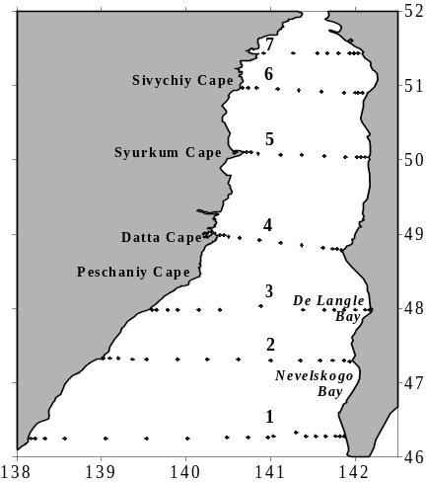
Figure 3. Typical layout of the FERHRI oceanographic sections
- Cape Olimpiady–Pereputie (46.3°N);
- Cape Zolotoy– Cape Slepikovskogo (47.3°N; secular section);
- Grossevichi–Cape Illinskiy (48.0°N);
- Krasniy Partizan (Cape Datta)–Cape Lamanon (49.0°N);
- Cape Syurkum–Cape Korsakov (50.0°N);
- Cape Sivuchiy–Cape Zhonkiyer (50.9°N);
- Cape Orlova–Cape Uandi (51.4°N).
The secular section 2 has been occupied 170 times; 39 quality-checked sections were used in this work.
The TINRO research vessels occupied six repeat sections in the northern part of the Tartar Strait (Figure 4). Data of eight quality-checked TINRO surveys were used in this study.
The TINRO research vessels only worked in the Strait from April to November since winter conditions were too hazardous for non-ice-strengthened vessels because of sea ice and abrupt wind changes. As a
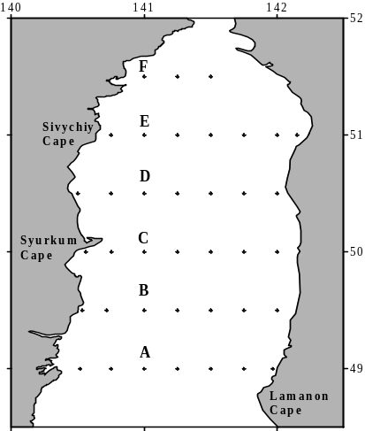
Figure 4. Typical layout of the TINRO oceanographic sections

Table 1
Tartar Strait surveys used in this work
Year | Dates | No. of stations | Ship name
1960 | May 4–16 | 122 | Dalnevostochnik
1975 | May 16–31 | 65 | Dalnevostochnik
1976 | May 23–June 22 | 44 | Vikhr
1977 | May 24–31 | 67 | Valerian Uryvaev
1978 | May 18–25 | 125 | Dalnevostochnik
1981 | May 16–20 | 52 | Trubchevsk
1985 | Nov 9–22 | 72 | Valerian Uryvaev
1986 | Sep 26–Oct 2 | 53 | Valerian Uryvaev
1987 | May 4–14 | 52 | Valentin
1988 | May 1–9 | 65 | Professor Levanidov
1989 | Aug 18–25 | 86 | Igor Maximov
1990 | Aug 9–24 | 88 | Valerian Uryvaev
1991 | Sep 5–12 | 114 | Vyacheslav Frolov
1993 | Sep 21–28 | 85 | Professor Khromov
1994 | June 4–12 | 90 | Pavel Gordienko

result, there is no winter data north of 47°N. Regrettably, suitable ice-strengthened research vessels operated by FERHRI were used elsewhere at the same time, studying mainly the tropical Pacific Ocean.
A major problem with the Tartar Strait observations is data quality. Numerous datasets were not published, with a rare exception of the SakhNIRO data. The world’s largest research fleet, >30 large-capacity ships, was concentrated in Vladivostok, but scientific equipment and supplies were sent from afar rather than manufactured here (and these shipments were often late). For instance, Nansen bottles were produced in Georgia; thermometers, in East Germany; and normal water, in Moscow. Data flow was huge: for example, 10 large research vessels operated by FERHRI alone worked the total of approximately 10,000 oceanographic stations each year. The typical number of stations per day amounted to 3–4 and should be considered high taking local harsh weather into account; the average number of stations per cruise was around 200, with very little time available for in-cruise quality control. The average interval between cruises was 25 days, leaving no time for post-cruise data quality control, so that raw data were sent to the Obninsk data center near Moscow without proper screening. To make it worse, original CTD data with the 1 m vertical resolution were destroyed.
Quality of salinity data was especially low. Consider, for example, deep-water salinity data. The salinity of the Japan Sea deep waters was known to vary within a very narrow range, 34.05–34.08 psu (e.g. Gamo and Horibe, 1976). However, Soviet measurements showed overestimated and underestimated values until 1993, when the first international expedition in the Japan Sea took place. For example, salinity values of 33.96 psu and 34.20 psu at 1,000 m level were admitted as authentic (Pokudov et al., 1976).
Erroneous values of 33.8–34.2 psu are cited as typical for subsurface waters below halocline in the western Tartar Strait (Yarichin, 1982). The high-biased salinity values of 34.16 psu at 1000 m measured by R/V “Vityaz” were published (Report of “Vityaz”, 1954). Erroneous salinity values are quite common in the TINRO data. For example, the salinity exceeding 34.6 psu at 50°N was reported from the 10th cruise of R/V “Krym”. Even some climatic (long-term average) maps show salinities that are obviously incorrect, e.g. S>34.2 psu below 400 m (Figure 5).
Intermediate layers of low and high salinity have recently been found in the northern Japan Sea (Kim and Kim, 1999), however such layers were not observed from Soviet CTD data of 1980–1990. The problem of data quality was not discussed until the Regional Oceanographic Data Center was established at FERHRI. But even now there is no equipment in Vladivostok to calibrate CTD probes. Research cruises in the Tartar Strait with foreign scientists, who would bring along high-quality CTD probes, were forbidden until recently. Therefore, high-quality data on the Tartar Strait salinity are rare, supplied largely by recent international expeditions, e.g. R/V “Akademik Lavrentiev”, May 1995, and R/V “Professor Khromov”, July 1999 and July 2002; some high-quality salinity data have been obtained by profiling floats, e.g. float 194.
WATER MASSES OF THE JAPAN SEA with emphasis on the TARTAR STRAIT
According to a widely used definition by Dobrovolskiy (1961) the term water mass (WM hereafter) refers to a large volume of water with spatially uniform characteristics that remain relatively stable for a long time. Vertical combination or assembly of water masses is called water structure. The water mass distribution within a given area can be determined by cluster analysis (Luchin, 2003), or EOF analysis (Yasui et al., 1967), or by classification of vertical gradients of hydrophysical parameters (Radzikhovskaya, 1961). Water masses are usually distinguished with the help of TS-analysis (Mamaev, 1987). Besides temperature and salinity, concentration of dissolved oxygen is sometimes used for identification of water masses.
Figure 6 shows a TS-curve typical of the Japan Sea subtropical waters; it also shows temperatures and salinities of the water mass cores and interfaces.
Except for the water mass cores, which are points of extreme values on a TS-curve, water masses indices are used, i.e. TS-coordinates of intersection points of tangents to adjacent segments of TS-curves. Such indices are considered to characterize water mass formation areas. As can be seen from Figure 6, indices of water masses B and D are very close to their core values. Water mass C has the indices of 5°C and 34.0 psu, which are distinct from the core values of 3°C and 34.05 psu at 209 m.
Figure 6 does not show the deep WM core because it is located below the deepest level (807 m) of profiling float measurements. It is clear that characteristics of
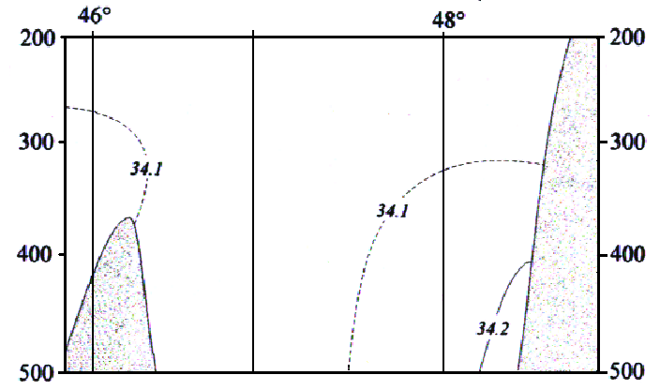
Figure 5. Salinity section along 141°E in autumn (Pischalnik and Arkhipkin, 2000)
the deep and bottom WMs are different in the shallow and deep parts of the sea. Temperature and salinity of the WM cores are also different depending on the station position and season. However, WM indices and their attributes (high or low salinity) are constant.
Up to the mid-20th century, only two basic WM were considered to occupy the Japan Sea, except for the surface and bottom waters (Suda, 1932; Uda, 1934): the deep or proper water below 200 m, with T=0–1°C and S=34.0–34.1 psu; and the subtropical or Pacific water, with T>10°C and S=34.5 psu. Then, in the 1950s, two new WMs were found: the intermediate low-S WM (Miyazaki, 1953) and the subsurface cold WM (Leonov, 1958). The two more WM were distinguished by Kim and Kim (1999): the intermediate high-S WM and the intermediate low-S WM. Zuenko and Yurasov (1995) identified a number of relatively small-scale and short-lived WMs in various parts of the sea; these water bodies, however, do not correspond to the above definition of WM, largely because of their small spatial and temporal scales and variability of their characteristics.
The Tartar Strait contains all known Japan Sea WMs. From its vertical thermal structure the Tartar Strait water column can be divided into the following strata: the relatively warm upper layer; the maximum vertical gradient layer or thermocline; the subsurface temperature minimum layer; and the deep layer. From its vertical salinity structure the Tartar Strait water column can be divided into the following strata: the relatively fresh upper layer; the high-salinity layer; the low-salinity layer(s); the intermediate high-salinity layer; and the deep layer.
As shown below, a thermohaline front divides the strait into two parts with different WMs and different vertical assemblies of WMs.
The Strait’s vertical structure is a combination of layers representing various WMs. Eight WMs are distinguished in the Tartar Strait, including the subtropical high-S surface WM and subarctic low-S surface WM; the subsurface and intermediate low-S WM; the cold subsurface WM; the intermediate
high-S WM; and the proper (deep) WM. The eighth, bottom WM differs from the deep WM by its higher temperature and is only found in the deep basin. The subsurface low-S layer and the intermediate high-S and low-S layers can only be traced from high-quality CTD data. Examples of TS-curves of the Tartar Strait waters are shown in Figures 7a, b and c.
Let us consider features of the Tartar Strait WMs.
Surface water masses. Whereas the surface WMs temperature is highly variable, their salinities are much more stable, e.g. the high S of the subtropical WM and the low S of the subarctic WM. The core of the surface high-S WM is near 50 m depth (Figure 7a). This WM becomes a subsurface one only when the fresh water layer comes to the surface, e.g. near Cape Kril’on.
Subsurface low-S WM (not shown in Figure 7). This WM is thin and usually exists in summer under a thin surface high-S layer.
Intermediate low-S WM (Figure 7b). It differs from the subsurface WM by its depth (~100 m) and salinity (>34 psu).
Intermediate high-S WM. It is separated from the surface high-S WM by the intermediate low-S WM. Its core is near 300 m depth.
Cold subsurface WM (Figure 7c). Its T<1.5°C, while its S varies widely.
Proper (deep) WM. This WM is observed below 250 m, with T=0.12–1.2°C and S=34.05–34.08, which is similar to the deep water T and S elsewhere in the Japan Sea.
VERTICAL WATER STRUCTURE OF THE SOUTHERN TARTAR STRAIT
Vertical water structure in the southern part of the Strait is made up of the following water masses: fresh surface WM, surface and intermediate high-S WM, subsurface and intermediate low-S WM, and proper WM. Some of them are of subtropical origin, whereas others are of subarctic origin. However, origin of one WM (see below) is not clear.
Basic features of the southern part of the sea (south of 48°N) are thick surface layers of subtropical (high salinity) and subarctic (low salinity) waters (Figure 8).

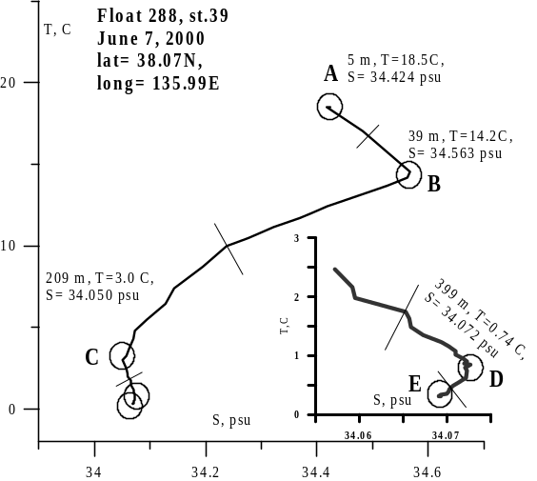
Figure 6. TS-curve for station 39 of profiling
float 288. The inset shows the enlarged deepest part of the TS-curve. The following water masses (WM) are noted: surface WM (A); subsurface high-S WM (B); intermediate low-S WM (C);
intermediate high-S WM (D); deep WM (E). Sometimes the bottom WM is distinct, which is usually warmer than the deep WM.

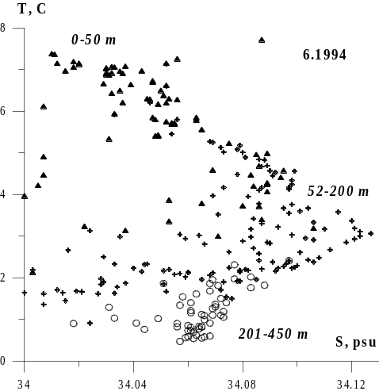
Figure 7a. TS-diagram for all stations occupied in June 1994. Triangles, 0–50 m; crosses, 52–200 m; circles, 201–450 m

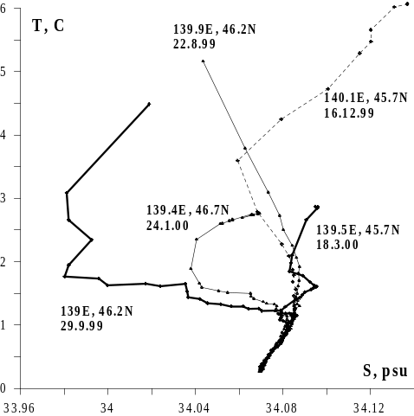
Figure 7b. TS-curves for stations with a low-S layer. Thick curves, float 223;
thin curves, float 225; dotted line, float 224

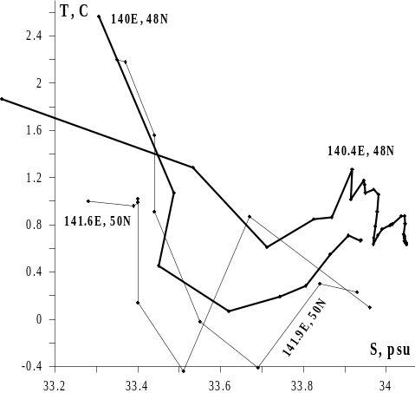
Figure 7c. TS-curves for stations with the cold subsurface water mass. Thin curves, May 1977; thick curves, July 1999
Surface warm high-salinity waters (HSL, or HSL-1, for “high-salinity layer”) are transported by a branch of the Tsushima Current (Miyazaki, 1953) toward the Tartar Strait, becoming colder and fresher underway. In spite of this transformation, they retain some basic features such as the relatively high temperature and salinity. Even in May they have T>6°С and S>34.1 psu. Salinities exceeding 34.2 psu are rare in the Strait. The HSL thickness in spring seldom exceeds 120 m. The HSL core depth changes seasonally. In winter and early spring (April) it is below 50 m and near the bottom in La Perouse Strait. In late May and during summer the HSL core is at the surface. In winter and spring these waters are found near the Sakhalin coast only between 140.6°E and 141°E and the core is usually observed near Moneron Island (141.1–141.2°E). Warm subtropical waters are observed in the southeastern part of the Strait close to the Sakhalin coast. A band of the Okhotsk Sea cold and fresh waters extends along the coast from La Perouse Strait to 47°N. Its indices (T<2°С, S<33.5 psu) differ sharply from those of local waters, both surface and deep.
A subsurface layer of cold water (CWL) is observed south of 48°N, only near the continental coast and only in spring. The layer of low salinity (LSL) deserves special attention because it was observed in the Tartar Strait for the first time but likely existed all the time. Earlier this layer was known to only exist in the western part of the sea (Kim and Chung, 1984) and form annually between the subarctic and northwest fronts (Danchenkov et al., 2003). In the southern part of the Tartar Strait this layer is found almost everywhere, except for shallow waters. In May the LSL core is at 10–20 m, below the near-surface thermocline. The LSL outcrops near the continental coast. The LSL core salinity and depth decrease toward the coast and differ considerably between the SW and SE Strait. Sometimes two low-S layers are observed simultaneously. For example, in
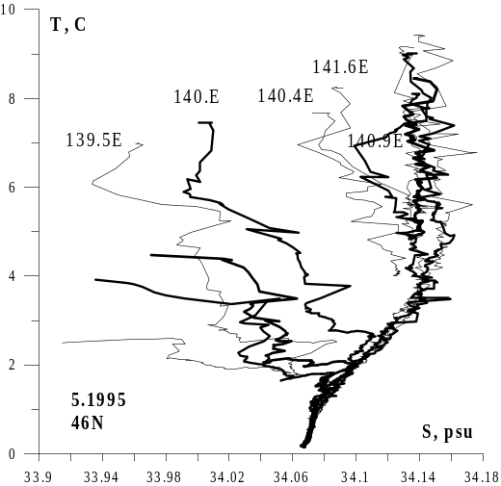
Figure 8. TS-curves of stations at 46°N, May 1995
May 1995 a thin subsurface layer with its core at 10–20 m and a thicker intermediate layer with its core at 100–200 m were observed at 139.5°E. The above differences justify the LSL division into two layers, namely the subsurface low-S layer (LSL-1) and the intermediate layer (LSL-2). Sometimes only one LSL is present, which is common in the mid-Strait. Two LSLs are evident in the eastern Strait: The LSL-1 wedges into the high-S layer while the LSL-2 is situated just under it. However, the LSL-2 was also observed beyond the area of subtropical high-S waters. The LSL is present in the Tartar Strait during most of the year and even in early winter, with its core salinity decreasing from 34.07 psu in March to 33.96 psu in late April (Figure 9).
In summer (July 1999) the LSL was only found at 46°N, between 60 and 120 m, with its core T=3–4°С and its core S=34.00–34.04 psu. At 48°N the LSL was not observed. The intermediate layer of high salinity (HSL-2) was observed in the southern part of the Strait. It differs from the surface high-S layer (HSL-1) by its lower temperature, core depth (usually about 300 m) and location (in deep basins only). When both HSL-1 and HSL-2 exist, they are separated by a low-S layer (LSL-2). Based on a high concentration of dissolved oxygen (>6.5 ml/l in July
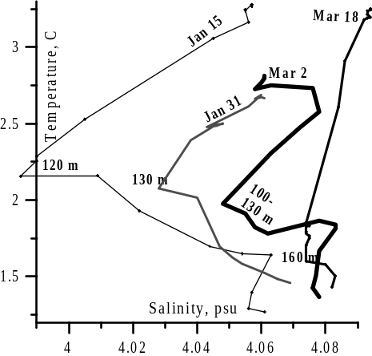
Figure 9. TS-curves of stations of profiling
float 194, January-March 2000. Salinity is given
as S-30. The float drift is shown in Figure 10.

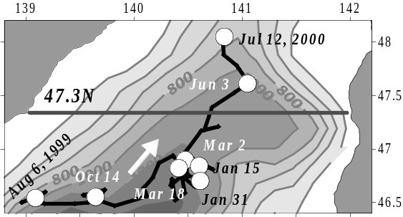
Figure 10. Trajectory of float 194 at 800 m depth, July 1999–July 2000. Thick line denotes the secular standard section.
1999 and July 2002), HSL-2 cannot be referred to as a part of HSL-1. Probably it is composed of high-S surface water mass, with its signature high oxygen content, modified by convection. In summer 1999 the HSL-1 with T=5–10°С and S=34.11–34.18 psu occupied mainly the Sakhalin shelf (141.7°E, 35–60 m), whereas the HSL-2 with T=1–2°С and S>34.075 psu was found almost everywhere in the Strait (139–141°E, 200–400 m) (Figure 11).
The HSL-2 thickness and depth at 48°N are significantly less than in the south, suggesting that the HSL-2 forms in the south and spreads northward.
VERTICAL WATER STRUCTURE OF THE NORTHERN TARTAR STRAIT
Vertical water structure in the northern Strait (north of 48°N) is simpler than in the southern Strait. Its main feature is the subsurface cold water layer (CWL). The CWL temperature is several degrees lower than temperature above and below CWL. The CWL was occasionally observed elsewhere in the Strait during most of the year. From May to November, the CWL was usually found in the “cold water domain” between 48°N and 51°N. Winter convection extends to 150–200 m depth in the deep basin and down to the bottom on the shelf. Thus, it is unclear where the CWL core is located in winter: either near the bottom where newly formed dense waters accumulate or at surface where water cooling is at maximum. In spring the coldest waters are observed at the surface. In early April the CWL and thermocline are absent. Homogeneous waters that cooled down in winter occupy the entire water column from the surface to the bottom. However, in May surface waters warm enough to form a thin
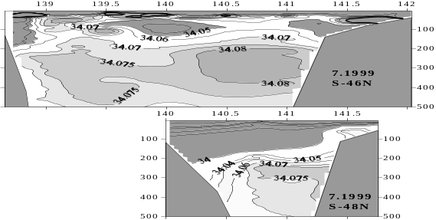

Figure 11. Salinity sections across the Tartar Strait, July 1999: 46°N (top);
48°N (bottom)
surface layer with a relatively high temperature. As a result, the thermocline and CWL were observed, with the CWL core off the continental coast at 30 m depth (under thermocline), located progressively deeper eastward (Figure 12).
In the Okhotsk Sea the CWL is outlined by the 0°С isotherm. In the Tartar Strait the CWL is between
-1.5°C and 1.5°C. The extremely low CWL core temperature, less than -1.5°C, was observed often enough, e.g. in May 1977 and May 1978. In summer the CWL warms from the surface and from below, so the CWL thickness decreases. In the western Strait the CWL is thicker and its core temperature is lower. High temperatures of surface waters could be explained by their solar heating. Relatively high temperatures of near-bottom waters could be explained by warm waters inflow from the south, which is confirmed by the increasing temperature and salinity near the bottom and their high values in the eastern Strait. Inflow of warm water is insignificant there. The influence of warm water is different at 47°N and at 51°N. At the southern section, except for an area north of Cape Kril’on, warm waters are located close to the coast, so the CWL is absent immediately off the coast. North of a thermal front at 48–49°N warm waters usually move north through the mid-Strait, thus breaking down the CWL (Figure 13).
Waters above and below the CWL are of different origin which explains their different salinities. The salinity above thermocline is very low, <33.2 psu in the northern Strait and <33.8 psu in the southern Strait. The minimum salinity (<30 psu) was observed in surface waters along the continental coast; probably, river discharge here is higher than in the eastern Strait. Therefore, surface waters in the NW Strait could be considered a separate water mass. Salinities observed off the Sakhalin coast are higher, suggesting the existence of a high-S surface or subsurface current. Beneath the CWL, salinities are much higher than at the surface, varying from 33.9 psu in the northern Strait to 34.05 psu in the southern Strait. The CWL core depth and salinity increase eastward. For example, at 50°N the average salinity within the 0.5°C isotherm increases from <33.0 psu near the continent to >33.8 psu near Sakhalin (Figure 14).
In July 1999 two CWLs were observed. The upper CWL centered at 50 m, with S=32.9–33.9 psu, was located within the halocline; the lower CWL centered at 160 m had the nearly uniform salinity of 33.98–34.01 psu (Figure 15).
The northern Strait undergoes strong surface freshening in summer. The attendant salinity decrease depends on a balance between river discharge and inflow of saline oceanic waters. Unfortunately, there are no dedicated measurements, such as series of surface drifters, to allow estimation of the northward inflow of saline waters. Runoff of most rivers flowing into the northern Strait was never measured. It could only be assumed that the basic balance between river discharge and northward oceanic inflow varies across the northern Tartar Strait. Summer warming of surface waters results in the upper layer’s thickness increase. In shallow waters, e.g. at 51.4°N, the CWL disappears completely in summer (Figure 16).

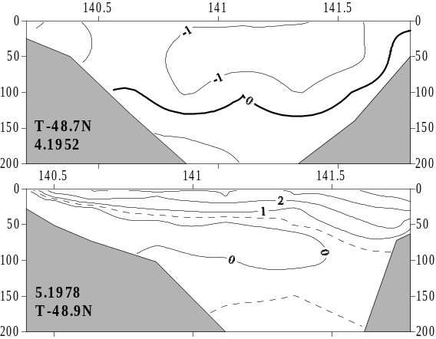
Figure 12. Temperature sections across the northern Strait: 12 April 1952, 48.7°N (top);
23–24 May 1978, 48.9°N (bottom)

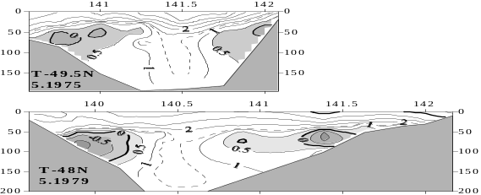

Figure 13. Temperature sections across the northern Strait: 21 May 1975, 49.5°N (top);
31 May 1979, 48°N (bottom)

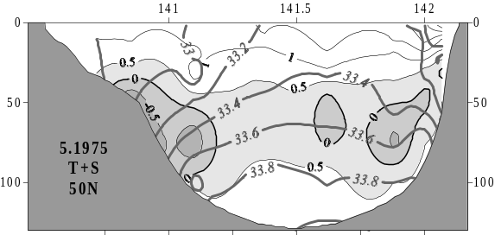
Figure 14. Temperature-salinity section across the northern Strait, 17–18 May 1975, 50°N
The CWL temperature increases from -1°C in May to 1.5°C in August (Figure 17).
Water characteristics within each layer change during the year, the upper layer being the most variable and the bottom layer being the least variable. Characteristic of near-bottom waters probably change after winter; however, they are not discussed in the present paper due to the lack of high-quality data.
SEASONAL VARIABILITY OF VERTICAL WATER STRUCTURE
Typical temperature, salinity and density of major subsurface and intermediate layers are shown in Table 2. Note that characteristics of LSL-1 and CWL are very close.
Therefore, renewal of LSL-1 could occur at the expense of CWL in summer along the southwestern continental coast. The CWL thickness and
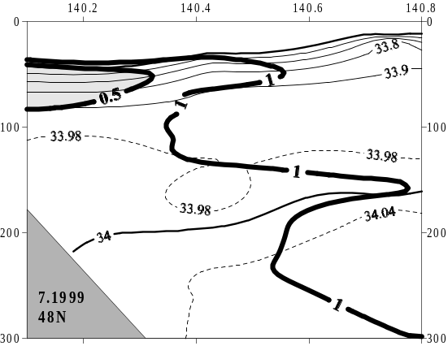
Figure 15. Temperature-salinity section along 48°N, July 1999: isotherms (thick lines);
isohalines (thin lines)

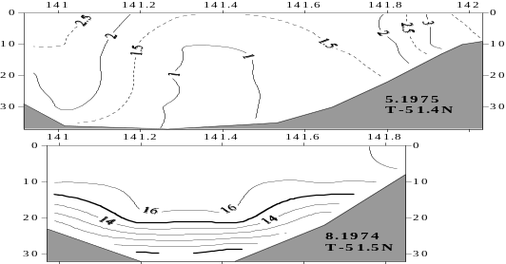
Figure 16. Temperature sections across the northern Strait (51.4–51.5°N): May 1975 (top);
August 1974 (bottom)
temperature change considerably during the year. It is possible to trace the CWL thickness change from variations of its boundary isotherm. Temporal variability of the 1°C isotherm, assumed to be the CWL boundary, is shown in Figure 18.
From Figure 18 one can conclude that the CWL area is at minimum in September–October and at maximum in May. In November, new cold waters begin to form in the eastern Strait. Though 50°N and 51°N, and 50°N and 51.4°N are close to each other, spatial distributions of temperature and salinity along these sections are different. In early summer, warm waters are found under CWL at 50°N. The CWL at 51°N and 51.4°N occupies the area just near the bottom. In late summer, the CWL is observed at 50°N and 51°N, but not at 51.4°N.
Seasonal variations of temperature penetrate much deeper than previously thought (200 m). For example, the temperature increase in 0–50 m layer in the area centered at 46.8°N, 140.3°E was accompanied by warning of 500–800 m layer (Figure 19).
Most measurements were made in the area centered at 46.7°N, 140.5°E. Temporal variations of temperature and salinity are shown in Figure 20 (p. xxx).

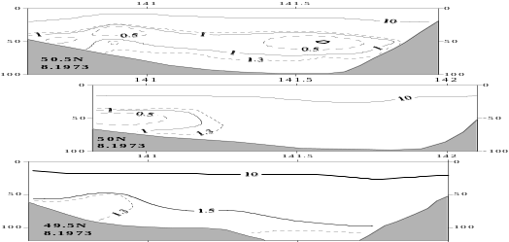

Figure 17. Temperature sections across the northern Strait, August 1973:
50.5°N (top); 50°N (middle); 49.5°N (bottom)

Table 2
Characteristics of the Tartar Strait water layers
Layer | Season | Core  depth, m | T, °С | S, psu | Density
LSL-1 | spring | 10–70 | 1.8–4.0 | <33.95 | 27.0–27.1
LSL-1  LSL-2 | summer  summer | 10–40  70–140 | >10.0  1.5–2.0 | <33.90  <34.02 | <26.1  >27.2
LSL-2 | autumn | 50–140 | 1.5–3.0 | <34.00 | >27.2
LSL-2 | winter | 100–150 | 1.8–2.2 | <34.03 | >27.2
HSL-2 | summer | 330 | 0.9 | 34.075 | 27.3
HSL-2 | autumn | 380 | 0.9 | 34.078 | 27.3
HSL-2 | winter | 300 | 0.9 | 34.083 | 27.3
CWL | spring | 40–100 | <0.5 | 33.5–33.8 | 26.9–27.1
CWL | summer | 30–70 | <1.0 | 33.6–33.8 | 26.9–27.1

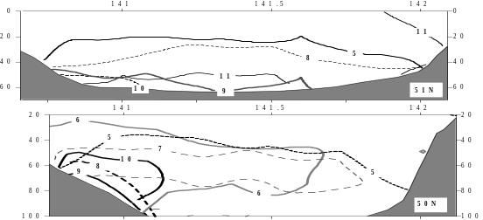
Figure 18. Distribution of the 1°C isotherm at 51°N (top) and 50°N (bottom) in different months shown by numbers

Fresh water mixes down to 100–140 m depth gradually from October to December. During this period stratification is stable. In March saline waters (>34.078 psu) form and reach 230 m depth. The stability of these waters is almost neutral. The temperature of these uniformly saline waters varies from 2.0–2.5°C at the surface to 0.8–1.0°C at 300 m. The winter mixing depth from two profiling floats (float 223 at 45.8°N, 139.3°E and float 224 at 45.5°N, 140.2°E) is different (Figure 21, p. xxx), although their separation distance from each other is relatively small.
The maximum depth of winter mixing (300 m) was observed from float 223. Despite the rapid cooling of the Strait from late November on, the warming effect of the Tsushima Current is noticeable even in winter, resulting in different sea ice cover distributions in the western and eastern Strait. In the eastern Strait, sea ice cover only extends to 48°N (Stolyarova, 1963), whereas in the western Strait sea ice cover extends to 46°N.

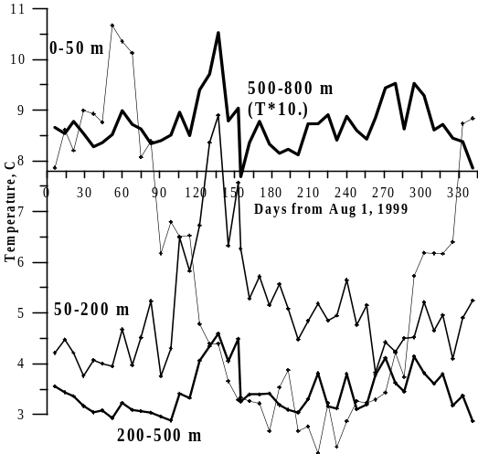
Figure 19. Seasonal variability of the mean temperature in 0–50 m, 50–200 m, 200–500 m, and 500–800 m layers (the latter’s temperature is multiplied by 10) from August 1999 to July 2000, from the profiling float 194 data.
The float track is shown in Figure 10.
HORIZONTAL STRUCTURE OF THE TARTAR STRAIT WATERS
Horizontal distributions of sea surface temperature (SST) and salinity (SSS) feature two fronts, thermal and haline, that separate cold, low-salinity waters of the NW Strait from warm, salty waters of the SE Strait (Figure 22).
The thermal and haline fronts are close to each other over most of the Strait, except for its northern part where salinity varies widely. The main front, termed the Tartar Front, is a branch of the Subarctic Front that divides subarctic and subtropical waters of the Japan Sea (Belkin and Cornillon, 2003). The Tartar Front’s path is rather sinuous: from the continental coast at 46.5°N to 48–49°N to the east to 141.5°E. Here the front splits. The Northern Front extends along the Sakhalin coast, whereas the Kril’on Front extends southeast to Cape Kril’on. The cold water north of the Tartar Front is called the cold domain (47.5–51.4°N, 141–142°E). Its width peaks at 51–50°N and rapidly decreases south of 49.5°N. The warm water south of the Tartar Front is called the warm domain, formed by a meander of the Tsushima Current centered near Moneron Island. Horizontal temperature gradients at the boundaries of the cold and warm domains are higher than between them. Thus, there are two Tartar Fronts, cold and warm one, and an inter-frontal zone in-between. Horizontal temperature gradients peak at 5°C/nm in the 48–49°N band and especially at the near-coastal Kril’on Front off SW Sakhalin. The Tartar Front below the surface is stationary or shifted east with depth (Figure 23). The cold-warm domain boundary is non-zonal at all depths.
In spring, the warm domain SSS>33.9 psu, while the cold domain SSS<33.5 psu.
Horizontal distribution of SST and SSS in summer is shown in Figure 24.
Two fronts and inter-frontal zone are observed at the surface. The warm front limits the warm domain with modified subtropical warm, high-salinity waters, centered off Moneron Island. The cold front limits the cold domain with cold, low-salinity waters, centered off the continental coast at 50–51°N. Despite large seasonal variability of SST and SSS some features of their spatial distribution are stable. For instance, the SST is at maximum in the warm domain and at minimum along the continental coast. The SSS is at maximum in the warm domain and at minimum along the continental coast in the northern Strait. Large interannual variability of temperature complicates selection of boundary isotherms for the warm and cold domains. The warm domain boundary at the surface differs little from the one at 100 m depth; however the cold domain boundary at the surface usually does not correspond to the one in deep waters (Figure 25).

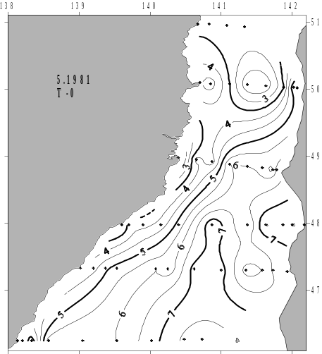
Figure 22. Sea surface temperature,
3–20 May 1981
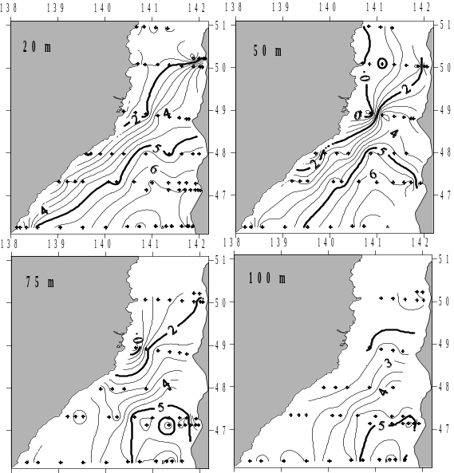
Figure 23. Temperature at 20, 50, 75, and 100 m depth, 3–20 May 1981

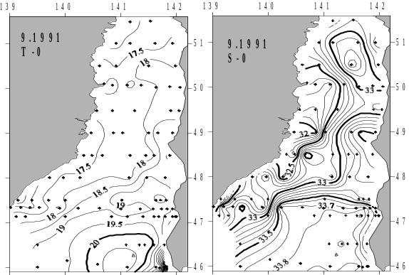
Figure 24. Sea surface temperature and salinity, September 1991

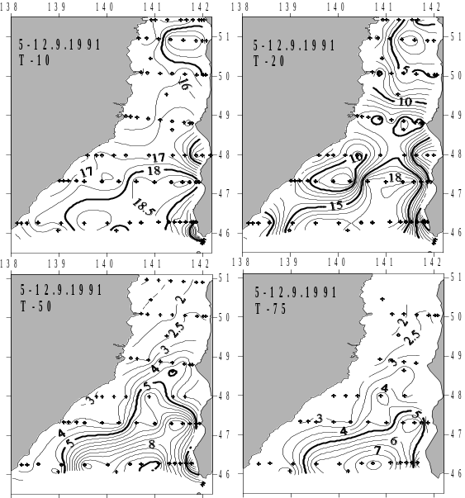
Figure 25. Temperature at 10, 20, 50 and 75 m depth, 5–12 September 1991
Horizontal temperature gradients peak at 20–30 m (thermocline) and below. The thermal front is distinct. The seasonal warming is at maximum in September. The warm domain in September 1991 was bounded by the 18°C, 15°C, 5°C and 3.5°C isotherms at, respectively, 10, 20, 50 and 75 m depth (Figure 25). Warm waters spread from Moneron Island to the north along 141°E and to the west toward the continental coast at 46–47°N. Warm waters reach Sakhalin between 47–48°N only. The warm water domain is bounded from the west by the Tartar Front at 48–49°N and from the east, by coastal fronts.
The cold domain front in September 1991 was bounded by the 15°C, 10°C, 3.5°C and 3°C isotherms at, respectively, 10, 20, 50 and 75 m depth (Figure 25). Based on their temperature, salinity and dissolved oxygen concentration, cold waters in different parts of the Strait have different origin. In the NW Strait, cold waters spread southward as a narrow band. Only at 48°N these cold waters occupy a large area, probably as a result of local upwelling. In the SE Strait, waters between Cape Kril’on (45.9°N) and 46.5°N are colder and fresher than waters of Nevelskoy Bay (47°N) and DeLangle Bay (48°N). Between Cape Kril’on and 46.5°N, the temperature and salinity of the coastal cold, fresh water increase, and its width decreases, as it moves northward. Cold, low-salinity waters spread from La Perouse Strait into the Japan Sea. Cold waters in Nevelskoy and DeLangle bays are probably a result of local upwelling.
ZONING OF THE TARTAR STRAIT
Long-term mean positions of fronts is shown in Figure 26.
The Tartar Strait is divided by fronts into several zones with a specific water mass dominating in each of them:

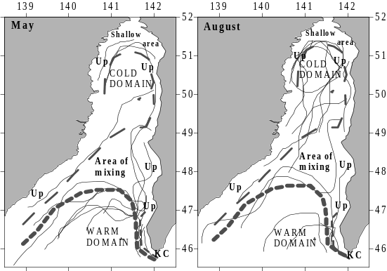
Figure 26. Long-term mean distributions of surface isotherms (thin lines), fronts (dashed lines) and inter-frontal zones in May (left) and August (right) of 1960–1989. Acronyms: Up, upwelling; KC, Kril’on Current.
- warm domain;
- cold domain;
- belt of the Okhotsk Sea waters (KC);
- inter-frontal zone;
- areas of coastal upwelling (Up);
- northern shallow area.
Warm domain and subtropical waters. In late summer the SST in the northern and southern Strait are similar. However, the warm domain does not reach the northern limit of the Strait. The 3°C isotherm is considered the northern limit of subtropical waters penetrating the Strait; the warm domain boundary is located south of 48°N (Probatov and Shelegova, 1968). The eastern Strait waters were divided into three parts (Cape Pogibi – Cape Zhonkiyer – Cape Lamanon – Cape Kril’on) based on the relative influence of warm subtropical waters (Piskunov, 1952). Subtropical waters were not considered to penetrate into the northern Strait (north of 50.9°N) at all. The area between 49.0–50.9°N was influenced by a warm current; the area between 46–47°N was affected by the cold East Sakhalin Current. Modified subtropical waters are not found in the western Strait, within 100 m isobath. However, surface waters in the western Strait are warmer than in the eastern Strait (Figure 27).
Warm and salty waters are transported northward along the Sakhalin coast up to 51°N by a nameless branch of the Tsushima Current, which explains the observed increase in temperature and salinity of the bottom layer (under CWL) of the cold domain. Subtropical waters penetrate up to 47°N even in winter, pushing north, up to 47.5°N, the sea ice cover in the eastern Strait. The warm water influence on sea ice cover is especially significant in March, when La Perouse Strait is blocked by the Okhotsk Sea ice and warm waters move mainly into the Tartar Strait. For example, on March 21, 1961, a warm water inflow from the south resulted in a merger of several polynyas into an ice-free corridor up to 49.5°N. By March 26 the ice-free corridor extended up to 50.5°N. By April 11 the entire eastern Strait was ice-free.

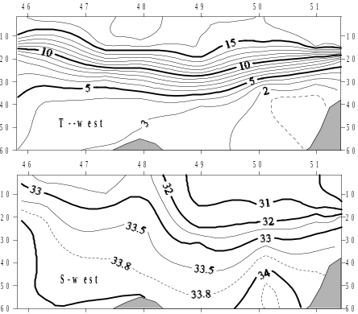
Figure 27. Temperature and salinity along the continental coast, 7–11 September 1991
Cold domain and CWL. The cold water domain grows in winter and peaks in April. Its surface boundary does not coincide with its deep-water boundary. In summer the CWL boundary is best traced at 50 m depth. Cold waters outcrop in upwelling areas (Figure 26). Even though the CWL was first observed long ago (Leonov, 1958), it has only been described recently (Pogodin and Shatilina, 1994; Zuenko, 1994). However, certain observations provided by Zuenko (1994), such as “existence of CWL within 20–100 m”, “depth of the minimum water temperature varying from 60–90 m in the central part of the strait to 20–30 m in the northern Tartar Strait, where water temperature is the lowest”, and “0–2°C temperature and 33–34 psu salinity within 45–52°N latitude belt preserving during the whole summer”, differ from our results. For example, a 100 m thickness of CWL was shown by Zuenko (1994) in the area, where water depth is much less than 100 m. It is difficult to check calculations of the cited CWL thickness, as the survey dates and research vessel name were not given. Therefore, below we only point out discrepancies between Zuenko (1994; italics below) and this study:
“Existence of CWL within 20–100 m”: In spring CWL is not observed and cold homogeneous waters extend from the surface to the bottom. The CWL as a surface layer is found in April and sometimes in May. In August–September the seasonal thermocline deepens offshore and appears as a front at 20 m level (Figure 28).
The CWL occupies the 100 m level in spring only. In summer this level is occupied by a rather warm and salty water from the deep layer.

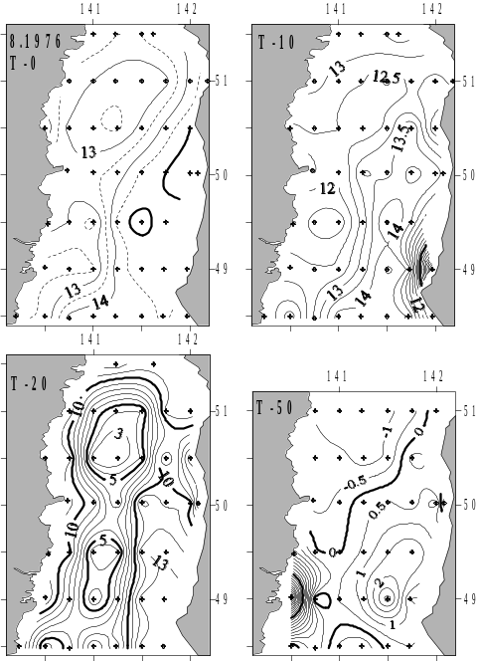
Figure 28. Temperature at 0, 10, 20 and 50 m depth, 8–23 August 1976
“Depth of the temperature minimum varies from 60–90 m in the central part of the strait to 20–30 m in the northern Tartar Strait, where water temperature is the lowest…”; “0–2°C water temperature and 33–34 psu salinity within 45°–52°N latitude belt preserve during the whole summer”: The CWL core is usually located at 50 m depth (Figures 13–15, 17, 18). The CWL core depth increases eastward. In the shallow northern Strait the CWL was briefly observed at 51.4°N in May only, and in June it was not found (Figure 29).
The coldest waters within CWL were observed at 50–51°N, rather than in the northern Strait. The CWL temperature and salinity increase over summer. Spatial distribution of the CWL characteristics in summer is shown in Figure 30.
In summer the CWL is usually absent at 46°N and 51.4°N; it is rare at 47°N, more frequent at 48°N, and common in the cold domain at 49–51°N.

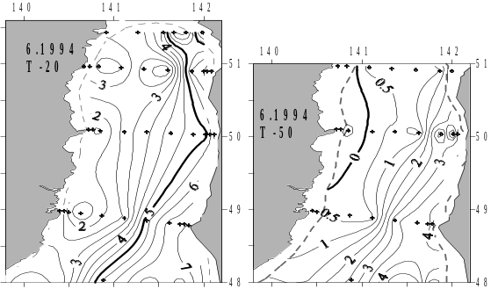
Figure 29. Temperature at 20 m and 50 m depths, 4–12 June 1994

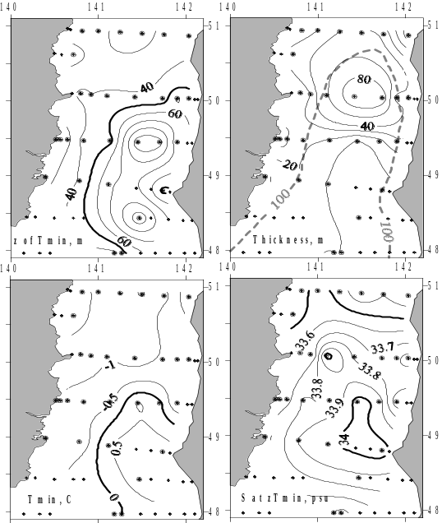
Figure 30. The CWL core depth, thickness, temperature and salinity, 29 May–22 June 1976. Stations, where CWL was not observed, are shown by dots.
Upwelling areas. In the warm domain the upper 100 m layer is nearly isothermal in winter, making tracing upwelling impossible. Upwelling is easily noticeable in the cold domain and in coastal areas owing to substantial temperature contrast between surface and subsurface waters, especially in summer. However summer upwelling in the northern Strait is rare because of a strong summer pycnocline. Here upwelling is common in spring (Figure 31) and autumn.
Offshore upwelling of cold waters is frequently observed under the thermocline (Figure 32).
In coastal areas, upwelling of cold subsurface waters is observed near Cape s. Persistent offshore winds are favorable for upwelling, e.g. off Cape Syurkum at 50°N. Upwelling also occurs where currents diverge, e.g. in Nevelskoy and DeLangle bays at 46.5–48.5°N.
Cold belt of the Okhotsk sea waters off Cape Kril’on. Band of cold water from the Okhotsk Sea is observed year-round between Cape Kril’on (45.9°N) and Cape Lopatina (46.6°N). It is regularly fed by the La Perouse Strait waters (Figure 33).
Its existence was noticed in the 19th century (Maidel, 1879; Zuev, 1887) in the form of a narrow coastal band (5–8 nm) of cold waters along the SW Sakhalin coast up to 46.7°N.
Cold waters spread northward in a thin layer (20–30 m), which narrows from Cape Kril’on to 46°N. In winter these waters are 0.5–1.5°С warmer than Nevelskoy Bay waters, whereas in spring and summer these waters are significantly colder than Nevelskoy Bay waters (Figure 34).

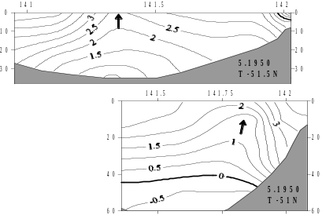
Figure 31. Temperature sections in the northern Strait during an upwelling episode, May 1950:
51.5°N (left); 51°N (right)

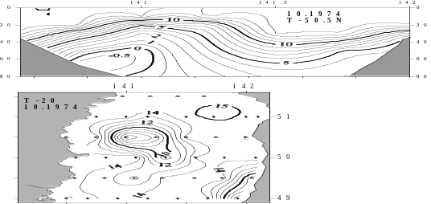
Figure 32. Upwelling of cold waters in the northern Strait, 3–7 October 1974: temperature section along 50.5°N (left); temperature at 20 m depth (right)

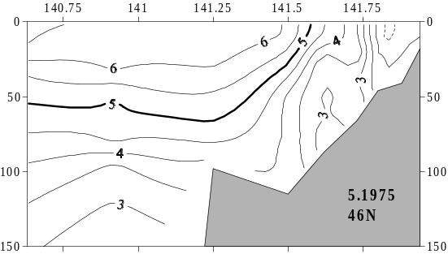
Figure 33. Temperature section along 46°N,
16 May 1975

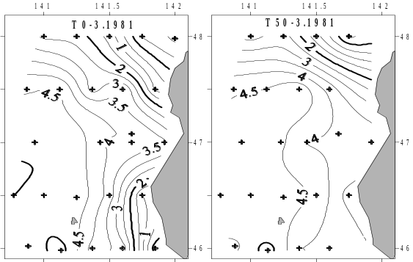
Figure 34. Temperature at 0 m (left) and 50 m depth (right), 9–11 March 1981
For example, in summer 1986 the 0–30 m waters were much colder (by 10–12°С) than Nevelskoy Bay waters (Figure 35).
Throughout the year the northward advection of the Okhotsk Sea waters is limited by 46.5°N. In some years these waters spread up to Kholmsk (47°N) and even farther north provided favorable winds (Probatov and Shelegova, 1968; Shelegova, 1960). The existence of this band was explained by local upwelling along the SW Sakhalin coast and southward advection of the upwelled waters. Zhabin et al. (1993) showed that cold waters enter the Okhotsk Sea through La Perouse Strait. Yarichin (1980) described a steady southward flow into La Perouse Strait off SW Sakhalin. Tanaka et al. (1996) found that the West Sakhalin Current flows southward along the western Sakhalin coast and then turns into La Perouse Strait. However, the low temperature and salinity of the cold band could not result from local upwelling (Danchenkov et al., 1999). Throughout the year, even in winter, the cold band waters are 1–1.5°С colder and 0.2–0.4 psu fresher than subsurface waters in this area. These cold, low-salinity waters are thought to originate between Cape Kril’on and Kamen’ Opasnosti Rock (45°47’N, 142°14’E). The mean sea level difference between the Okhotsk and Japan seas is 40 cm. However, this difference varies across La Perouse Strait and within the day. The cold intermediate layer between Cape Kril’on and Kamen’ Opasnosti is maintained by a branch of the cold East Sakhalin Current (or Kril’on Current, according to Maidel, 1879) (Figure 36).
The very peculiar plough-like bottom relief (Makarov, 1894) between Cape Kril’on and Kamen’ Opasnosti Rock causes upwelling of waters moving west. These waters are by 2–5°С colder and by 0.5–1.0 psu fresher than the Japan Sea surface waters (Figure 37).
Tides (and sometimes winds) cause the cold water to flow into the Japan Sea (Biryulin, 1954). After entering the Japan Sea the cold water flow turns to the right under the Coriolis force and extends north along Sakhalin (Veselova, 1963). When the tidal flow recedes, the cold water flow partly reverses, becomes entrained into the Soya Current and transported SE-ward, far from Kamen’ Opasnosti Rock. The width of the cold band is about 8 nm off Cape Kril’on and 5 nm at 46.8°N (Zuev, 1887). Its thickness is 10–20 m; horizontal temperature gradients across its boundary can be as high as 5°С/nm (Veselova, 1963).
The largest volume transport to the Japan Sea from the Okhotsk Sea was observed in winter, whereas the smallest one – in summer. From late April to mid-May 1963, transport to the Japan Sea decreased from 6 km³/hour to 1.4 km³/hour and transport to the Okhotsk Sea increased to 3.4 km³/hour (Shelegova, 1963). In summer, transport into the Japan Sea is small and varies from 0 on 17 July 1965, to 0.26 km³/hour on 14 July 1964 (Shelegova and Uranov, 1964).

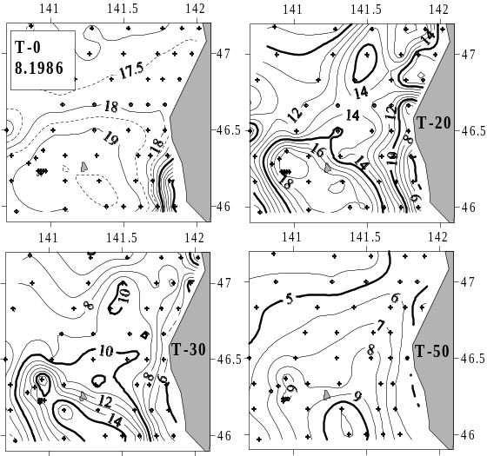
Figure 35. Temperature in the SE Strait at 0, 20, 30 and 50 m depth, 1–25 August 1986

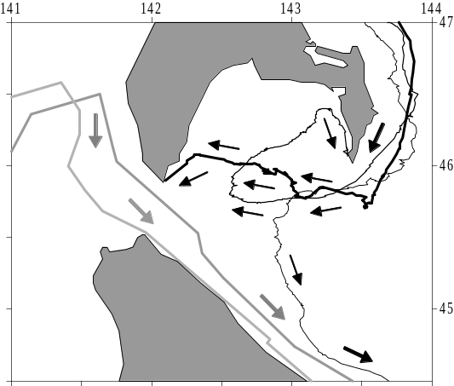
Figure 36. Trajectories of surface drifters
in La Perouse Strait, 1999–2000. Drifter tracks
in the warm Soya Current are shown by grey lines and arrows. Drifter tracks in the cold East Sakhalin Current and cold Kril’on Current are shown by black lines and arrows.

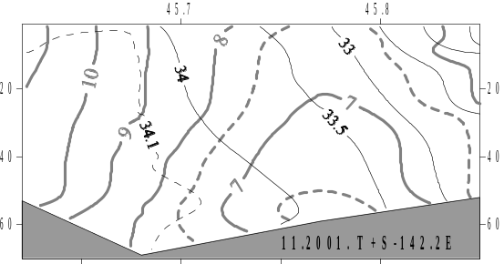
Figure 37. Temperature-salinity section along 142.2°E between Cape Kril’on and Kamen’ Opasnosti Rock, 5 November 2001
WATER MASS ORIGIN
Out of seven water masses (WM) present in the Tartar Strait four WMs form locally, namely two surface WMs, cold subsurface WM, and subsurface low-S WM.
Tartar Strait is considered the place of proper (deep) water mass formation with temperature of 0.2–0.5°C and salinity of 34.05–34.08 psu (Martin et al., 1992). This is explained by long, severe winter and existence of polynyas. However, winter cooling and mixture of fresh (surface) and saline (deep) waters result in the CWL formation. Its salinity (33.5–33.8 psu) and density do not change much from year to year (Figure 38); they are different from respective characteristics of the proper WM.
The CWL forms in spring not only in the cold domain (as was shown above), but, probably, in the narrow band along the continental coast as well. The salinity of this band (33.8–34.04 psu) in August 1976 was much higher than the salinity of CWL waters in the cold domain, while their temperatures were very similar in both areas.
Surface salinity in the southern Strait is higher than in the cold domain. Sea ice formation here could produce cold, saline waters. However, the mean 0–50 m layer density does not exceed 27.2 in winter, thus falling short of 27.33–27.34, which is characteristic of the Japan Sea deep waters (Figure 39).
Intermediate layer of high salinity (S=34.08 psu, T=0.9°C) is centered near 300 m depth. It probably forms in the area(s), where the surface high-S layer depth exceeds 300 m and where LSL-2 is found which wedges into this thick layer.
Surface waters in different parts of the Strait are formed by mixing waters of different origin. In general, salinity of surface waters decreases northward and westward. The only two exceptions are (a) band near Cape Kril’on with S<32.5 psu, and (b) northern shallow area with S<32.0 psu.
Lack of high-quality data prevents the identification of the source area of LSL-2. The layer is absent north of 47°N but present at 46°N everywhere across the Strait. Its characteristics in spring (T=2°С, S=33.9–34.0 psu, density sigma-t=27.15) are close to the characteristics of surface waters and CWL waters in the SW Strait (T<1.5°С, S=33.5–33.8 psu, density about 27.15). Probably, it forms there in spring.
In the cold domain, the temperature and salinity of the upper layer (above CWL) and of the near-bottom 70–120 m layer (under CWL) vary seasonally. The seasonal increase in temperature (Figures 40–41) and decrease in surface salinity are easily explained by solar radiation and river discharge. However, increase in the near-bottom temperature and salinity in the cold domain cannot be explained without taking account of inflow of warm, saline waters from the south. Unfortunately, lack of high-quality salinity data does not allow a detailed analysis.
SUMMARY AND CONCLUSIONS
Spatial structure of the Tartar Strait waters has been studied from historical oceanographic data collected in 43 research cruises conducted by FERHRI, TINRO and P.P. Shirshov Institute of Oceanology in 1960–2003. Seasonal variability of horizontal and vertical water structure has been analyzed. Seven water masses have been distinguished: surface low-S subarctic WM; surface high-S subtropical WM; subsurface low-S WM; intermediate low-S WM; intermediate high-S WM; cold subsurface WM; and proper (deep) WM.
Ten layers have been detected based on temperature and salinity features such as temperature minimum, salinity minimum, and salinity maximum. Two fronts have been identified, thermal and haline, that are close to each other – thus forming a single TS-front – over most of the Strait, except for its northern part where they diverge thus forming a double front. The main thermohaline front, termed the Tartar Front, is a
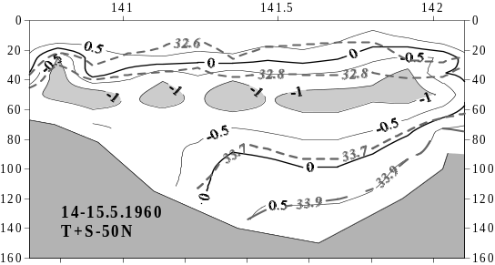
Figure 38. Temperature-salinity section along 50°N, 14–15 May 1960

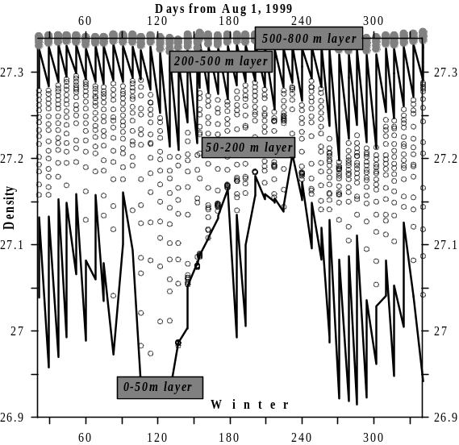
Figure 39. Seasonal variability of the vertically averaged density from the profiling float 194.
The float track is shown in Figure 10
branch of the Subarctic Front that separates subarctic and subtropical waters of the Japan Sea. The Tartar Front bifurcates into the Northern Front that continues along the west Sakhalin coast and the Kril’on Front that turns SE to Cape Kril’on. The Tartar Strait is divided by the above fronts into six zones: warm domain, cold domain, belt of the Okhotsk Sea waters, inter-frontal zone, areas of coastal upwelling, and northern shallow area. Basic characteristics of these zones have been determined; their seasonal variability has been analyzed and described.
Future research should include repeat high-resolution three-dimensional surveys of the Tartar Front, Northern Front and Kril’on Front, which would be important for physical, biological, and fisheries oceanography of this region. A deeper understanding of seasonal evolution of the Tartar Strait spatial structure is impossible without wintertime cruises that require ice-strengthened research vessels. Harsh conditions of the Tartar Strait provide a strong incentive to develop and utilize various unmanned, autonomous platforms such as surface and subsurface drifters, gliders, profiling floats and subsurface moorings.
ACKNOWLEDGEMENTS
The author is grateful to A.G. Pogodin and N.A. Rykov for presented historical data.

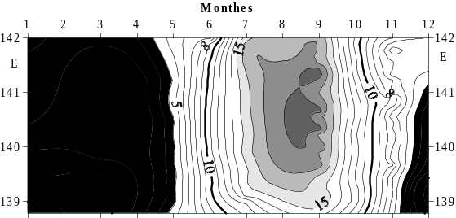
Figure 40. Seasonal cycle of SST at 47.3°N

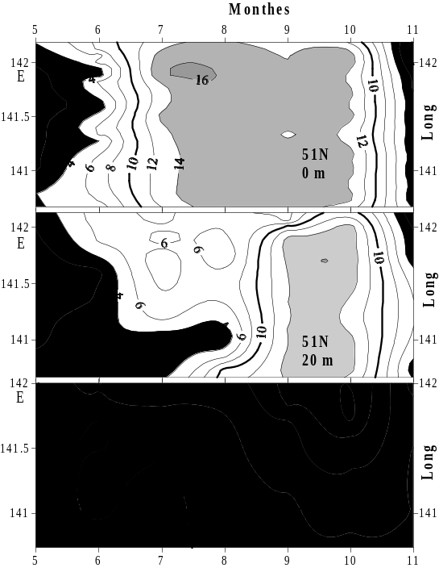
Figure 41. Seasonal cycle of temperature at 51°N at 0, 20, and 50 m depth.

REFERENCES

Atlas of water temperature of the northern Japan Sea by aircraft surveys. 1983. PUBLISHER, Yuzhno-Sakhalinsk, 39 p. (In Russian)
Belkin I., Cornillon P. 2003. SST fronts of the Pacific coastal and marginal seas. Pacific Oceanography, v. 1, No. 2, pp. 90–113.
Biryulin G.M. 1954. Hydrometeorological characteristics of fishery areas of Southern Sakhalin, In: Works of Kuril-Sakhalin Cooperative ZIN-TINRO Expedition in 1947–1949. Moscow, USSR Academy of Sciences, v. 1, pp. 167–303. (In Russian)
Danchenkov M.A. 1998. Oceanography of the Tartar Strait. FERHRI? Vladivostok. Manuscript. 48 p. (In Russian)
Danchenkov M.A., Aubrey D.G., Feldman K.L. 2003. Oceanography of area close to the Tumannaya River mouth (the Sea of Japan). Pacific Oceanography, v. 1, No. 1, pp. 61–69.
Danchenkov M.A., Aubrey D.G., Hong G.-H. 2000. Bibliography of the oceanography of the Japan/East Sea. PICES Sci. Rep., 13, 99 p.
Danchenkov M.A., Aubrey D.G., Riser S.C. 1999. Oceanographic features of La Perouse Strait. PICES Sci. Rep. 12, pp. 159–171.
Danchenkov M.A., Riser S.C. 2000. Observations of currents, temperature and salinity in the Japan Sea in 1999–2000 by PALACE floats. Oceanography of the Japan Sea, edited by Danchenkov M.A. Dalnauka, Vladivostok, pp. 33–40.
Danchenkov M.A., Riser S.C., Yoon J.-H. 2003. Deep currents of the central Sea of Japan. Pacific Oceanography, v. 1, No. 1, pp. 6–15.
Dobrovolskiy A.D. 1961. On the definition of water masses. Okeanologiya, v. 1, No. 1, pp. 12–24. (In Russian)
Gamo T., Horibe Y. 1983. Abyssal circulation in the Japan Sea. J. Oceanogr. Soc. Japan, v. 39, No. 2, pp. 220–230.
Hidaka K. 1966. Japan Sea, In: The encyclopedia of oceanography, edited by R.W. Fairbridge, Reinhold Pub. Co., N.-Y., pp. 417–424.
Ichiye T. 1984. Some problems of circulation and hydrography of the Japan Sea and the Tsushima Current. Ocean Hydrodynamics of the Japan and East China Seas, edited by T. Ichiye, Elsevier, New York etc., pp. 15–54.
Kim K., Chung J.Y. 1984. On the salinity minimum and dissolved oxygen maximum layer in the East Sea (Sea of Japan). Ocean Hydrodynamics of the Japan and East China seas, edited by T. Ichiye, Elsevier, New York etc., pp. 55–67.
Kim Y.-G., Kim K. 1999. Intermediate waters in the East/Japan Sea. J. Oceanography, v. 55, No. 2, pp. 123–132.
Kozlov B.M., Shelegova E.K. 1961. The influenced conditions of the fishery in the northern Tartar Strait. Rybnoye khozyaistvo, No. 7, pp. 9–11 (In Russian).
Leonov A.K. 1958. On the peculiarities of thermal structure and the currents of the Japan Sea. Trudy, USSR Geographical Society [Trudy Vsesoyuznogo Geographicheskogo Obshchestva], v. 90, No. 3, pp. 244–264. (In Russian)
Luchin V.A., Man’ko A.N. 2003. Water masses. Hydrometeorology and hydrochemistry of Russian Seas. V. 8. The Japan Sea. Saint-Petersburg, Gidrometeoizdat, pp. 243–256. (In Russian)
Maidel E.V. 1879. Extra notes on the cold current in La Perouse Strait. Morskoy sbornik, v. 171, No. 4, pp. 47–53. (In Russian)
Makarov S.O. 1894. "Vityaz" and the Pacific Ocean. Sankt-Petersburg. V. 2. 511 p. (In Russian)
Mamaev O.I. 1987. T,S-analysis of the World Ocean waters. Leningrad, Gidrometeoizdat, 296 p.; translated as: Temperature-Salinity Analysis of World Ocean Waters, Elsevier Publ., New York etc., 374 pp.
Martin S., Munoz E., Drucker R. 1992. The effect of severe storms on the ice cover of the northern Tatarskiy Strait. J. Geophys. Res., v. 97, No. 11, pp. 17753–17769.
Miyazaki M. 1953. On the water masses of Japan Sea. Bull. Hokkaido Reg. Fish. Res. Lab., vol. 7, pp. 1–65. (In Japanese)
Reports of complex oceanographic expeditions on R/V “Vityaz”. 1954. Moscow, USSR Academy of Sciences, v. 3, 350 p. (In Russian)
Piskunov I.A. 1952. Spring herring of the west Sakhalin coast. Izvestiya TINRO, v. 37, pp. 3–67 (In Russian)
Pischalnik V.M., Arkhipkin V.S. 2000. Oceanographic atlas of Sakhalin shelf. Part 1. SakhNIRO, 173 pp. (In Russian)
Pischalnik V.M., Klimov S.M. 1991. Catalogue of oceanographic expeditions at the shelf of Sakhalin (1948-1987). PUBLISHER, Yuzhno-Sakhalinsk, 166 p. (In Russian)
Pogodin A.G., Shatilina T.A. 1994. On seasonal and year-to-year water temperature variability in the northern Japan Sea. Manuscript. TINRO, 78 p. (In Russian)
Pokudov V.V., Man’ko A.N., Khlusov A.N. 1976. Peculiarities of hydrological conditions of the Japan Sea regime in winter. Trudy FERHRI, No. 60, pp. 74–115. (In Russian)
Probatov A.N., Shelegova E.K. 1968. Distribution of catches of spawning herring at southern Sakhalin. Izvestiya TINRO, v. 65, pp. 35–41. (In Russian)
Ponomarev V.I, Yurasov G.I. 1994. The Tatar (Mamiya) Strait currents. J. Korean Soc. Oceanography, v. 6, No. 4, pp. 335–339.
Radzikhovskaya M.A. 1961. Water masses of the Japan Sea. Basic features of geology and hydrology of the Japan Sea, edited by V.N. Stepanov, Moscow, USSR Academy of Sciences, pp. 108–121. (In Russian)
Riser S.C., Warner M.J., Yurasov G.I. 1999. Circulation and mixing of water masses of Tatar Strait and the northwestern boundary region of the Japan Sea. J. Oceanography, v. 55, No. 2, pp. 133–156.
Sailing directions of the north-west Pacific Ocean. 1914. Part 2. PUBLISHER, Saint Petersburg.
Sailing directions of the north-west Pacific Ocean. 1970. Part 2. PUBLISHER, Leningrad.
Stolyarova G.A. 1963. On forms and unity of ice of the Tartar strait. FERHRI Works, No. 13, pp. 129–138. (In Russian)
Shelegova E.K. 1960. The case of abrupt cooling in summer at the South-Western Sakhalin coast. Izvestiya TINRO, v. 46, pp. 249–251. (In Russian)
Shelegova E.K. 1963. Oceanographical conditions of fishery areas of Sakhalin and south-west Kamchatka in 1963. TINRO Report, No. 8706, 34 p. (In Russian)
Shelegova E.K., Uranov E.N. 1964. Oceanographical conditions in the Tartar Strait and south-west Okhotsk Sea. TINRO Report, No. 9279, 75 p. (In Russian)
Suda K. 1932. On the bottom water of the Japan Sea. J. Oceanography, v. 4, No. 1, pp. 221–241.
Supranovich T.I. 1989. Maximum and mean velocity of surface current in the Tartar Strait. FERHRI Works, No. 39, pp. 34–36. (In Russian)
Tanaka I., Nakata A., Yagi H., Samatov A.D., Kantakov G.A. 1996. Result of direct current measurements in La Perouse Strait (the Soya Strait), 1993–1996. Manuscript, 13 p.
Uda M. 1934. The results of simultaneous oceanographical investigations in the Japan Sea and its adjacent waters in May and June 1932. J. Imp. Fish. Exp. Station, v. 5, pp. 57–190. (In Japanese)
Veselova L.E. 1963. Some peculiarities of thermal conditions of waters along south-western Sakhalin coast. FERHRI Works, No. 13, pp. 42–63. (In Russian)
Yakunin L.P. 1987. Sea Ice Atlas of the Far Eastern Seas of the USSR. PUBLISHER,Vladivostok, 79 p. (In Russian)
Yarichin V.G. 1980. Condition of the researches of the Japan Sea water circulation. FERHRI Works, No. 80, pp. 46–61. (In Russian)
Yarichin V.G. 1982. Some peculiarities of horizontal Japan Sea water movements north of 40°N. FERHRI Works, No. 96, pp. 111–120. (In Russian)
Yasui M., Yasuoka T., Tanioka K., Shiota O. 1967. Oceanographic studies of the Japan Sea. 1. Water characteristics. The Oceanogr. Magazine, v. 19, No. 2, pp. 177–192.
Yoon J.H. 1991. The branching of the Tsushima Current. Rep. Res. Inst. Appl. Mech. Kyushu Univ., v. 38, No. 108, pp. 1–21.
Yurasov G.I., Yarichin V.G. 1991. Currents of the Japan Sea. PUBLISHER, Vladivostok, 176 p. (In Russian)
Zhabin I.A., Gramm-Osipova O.L., Yurasov G.I. 1993. Wind upwelling at the north-west Japan Sea coast. Meteorologiya i Gidrologiya, No. 10, pp. 82–86. (In Russian)
Zuenko Yu.I. 1994. Cold subsurface layer in the Japan Sea. Complex study of marine resources and their environments. PUBLISHER, Vladivostok, pp. 40–45. (In Russian)
Zuenko Y.I., Yurasov G.I. 1995. Water masses of the north-western Japan Sea. Meteorologiya i Gidrologiya, No. 8, pp. 50–57. (In Russian)
Zuev A. 1887. Observations of water temperature in the northern Japan Sea. Notes on Hydrography, No. 2, pp. 53–59. (In Russian)

