Software Requirements Specification
for
PharmApp
Version 1.0 approved
Prepared by Chiriac Dan - Constantin
Cuptor Iuliana – Stefania
Ratoi Liviu
Ursachi Gabriela

Faculty of Automatic Control and Computer Engineering
22 May 2022
Table of Contents
Table of Contents ii
Revision History ii
1. Introduction 1
1.1 Purpose 1
1.2 Document Conventions 1
1.3 Intended Audience and Reading Suggestions 1
1.4 Product Scope 1
1.5 References 1
2. Overall Description 2
2.1 Product Perspective 2
2.2 Product Functions 2
2.3 User Classes and Characteristics 3
2.4 Operating Environment 3
2.5 Design and Implementation Constraints 3
2.6 User Documentation 3
2.7 Assumptions and Dependencies 3
3. External Interface Requirements 3
3.1 User Interfaces 3
3.2 Hardware Interfaces 4
3.3 Software Interfaces 4
3.4 Communications Interfaces 4
4. System Features 4
5. Other Nonfunctional Requirements 4
5.1 Performance Requirements 4
5.2 Safety Requirements 5
5.3 Security Requirements 5
5.4 Software Quality Attributes 5
5.5 Business Rules 5
6. Other Requirements 5
Appendix A: Glossary 5
Appendix B: Analysis Models 5

Revision History
Name | Date | Reason For Changes | Version
PharmApp | 22.05.2022 | Release | 1.0

Introduction

Purpose
PharmApp is a desktop application for managing the staff of a pharmacy, as well as the administration of marketed products. On the one hand, it deals with the sale and supply of medicines, as well as checking stocks. Also, it considers the organization of the pharmacy staff and the allocation of rights according to the actions that each type of employee can exercise.
It does not require a network connection, it uses local data storage to retain the necessary information. Details and specifications of the functionality of this application are defined in sections 3 and 4. An overview of the application is given in section 2, and a list of requirements is given in section 5. This documentation refers to the release version on this application.

Document Conventions
This document follows the IEEE standard formatting for software development. The standard defines a regular formatting this document follows including writing to be done in third-person, passive voice as well as readable and grammatically correct text.

Intended Audience and Reading Suggestions
This document is intended for both users and developers. Since a user needs information on how to use this application, he should continue to read section 3, 4 and 5. In the case of developers, because they need a detailed and depth understanding about the application, it is recommended to read whole document, with increased attention on section 2.
The document starts off with an overview of the functions and specifications for this app in section 2, then moves on to describe the requirements for interfacing with external hardware and software in section 3. Section 4 describes the application functions in great detail and section 5 lists various requirements the application must respects after completion.

Product Scope
PharmApp is a simple , easy-to-use application developed on .NET platform. It is being intended for the pharmaceutical field and it provides a solution for maintaining and retrieving data related to a pharmacy management in a secure context. For this purpose, the application has an authentication mechanism and it is intended for use only by users who already have an account created or by an administrator who has an account set up at the time of application release.
It does not require users to have advanced computer knowledge in order to use the application, because it offers a simple graphical interface that contains graphical controls suggestive of different types of actions.

References
N/A

Overall Description

Product Perspective
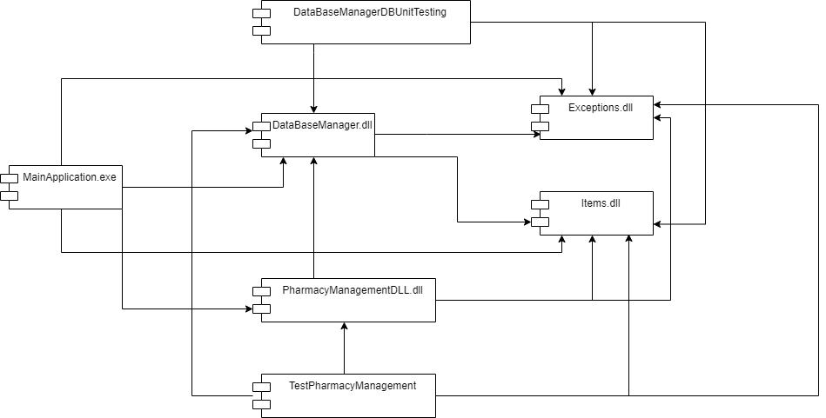
PharmApp is an academic project, realized to practice with programming engineering concepts. It is a self-contained project, implemented as a Windows Forms Application using C# programming language and .NET framework. The data required for this application is stored within two tables from a SQLite database.

In the figure above are presented the application components and their dependency relations. Each module has been implemented as a DLL (Dynamic Link Library) file.
ExceptionsDll module provide custom exceptions definitions;
ItemsDll module is used for providing structures and basic object used in context of application;
DatabaseDll is a module that handles the interaction between application and SQLite database;
PharmacyManagementDll module implements the protection proxy mechanism in accordance with established acces right rules.
For each functional module is developed an unit test module.
Application entry point is represented by MainApplication.exe.

Product Functions
The major functions the PharmApp must perform for the end user are the following:
- Authentication mechanism - entering username and password account;
- Possibility to manage application users – this function is specific only for admin instance;
- Possibility to handle with pharmacy products, in terms of sale, stock update , or just information queries – this functionality is open to all pharmacy employees except the admin.

User Classes and Characteristics
This application is designed to be easy to use. It intends to provide the necessary functionalities for three categories of users:
The first class of users is represented by pharmacy administrator : it is required to be a person with good organizational skills because it’s in his responsibility to manage database access.
Another class is represented by pharmacy assistant – this category must have knowledge of the types of drugs and therapeutic indications .
The third class of user is the pharmacist - an user with knowledge similar to assistants, but some new characteristics : attention to detail and a few years of experience in pharmaceutical field.

Operating Environment
Since PharmApp is developed using .NET Framework, it is compatible with only all version of Windows operating system starting with Windows XP Service Pack 3. Also, .NET Framework 4.7.2 or a newer version is required to be installed on the system.

Design and Implementation Constraints
Since PharmApp is being designed and implemented in a single semester as a project for Programming Engineering subject, it is possible that time is the most limiting factor in this development cycle. Another constraint is that application is supposed to have an authentication mechanism, to prevent unauthorized access, so we need a deep understanding of protection proxy pattern and databases knowledge, but also hash mechanism knowledge for securely storing sensitive data.

User Documentation
PharmApp contains a clear and explicit in-app help, accessible on Help Button Click. It provides the user guidance regarding the use of the application and the interpretation of the information meaning.

Assumptions and Dependencies
We are assuming that it will be a preconfigured admin account when launching the application. Otherwise, the application would be impossible to use .

External Interface Requirements

User Interfaces
The user interface will be separated into two main components : one window for authentication mechanism and another one for displaying buttons for each action that can be done in the context of managing a pharmacy.
When starting the application, a window with two text boxes will be displayed to enter account credentials : username and password. If the data entered does not correspond to an existing user, an error message will be displayed, and use of the application will be impossible until valid data is entered.
If we assume that valid data has been entered, then the second window will be displayed. This one contains the username of authenticated user in the upper left corner and a ‘logout’ button in the upper right corner. It also contains one button for each possible action. If there are some disabled buttons, this means that the logged user hasn’t access right for those actions. If the user access a button on whose action is included in his access rights, then a new smaller window will be displayed to allow them to insert the necessary data, in order to insert, update, delete or just query the information from database. If user tries to insert invalid data, they will be alerted by an error message displayed.
There is an explicit indicator inside user interface to open in-app help. It is displayed as ‘?’ button.

Hardware Interfaces
There is not much heavy hardware needed to run this application. Hardware interfaces include a display monitor, a mouse and a keyboard. The mouse is used to interact through left click to allow the user to interact with certain objects displayed on the monitor. The keyboard is used to introduce necessary data in specific text or number entry spaces.

Software Interfaces
To run this application the user’s system must runs any Windows operating system, starting with Windows XP Service Pack 3 and to have installed .NET Framework 4.7.2 or a newer version.

Communications Interfaces
No communication standard is required for this application. It is a standalone application, without dependencies on remote resources. It is also an offline application, so it’s not necessary a network connection.

System Features
This application features are covered in-depth in the user guideline.

Other Nonfunctional Requirements

Performance Requirements
This application is able to run on all version of Windows, starting with Windows XP Service Pack 3. It is recommended to have at least 512 MB RAM and at least 1 GHz CPU. No dedicated graphics card is needed.

Safety Requirements
Using this application does not present any safety risks.

Security Requirements
Since the authentication data is stored in a database, only the administrator will have access to this information. If an unauthorized person manages to access information about users' accounts, this could jeopardize the entire activity of the pharmacy. So it is recommended to update user’s password constantly and to set strong password each time .

Software Quality Attributes
PharmApp is thought to be a simple, fast, easy to use and useful tool that offers the possibility of a correct management of databases. This software must be robust and as bug-free as possible to ensure a good management of a pharmacy activity. This application is designed to be used for as long as possible. There are been chosen maintainability and reliability over portability.

Business Rules
It is the policy of the development team to follow all codes of conduct established by the University.

Other Requirements
Appendix A: Glossary
N/A
Appendix B: Analysis Models
All diagrams are available in the electronic documentation.

