Project summary

Here we propose an exploration of the Douglas-fir (Pseudotsuga menziesii) hologenome, by monitoring changes of expression in Douglas-fir and microbiome transcriptome to an environmental gradient and to an environmental change. To effectively monitor changes in RNA expression of the microbiome of Douglas-fir, we will design and employ a bioinformatics pipeline sensitive to the statistical constraints inherent in sampling a microbiome transcriptome.

Hypothesis: The metabolisms of plant host and microbiome are responsive to both environmental change and interact among themselves. These interactions in the context of environmental change can be antagonistic (disease and immune response), but also may be mutualistic/complementary.

The transcriptomes of host and microbiome represent one of the most tractable methods for observing interactions of host and microbiome with one another and with environmental change. To test these studies of the Douglas-fir microbiome transcriptome are proposed, one survey and one experiment:

1) Changes in host and microbiome gene expression with height and exposure in the canopy of old growth Douglas-fir forest.

6 trees will be climbed, from several locations in the HJ Andrews forest (andrewsforest.oregonstate.edu). Needles will be sampled every ten meters, as high into the canopy as can be safely climbed. This interval of sampling may vary with the results of our power analysis, see below. The entire leaf microbiome will be sampled including both endophytic and epiphytic microbes. As such, whole needles will be placed into 1.5 mL centrifuge tubes, then into a 1 liter dewars with liquid nitrogen attached to climbers. The smaller dewars will be lowered with drop line occasionally, to transfer needle samples into a 50L dewars at base of operations on the ground, and to refill liquid nitrogen reservoirs. RNA will be isolated, ribosomal RNA will be removed, cDNA libraries constructed and sequenced via illumina Hi-seq system. Bioinformatic pipelines are discussed below.

Predictions:

The combined transcriptome of Douglas-fir and its microbiome will show increased expression in antioxidant and pigmentation pathways, such as melanin¹ and anthocyanin production², with increasing height/exposure in the canopy and with increased exposure resulting from effects of deforestation.

We predict a mutualistic inverse relationship of microbiome vs. host antioxidant and pigementation pathways – i. e. if the microbiome seems to be producing a mutually useful metabolite, host expression for that product or similar products in the host tree may be allowed to remain at relatively lower rates. Host tree transcriptomes that contain microbial UV-, and drought/oxidative-stress related reads will show less upregulation of host production of antioxidants or pigments (anthocyanins and carotenoids).
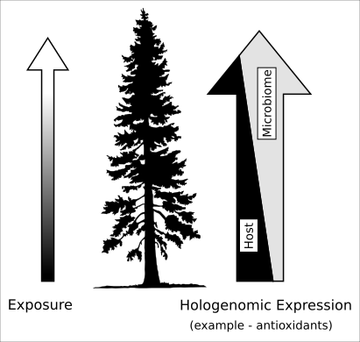
Figure 1 – we predict that in some metabolic pathways, microbiomes
may share some mutually useful products such as antioxidants with
host, and that the microbiome and host metabolisms can be complementary.
Environmental change may influence what products are shared. Here
antioxidant and UV-absorbent products such as pigments may be produced
by the microbiome with height in the canopy, reducing the need for the
host tree to produce non-chlorophyll pigments.

2) Changes in host and microbiome gene expression of newly exposed remnant or edge trees.

Presence of forest and stage of forest succession has been shown to affect fungal microbiome community assembly^{3,4}. We will investigate changes in host and microbiome RNA response to the increased exposure and isolation resulting from timber harvest. In cooperation with a private tree farm operation, we will sample microbiome leave trees from cutblocks (https://oregonforests.org/Harvest_Regulations). Trees marked to be left will be sampled before and following harvest events for two years. Both RNA and DNA will be isolated from leaf samples, to examine both changes in expression and shifts in microbial community composition. DNA will be purified from leaves, selectively PCR-amplified using fungal and bacterial(Kyle??!!)-specific primers , and prepped for sequencing with illumina MiSeq sequencer system. RNA related laboratory preparation of samples will be as above, and bioinformatic pipelines are explained below.

Predictions:

Using a classical insular (‘island’) biographical theoretical framework⁵ and following observations from Arnold et al.³ and Chaverri and Vilchez⁴, we predict a shift in species composition of the microbiome following isolation of trees. This shift will be temporal – in the first year following harvest, forest associated microbes will be lost, microbial load diversity will be generally reduced (fig 2d). In the second season following harvest, microbial species richness may rebound, but community composition will be fundamentally changed to longer-dispersing, cosmopolitan species.

We also predict upregulation of antioxidant pathways, and other pathways related to drought and UV stress tolerance, in both microbiome and host transcriptome, with the increased exposure from deforestation.

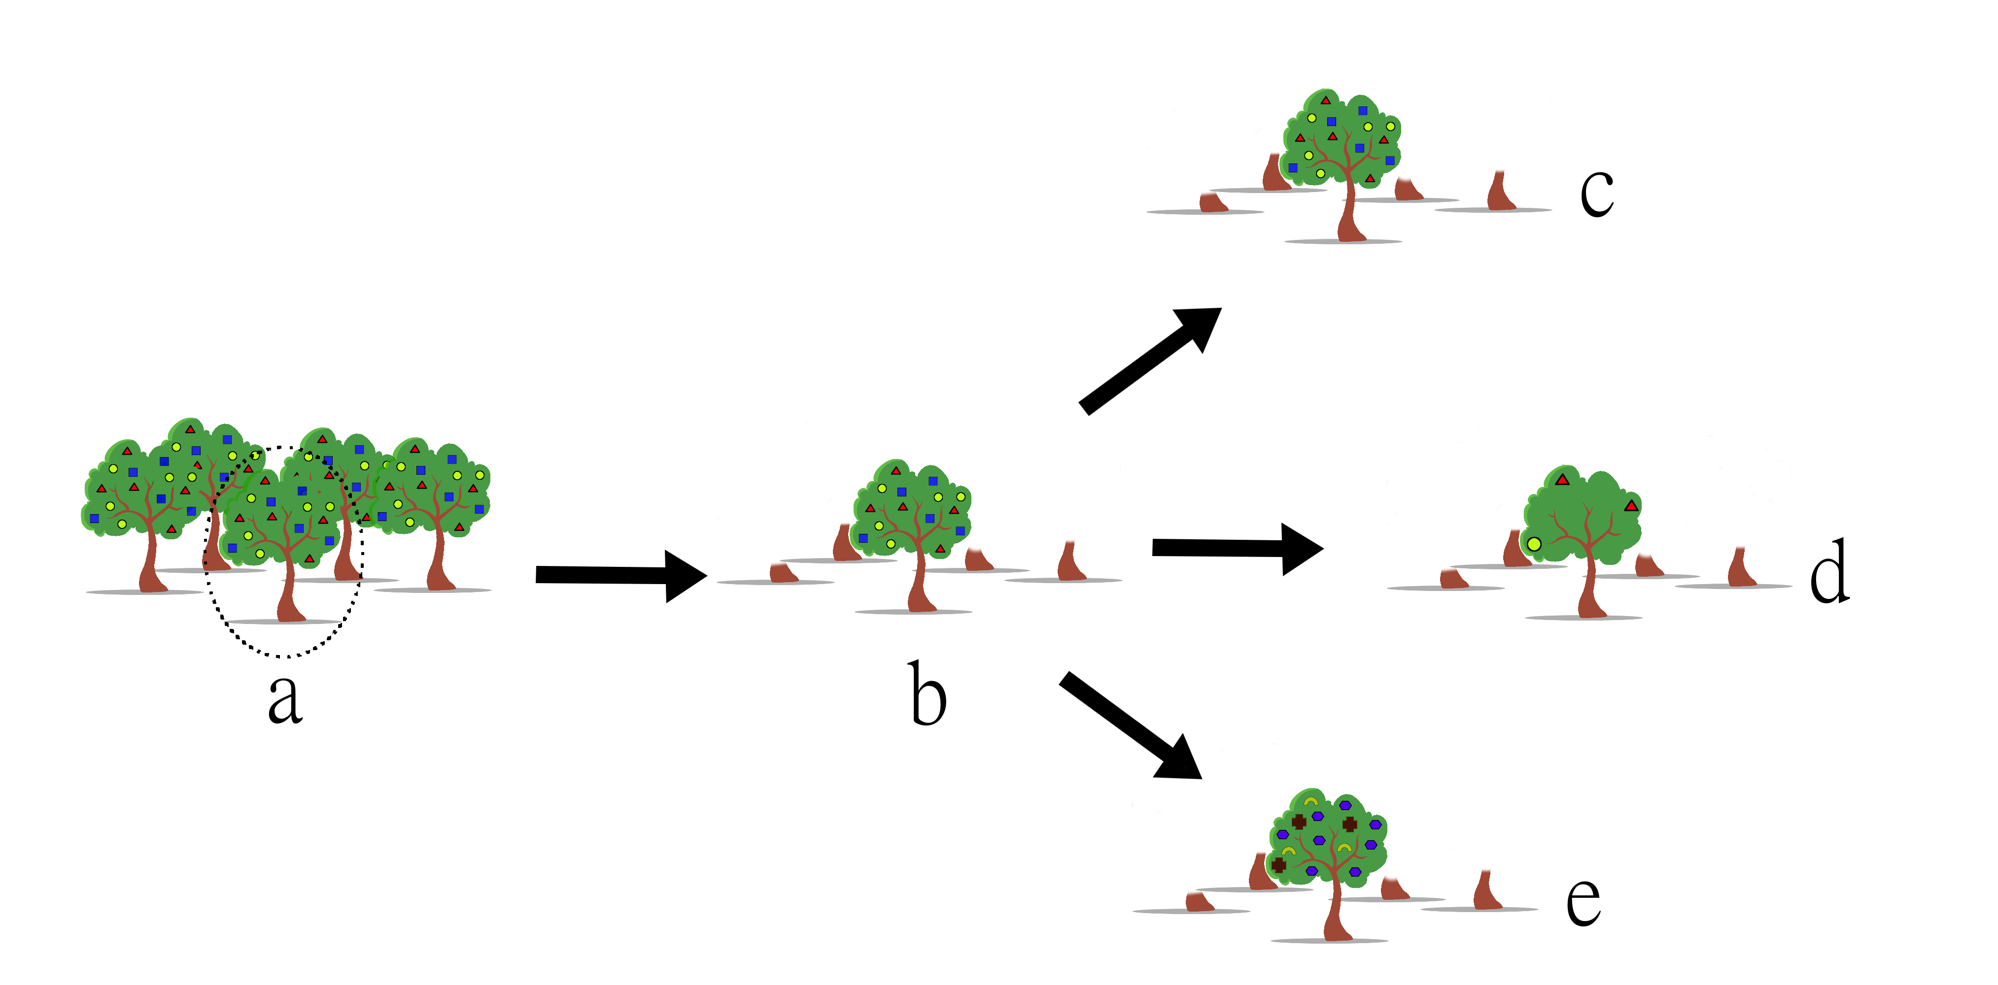
Figure 2 – We propose to sample the microbiome DNA and the transcriptome of Douglas-fir leave trees and their microbes. Sampling will occur prior (a) to the harvest (b), and for two years following. Possible outcomes include no change in microbial community composition (c), reduced diversity of microbes (d), or unchanged/increased species richness, but with a significant shift in microbiome community composition (e).

Bioinformatics:

RNAseq studies of large organisms very often leave 15-20% of total reads unaligned to the genome of the targeted organism. These reads are typically discarded, as RNA expression in the large organism is usually the focus of RNAseq studies. These discarded reads can originate from sequencer error and laboratory contamination, but many also originate from the transcriptome of the microbiome. Through careful curation of these “trash” read libraries, without minimum abundance cutoffs, we can draw an outline of metabolic activity in the microbiome.

In a first exploration of existing data, we aligned 11 transcriptome samples from a publicly available dataset⁶ to host P. menziesii genome⁷. For each of these samples, approximately 15% of reads are unalignable to the host. The average proportion of total reads per sample detected on first sweep was 0.4 %. This amounted to average of ~50,000 fungal reads per sample, with each sample containing an average of ~11,700,000 reads before alignment to host . If this rate applies to other sequencing events, in a single lane of illumina HiSeq 3000/4000 with 50bp per read, we may expect to see as many as 2,700,000 fungal reads. Prokaryotic reads were not examined but are of equal interest, and could be estimated similarly, provided RNAseq libraries were not created via poly-A selection methods.

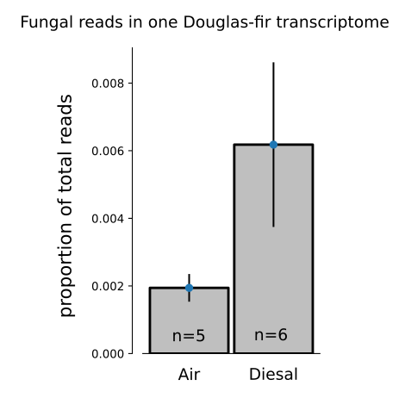

As an initial step, power analysis will be conducted. This will involve examining additional existing plant transcriptomes from public databases in the same manner as above to more confidently estimate expected ratio of microbiome reads. Following this, RNAseq power analysis will be conducted using
the RnaSeqSampleSize package in R⁸.

As a second step, we propose the development of a pipeline for more precise identification of origin (host, fungal, prokaryotic, other eukaryotic) of a read and assignment of possible function. The smaller number of microbiome reads allows more computational resources and time to be allocated to each read. Following de novo assembly of reads, a naive bayesian classifier⁹ will be trained on SNP calls and other small polymorphisms from aligned homologous reads from genomic databases (JGI mycocosm, NCBI Microbial Genomes. EnsemblBacteria, etc) for origin, and gene function from public databases of genes such as NCBI’s Genbank database. SNPs discovered among homologous genes from these used as multinomial-type features to train the classifier algorithm.

After removal of host reads and sorting by function and origin, distance-based ordinations can then be used to visualize (dis)similarity of samples, from both a taxonomic and functional standpoint. PERMANOVA or other dissimilarity pseudo-linear models will be used to statistically test dissimilarity of samples by height or pre/post isolation treatment.
