Management Plan

Organizational chart

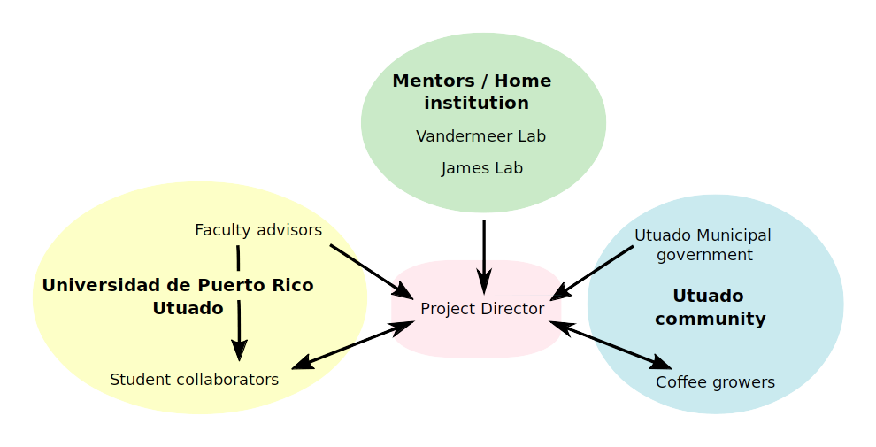

Stakeholders fall into three categories: (1) Collaborators at home institution, the University of Michigan (UM), (2) collaborators at the Universidad de Puerto Rico Utuado (UPRU), and (3) the community of Utuado. Unidirectional arrows indicate an advisory position or a governing position, or both. Bi-directional arrows indicate non-hierarchical relationships between closely collaborating parties.

Advisory panel
An advisory panel will be assembled from the advisory and governing stakeholders: Tim James and John Vandermeer, along with collaborating faculty at UPRU who will supervise undergraduate researchers on the culture collection effort. Additionally, coffee growers from all plots or other interested coffee growers of Utuado will be welcomed as members of the advisory board. These members will contribute their respective expertise both to creating and assessing the success of these benchmarks.

Administrative timeline, with stakeholders who will contribute and assess results:

Fall, 2020:
- Select sample sites remotely and contact growers (coffee growers, Vandermeer lab). Begin soliciting permits, if required (Utuado Municipal government)
- Visit 1 to sites:
- confirm interest and cooperation of growers/landowners for sample sites (coffee growers)
- Commit grower for arabica seedlings (coffee growers and associated plant nurseries)

Winter 2020/2021:
- Develop and test species-specific primers for direct PCR assays for Lecanicillium lecanii (James lab)
- Begin trials and power analysis of metatranscriptome methods (James lab)
- Visit 2 to sites
- Sanitize seedlings and place seedlings at sample locations (coffee growers)
- Identify undergraduate collaborators in preparation for creation and curation of culture libraries at each sample site (UPRU)

Spring 2021:
- Visit 3:
- Undertake sampling at sites (coffee growers)
- Initiate culture libraries with in-country collaborators (UPRU)
- Stabilize samples for RNAseq libraries and submit for sequencing (James lab)
- If export permits allow, return to Michigan with remaining leaf tissue, stabilized
- Prepare multiplexed ITS-only illumina-tagged ITS libraries and submit for sequencing (James lab)
- Direct PCR screens for L. lecanii and H. vastatrix (James lab)

Summer 2021
- Begin ITS barcoding and archiving of culture library (UPRU)
- Begin analysis of ITS and RNAseq data and point patterns of L. lecanii and H. vastatrix. (Vandermeer lab)

Fall-Summer 2021
- Continue analysis
- Begin writing of manuscripts (UM and UPRU collaborators) We expect three manuscript products:
- Methods report on sampling host transcriptomes
- Ecological summary of patterns observed in (meta)transcriptomic, fungal community ITS, and direct PCR data
- Final report on culture library, including possible candidates for antagonism to rust

Strategy to enhance coordination, collaboration, communication, and data sharing and reporting among members of the project team and stakeholder groups:

Difficulties in communication can emerge from geographic, cultural, and economic differences among stakeholders. The PD will address this directly, by maintaining monthly meeting schedules with all stakeholders, in small groups, and by making at least three scheduled visit to sites and the surrounding community, to meeting personally with academic and coffee grower partners.

Co-authorship on manuscripts will include all collaborators who make a significant contribution to the research, taking into consideration that skill sets and official academic standings will vary quite a bit among partners.

A good faith effort at skill sharing in all aspects of the project be made, including bioinformatics. The PD will commit to helping any interested stakeholder to understand the tools and results of this project. Particular efforts will be made to (1) make scientific results meaningful and useful to growers, and (2) train interested collaborators, faculty or student, at Utuado in all computational tools and methods.

All code, read libraries, and bioinformatics tools will be open-source, maintained and archived on a public repository, with the minimum embargo time needed for publication (see data management plan). All fungal cultural strains of interest will be deposited in the Agricultural Research Service (ARS) Culture Collection (nrrl.ncaur.usda.gov). No attempts to patent strains or otherwise privately bioprospect from cultures will be pursued by the PD or associated researchers. This will insure that all collaborators and stakeholders, and the public, will have equal access to the results of this research.

How the project will be sustained beyond termination of an award

The results of this project are intended to be immediately meaningful to coffee growers, and will stand alone as a contribution to coffee agriculture. However, several fruitful further directions of research could lead from this project.

Complete, meaningful screening of candidate protective fungi discovered in this process requires in silico, in vitro, in vivo and ecological experiments. Following this study, the future work that will remain therefore are in vitro (Tanney, McMullin, Green, Miller, & Seifert, 2016; Tanney, McMullin, & Miller, 2018) and in vivo (Arnold et al., 2003) tests for mutualisms.

Additionally, we here treat forests as black boxes of ecological complexity. However, as antagonists to the rust are uncovered in the proposed project, investigation should be made an deeper understanding of the exact ecological mechanisms that allow organisms from forests to act as biocontrols for the coffee leaf rust, as Vandermeer, Perfecto, James and colleagues have done with the white halo fungus.

Finally, if the novel bioinformatic method tested here for sampling plant microbiomes proves successful, this method of “scavenging” the microbiome from plants transcriptomes will need further development, including software development to make the method more available for other researchers.

In all of the above directons, given sufficient interest by growers and researchers, further grant funding will be sought to continue further work.

