Intro:

Coffee is among the most traded commodities in the world (____). It is an important contributor to the economies of more than ____ countries. Its production affects the livelihoods of thousands (millions) of people (____).

The largest threat to the economy of coffee is the fungal disease known as the coffee rust (Hemileia vastatrix) (____). This disease attacks the the leaves of coffee trees, causing lesions at infection sites and eventually extensive leaf loss (for a good summary, see .

The causes for this outbreak were complex: social (______), economic (______), ecological (______) and climatological (_____) factors are all thought to have played a part. Accordingly, there is no single, simple remedy for outbreaks of the coffee rust, and there is no guarantee that the outbreaks of the first part of this decade were isolated or unusual events. Indeed, climate change is expected to exacerbate some of the conditions that promote the coffee rust (__________). Economic conditions that have helped to give rise to the epidemic (_______) have not changed appreciably in the last several years. Thus there is reason to believe that more epidemics of the coffee rust in the western hemisphere may occur.

The coffee rust disease was not known in Latin America unti 1970 (_____). Even after being first observed, the disease did not emerge as a major pathogen in the region, and was thought even to be under control (_____). The coffee rust surged suddenly to epidemic levels in various areas of latin America in the years 2008-2015. Traditional understanding is that strict quarantine procedures kept the Americas free from coffee rust until the first infected coffee trees were reported in 1970 (______). Whether or not quarantine efforts totally explain the early invisibility of the coffee rust in the Americas, there was a 20-30 year delay between first observation of the rust and the emergence of large coffee rust epidemics. Thus it is important to ask, why did coffee rust delay so long in reaching epidemic levels in Latin America while the disease prospered in other regions of the world?

Forest fungi and the coffee rust

Chemical fungicides are effective for preventing coffee rust, but come with environmental and economic cost (_______). Additionally, correct timing of fungicide applications is critical for fungicides to be effective (______). Hybridization programs have also produced rust-resistant varieties of coffee, most commonly the result of hybridization of C. arabica with C. canephora (________). However, the coffee rust has repeatedly demonstrated the ability to evolve to overcome resistence in resistant coffee varieties and species (McCook 2014, both cited in Vandermeer red queen). Unfortunately, hybrids consistently have a lower cupping quality (______). The long term problems presented by chemical controls and breeding programs has led some to consider biocontrols as a method for mitigating the coffee rust and other pests (_______).

One fungus that has shown to be particularly promising biocontrol for the coffee rust disease is Lecanicillium lecanii ( ______ )*, or white halo fungus. It is one of few biocontrol fungi observed to directly attack and digest plant pathogen tissues (_electron micro paper_, Ownley 2009__). Adding to this promise is L. lecanii’s ability to naturally colonize several important crops as an endophyte (____), or a symptom-less member its host plant microbiome (___Wilson 1995____). This ability implies that it may be possible to introduce the fungus into the tissue of crops like coffee, and operate in perpetuity as a protective partner to its host plant (___Vega 2008__).

*L. lecanii is also known as Verticillium lecanii, Akanthomyces lecanii, and Cordyceps or Torrubiella confragosa (teleomorph) (__Sung 2015, Kepler 2017_____).

However, fungal biocontrols have yet to become a useful tool for control of the coffee rust. No consensus exists on how to apply protective fungi to plants such that they reliably establish in their host plants as endophytes and biocontrols (__Vidal 2015, ____). L. lecanii, is one example of this: despite its large potential as a biocontrol agent, it also has yet to emerge as a simple and practical product to counter the effects of the coffee rust (_____). For several years, in the region of the here-proposed-project, coffee farmers have experimented with applications spore-and-mycelium slurries of locally-sourced strains of L. lecanii widely on coffee trees, ultimately with little or no apparent reduction in the severity of the coffee rust. This is in accordance with the general under-performance of fungal biocontrols for plant pathogens (______).

John Vandermeer, Ivette Perfecto, and collaborators have intensively examined the ecological relationships involving the coffee on farms in Chiapas, Mexico and in Puerto Rico (________). They’ve documented an extensive network of interactions among the coffee rust, Azteca ants, coffee scale insects, and hyperparasitism of the coffee rust by the white halo fungus. When all of the myriad of ecological players they have examined are present, the ecological network appears allow the white halo fungus reach high-enough population density to act as a control on the population of the coffee rust.

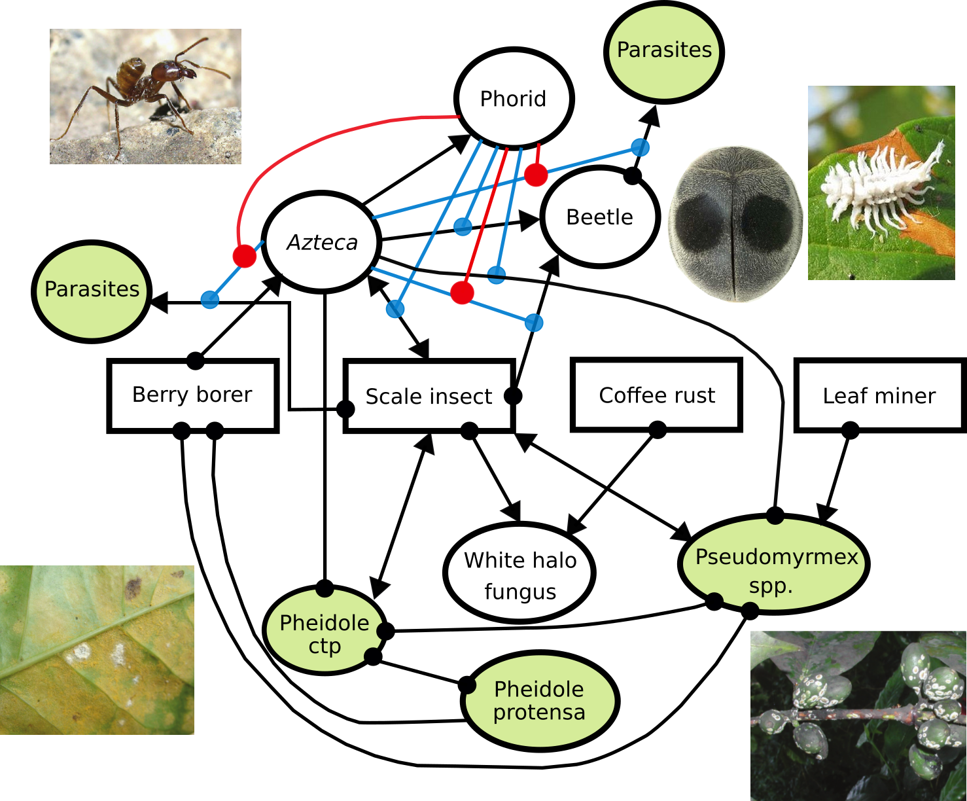

In any given location where L. lecanii seems to be active in controlling the coffee rust, any of the ecological players noted by Vandermeer and Perfecto might be naturally absent. Regardless of the species present at each site, the work by Vandermeer, Perfecto, and colleagues supports the general idea that sufficient ecological complexity must be present for the success of some services, such as the control of the coffee rust by the white halo fungus (____vandermeer book___).

The underperformance by biocontrol agents discussed above may therefore be more fundamental than a problem of proper application techniques. Artificially introduced biocontrol organisms face with the vast, diverse array of resident microbes that are already present in plant microbiomes at the time of application (____), This existing microbiome apparently typically only allows spotty, often-temporary, highly-local infection of the host by new fungi (__Vega something, endophyte papers showing local infection in Vega review__), limiting the utility of the biocontrol fungus for the plant. Additionally, protection afforded by fungi to their plant hosts is often specific

This is a deep critique of microbe-based biocontrols. The studies reviewed above suggest that biocontrols will fail as a tool for farmers, as long as we underestimate the complexity of the microbiomes and the ecosystems of our food plants. If microbial biocontrol species require the kind of complexity that Perfecto and Vandermeer have described to sustain them, the current efforts to put a few famous species of fungi in blenders and spray them on leaves of our food seems sadly misled.

This body of research suggests that perhaps only continual exposure by plant throughout its lifetime to a diversity of fungi and numerous other organisms may produce the kind of results that one would hope for with microbial biocontrols. This level of exposure and diversity may only be economically possible for farmers when wild ecosystems such as forests are present nearby and are able to export these microbes as an ecosystem service. This proximity to forests may be necessary because farms are simplified ecosystems (_____) and may not contain sufficient ecological complexity themselves to maintain conditions necessary for microbes of interest. Thus, forests may be sources of benefical, otherwise-unavailable microbes to surrounding simplified ecosystems, such as farms.

This process of benefits from “biodiversity export” by forests has been shown in other organisms: forest-dwelling pollinators visit nearby coffee farms in Costa Rica (_____), resulting in an ecosystem service valued at thousands of dollars annually. Regeneration of plant species diversity secondary forest is enhanced by proximity to older forest (__chazdon 2003 __), probably due to seed dispersal.

Data from microbial ecology research is scant but promising: sterile plants placed under forest canopy are apparently exposed to more fungal spores and were observed to establish their fungal microbiomes more quickly than those placed in clearings ( __Arnold 2003__), and forest soils in tropical regions may contain higher a diversity of microorganisms in their soils than in pasture soils (__Bohannan___). Chaverri et al. ( _________) found older forests harbored more fungal species of the family of the white halo fungus, Cordycipitaceae, and closely related Clavicipitaceae. They also observed that within their study area, second-growth forest located adjacent to primary forest showed higher fungal diversity than secondary forest located away from primary forest. Peay et al. found that large, “mainland” forest patches act as sources of mycorrhizal fungal diversity to surrounding forest fragments, and that this ecosystem service decreased with distance (_Peay papers_2010Ecology and 2012MolEco _).

Forests may become especially important with increasing climate volatility and warming, pathogen loads on food crops are expected to increase (___________). Deforestation rates in the tropics have continued at alarming rates, and

Early British coffee plantations of South Asia where the rust first wreaked havoc, heavy deforestation occurred and large monocultures of coffee plants were established (_________). Following our hypothesis, this grand ecological simplification of Sri Lanka and elsewhere may have contributed to the meteoric rise of the coffee rust in this region. We can speculate farther, by applying this model of biocontrol to coffee in Latin America: antagonism to the coffee rust by L. lecanii or other hyperparasitic fungi may have been an important factor in explaining why large coffee rust epidemics did not occur immediately in the Americas. Historically abundant forests in many coffee-growing regions may have supplied the ecosystem service of fungal biocontrol, and as forests are cleared this service may be disappearing.

We hypothesize that forests in coffee-producing regions are reservoirs of beneficial microorganisms that disperse to surrounding landscapes, providing a the valuable ecosystem service to food crops. We propose here to test this result in a landscape matrix of forest and small-scale coffee farms (___figs__).

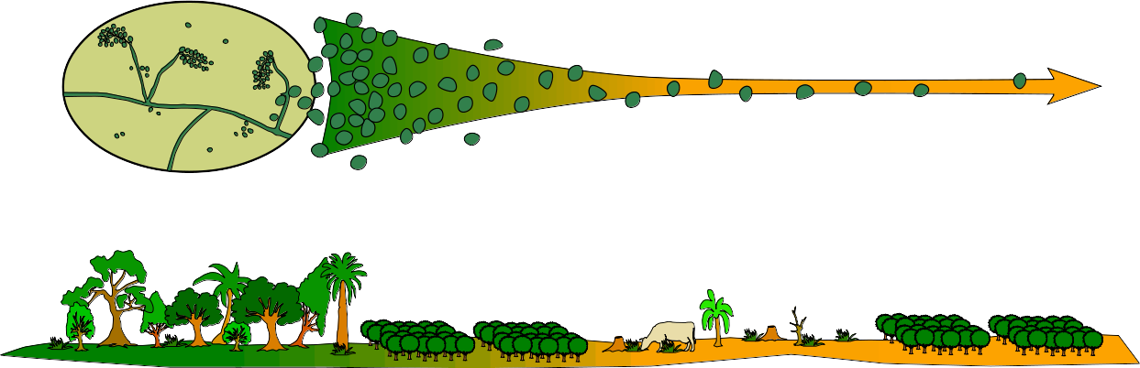

Goals:

1) Determine the importance of proximity of forests to the health and productivity of coffee farms in areas at risk of coffee rust epidemic.

2) Uncover new beneficial microorganisms for the cultivation of coffee, and explore their spatial patterns.

3) Work with local communities, government, conservationists and coffee-growers in a mutually beneficial relationship for all involved.

Methodology:

This project will consist of a field phase and a laboratory phase. The field phase will planned and coordinated in cooperation with the agronomists of the Cotacachi canton government, the members of a coffee grower coop (www.aacri.com), and independent coffee-growers in the area. The lab phase of the project will require access to a laboratory space where fungal cultures can be grown, and cultures and plant samples can be prepared for sequencing. This will be available through our collaboration with Universidad Técnica del Norte (UTN) in Ibarra. Additionally, if community partners are found in the more eastern areas of Cotacachi canton, a facility will be used to stabilize and store samples prior to transportation to Ibarra. Such facilities are available in Apuela, where coffee growers maintain warehouse and basic laboratory spaces.

Field methods:

The landscape of Cotacachi province is a matrix of forest, small-scale farms, and pasture. The farms are often single-family farms or fincas, with multiple types of crops in production, but very often with coffee trees. In the Cotacachi province organic farming of high-quality arabica coffees is common.

We will sample three, approximately 1 km x 1 km areas (__ fig ___). These areas will be selected on the basis of: (1) density of coffee farms, (2) landholder interest in this project, and (3) adjacency of plot to a large forest area on one side. Plots will be sampled according to a grid of points spaced every 100m.

The mycobiome of the closest non-resistant coffee tree to each of the points will be examined. Two leaves and some 1rst and 2nd year stem tissue from each tree will be collected for endophyte/epiphyte culture (see laboratory methods below). The same amount of each will also be collected for direct, culture-free DNA sequencing. 200 grams of soil will be collected, enough for both fungal culture and direct DNA sequencing. If the coffee rust is present on the plant, infection severity will be noted (__Avelino 2005__), as well as proportion of rust lesions parasitized by L. lecanii. For points lying inside of forests and forest fragments

In addition to mature coffee plants, seedlings of sufficient size will be sourced and used as “bait” plants. These seedlings will be placed regularly at a subset of sampling sites. Leaves from these seedlings with be removed, such that the second flush of the defoliated seedlings will occur in situ, These new leaves from seedlings will be sampled for endophytic fungi in the same manner as with leaves from mature trees.

Finally, rainwater spore traps will be positioned in a subset of , in the form of funnels into sterilized 4-liter jugs with fungal growth inhibitors and DNase inhibitors (___Peay 2012__). The water in these spore traps will collected, filtered to removed large debris, and centrifuged repeatedly to entrap spores as a pellet. Spores will then be preserved in DNA-stabilizing buffers and processed as with leaf tissue and soil samples.

Both seedlings and spore trap protocols represent a significantly additional amount of labor. As large a subset of spore and seedling sample sites as can reasonably managed will be installed, but this number will depend on the level of interest by coffee-grower collaborators. As a first goal, we will attempt to sample 25% of all sample sites for spore deposition and with seedlings.

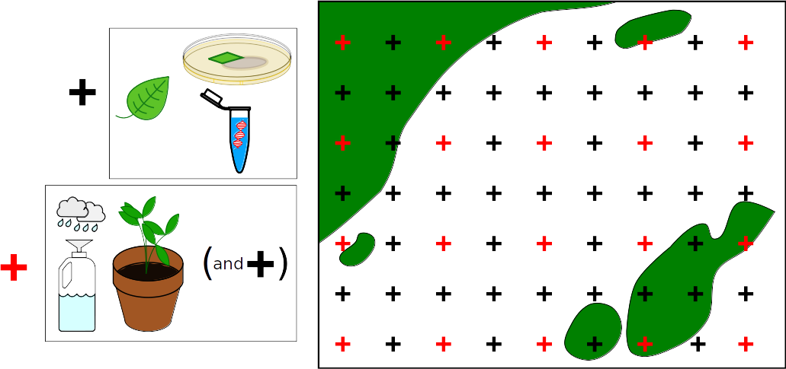

Lab methods:

Direct PCR – Leaf, wood, soil, and spore-trap samples will be processed for DNA extraction and sequencing. ITS region illumina metabarcoding of leaves and woody tissue (__Thomas 2019__), and soil (________) will provide an overall picture of fungal microbiomes. However, metabarcoding can be an inexact tool when searching for particular microbial species among the entire microbiome. As such L. lecanii and H. vastatrix species specific primers in ITS region will be designed and used to specifically confirm the presence of these fungi in plants, even if symptoms are not otherwise present. Primers will be designed for the ITS region, using existing sequence data available in public databases.

Culture library – Endophytic fungi from leaves will be processed (__Thomas 2014___) and cultivated on 2% MEA. Sporulating fungi will be grouped into morphospecies, and given preliminary IDs by morphology. Any specimens of interest will be grown in liquid media for DNA purification and sequencing, and identified using full ITS sequences. Researcher collaborators at UTN will be sought to aid with this aspect of the project, to be trained in cultivation of fungi and extraction of DNA from fungal cultures.

Neither cultures nor genomic DNA shall be exported outside of Ecuador. ITS-region-only-DNA will be sent to the nearest appropriate sequencing facilities, which is reported to be in Brasil. ITS is non-coding region of the fungal genome that is used as a barcode for identifying fungal species. It is not useful in any way for bioprospecting. All fungal strains found to be of interest will given over to a public culture collection, to be maintained as Ecuadorian public intellectual property.

Statistical analysis

Visually scored, incidence (presence/absence) data of the coffee rust and L. lecanii will be recorded and analysed as point-pattern data (_______), as will detection of these two species by species-specific primers. These spatial incidence data will be fitted to point pattern models (__Baddeley 2015__), and tested for trends of decay with distance from forest edges. Confounding variables, including elevation, coffee variety and agricultural methods, will be included in models as covariates.

Spatial analyses of entire fungal communities from illumina sequence data, rather than single species, will be examined with multivariate spatial statistical methods. Variation in our fungal community matrix will be analyzed with a comparison of redundancy analyses of spatial and environmental variables, also known as variation partitioning (__Borcard 1992___). Community dissimilarity will also be compared directly to samples of seedlings placed

Hypothesis:
Coffee plants that are close to forest edges host mycobiomes will be exposed to a greater variety of beneficial microbes, including microbes that antagonize the coffee rust.

Predictions:
1 - Coffee rust severity will decrease with proximity to forest.

2 - The entire fungal communities of coffee plants will more closely resemble forest plants than coffee plants located farther away from forests.

3 - Incidence and symptoms of Lecanocillium will increase in frequency with proximity to forest, especially older and larger forest areas, in the air (spore traps), soil, and microbiome of plants (as endophytes of leaves).

4 - Parasitism of rust lesions by L. lecanii will decrease with distance from forest.

5 - Rust spores in the air column and in soil will not vary with distance from forest.

Budget and timeline:

This is to be filled out in more detail…at the moment, costs include:

- Transport for myself to and from Ecuador (+ other North American or European collaborators?).
- Salaries for helpers and to compensate coffee growers.

Field:
- Transport around country
- Housing in Apuela and Ibarra
- Spore traps with DNA stabilizers
- Daily transport to sites
- Random field equipment (coolers, ice, plastic bags, etc)

Lab:
- 1 lane illumina sequencing
- Illumina preparation at a core facility
- DNA extraction materials
- PCR reagents and expendables
- Culture – plates and media

I estimate about US$25,000 and two years. Field portion will be several months, with significant lead up to this needed to build contacts and talk to coffee growers.

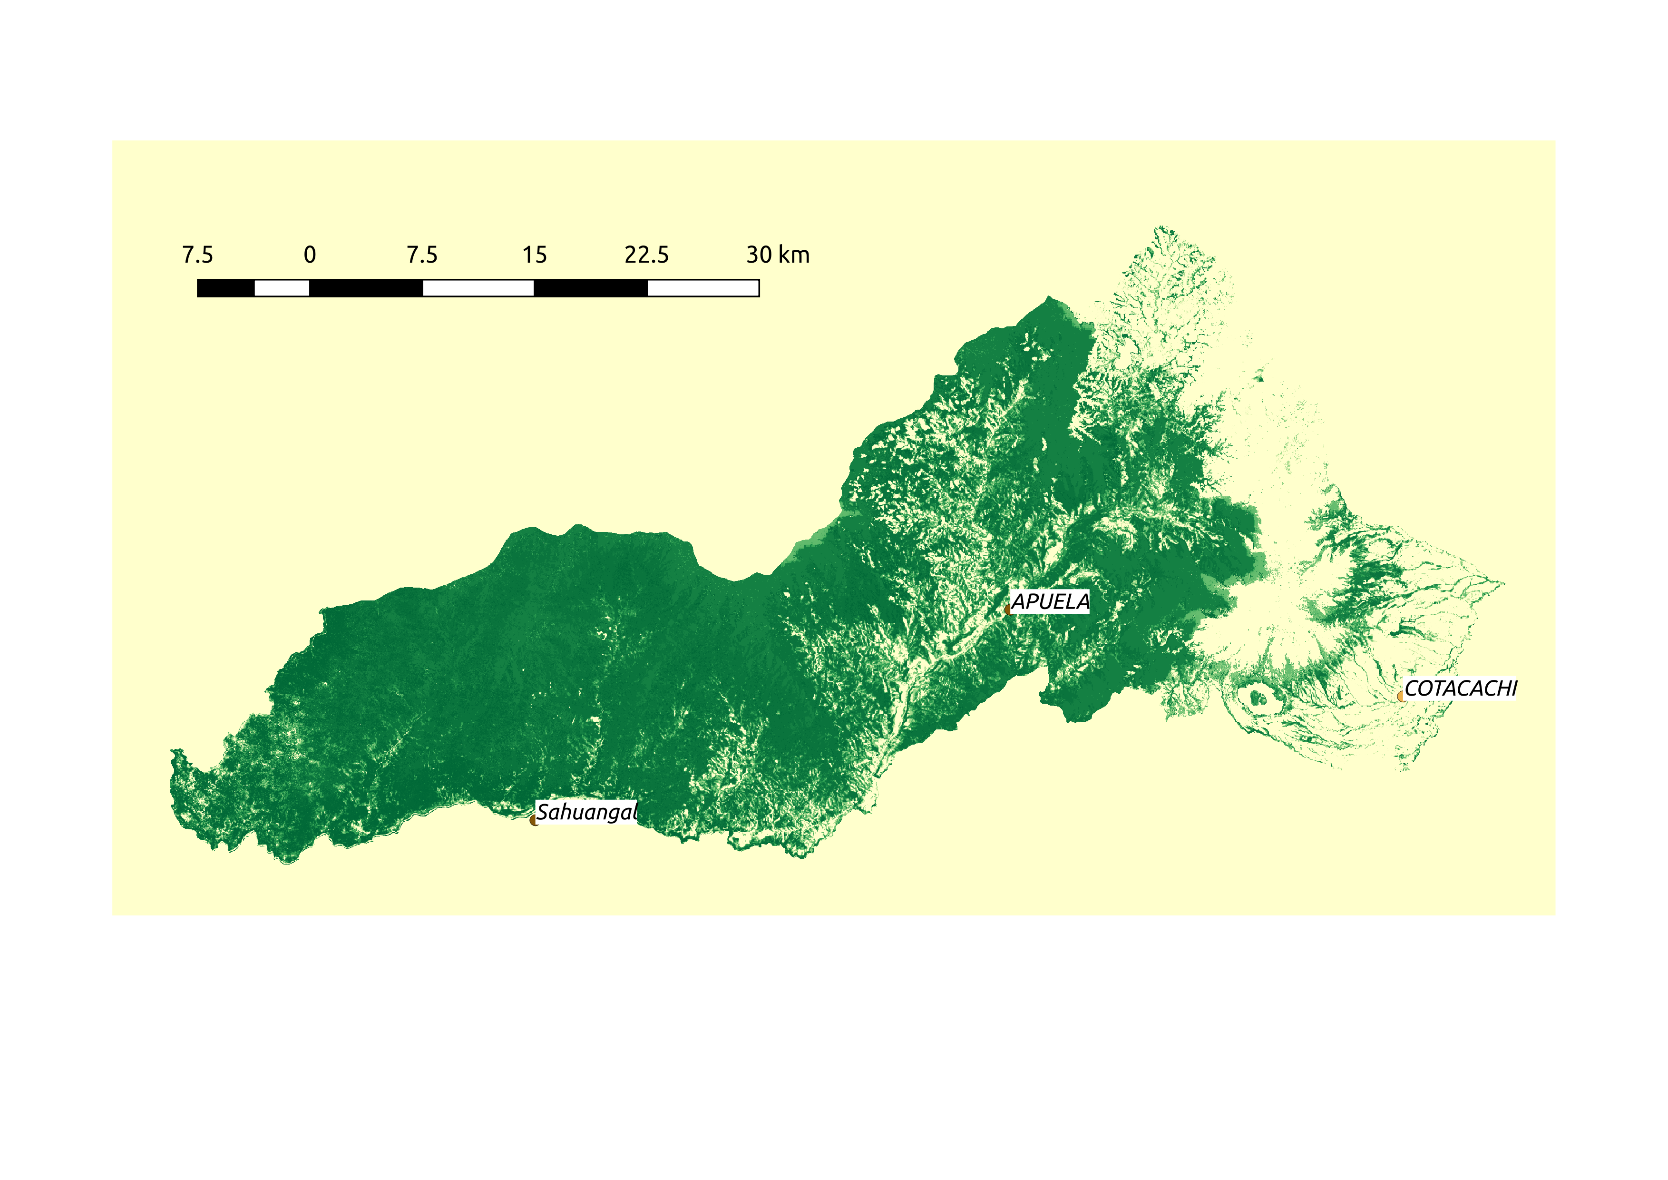
Site – Cotacachi canton, Imbabura province.

