# Introduction:

Coffee is among the most traded agricultural commodities in the world: in 2018 an estimated ten *billion* kilograms of coffee were produced1, and a nearly equal amount consumed2. Its agricultural production is an integral component of the livelihoods of millions of coffee growers and associated workers and their families3.

The largest threat to the economy of coffee is the fungal disease known as the coffee leaf rust (*Hemileia vastatrix*)4. This disease attacks the the leaves of coffee trees, causing lesions at infection sites and eventually extensive leaf loss. Leaf loss eventually results in dead or debilitated trees that offer drastically reduced yields. The first instances of uncontrolled coffee rust disease were observed in Latin America in 19705, but the disease did not cause catastrophic damage until several decades later, in a series of epidemics in the years 2008-2013 throughout Central and South America6. These epidemics resulted in millions in dollars of losses in populations of workers and growers already living in precarious conditions7.

The causes for the disastrous outbreaks were complex: social, economic, ecological, and climate conditions are all thought to have played a part6–9. Accordingly, there is no single, simple remedy known for controlling outbreaks of the coffee rust, and there is no guarantee that the outbreaks of the first part of this decade were isolated or unusual events. Indeed, climate change is expected to exacerbate some of the conditions that promote the coffee rust6,10. Economic conditions that have helped to give rise to the epidemic have not changed appreciably in the last several years3. Thus there is reason to believe that more epidemics of the coffee rust in the western hemisphere may occur.

Even after being first observed, the disease did not emerge as a major pathogen in the Americas, and was thought even to be under control7. This is in contrast to nearly every other coffee growing region of the world outside of eastern Africa. In these other regions, when regions of arabica production were exposed to the coffee rust, the rust typically rapidly laid waste to Arabica coffee plantations. Traditional understanding is that strict quarantine procedures kept the Americas free from coffee rustuntil the first infected coffee trees were reported in Brazil in 19705. The coffee rust did finally and suddenly surge to epidemic levels, after a 20-30 year delay from first observation of the rust. This can be compared to other regions such as Sri Lanka, the Philippines, and elsewhere where the rust rose from obscurity to epidemic in just years after first observations5. Why did the coffee rust delay so long in reaching epidemic levels in Latin America long after the disease so quickly devastated other regions of the world?

### Human efforts to control the rust

Traditionally, the answer given to this question is that a combination of efforts by growers to control the rust with chemical fungicides, quarantines, and resistant varieties of coffee, in combination with lucky climatic conditions and topography slowed the rust until now7,9. We argue that this answer leaves out the role of forests in the controlling the rust and that massive forest fragmentation and deforestation may be contributing to the epidemics of coffee rust recently experienced in Latin America.

Chemical fungicides are effective for preventing coffee rust, but come with environmental and economic cost7,9 and so were not fully employed to their potential in the Americas for combating the rust. Best practices for fungicide applications are highly specific to local conditions4,9, and therefore require local research to develop these best practices. The precise application requirements of fungicides and their relatively high cost was a historical handicap to the effectiveness of pesticides against the rust, particularly in times of low prices and low government support7.

Breeding programs represented the other major tool available to coffee growers. Such programs have produced rust-resistant varieties of coffee, most commonly the result of hybridization of *C. arabica* with *C. canephora*8. However, the coffee rust has repeatedly evolved to overcome resistance genes in coffee varieties4,11. Arabica-robusta hybrids are also frequently assumed to have lower cupping quality than arabica coffees (but see 12), thus fetching a lower price for growers13, and lending to the appeal of retaining pure arabica varieties despite the threat of the rust. In addition, there are costs for new seed and time/harvest lost while converting farms over to hybrid plants. For these reasons, Latin America has been slow to completely abandon traditional arabica varieties that are susceptible to rust infection. All coffee varieties in cultivation in the Americas at the time of the first observation of the rust were found to be susceptible4,14. Subsequent conversion to resistant coffee varieties was uneven and did not even occur in regions where it was not thought necessary or growers were unable to afford the cost5. Many regions continued to grow non-resistant varieties of arabica coffee until the recent arrival of the coffee leaf rust, changing only when disaster finally struck7,15, and many areas apparently continue still to use non-resistant varieties of coffee, including some growers in the Cotacachi canton of Ecuador, the area proposed for this study.

Climate and topography may explain some of the delay in the expansion of the rust: cool highland regions which abound in the tropical andean regions are traditionally assumed to be safer from coffee leaf rust. Closer examination of the effects of elevation on the coffee rust reveals that the relationship between climate and rust severity is not so simple, but instead quite complex and highly localized.9

The use of chemical controls and breeding programs against the coffee leaf rust in Latin America were limited by practical constraints, and the effects of climate on the rust are varied and complex. As such there is reason to doubt that these factors alone explains the lag in the coffee rust epidemics.

### The future, and clues to the past.

The long term potential limitations of chemical controls and breeding programs mentioned above has led some to consider biocontrols as an additional method for mitigating the coffee rust and other pests. An inquiry into biocontrols of the rust also leads to some hypotheses about the slowness of the coffee rust to reach epidemic levels in the Americas.

Numerous microbial antagonists to the coffee leaf rust have been observed8,16,17. One fungus that has shown to be particularly promising biocontrol for the coffee rust disease is *Lecanicillium lecanii*18, or white halo fungus*. It is one of few biocontrol fungi observed to directly attack and digest plant pathogen tissues19,20. Adding to this promise is *L. lecanii*’s ability to naturally colonize several important crops as an endophyte20–22, or a symptom-free member its host plant microbiome23. This ability implies that it may be possible to introduce the fungus into the tissue of crops like coffee, and operate in perpetuity as a protective partner to its host plant24.

*L. lecanii is also known as *Verticillium lecanii*, *Akanthomyces lecanii*, and *Cordyceps* or *Torrubiella confragosa* (teleomorph)25,26.

However, fungal biocontrols have yet to become a useful tool for control of the coffee rust. This is representative of the general under-performance of biocontrols against leaf pathogens27,28. No consensus exists on how to apply protective fungi to plants such that they reliably establish in their host plants as endophytes and biocontrols29. *L. lecanii*, is one example of this: despite its promise as a biocontrol agent, it also has yet to emerge as a simple and practical product to counter the effects of the coffee rust. For several years, in the region of the here-proposed-project, coffee farmers have experimented with applications spore-and-mycelium slurries of locally-sourced strains of L. lecanii widely on coffee trees, ultimately with little or no apparent reduction in the severity of the coffee rust.

John Vandermeer, Ivette Perfecto, and collaborators have intensively examined the ecological relationships involving the white halo fungus and the coffee leaf rust on farms in Mexico and in Puerto Rico8,30–32. They’ve documented an extensive network of interactions among the coffee rust, *Azteca* ants, coffee scale insects, and hyperparasitism of the coffee rust by the white halo fungus*.* When all of the myriad of ecological players they have examined are present, the ecological network appears allow the white halo fungus reach high-enough population density to act as a control on the population of the coffee rust.

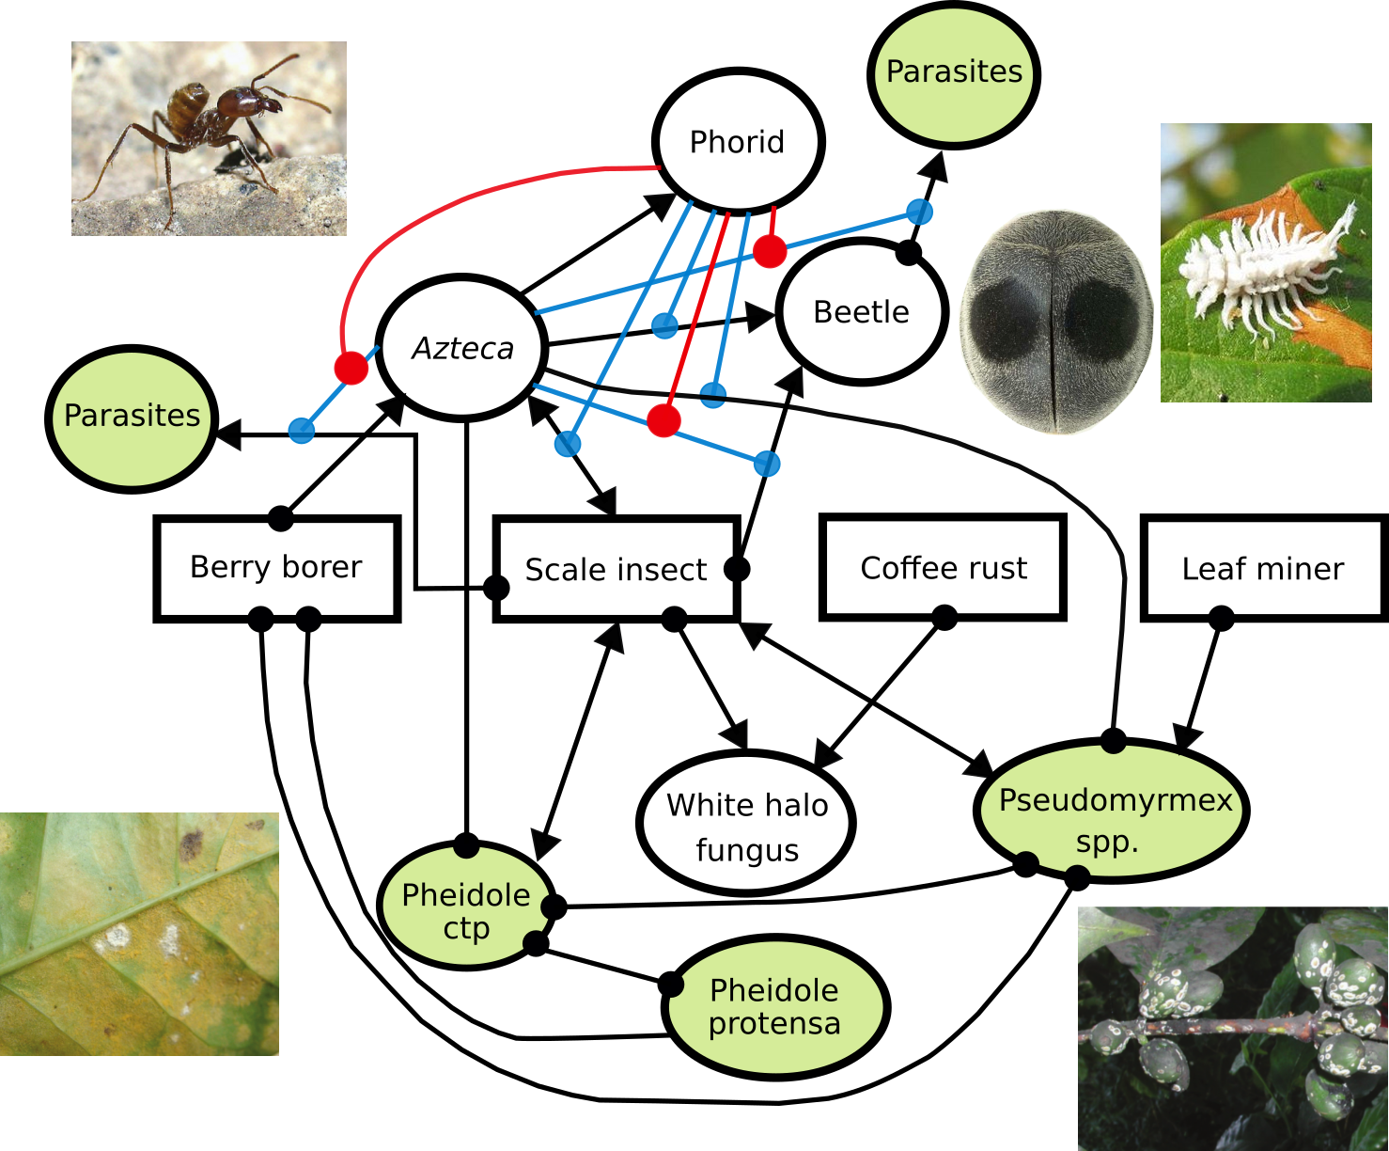

In any given location where *L. lecanii* seems to be active in controlling the coffee rust, any of the ecological players noted by Vandermeer and Perfecto might be naturally absent. Regardless of the species present at each site, the work by Vandermeer, Perfecto, and colleagues supports the general idea that sufficient ecological *complexity* must be present for the success of some services, such as the control of the coffee rust by the white halo fungus30. They therefore argue that the future of coffee may require an *agroecological* outlook that incorporates these networks of biological interactions into pest management plans.

Under-performance by microbial biocontrol agents like *L. lecanii* may therefore be a more fundamental flaw than simple misapplication of treatments. Biocontrol microbes that are applied to mature plants are faced with the vast, diverse array of resident microbes that are usually already present in nearly all plant tissue at the time of application33–36. In addition, plants are bombarded by naturally occurring spores37, at a rate that is probably economically impossible to rival with biocontrol application systems.

Given this, a plant’s microbiome may often only allow spotty and often temporary, local infections of the host by biocontrol fungi, limiting the utility of the biocontrol fungus.

This is a deep critique of microbe-based biocontrols. Together, the studies reviewed above suggest the possibility that biocontrols will fail as a tool for farmers, as long as we underestimate the complexity of the microbiomes and the ecosystems of our food plants. If microbial biocontrol species require the kind of complexity that Perfecto and Vandermeer have described to sustain them at effective levels, the current efforts to put a few famous species of fungi in blenders and spray them on leaves of our food seems sadly misled.

This body of research suggests that perhaps only continual exposure by plant throughout its lifetime to a diversity of fungi and numerous other organisms may produce the kind of results that one would hope for with microbial biocontrols. This level of exposure and diversity may only be economically possible for farmers when wild ecosystems such as forests are present nearby and are able to export these microbes as an ecosystem service. This proximity to forests may be necessary because farms are simplified ecosystems, especially “technified” farms, and may not contain sufficient ecological complexity themselves to maintain conditions necessary for microbes of interest5,30,38. Thus, **forests may be necessary sources of unique and beneficial microbes to surrounding simplified ecosystems, such as farms**.

This process of benefits from “biodiversity export” by forests has been shown in other organisms: forest-dwelling pollinators visit nearby coffee farms39,40, resulting in an ecosystem service valued at thousands of dollars annually. Regeneration of plant species diversity secondary forest is enhanced by proximity to older forest41, probably due to seed dispersal.

The first coffee leaf rust epidemic may be an example of the consequences on agriculture of removing nearby forests. In the areas of British coffee plantations of Sri Lanka where the rust first wreaked havoc, heavy deforestation occurred and large monocultures of coffee plants were recently established42. The coffee rust was known on wild rubiaceous trees in Sri Lanka prior to the epidemic42, acting both as a source of the pathogen and as evidence of the possibility that forests systems were holding this pathogen in check. Following our hypothesis, this grand ecological simplification of Sri Lanka may have contributed to the meteoric rise of the coffee rust in this region. The renowned investigator of the coffee leaf rust, H. M. Ward, believed that deforestation and monoculture systems of coffee agriculture was much to blame for much of the rapid spread of the rust5 on the island, which ultimately effectively ended arabica production there.

Biocontrol as an ecosystem service by forests to nearby agriculture may offer another explanation for the long delay of coffee rust epidemics in the Americas. Antagonism to the coffee rust by *L. lecanii* numerous other microbes may have been at work, as most areas where coffee is grown in the Americas are also historically forested. As deforestation accelerated43–45 in the mid-20th century, and forests edges retreated farther and farther from areas of coffee cultivation, beneficial microbes that required the forest habitat may have become increasingly rare. Organisms such as the white halo fungus may not have been able to sustain population levels sufficient to act as biocontrols against the rust in the increasingly vast and increasingly simplified landscape.

Other microbial evidence for this hypothesis:

* The coffee rust is observed on wild arabica and other members of the coffee family in forest settings 5,46, apparently in an equilibrium with its prey. Coexistence of coffee and its pathogens is possible, in the right ecological setting (forests).
* Many microbial antagonists to coffee rust are thought to exist in the wild16,31,47,48, especially in the forests of Ethiopa where coffee and the coffee leaf rust are thought to have coevolved extensively. However, none of the antagonists of the rust have yet successfully performed as biocontrols.
* Coffee tree germplasm from the forests in the native range of arabica and the rust do not show promise for finding further resistance genes4, despite the lower intensity of the rust in these areas. This may imply that other mechanisms beyond host resistance genes are at work in controlling the coffee rust.
* Incidence of the coffee leaf rust was found to be positively correlated with percent of nearby land in pasture in Costa Rica, as opposed to more complex land uses such as shade coffee, forest, or other agriculture49.
* Sterile plants placed under forest canopy are apparently exposed to more fungal spores and were observed to establish their non-disease fungal microbiomes more quickly than those placed in clearings37.

* Forest soils in a tropical landscape undergoing deforestation was shown to contain a higher diversity of microorganisms in their soils than in adjacent pasture soils50.
* Old growth tropical forest at a site in Costa Rica harbored more fungal species of the family of the white halo fungus, Cordycipitaceae, and closely related Clavicipitaceae51, than in nearby second growth forests.
* Second-growth forest located beside primary forest showed higher fungal diversity than secondary forest located away from primary forest, in the same study51. This suggests the “export of microbial diversity” hypothesized above is occurring and helps secondary forests to recover important microorganisms.
* Large, “mainland” forest patches in coastal California were observed act as sources of mycorrhizal fungal diversity to surrounding forest fragments, and that this ecosystem service decreased with distance52,53.

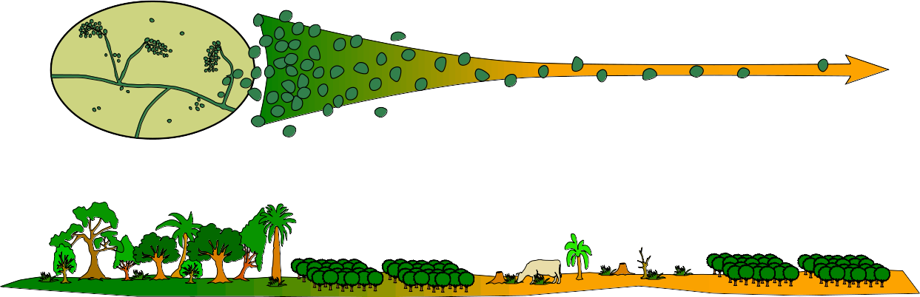

### Goals:

1) Determine the importance of forests to the health of coffee farms in regions of the coffee rust epidemic.

2) Uncover new beneficial microorganisms for the cultivation of coffee, and explore their ecological patterns.

3) Work with local communities, government, conservationists and coffee-growers to promote scientific, sustainable, and affordable agroecological pest management strategies.

### Methodology:

This project will consist of a field phase and a laboratory phase. The field phase will be planned and coordinated in cooperation with the agronomists of the Cotacachi canton government, the members of a coffee grower coop ([www.aacri.com](http://www.aacri.com/)), and independent coffee-growers in the area. The lab phase of the project will require access to a laboratory space where fungal cultures can be grown, and cultures and plant samples can be prepared for sequencing. This will be available through our collaboration with Universidad Técnica del Norte (UTN) in Ibarra. Additionally, if community partners are found in the more eastern areas of Cotacachi canton, a facility will be used to stabilize and store samples prior to transportation to Ibarra. Such facilities are available in Apuela, where coffee growers maintain warehouse and basic laboratory spaces.

# Field methods:

Site - The landscape of Cotacachi province is a matrix of forest, small-scale farms, and pasture (include a map?). The farms are often single-family farms or *fincas*, with multiple types of crops in production, but very often with coffee trees. In the Cotacachi province organic farming of high-quality arabica coffees is common.

Protocols - We will sample three, approximately 1 km x 1 km areas (Figure 2). These areas will be selected on the basis of: (1) density of coffee farms, (2) landholder interest in this project, and (3) adjacency of plot to a large forest area on one side. Plots will be sampled according to a grid of points spaced every 100m.

The mycobiome of the closest non-resistant coffee tree to each of the points will be examined. Two leaves and some 1rst and 2nd year stem tissue from each tree will be collected for endophyte/epiphyte culture (see laboratory methods below). The same amount of each will also be collected for direct, culture-free DNA sequencing. 200 grams of soil will be collected, enough for both fungal culture and direct DNA sequencing. If the coffee rust is present on the plant, infection severity will be noted9 , as well as proportion of rust lesions parasitized by *L. lecanii.*

For points lying inside of forests and forest fragments, the closest member of Rubiaceae to the grid point will be sampled in the same manner as cultivated coffee plants: the members of the genus *Hemileia* very often parasitize plants in Rubiaceae54, and may have coevolved with these hosts. They may also therefore tend to harbor hyperparasites or other antagonists to *Hemileia* rusts.

In addition to mature coffee plants, seedlings of sufficient size will be sourced and used as “bait” plants. These seedlings will be placed regularly at a subset of sampling sites. Leaves from these seedlings with be removed, and bark will will be sanitized. The second flush of leaves from these defoliated seedlings will occur *in situ* (forest) with a relatively reduced initial fungal diversity37 and will then accumulate species from the surroundings. These new leaves from seedlings will be sampled for endophytic fungi in the same manner as with leaves from mature trees.

Finally, rainwater spore traps will be positioned in a subset of , in the form of funnels into sterilized 4-liter jugs with fungal growth inhibitors and DNase inhibitors53. The water in these spore traps will collected, filtered to removed large debris, and centrifuged repeatedly to entrap spores as a pellet. Spores will then be preserved in DNA-stabilizing buffers and processed as with leaf tissue and soil samples.

Both seedlings and spore trap protocols represent a significantly additional amount of labor. As large a subset of spore and seedling sample sites as can reasonably managed will be installed, but this number will depend on the level of interest by coffee-grower collaborators. As a first goal, we will attempt to sample 25% of all sample sites for spore deposition and with seedlings.

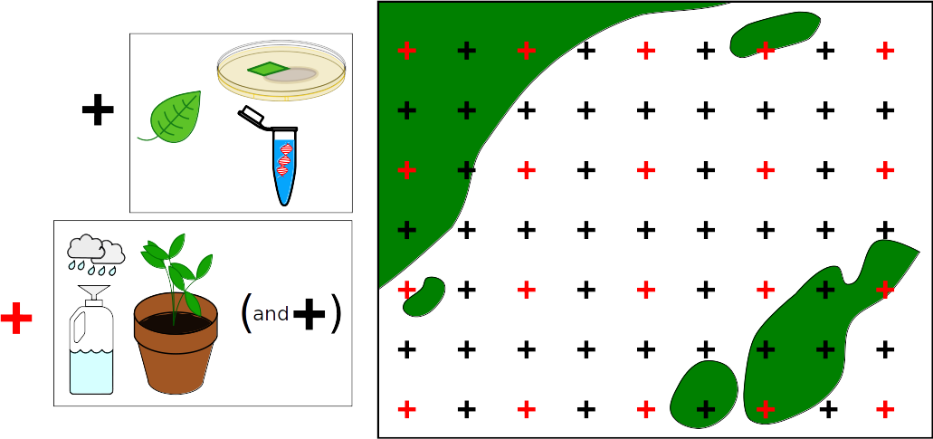

# Lab methods:

*Direct PCR* – Leaf, wood, soil, and spore-trap samples will be processed for DNA extraction and sequencing. ITS region illumina metabarcoding of leaves and woody tissue55, and soil50,56 will provide an overall picture of fungal microbiomes. However, metabarcoding can be an inexact tool when searching for particular microbial species among the entire microbiome. As such *L. lecanii* and *H. vastatrix* species specific primers in ITS region will be designed and used to specifically confirm the presence of these fungi in plants, even if symptoms are not otherwise present. Primers will be designed for the ITS region, using existing sequence data available in public databases.

*Culture library* – Leaves will be processed for cultivation of endophytic fungi: leaves will be surface- sterilized, sectioned and plated on malt agar medium, following Thomas and Vandegrift et al.57 Sporulating fungi will be grouped into morphospecies, and given preliminary IDs by morphology. Any specimens of interest will be grown in liquid media for DNA purification and sequencing, and identified using full ITS sequences. Researcher collaborators at UTN will be sought to aid with this aspect of the project, to be trained in cultivation of fungi and extraction of DNA from fungal cultures.

Neither cultures nor genomic DNA shall be exported outside of Ecuador. ITS-region-only-DNA will be sent to the nearest appropriate sequencing facilities, which is reported to be in Brasil. ITS is a non-coding region of the fungal genome that is used as a barcode for identifying fungal species. It is not useful in any way for bioprospecting. All fungal strains found to be of interest will given over to a public culture collection, to be maintained as Ecuadorian public intellectual property.

### Hypotheses:

H1) Forest ecosystems provide biological complexity necessary for microbial biocontrols of the coffee leaf rust to thrive and keep coffee leaf rust populations from reaching epidemic levels.

H2) This biocontrol service diminishes with distance from forest edge due to dispersal limitation of fungal spores.

### Predictions:

1 - Coffee rust severity will decrease with proximity to forest.

2 - The fungal microbiome of coffee plants close to the forest edge will more closely resemble forest plants’ microbiomes than coffee plants located farther away from forests.

3 - Incidence and symptoms of *Lecanocillium* will increase in frequency with proximity to forest, especially older and larger forest areas, in the air (spore traps), soil, and microbiome of plants.

4 - Parasitism of rust lesions by *L. lecanii* will decrease with distance from forest.

5 - Rust spores in the air column and in soil will not vary with distance from forest.

### Statistical analysis

Visually scored, incidence (presence/absence) data of the coffee rust and *L. lecanii* will be recorded and analysed as point-pattern data58, as will data from the detection of these two species by species-specific primers as described above. These spatial incidence data will be fitted to point pattern models, and tested for trends of decay with distance from forest edges. Confounding variables, including elevation, coffee variety and agricultural methods, will be included in models as covariates.

Spatial analyses of entire fungal communities from illumina sequence data, rather than single species, will be examined with multivariate spatial statistical methods. Variation in our fungal community matrix will be analyzed with a comparison of redundancy analyses of spatial and environmental variables, also known as variation partitioning59,60. Community dissimilarity will also be compared directly to samples of seedlings placed in forest settings.

### Budget and timeline:

I estimate about US$25,000 and two years. Field portion will be several months, with significant lead up to this needed to build contacts and talk to coffee growers.

*This is to be filled out in more detail…at the moment, costs include:*

* Transport for myself to and from Ecuador (+ other North American or European collaborators?).
* Salaries for helpers and to compensate coffee growers.

Field:

* Transport around country
* Housing in Apuela and Ibarra
* Spore traps with DNA stabilizers
* Daily transport to sites
* Random field equipment (coolers, ice, plastic bags, etc)

Lab:

* 1 lane illumina sequencing
* Illumina preparation at a core facility
* DNA extraction materials
* PCR reagents and expendables
* Culture – plates and media

Site – Cotacachi canton, Imbabura province:

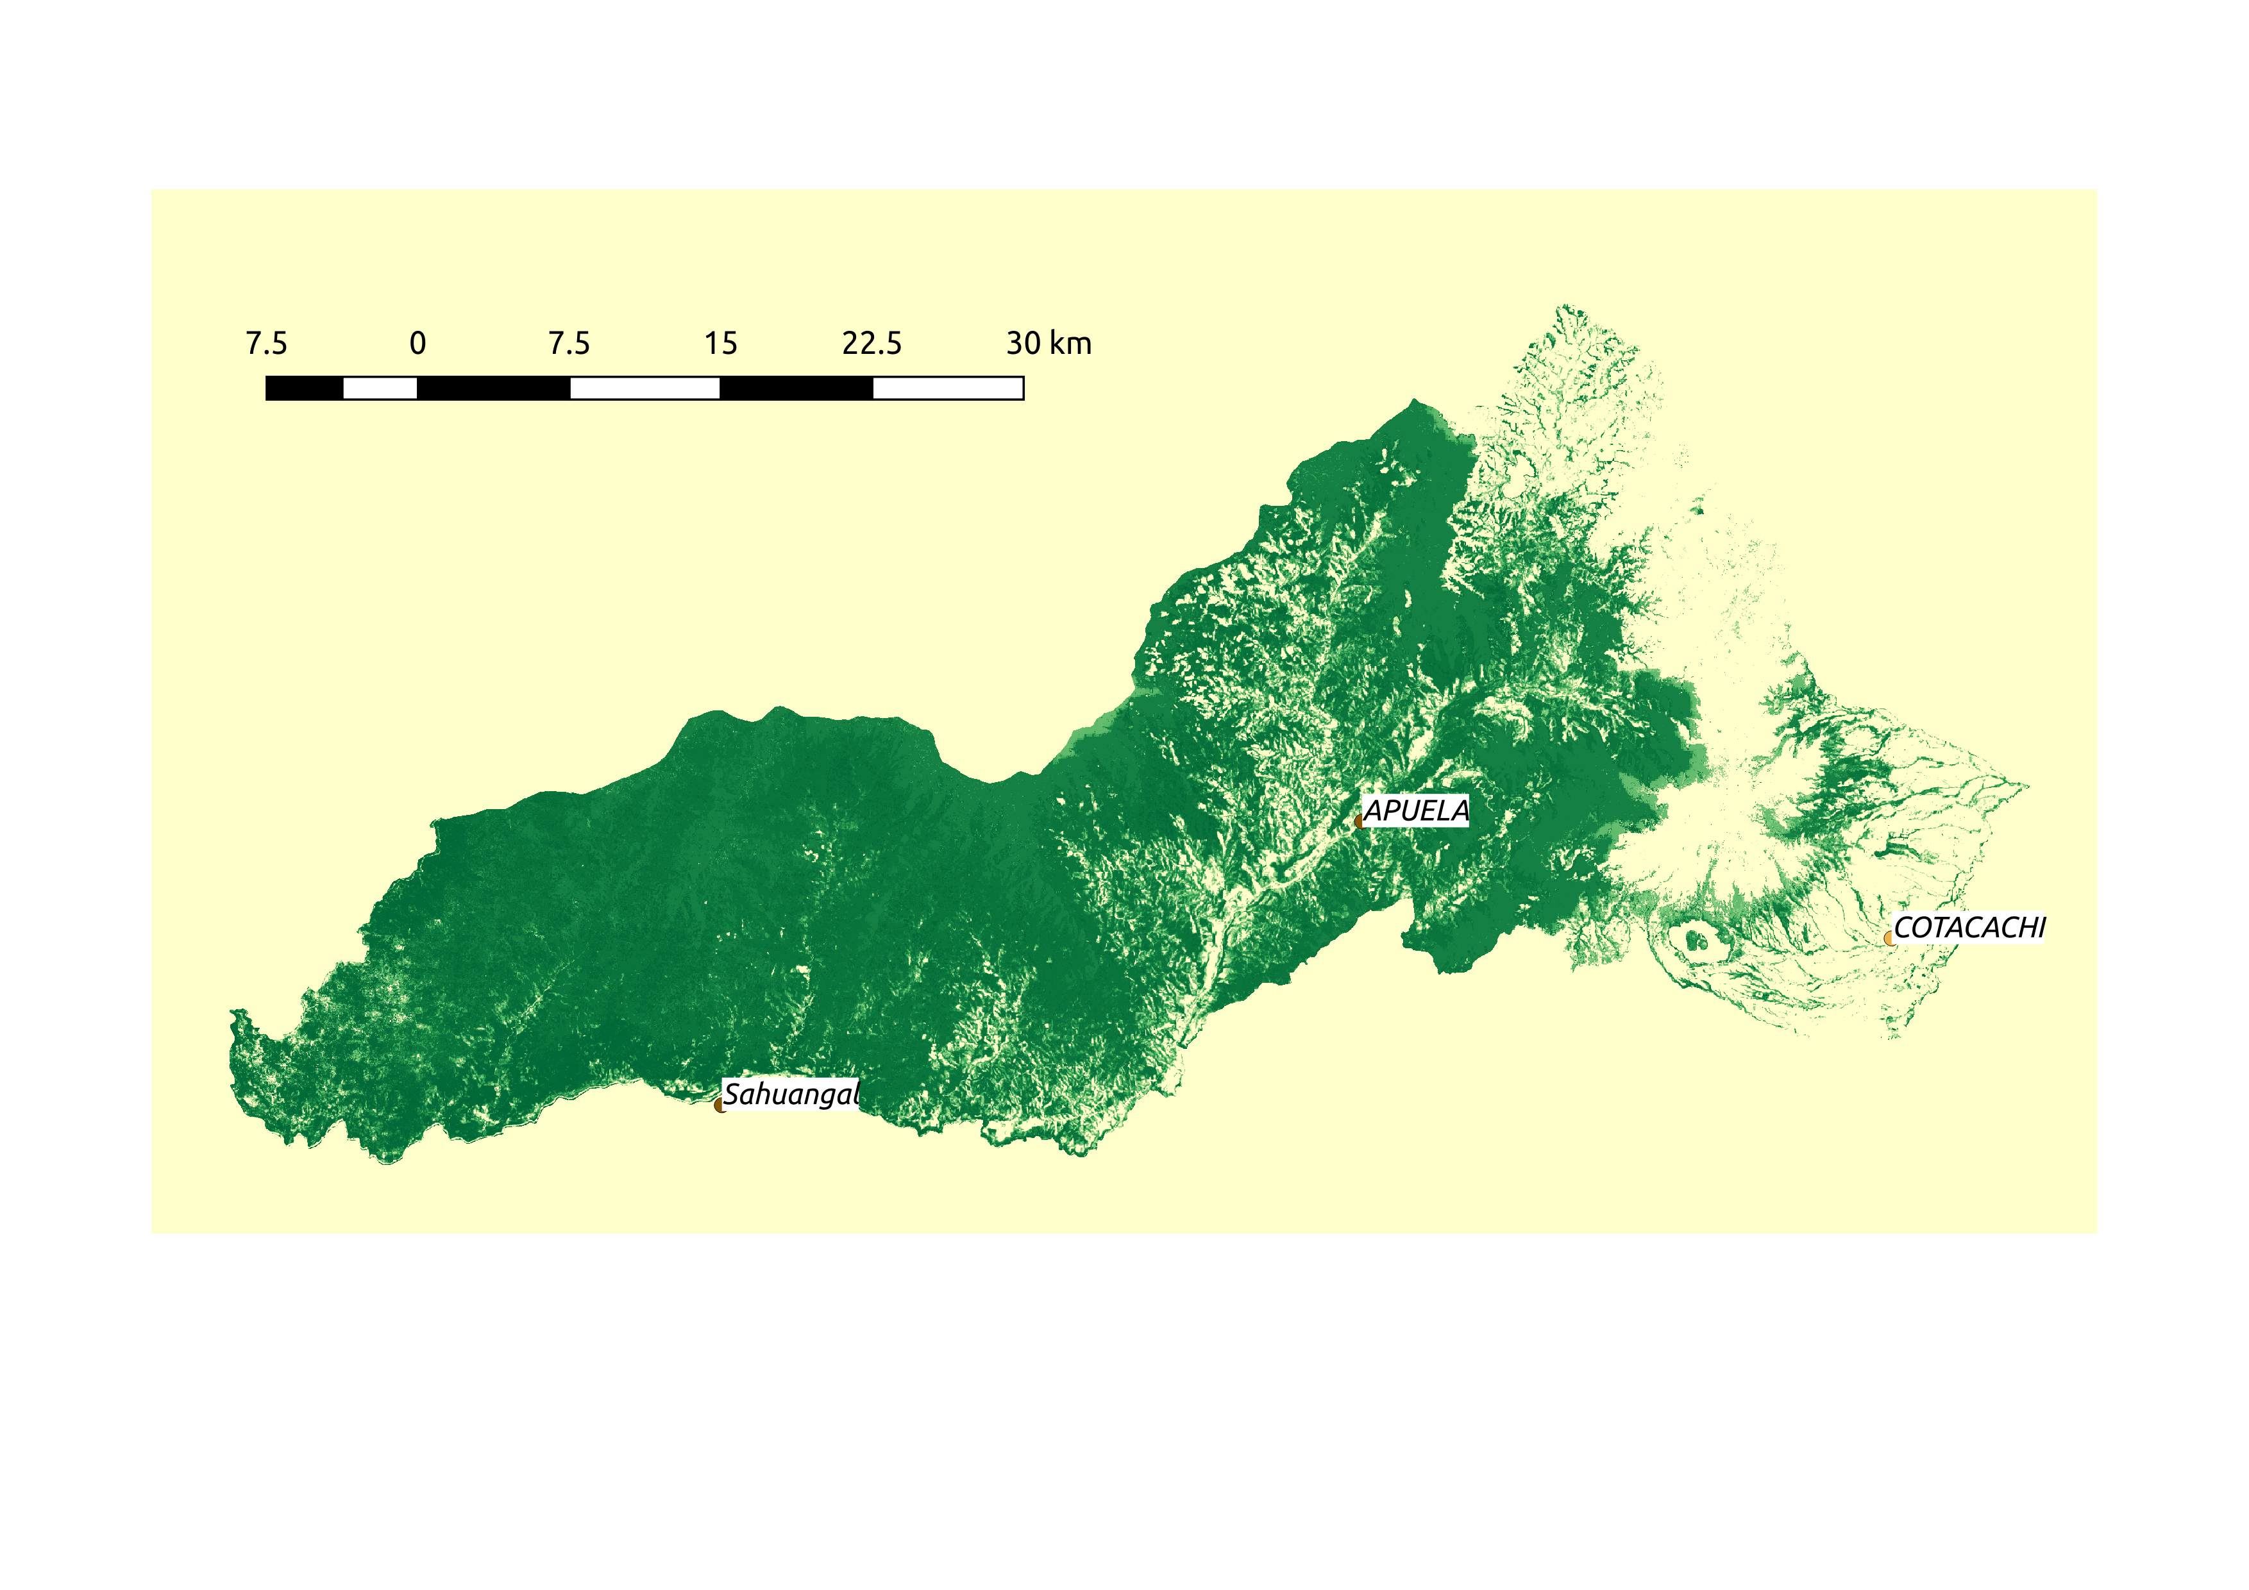

1. World production of coffee by country. *International Coffee Organization.* <[www.ico.org/prices/po-production.pdf](http://www.ico.org/prices/po-production.pdf)>. Accessed May 3, 2019.

2. World consumption of coffee by country. *International Coffee Organization.* <<http://www.ico.org/prices/new-consumption-table.pdf>>. Accessed May 3, 2019.

3. Five-Year Action Plan for the International Coffee Organization. *International Coffee Organization.* <[www.ico.org/documents/cy2016-17/icc-120-11e-five-year-action-plan.pdf](http://www.ico.org/documents/cy2016-17/icc-120-11e-five-year-action-plan.pdf)> (2017).

4. Talhinhas, P. *et al.* The coffee leaf rust pathogen *Hemileia vastatrix*: one and a half centuries around the tropics. *Molecular Plant Pathology* **18**, 1039–1051 (2017).

5. McCook, S. Global rust belt: *Hemileia vastatrix* and the ecological integration of world coffee production since 1850. *Journal of Global History* **1**, 177–195 (2006).

6. Avelino, J. *et al.* The coffee rust crises in Colombia and Central America (2008–2013): impacts, plausible causes and proposed solutions. *Food Sec.* **7**, 303–321 (2015).

7. McCook, S. & Vandermeer, J. The Big Rust and the Red Queen: Long-Term Perspectives on Coffee Rust Research. *Phytopathology* **105**, 1164–1173 (2015).

8. Vandermeer, J., Jackson, D. & Perfecto, I. Qualitative Dynamics of the Coffee Rust Epidemic: Educating Intuition with Theoretical Ecology. *BioScience* **64**, 210–218 (2014).

9. Avelino, J. *et al.* The intensity of a coffee rust epidemic is dependent on production situations. *Ecological Modelling* **197**, 431–447 (2006).

10. Davis, A. P., Gole, T. W., Baena, S. & Moat, J. The Impact of Climate Change on Indigenous Arabica Coffee (Coffea arabica): Predicting Future Trends and Identifying Priorities. *PLOS ONE* **7**, e47981 (2012).

11. Alvarado-Alvarado, G. & Moreno-Ruiz, L. G. Cambio de la virulencia de Hemileia vastatrix en progenies de Caturra x Híbrido de Timor. *Cenicafé* **56**, 110–126 (2005).

12. Van der Vossen, H. The cup quality of disease-resistant cultivars of Arabica coffee (*Coffea arabica*). *Experimental Agriculture* **45**, 323–332 (2009).

13. Illy, E. The First Asian Regional Round-Table on Sustainable, Organic and Speciality Coffee Production, Processing and Marketing. (2001).

14. Rodrigues, C. J., Bettencourt, A. J. & Rijo, L. Races of the Pathogen and Resistance to Coffee Rust. *Annu. Rev. Phytopathol.* **13**, 49–70 (1975).

15. Valencia, V. *et al.* Smallholder response to environmental change: Impacts of coffee leaf rust in a forest frontier in Mexico. *Land Use Policy* **79**, 463–474 (2018).

16. Silva, H. S., Tozzi, J. P., Terrasan, C. R. & Bettiol, W. Endophytic microorganisms from coffee tissues as plant growth promoters and biocontrol agents of coffee leaf rust. *Biological Control* **63**, 62–67 (2012).

17. Harnessing the power of natural enemies to fight coffee leaf rust. Available at: https://worldcoffeeresearch.org/work/biocontrol-coffee-leaf-rust/harnessing-power-natural-enemies-fight-coffee-leaf-rust/. (Accessed: 7th May 2019)

18. Zare, R. & Gams, W. A revision of Verticillium section Prostrata. IV. The genera Lecanicillium and Simplicillium gen. nov.°). *Nova Hedwigia* 1–50 (2001). doi:10.1127/nova.hedwigia/73/2001/1

19. Askary, H., Benhamou, N. & Brodeur, J. Ultrastructural and Cytochemical Investigations of the Antagonistic Effect of Verticillium lecanii on Cucumber Powdery Mildew. *Phytopathology* **87**, 359–368 (1997).

20. Ownley, B. H., Gwinn, K. D. & Vega, F. E. Endophytic fungal entomopathogens with activity against plant pathogens: ecology and evolution. *BioControl* **55**, 113–128 (2010).

21. Gurulingappa, P., McGee, P. A. & Sword, G. Endophytic Lecanicillium lecanii and Beauveria bassiana reduce the survival and fecundity of Aphis gossypii following contact with conidia and secondary metabolites. *Crop Protection* **30**, 349–353 (2011).

22. Gurulingappa, P., Mc Gee, P. & Sword, G. A. In Vitro and In Planta Compatibility of Insecticides and the Endophytic Entomopathogen, Lecanicillium lecanii. *Mycopathologia* **172**, 161–168 (2011).

23. Wilson, D. Endophyte: The Evolution of a Term, and Clarification of Its Use and Definition. *Oikos* **73**, 274–276 (1995).

24. Vega, F. E. Insect pathology and fungal endophytes. *Journal of Invertebrate Pathology* **98**, 277–279 (2008).

25. Sung, G.-H. *et al.* Phylogenetic classification of *Cordyceps* and the clavicipitaceous fungi. *Studies in mycology* **57**, 5–59 (2007).

26. Kepler, R. M. *et al.* A phylogenetically-based nomenclature for Cordycipitaceae (Hypocreales). *IMA fungus* **8**, 335–353 (2017).

27. Andrews, J. H. Biological control in the phyllosphere: Realistic goal or false hope? *Canadian Journal of Plant Pathology* **12**, 300–307 (1990).

28. Orozco-Mosqueda, M. del C., Rocha-Granados, M. del C., Glick, B. R. & Santoyo, G. Microbiome engineering to improve biocontrol and plant growth-promoting mechanisms. *Microbiological Research* **208**, 25–31 (2018).

29. Vidal, S. & Jaber, L. R. Entomopathogenic fungi as endophytes: plant–endophyte–herbivore interactions and prospects for use in biological control. *Current Science* **109**, 46–54 (2015).

30. Vandermeer, J., Perfecto, I. & Philpott, S. Ecological Complexity and Pest Control in Organic Coffee Production: Uncovering an Autonomous Ecosystem Service. *BioScience* **60**, 527–537 (2010).

31. Vandermeer, J., Hajian-Forooshani, Z. & Perfecto, I. The dynamics of the coffee rust disease: an epidemiological approach using network theory. *Eur J Plant Pathol* **150**, 1001–1010 (2018).

32. Vandermeer, J., Perfecto, I. & Liere, H. Evidence for hyperparasitism of coffee rust (Hemileia vastatrix) by the entomogenous fungus, Lecanicillium lecanii, through a complex ecological web. *Plant Pathology* **58**, 636–641 (2009).

33. Gamboa, M. A. & Bayman, P. Communities of Endophytic Fungi in Leaves of a Tropical Timber Tree (Guarea guidonia: Meliaceae)1. *Biotropica* **33**, 352–360 (2001).

34. Lodge, D. J., Fisher, P. J. & Sutton, B. C. Endophytic fungi of *Manilkara bidentata* leaves in Puerto Rico. *Mycologia* **88**, 733–738 (1996).

35. Bodenhausen, N., Horton, M. W. & Bergelson, J. Bacterial Communities Associated with the Leaves and the Roots of Arabidopsis thaliana. *PLOS ONE* **8**, e56329 (2013).

36. Gamboa, M. A., Laureano, S. & Bayman, P. Measuring diversity of endophytic fungi in leaf fragments: Does size matter? *Mycopathologia* **156**, 41–45 (2003).

37. Arnold, A. E. & Herre, E. A. Canopy cover and leaf age affect colonization by tropical fungal endophytes: Ecological pattern and process in *Theobroma cacao* (Malvaceae). *Mycologia* **95**, 388–398 (2003).

38. Kremen, C. & Miles, A. Ecosystem services in biologically diversified versus conventional farming systems: benefits, externalities, and trade-offs. *Ecology and Society* **17**, (2012).

39. Ricketts, T. H., Daily, G. C., Ehrlich, P. R. & Michener, C. D. Economic value of tropical forest to coffee production. *PNAS* **101**, 12579–12582 (2004).

40. Priess, J. A. *et al.* Linking deforestation scenarios to pollination services and economic returns in coffee agroforestry systems. *Ecological Applications* **17**, 407–417 (2007).

41. Chazdon, R. L. Tropical forest recovery: legacies of human impact and natural disturbances. *Perspectives in Plant Ecology, Evolution and Systematics* **6**, 51–71 (2003).

42. Webb, J. *Tropical pioneers : human agency and ecological change in the highlands of Sri Lanka, 1800-1900*. (Ohio University Press, 2002).

43. Rosa, I. M. D., Smith, M. J., Wearn, O. R., Purves, D. & Ewers, R. M. The Environmental Legacy of Modern Tropical Deforestation. *Current Biology* **26**, 2161–2166 (2016).

44. Fearnside, P. M. Deforestation in Brazilian Amazonia: History, Rates, and Consequences. *Conservation Biology* **19**, 680–688 (2005).

45. González-Jaramillo, V. *et al.* Assessment of deforestation during the last decades in Ecuador using NOAA-AVHRR satellite data. *Erdkunde* **70**, 217–235 (2016).

46. Samnegård, U., Hambäck, P. A., Nemomissa, S. & Hylander, K. Local and Regional Variation in Local Frequency of Multiple Coffee Pests Across a Mosaic Landscape in *Coffea arabica*’s Native Range. *Biotropica* **46**, 276–284 (2014).

47. Haddad, F., Maffia, L. A., Mizubuti, E. S. G. & Teixeira, H. Biological control of coffee rust by antagonistic bacteria under field conditions in Brazil. *Biological Control* **49**, 114–119 (2009).

48. Haddad, F., Saraiva, R. M., Mizubuti, E. S. G., Romeiro, R. S. & Maffia, L. A. Isolation and selection of *Hemileia vastatrix* antagonists. *Eur J Plant Pathol* **139**, 763–772 (2014).

49. Avelino, J., Romero-Gurdián, A., Cruz-Cuellar, H. F. & Declerck, F. A. J. Landscape context and scale differentially impact coffee leaf rust, coffee berry borer, and coffee root-knot nematodes. *Ecological Applications* **22**, 584–596 (2012).

50. Rodrigues, J. L. M. *et al.* Conversion of the Amazon rainforest to agriculture results in biotic homogenization of soil bacterial communities. *PNAS* **110**, 988–993 (2013).

51. Chaverri, P. & Vilchez, B. Hypocrealean (Hypocreales, Ascomycota) fungal diversity in different stages of tropical forest succession in Costa Rica. *Biotropica* **38**, 531–543 (2006).

52. Peay, K. G., Garbelotto, M. & Bruns, T. D. Evidence of dispersal limitation in soil microorganisms: Isolation reduces species richness on mycorrhizal tree islands. *Ecology* **91**, 3631–3640 (2010).

53. Peay, K. G., Schubert, M. G., Nguyen, N. H. & Bruns, T. D. Measuring ectomycorrhizal fungal dispersal: macroecological patterns driven by microscopic propagules. *Molecular Ecology* **21**, 4122–4136 (2012).

54. Ritschel, A. Monograph of the genus *Hemileia* (Uredinales). (2005). Available at: https://www.schweizerbart.de/publications/detail/isbn/9783443591021/Bibl_Mycologica_Band_200_Ritschel. (Accessed: 2nd May 2019)

55. Thomas, D., Vandegrift, R., Roy, B. A., Hsieh, H.-M. & Ju, Y.-M. Spatial patterns of fungal endophytes in a subtropical montane rainforest of northern Taiwan. *Fungal Ecology* **39**, 316–327 (2019).

56. Castañeda, L. E. & Barbosa, O. Metagenomic analysis exploring taxonomic and functional diversity of soil microbial communities in Chilean vineyards and surrounding native forests. *PeerJ* **5**, e3098 (2017).

57. Thomas, D. C., Vandegrift, R., Ludden, A., Carroll, G. C. & Roy, B. A. Spatial Ecology of the Fungal Genus *Xylaria* in a Tropical Cloud Forest. *Biotropica* **48**, 381–393 (2016).

58. Baddeley, A., Rubak, E. & Turner, R. *Spatial point patterns: methodology and applications with R*. (Chapman and Hall/CRC, 2015).

59. Borcard, D., Legendre, P. & Drapeau, P. Partialling out the Spatial Component of Ecological Variation. *Ecology* **73**, 1045–1055 (1992).

60. Legendre, P. & Legendre, L. *Numerical Ecology*. **24**, (Elsevier, 2012).untry. <<http://www.ico.org/prices/new-consumption-table.pdf>>. Accessed May 3, 2019

3. Internation Coffee Organization. Five-Year Action Plan for the International Coffee Organization. (2017).

4. Talhinhas, P. *et al.* The coffee leaf rust pathogen Hemileia vastatrix: one and a half centuries around the tropics. *Molecular Plant Pathology* **18**, 1039–1051 (2017).

5. McCook, S. Global rust belt: Hemileia vastatrix and the ecological integration of world coffee production since 1850. *Journal of Global History* **1**, 177–195 (2006).

6. Avelino, J. *et al.* The coffee rust crises in Colombia and Central America (2008–2013): impacts, plausible causes and proposed solutions. *Food Sec.* **7**, 303–321 (2015).

7. McCook, S. & Vandermeer, J. The Big Rust and the Red Queen: Long-Term Perspectives on Coffee Rust Research. *Phytopathology* **105**, 1164–1173 (2015).

8. Vandermeer, J., Jackson, D. & Perfecto, I. Qualitative Dynamics of the Coffee Rust Epidemic: Educating Intuition with Theoretical Ecology. *BioScience* **64**, 210–218 (2014).

9. Avelino, J. *et al.* The intensity of a coffee rust epidemic is dependent on production situations. *Ecological Modelling* **197**, 431–447 (2006).

10. Davis, A. P., Gole, T. W., Baena, S. & Moat, J. The Impact of Climate Change on Indigenous Arabica Coffee (Coffea arabica): Predicting Future Trends and Identifying Priorities. *PLOS ONE* **7**, e47981 (2012).

11. Alvarado-Alvarado, G. & Moreno-Ruiz, L. G. Cambio de la virulencia de Hemileia vastatrix en progenies de Caturra x Híbrido de Timor. *Cenicafé* **56**, 110–126 (2005).

12. Van der Vossen, H. The cup quality of disease-resistant cultivars of Arabica coffee (*Coffea arabica*). *Experimental Agriculture* **45**, 323–332 (2009).

13. Illy, E. The First Asian Regional Round-Table on Sustainable, Organic and Speciality Coffee Production, Processing and Marketing. (2001).

14. Rodrigues, C. J., Bettencourt, A. J. & Rijo, L. Races of the Pathogen and Resistance to Coffee Rust. *Annu. Rev. Phytopathol.* **13**, 49–70 (1975).

15. Valencia, V. *et al.* Smallholder response to environmental change: Impacts of coffee leaf rust in a forest frontier in Mexico. *Land Use Policy* **79**, 463–474 (2018).

16. Silva, H. S., Tozzi, J. P., Terrasan, C. R. & Bettiol, W. Endophytic microorganisms from coffee tissues as plant growth promoters and biocontrol agents of coffee leaf rust. *Biological Control* **63**, 62–67 (2012).

17. Harnessing the power of natural enemies to fight coffee leaf rust. Available at: https://worldcoffeeresearch.org/work/biocontrol-coffee-leaf-rust/harnessing-power-natural-enemies-fight-coffee-leaf-rust/. (Accessed: 7th May 2019)

18. Zare, R. & Gams, W. A revision of Verticillium section Prostrata. IV. The genera Lecanicillium and Simplicillium gen. nov.°). *Nova Hedwigia* 1–50 (2001). doi:10.1127/nova.hedwigia/73/2001/1

19. Askary, H., Benhamou, N. & Brodeur, J. Ultrastructural and Cytochemical Investigations of the Antagonistic Effect of Verticillium lecanii on Cucumber Powdery Mildew. *Phytopathology* **87**, 359–368 (1997).

20. Ownley, B. H., Gwinn, K. D. & Vega, F. E. Endophytic fungal entomopathogens with activity against plant pathogens: ecology and evolution. *BioControl* **55**, 113–128 (2010).

21. Gurulingappa, P., McGee, P. A. & Sword, G. Endophytic Lecanicillium lecanii and Beauveria bassiana reduce the survival and fecundity of Aphis gossypii following contact with conidia and secondary metabolites. *Crop Protection* **30**, 349–353 (2011).

22. Gurulingappa, P., Mc Gee, P. & Sword, G. A. In Vitro and In Planta Compatibility of Insecticides and the Endophytic Entomopathogen, Lecanicillium lecanii. *Mycopathologia* **172**, 161–168 (2011).

23. Wilson, D. Endophyte: The Evolution of a Term, and Clarification of Its Use and Definition. *Oikos* **73**, 274–276 (1995).

24. Vega, F. E. Insect pathology and fungal endophytes. *Journal of Invertebrate Pathology* **98**, 277–279 (2008).

25. Sung, G.-H. *et al.* Phylogenetic classification of *Cordycep*s and the clavicipitaceous fungi. *Studies in mycology* **57**, 5–59 (2007).

26. Kepler, R. M. *et al.* A phylogenetically-based nomenclature for Cordycipitaceae (Hypocreales). *IMA fungus* **8**, 335–353 (2017).

27. Andrews, J. H. Biological control in the phyllosphere: Realistic goal or false hope? *Canadian Journal of Plant Pathology* **12**, 300–307 (1990).

28. Orozco-Mosqueda, M. del C., Rocha-Granados, M. del C., Glick, B. R. & Santoyo, G. Microbiome engineering to improve biocontrol and plant growth-promoting mechanisms. *Microbiological Research* **208**, 25–31 (2018).

29. Vidal, S. & Jaber, L. R. Entomopathogenic fungi as endophytes: plant–endophyte–herbivore interactions and prospects for use in biological control. *Current Science* **109**, 46–54 (2015).

30. Vandermeer, J., Perfecto, I. & Philpott, S. Ecological Complexity and Pest Control in Organic Coffee Production: Uncovering an Autonomous Ecosystem Service. *BioScience* **60**, 527–537 (2010).

31. Vandermeer, J., Hajian-Forooshani, Z. & Perfecto, I. The dynamics of the coffee rust disease: an epidemiological approach using network theory. *Eur J Plant Pathol* **150**, 1001–1010 (2018).

32. Vandermeer, J., Perfecto, I. & Liere, H. Evidence for hyperparasitism of coffee rust (Hemileia vastatrix) by the entomogenous fungus, Lecanicillium lecanii, through a complex ecological web. *Plant Pathology* **58**, 636–641 (2009).

33. Gamboa, M. A. & Bayman, P. Communities of Endophytic Fungi in Leaves of a Tropical Timber Tree (Guarea guidonia: Meliaceae)1. *Biotropica* **33**, 352–360 (2001).

34. Lodge, D. J., Fisher, P. J. & Sutton, B. C. Endophytic fungi of Manilkara bidentata leaves in Puerto Rico. *Mycologia* **88**, 733–738 (1996).

35. Bodenhausen, N., Horton, M. W. & Bergelson, J. Bacterial Communities Associated with the Leaves and the Roots of *Arabidopsis thaliana*. *PLOS ONE* **8**, e56329 (2013).

36. Gamboa, M. A., Laureano, S. & Bayman, P. Measuring diversity of endophytic fungi in leaf fragments: Does size matter? *Mycopathologia* **156**, 41–45 (2003).

37. Arnold, A. E. & Herre, E. A. Canopy cover and leaf age affect colonization by tropical fungal endophytes: Ecological pattern and process in *Theobroma cacao* (Malvaceae). *Mycologia* **95**, 388–398 (2003).

38. Kremen, C. & Miles, A. Ecosystem services in biologically diversified versus conventional farming systems: benefits, externalities, and trade-offs. *Ecology and Society* **17**, (2012).

39. Ricketts, T. H., Daily, G. C., Ehrlich, P. R. & Michener, C. D. Economic value of tropical forest to coffee production. *PNAS* **101**, 12579–12582 (2004).

40. Chazdon, R. L. Tropical forest recovery: legacies of human impact and natural disturbances. *Perspectives in Plant Ecology, Evolution and Systematics* **6**, 51–71 (2003).

41. Samnegård, U., Hambäck, P. A., Nemomissa, S. & Hylander, K. Local and Regional Variation in Local Frequency of Multiple Coffee Pests Across a Mosaic Landscape in *Coffea arabica*’s Native Range. *Biotropica* **46**, 276–284 (2014).

42. Haddad, F., Maffia, L. A., Mizubuti, E. S. G. & Teixeira, H. Biological control of coffee rust by antagonistic bacteria under field conditions in Brazil. *Biological Control* **49**, 114–119 (2009).

43. Haddad, F., Saraiva, R. M., Mizubuti, E. S. G., Romeiro, R. S. & Maffia, L. A. Isolation and selection of *Hemileia Vastatrix* antagonists. *Eur J Plant Pathol* **139**, 763–772 (2014).

44. Rodrigues, J. L. M. *et al.* Conversion of the Amazon rainforest to agriculture results in biotic homogenization of soil bacterial communities. *PNAS* **110**, 988–993 (2013).

45. Chaverri, P. & Vilchez, B. Hypocrealean (Hypocreales, Ascomycota) fungal diversity in different stages of tropical forest succession in Costa Rica. *Biotropica* **38**, 531–543 (2006).

46. Peay, K. G., Garbelotto, M. & Bruns, T. D. Evidence of dispersal limitation in soil microorganisms: Isolation reduces species richness on mycorrhizal tree islands. *Ecology* **91**, 3631–3640 (2010).

47. Peay, K. G., Schubert, M. G., Nguyen, N. H. & Bruns, T. D. Measuring ectomycorrhizal fungal dispersal: macroecological patterns driven by microscopic propagules. *Molecular Ecology* **21**, 4122–4136 (2012).

48. Webb, J. *Tropical pioneers : human agency and ecological change in the highlands of Sri Lanka, 1800-1900*. (Ohio University Press, 2002).

49. Ritschel, A. Monograph of the genus *Hemileia* (Uredinales). (2005). Available at: https://www.schweizerbart.de/publications/detail/isbn/9783443591021/Bibl_Mycologica_Band_200_Ritschel. (Accessed: 2nd May 2019)

50. Thomas, D., Vandegrift, R., Roy, B. A., Hsieh, H.-M. & Ju, Y.-M. Spatial patterns of fungal endophytes in a subtropical montane rainforest of northern Taiwan. *Fungal Ecology* **39**, 316–327 (2019).

51. Castañeda, L. E. & Barbosa, O. Metagenomic analysis exploring taxonomic and functional diversity of soil microbial communities in Chilean vineyards and surrounding native forests. *PeerJ* **5**, e3098 (2017).

52. Thomas, D. C., Vandegrift, R., Ludden, A., Carroll, G. C. & Roy, B. A. Spatial Ecology of the Fungal Genus *Xylaria* in a Tropical Cloud Forest. *Biotropica* **48**, 381–393 (2016).

53. Baddeley, A., Rubak, E. & Turner, R. *Spatial point patterns: methodology and applications with R*. (Chapman and Hall/CRC, 2015).

54. Borcard, D., Legendre, P. & Drapeau, P. Partialling out the Spatial Component of Ecological Variation. *Ecology* **73**, 1045–1055 (1992).

55. Legendre, P. & Legendre, L. *Numerical Ecology*. **24**, (Elsevier, 2012).