Introduction
Peatlands are famously large reservoirs of terrestrial organic carbon (___). Their carbon dynamics and

Methods

Field

Site
Peat cores were collected from thermokarst hollows (AT) and palsa plateaus (AP) in Áidejávri in Finnmark, Norway (Fig. ___). The site is located at approximately 68.75 N and 23.33 E. Áidejávri is placed on a plateau called Finnmarksvidda with an area of ca. 22,000 km 2 and at an elevation of around 370 m above sea level (___Kjær et al., 2024___). The mean annual temperature reported from the nearest weather station (Šihččajávri) is around -1.6 °C, and a mean annual precipitation of 577 mm was documented (reference period 1991-2020; Norwegian Centre for Climate Services, n.d.). The study site is a permafrost peatland, consisting of intact palsas as well as thermokarsts with different successional stages. According to Kjær et al. (___2024___) the soil in Áidejávri can be characterized as a Histosol (___IUSS Working Group WRB, 2022___), and the exact age of the peatland in Áidejávri is unknown (___Kjær et al., 2024___). Throughout the whole time before permafrost started to form, the peatland was most likely a fen, as evidenced by macrofossil data (___Henrich, 2025___). It was assumed that the thermokarst structures in Áidejávri developed within the last century, supposing a similar accumulation rate of C as nearby thermokarsts (___Henrich, 2025___). Samples were collected from two thermokarst hollows and a surrounding palsa (Fig. ___c). Based on macrofossil data (___), the thermokarst cores AT2, AT3 and AT5 were sampled from a thermokarst hollow that is dominated by Sphagnum lindbergii Schimp. as well as some Eriophorum L. sp. (___Henrich, 2025___). The dominating vegetation at the palsa consisted of Empetrum nigrum L., Ledum palustre L., Vaccinium uliginosum L., Rubus chamaemorus L., and various lichens such as Cladonia spp., as well as mosses, but there was only little to no Sphagnum. Additionally, Betula nana L., Andromeda polifolia L. and Vaccinium vitis-ideae L. were present at the palsa. Nearby meteorological station Šihččajávri reports an average annual air temperature of -1.6°C and average annual precipitation of 577 mm for the years 1991–2020 (___Norwegian Center for Climate Services, n.d.___).

Sample collection and processing
Four palsa cores and four thermokarst cores were sampled in mid-July of 2024 (___Fig. 1___c-e). All four thermokarst cores were taken from mature thermokarsts. The successional stages of the thermokarst were determined based on differences in physical features and the present vegetation (Henrich, 2025). Three of the thermokarst cores were collected from the same thermokarst hollow (AT2, AT3 and AT5) while one was collected from another hollow (AT1;___Fig. 1___c). The palsa cores were sampled close to the thermokarst hollows (___Fig. 1___c). The cores were divided into five different depth sections, respectively (___Tab. 1___). The samples of all palsa cores were taken from the assigned depth sections 1 to 5. The absolute sampling depths of the thermokarst cores were chosen in a way that allows comparability between palsa and thermokarst. Since permafrost collapse caused the peat to drop, it was individually determined, based on peat morphology, which absolute depths of each thermokarst core were equivalent to the sampled depths of the palsa. Hence, although having different absolute depths (___Tab. 1___), depth section 1 of each thermokarst core was expected to be the same age as depth section 1 of the palsa cores and so on. For depth section 3 no corresponding samples were taken from the thermokarst cores. Moreover, the newly formed peat of the thermokarst was assigned to depth section 0 which represents the top 40 cm of all thermokarst cores (___Tab. 1___). At the end of August 2024, the thawing depth of the palsa was at around 70 cm (___Henrich, 2025___). Hence, depth sections 1, 2 and 3 of the palsa were interpreted as the active layer which shows annual freeze-thaw cycles (___Tab. 1___). Depth sections 4 and 5 will be interpreted as permafrost peat which stays frozen throughout the year.

The sampling of the first 40 cm of the thermokarst cores was performed manually with a bended aluminum sheet (50x6x13 cm). The deeper parts of the cores were collected with a Russian peat corer (5.2 cm diameter; Royal Eijelkamp, Giesbeck, Netherlands). In the palsa, the samples from the active layer were cut out with a serrated knife while the deeper depths from the permafrost layer were sampled by hammering a steel pipe (3 cm diameter) into the frozen ground. After sampling, the peat was kept frozen at -24 °C until the beginning of the laboratory analyses in November 2024. Prior to laboratory analyses, the frozen samples were thawed at 5 °C over night in the beginning of November 2024. After thawing, all disruptive materials such as roots or insects were removed, and the samples were homogenized with a mixer. Whenever no analyzes were performed, the thawed and homogenized samples were stored at 2 °C.

Table 1.
Geomorphic feature | Plot | Depth section (cm)
 |  | Newly formed peat | Active layer/former active layer |  |  | Permafrost layer/former permafrost layer
 |  | Section 0 | Section 1 | Section 2 | Section 3 | Section 4 | Section 5
Palsa | AP1-4 | - | 0-20 | 20-40 | 50-70 | 80-100 | 100-120
Thermokarst | AT1 | 0-40 | 63-83 | 83-103 | - | 143-163 | 163-183
Thermokarst | AT2 | 0-40 | 43-63 | 63-83 | - | 123-143 | 143-163
Thermokarst | AT3 | 0-40 | 60-80 | 80-100 | - | 140-160 | 160-180
Thermokarst | AT5 | 0-40 | 50-70 | 70-90 | - | 130-150 | 150-170

Peat chemistry and electrochemical properties
Direct elemental analyses included quantification of C, H, N , S, O, and their respective molar ratios. Elemental concentrations of the samples were determined with the dry combustion method (___Matejovic, 1993___; ___Matejovic, 1997___). For this, ca. 5 g of peat sample were dried at 40 °C for three days. The dried samples were then ground (MM 400, Retsch GmbH, Haan, Germany). Next, 15 mg of the ground samples and ca. 45 mg of tungstic oxide powder were weighed into tin boats, folded and analyzed for C, H, N and sulfur (S) (vario EL cube, Elementar Analysesysteme GmbH, Langenselbold, Germany). For the O analyzes, 2-3 mg of ground sample were weighed into silver boats, folded and measured (rapid OXY cube, Elementar Analysesysteme GmbH, Langenselbold, Germany). The results were converted into mg per g peat, and stoichiometric ratios were calculated. pH was measured using 1:5 soil:water ratio, after one hour equilibration, using standard pH electrodes. Other peat chemical and electrochemical properties were estimated via mid infrared spectroscopy (MRS), using a Fourier transform infrared (FTIR) Cary 660 spectrometer (Agilent Technologies, Santa Clara, California USA) in the range 650–4,000 cm⁻¹ at a resolution of 0.5–2 cm⁻¹. For MRS, 2 mg of powdered sample were mixed with 200 mg of KBr and pressed into 13 mm pellets. Resulting absorption spectra were baseline corrected using a Rubberband algorithm (___) and normalized by total area, using the R package “ir” (___Teickner 2022___). Other soil properties were estimated with FTIR spectra using the “irpeat” package (___), and accompanying models from the “irpeatmodels” package (___), including humification indices, holocellulose content, lignen content, phosphorus (P), bulk density, decomposition indices, and electron donor/acceptor capacity (___Teickner2022__).

Microbial Carbon Use Efficiency:

WHC estimation
All samples, except four, were considered water saturated. For the remaining four samples, the maximum water holding capacity (WHC_{max}) was determined. Around ¼ of glass-fritted drainage tubes were filled with peat sample and weighed. Distilled, dionized water was added to the samples. The glass-fritted drainage tubes were closed with parafilm and stored at 5 °C until all of the excess water was drained off and the peat samples had achieved their WHC_{max}. The samples were weighed, dried at 105 °C for 24 hours and weighed again. WHC_{max} in g H₂O per g peat was calculated as the fresh weight of peat at WHC_{max} minus their dry weight to estimate water weight, divided by the dry soil weight. Gravimetric water content (g H₂0 per g peat) for all samples was calculated in the same way as the water holding capacity by weighing the original peat samples before and after drying the peat at 105 °C for 24 hours.

Microbial respiration
Peat samples were air-dried to achieve a homogenous water content of 150% throughout all the samples (250% for depth section 1 of the thermokarst samples as those had a very high WHC_{max}) and then prepared for the pre-incubation. Ca. 15 mg of all palsa samples as well as the thermokarst samples of depth sections 4 and 5 were pre-incubated under oxic conditions for nine days at 15 °C, respectively. Accordingly, ca. 15 mg of all thermokarst samples as well as the palsa samples of depth sections 4 and 5 were pre-incubated under anoxic conditions, respectively, by flushing the incubation flasks with N₂ for 30 minutes. The pre-incubation of the anoxic samples lasted for 20 days at 15 °C.

After finishing pre-incubation, the microbial respiration was determined. For this, the incubation flasks of the oxic samples were flushed with synthetic air for 15 minutes, and an overpressure was created. In the following, the CO₂ production was determined by measuring the concentration of CO₂ four times (t0, t1, t2, t3) over a period of 48 hours with a gas chromatograph (8610C GC, SRI Instruments Europe GmbH, Bad Honnef, Germany). At t3, the CH₄ concentration was measured, additionally. The incubation flasks of the anoxic samples were flushed with N₂ for 20 minutes, and overpressure was created. Since the anoxic conditions were expected to support the production of CH₄ rather than CO₂ (___Burgin et al., 2011___; ___Wilson et al., 2019___), a measurement of both CO₂ and CH₄ concentration for four times (t0, t1, t2, t3) over a period of 160 hours followed. However, since no CH₄ production was measured for both the oxic and the anoxic samples (see results), respiration was calculated only based on the values of the measured CO2 production. The produced CO₂ – C over the measuring period (∆CO₂ − C) in µg was calculated with equation (___1___):

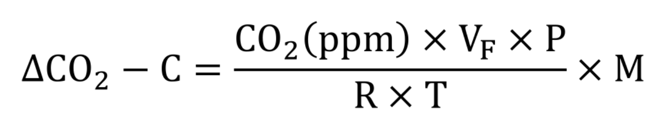(___1___)

Where CO₂ (ppm) is the produced CO₂ over the time of incubation (ppm), calculated by multiplying the slope of the function representing the increase of CO₂ over time (ppm h-1) with the time of incubation (h), V_{F} is the volume of the incubation flask reduced by the volume of sample inside the flask (m⁻³), P is the total pressure, meaning the sum of the overpressure in the incubation flask and the surrounding air pressure (Pa), R is the gas constant of 8.314 (J K-1 mol-1), T is the incubation temperature (K) and M is the molar mass of C (g mol⁻¹).

The C invested in respiration (C_{Respiration}) in µg CO₂ - C per g peat per day was then calculated using equation (___2___):
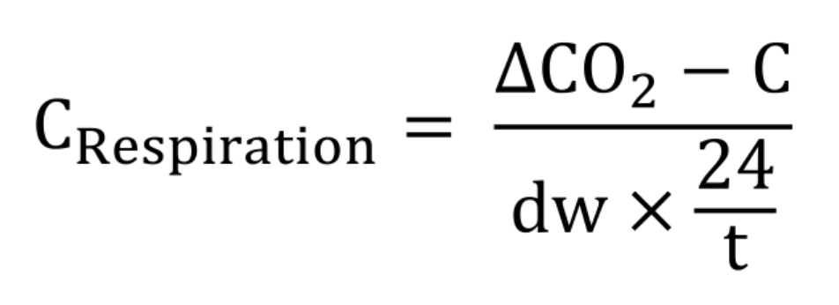(__2__)

Where dw is the dry weight of the peat sample (g) and t is the time of incubation (h).

Microbial biomass carbon
Microbial biomass carbon (MBC) was determined by applying the chloroform fumigation-extraction (CFE) method (___Vance et al., 1987___). The aim of the method is to calculate the MBC by determining the difference between the total organic C (TOC) that was extracted from a soil fumigated with chloroform and a replicate of the same soil sample that was left un-fumigated. Since the fumigation with chloroform leads to lysis of the microbial cells in the samples, the difference between TOC in fumigated and unfumigated soils, corrected with a conversion factor, is expected to equal the MBC (___Vance et al., 1987___). For this, ca. 5 g of each respective sample were weighed into two jars, respectively. One half of the replicates was extracted immediately. Extraction was performed by adding 25 ml of a 0.5M K₂SO₄ solution to the samples, respectively (___Horwath & Paul, 1994___). Samples were shaken for 1 hour at 12 agitations/min (Reax 20, Heidolph Scientific Products GmbH, Schwabach, Germany) and filtered (Rotilabo® filters, Type 113P, cellulose, membrane diameter 125 mm, Carl Roth GmbH+Co. KG, Karlsruhe, Germany). The remaining half of the replicates was fumigated prior to extraction. The samples were put in a desiccator, chloroform was added in an open jar, and the desiccator was sealed. Next, the desiccator was evacuated by creating a vacuum which caused the chloroform to boil and, hence, exposed the peat samples to the chloroform vapor. The evacuation lasted for 5 minutes to ensure that the chloroform vapor reached the peat samples completely. After 48 hours, the chloroform was removed by evacuating the desiccator and re-opening it to the atmosphere for 5 times. The samples were left open for another hour outside of the desiccator to get rid of all the remaining chloroform before adding the K₂SO₄ and performing the extraction in the same way as described above for the unfumigated samples. After extraction, the resulting solutions were stored at -20 °C and all samples were analyzed for their TOC content. The TOC values were converted into µg C per g peat. MBC in µg C per g peat was calculated as the mass of organic C extracted from fumigated soil minus the mass of organic C extracted from non-fumigated soil, divided by the conversion factor k_{c} = 0.45 (___Joergensen 1996___). Some of the calculated MBC values were negative (___Tab. A.1___) likely due to the high organic C content in the peat and the high variability within the samples (see results). To handle the negative values, all negative MBC values as well as the values below 50.0 µg C per g peat were set to a minimum value of 50.0 µg C per g peat.

¹⁸O incubations and quantification
The ¹⁸O-method (___Spohn et al., 2016a; Zheng et al., 2019___) was applied to determine microbial growth and microbial CUE. This method is based on addition of H₂¹⁸O or H₂¹⁶O to soil samples followed by incubation. After incubation, the DNA of all samples is extracted, and by analyzing the atom percent (at% )of ¹⁸O in DNA from H₂¹⁸O-labeled soil samples in comparison to natural abundance control samples (H₂¹⁶O), the production of DNA during the incubation time can be determined and later converted into microbial growth (___Spohn et al., 2016a___). For this, 300 mg of each pre-incubated peat sample were weighed into vials two times. 150 µl of H₂¹⁸O were added to one of the replicates to achieve an ¹⁸O enrichment of ca. 41.0 at%, and 150 µl of H₂¹⁶O were added to the second replicate to prepare the natural abundance controls. For the anoxic samples the weighing was done prior to the anoxic pre-incubation into air-tight glass vessels, and the H₂¹⁸O and H₂¹⁶O were added with a syringe to ensure that the samples were free of O₂. In these anoxic treatments, H₂¹⁸O or H₂¹⁶O was weighed prior to injection. Samples were then incubated for ca. 48 (oxic) or ca. 64 (anoxic) hours at 15 °C, respectively. H₂¹⁶O and H₂¹⁸O incubations were handled in an identical manner. Following DNA purification (see next) ¹⁸O/¹⁶O isotope ratio of the DNA samples was analyzed by the Competence Center for Stable Isotopes of the Georg-August-University Göttingen via Isotope ratio mass spectrometry (IRMS).

DNA purification
After incubation, DNA extraction of both the H₂¹⁸O and H₂¹⁶O samples was performed using the SPINeasyTM DNA Kit for Plant (MP Biomedicals) according to manufacturer protocols with minor modifications. Since peat samples were dried to a water content of 150% but had far higher water holding capacities, a large part of the added lysis buffer was soaked up by the peat, and the peat had to be pressed down to gain as much liquid as possible and approximately achieve the intended 700 µl. In four samples, an additional amount of 300 µl lysis buffer had to be added and centrifuged again to gain enough supernatant. Eluted DNA was collected in the microcentrifuge tubes which were weighed and immediately frozen to -80 °C, minus a 5 µl aliquot of the eluate which was used to quantify the extracted DNA via PicoGreen method (___Sandaa et al., 1998___). Resulting DNA was later cleaned with the GeneClean® II kit (MP Biomedicals) following manufacturer protocols. Twelve of the purified samples were again quantified to determine rate of loss of DNA during the purification step (Tab. A.2). After purification, the samples were dried at 55 °C over night and stored at -20 °C.

CUE calculation
Based on the determined values of microbial respiration, MBC and ¹⁸O abundance, the CUE
was calculated according to equation (___3___) (___Manzoni et al., 2012___):

 (___3___)

Where C_{Growth} is the microbial growth in µg C per g peat per da that was calculated using the amount of produced DNA during the incubation (DNA_{p}) in µg (___Zheng et al., 2019___; ___Tian et al., 2023___):

 (___4___)
where DNA_{P} is the produced DNA during the incubation (µg), calculated according to equation (___5___):

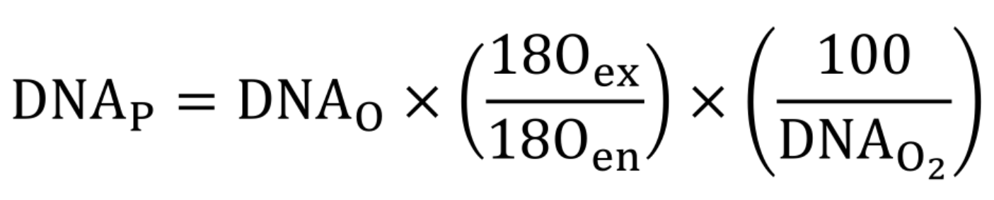(___5___)

and where MBC is the microbial biomass C (µg per g peat), DNA_{c} is the determined DNA concentration (µg per g peat), dw is the dry weight of the peat (g), t is the time of incubation (h), DNA_{O} is the measured amount of O from the isotopic analyses (µg), ¹⁸O_{ex} is the excess of ¹⁸O in the samples compared to the 16O replicates (at%), ¹⁸O_{en} is the enrichment of ¹⁸O within the respective sample, depending on the amount of ¹⁸O added to the sample before DNA extractions (at%), and DNA_{O2} is the O₂ content of DNA (weight%). C_{Respiration} was calculated based on equations (___1___) and (___2___). Additionally, the turnover time of microbial biomass in days was calculated using equation (___6___) (___Zheng et al., 2019___; ___Tian et al., 2023___):
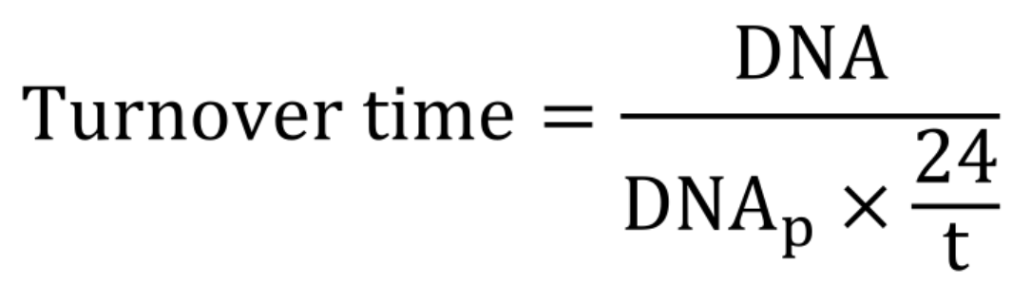(___6___)

where DNA is the quantity of DNA (µg), and t is the time of incubation (h).

The laboratory analyses, including respiration measurements, determination of MBC as well as DNA extraction, quantification and purification were performed within one month after starting the pre-incubation, and the samples were stored at 15 °C to ensure comparability of the derived results for the final CUE calculation.

Prokaryotic metabarcoding survey

For prokaryotic community analysis, 16s rRNA v4 amplicon sequencing was undertaken. DNA purification was done with MP Biomedical FastDNATM Spin Kit for Soil, following manufacturer protocols, with 450 mg soil samples. DNA was eluted in 75 μL volumes, and quantified using a Qubit 4 Fluorometer (Invitrogen, Waltham, Massachusetts, USA) with a dsDNA High Sensitivity Assay Kit. DNA quality in terms of A260/A230 and A260/A280 ratios were measured with Nanodrop One (Thermo Scientific, Waltham, Massachusetts, USA). Quality and total DNA yields varied heavily among samples, most likely due to the abundance of humic acids which were often visible as discoloration in eluted DNA. Several standard silicon matrix and glass-milk DNA cleaning kits were used in attempt to reduce humic acid contamination, but were not successful without near complete loss of DNA. Instead, discolored DNA solutions were diluted at 10× and added bovine albumin serum (BSA) was added to PCR mix, to improve success of PCRs (see next).

Microbial community positive controls (“mock communities”) were created using culture and DNA purification from readily available freezer stocks of Bacillus subtilis (Bacillota), Chryseobacterium luteum (Bacteroidota), Clostridium roseum (Bacillota), Enterobacter mori (Gammaproteobacteria), Franconibacter helveticus (Gammaproteobacteria), Glycomyces tenuis (Actinomycetetota), Pseudomonas fluorescens (Gammaproteobacteria), Pseudomonas putida (Gammaproteobacteria), Rhizobium endophyticum (Alphaproteobacteria), Streptomyces acidiscabies (Actinomycetatota), Variovorax guangxiensis (Betaproteobacteria), at equimolar concentrations and combined. Detailed information for strain identifications is available on request. Duplicate samples of mock community DNA standards were were included for sequencing. Duplicate negative (pure water) PCR controls were also included for sequencing.

Polymerase chain reaction (PCR) was conducted using Q5® High-Fidelity DNA Polymerase (New England Biolabs, Ipswich, Massachusetts, USA), in 25 μL volume reactions following manufacturer recipe and protocols (https://www.neb.com/de-de/protocols/pcr-using-q5-high-fidelity-dna-polymerase-m0491, accessed 23.09.2026) for , using including the use of 5X Q5 High GC Enhancer and 2 μL template DNA. Primers targeting 16S variable region 4 (16S V4) were used: forward primers targeted 16S 515F site (5’–GTGYCAGCMGCCGCGGTAA–3’) (___Parada2016___), but in three phased versions, differing by single basepair steps (___Wu, Wen, Qin, et al2015___) in equimolar concentrations totaling to the recommended single forward primer quantity. Reverse primers targeted 806R site (5’–GGACTACNVGGGTWTCTAAT–3’) (___Apprill2015___). All primers were tagged with Illumina nextera adapters, and in a second stage PCR with sample-specific barcodes. See supplementary information (___) for complete first-stage primer sequences. Unique sample barcodes were attached via secondary PCR, and sequenced with a Illumina iSeq platform at the University of Bayreuth Keylab for Genomics and Bioinformatics. (www.genomics.uni-bayreuth.de).

Bioinformatics and Statistical analysis:

16S rRNA sequence data denoising and cleaning
Sequence data were processed with command line tools using GNU BASH shell version 5.2.21 in a Ubuntu 24.04.5 computing environment. Where necessary, cleaning and reformatting of data were conducted with the pandas package version ____ in Python 3.12.3, and bioinformatic and statistical pipelines were conducted in R version 4.5.2. Graphics were generated with ggplot2, version 4.0.3 (___). A Jupyter notebook is available for most details of the bioinformatic and statistical pipelines, in the associated github repository (___), also viewable online with Jupyter nbviewer (___).

Primers were trimmed with cutadapt version 2.8 with Python 3.8.10. Denoising of reads and removal of chimeric reads was conducted with the dada2 package version 1.40.0 (__Callahan, McMurdie, Holmes2016___). Taxonomic identification of resulting amplicon sequence variants (ASVs) was done with the assignTaxonomy function from the dada2 package, which implements the Naive Bayesian Classifier algorithm (___Wang et al. 2007___), queried against the non-redundant 99% similarity radius SILVA 16S reference sequence database, version 138.2 (___). Taxonomic assignments were made to genus level. All reference 16S V4 sequences from ASVs were aligned using SSU-ALIGN version 0.1.1 (___) with a Bacterial evolutionary model. Resulting alignment was masked to retain only very high posterior probabilities for sequence placements and columns with high fractions of high-confidence sequence placements (pf and pt > 0.9999). Phylogenetic trees of all ASV reference sequences were constructed using FastTree2 version 2.1.7 (___) with a generalized time-reversible model. Archaeal sequences were used to root the resulting tree using the root command from the APE library (___) in R. The resulting ASV reference sequences, community matrix, phylogenetic tree and taxonomy data were handled as a phyloseq objects using the phyloseq package version 1.56.0 (___).

OTU definition was calibrated using mock community positive controls. Using the tip_glom function in the phyloseq package, ASVs were merged at various cophenetic distances, until the best possible balance between artificial merging of splitting of mock community taxa was reached at h=0.007. At this similarity radius, some splitting of most mock community taxa was still observed, but at any greater cophenetic distance Variovax was merged into other clades (see online Jupyter notebook for details). Maximum abundances from all OTUs observed PCR negative controls and mock community were subtracted from all other samples to reduce overall effects of possible index hopping (___Guenay-Greunke2021___). Consistent, large differences were observed between read abundances among taxa in mock community controls. A square-root transformation was applied to all abundances within each sample to reduce differences in abundance among target organisms without bringing rare, likely-contaminant OTUs to prominence, a problem which we observed in our data when log transformations were attempted. Abundances were then converted to relative abundance per sample (%), except where read abundances were required.

Bacterial Community analysis

Distance matrices of Bray-Curtis dissimilarities (___BrayCurtis1957___) among all samples were used as the basis for community-level analyses of bacteria. Dissimilarities were visualized with Non-metric multidimensional scaling (NMS) ordinations using the metaMDS() function from the vegan package (___), as implemented in the ordinate() command from the phyloseq package. Ward’s hierarchical clustering algorithm (___) was utilized for clustering of samples using the hclust() command in R. Groups were defined by cutting at a cophenetic height of 1.25, which was the lowest grouping that showed sensible patterns when mapped onto NMS ordinations and in agreement with depth section and geomorphological categories. Indicator species were calculated for each resulting cluster using the multipatt() command from the indicspecies package (___De Cáceres and Legendre 2009___), with Benjamini-Hochberg correction for multiple comparisons with a false discovery rate of 0.05 or less. Indicator species were visualized with the tabasco() command from vegan package and in Krona plots as implemented in plot_krona() function from the taxplore package (___). Differential abundance models for direct contrasts of OTU abundances among soil samples were conducted with the ANCOM-BC2 package (___), on read abundances that had been “cleaned” as above to reduce contamination and sequencing artifacts using positive and negative controls, but not square-root transformed nor converted to relative abundances.

Prediction of function in some ASVs and grouping into functional groups was conducted by extracting 16S rRNA seqences from all metagenome-assembled genomes (MAGs) observed by
Duchesneau et al. (___2025___) using the program “barrnap” version 0.9 (https://github.com/tseemann/barrnap) and formatted as a blastn (___) database. All full length (270 bp) matches from our OTUs with greater than 98% sequence similarity to a MAG from the dataset of Duchesneau et al. (___2025___) were retained as possible functionally-similar organisms, and were categorized according to the categories proposed by the authors in supplementary data 7.

CUE statistical methods
JSDM of

