Dan Thomas

12.06.2024

Some notes for additional microbiological sampling in the permafrost project:

For each micro-fossil core taken as planned in the original experimental design, an additional accompanying soil will also be extracted for CUE and microbial community sampling. Werner will use most of the material for estimating CUE: he will separate each core into several smaller sections based on distance from surface and frost-line, and these will be homogenized and sieved at BayCEER. Dan will then harvest ~1 g of the soil from each section that Werner creates for microbial sampling. So much of the microbial community samples will be harvested in the lab after the arrival of the soil cores to BayCEER.

However, some collection of separate samples for microbial sampling will occur in the field. These are the numbered arrows in the diagram:

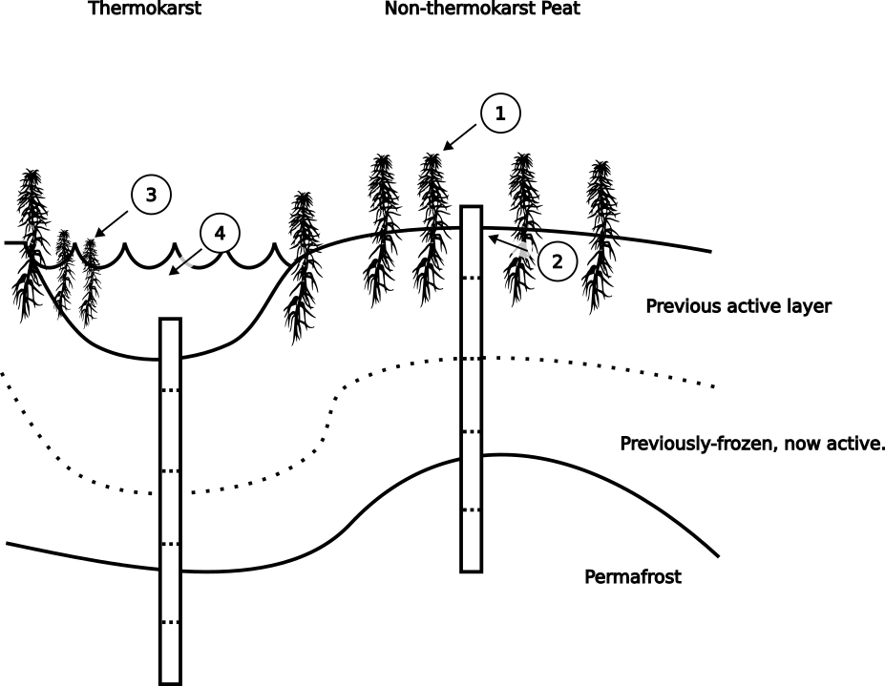

1. Living sphagnum heads. Fill one micro-centrifuge tube with living material from the top of the sphagnum plant closest to the site of the core. Grab with gloved fingers and/or a pocket knife and forceps.

2. Uppermost soil. Fill one micro-centrifuge tube with field-moist soil from the uppermost layer of soil, where the photosynthesizing layer of sphagnum layer stops and the brown, dead, dense mat of sphagnum peat begins. A small kitchen spoon and/or pocket knife may come in handy here.

3. Floating or encroaching sphagnum on thermokarst. If there is floating, photosynthesizing sphagnum on the water above the site of the core, fill a micro-centrifuge tube with this material, as per #1 above.

4. Water from karst. At each thermokarst where cores are taken, fill a micro-centrifuge tube with thermokarst water. Label before dipping into the water so you don't have to wait for the tube to dry. Dry off with a towel before placing with other samples so other tubes aren't exposed to excessive water.

Some notes about reducing cross contamination for microbial sampling:

* For handling of microbial samples in the field, wear disposable laboratory gloves. Between collection of different samples, spray gloves with ≥70% ethanol and wipe with a clean paper towel. It is okay if the gloves are discolored from soil, but no actual soil material should remain on the gloves between samples. Gloves should be discarded and replaced with fresh gloves at regular intervals, i.e. with every new core, or approx. every half-hour (whichever comes first).
* If you remove the gloves to do other tasks, keep the gloves inside-out when they are not on your hands. When replacing them onto your hands, invert them again so that the previous exterior side is again on the outside, and give an ethanol clean. If this is too complicated, discard the gloves and get a new pair.
* Place material directly into micro-centrifuge tubes, which are sterile.
* Minimize the amount of time that the micro-centrifuge tubes are open to the environment, open only just before collection, close immediately after.
* Try to keep samples cool and out of the sun. If possible, keep them on ice or cool packs, until they can be frozen.
* Whenever tools are used, such as a trowel or spoon for taking the upper layer of soil, do an ethanol clean with ≥70% ethanol and paper towel between collection of samples.
* If a lighter is available, it is also good to run the surface of metal tools over a small flame after ethanol rinse where this is possible, such as with spoons or pocket knives, etc. Be careful, the remaining ethanol can catch fire!

Labeling:

Please label all samples/micro-centrifuge tubes. Make sure that the labeling system includes information that allows us to determine which soil core the sample is associated with, and which type of sample material it is. A possible abbreviation system for the type of sample material could be:

S = sphagnum head plant material (#1 or #3 above)

U = uppermost soil (#2 above)

W = water from thermokarst (#4 above)

Also write the date somewhere on the tube. So each tube should have written directly on it:

[name/number of associated soil core] + [ S / U / W ] + date

* Use permanent markers. I will send two permanent, fine-tipped "sharpies".
* If the micro-centrifuge tube has become muddy during the sampling, wipe the exterior with a paper towel and wait for the surface to dry enough to allow writing with pen.
* It is often useful to write labels before going to the field for sampling, to reduce errors from rushing and to avoid having to write on dirty tubes. Bring extra blank micro-centrifuge tubes for when mistakes happen.
* Keep additional notes somewhere so that it is clear to others which sample corresponds to which core/location, and any other information that might be of interest. A spreadsheet of sample information is always welcome but not required.