Documenting project work
SportHub web application

Premontrei Vocational High School and Technical School
Keszthely
2026
Software Development and Testing Major
5-0613-02-03
Created by:
Matthew Farkas, Daniel Decs

Content
Introduction 3
Annex 5
Database 6
Backend 7
Frontend 8
Applications 9

Introduction
The aim of the project, implemented within the framework of the project work, was to design and develop a web application that supported users in effectively mapping and utilizing local sports opportunities. With the application, we created a central, user-friendly platform that collected and organized the sports opportunities available in local communities, facilitating easy access and transparency of information.
The system aimed to address the problem that people who wanted to play sports often had difficulty finding reliable and up-to-date information about sports facilities, sports programs, and community events available near their homes. The application provided the ability to search and filter by different sports, venues, and events, taking into account aspects such as geographic location, accessibility, opening hours, costs, and user ratings and feedback related to the given options.
The target group was a broad group of people who wanted to do sports. This included regular exercisers who were looking for new locations or training opportunities, as well as beginners who were just getting to know a sport and needed help taking their first steps. The application proved to be particularly useful for those who had moved to a new city or town, as they found it difficult to find suitable sports facilities in an unfamiliar environment.
The project also aimed to promote a healthy lifestyle and regular physical activity, as well as to reduce the negative effects of a sedentary lifestyle. With the application, we wanted to encourage users to develop and maintain an active lifestyle by making sports opportunities easily accessible and attractive. We also contributed to increasing the visibility of local sports communities, sports clubs and service providers, thereby helping to strengthen community relations.
The aim of the thesis was not only to present the functionality of the application, but also to analyze the technological solutions, design principles and user needs applied during the development process. In the thesis, we presented the steps of the system design, the technologies used, and the decisions that served to improve the user experience and the efficiency of the system.
Our Gantt chart helped us a lot in meeting deadlines and moving forward more smoothly!

Appendix
Gantt chart
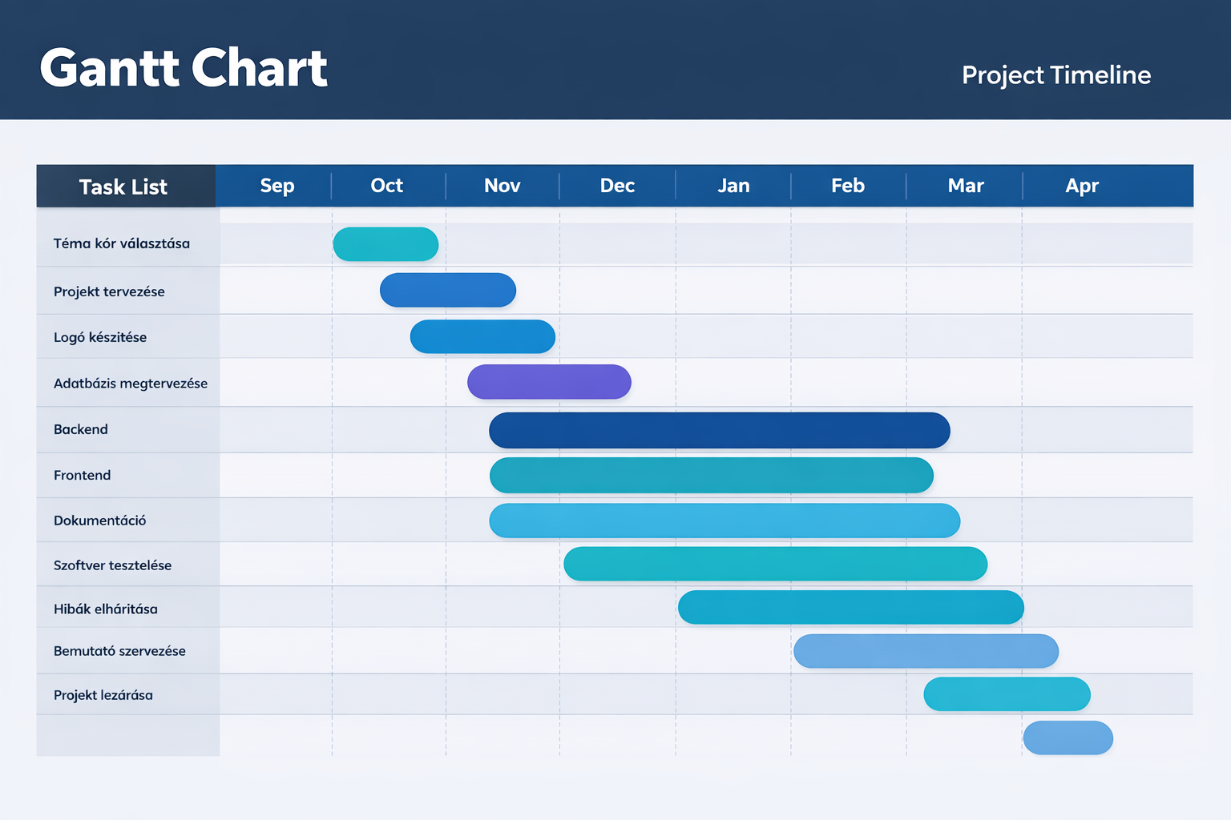
1 : Gantt chart (own source)

Database
The database is one of the most important parts of the project, as it provides structured storage and management of the data necessary for the operation of the application. The database allows information to be retained, retrieved, and modified in the long term. Without it, the application would not be able to properly manage user data and the information necessary for the operation of the system.
During the project, we used a relational database , which is built up of tables. These tables consist of rows and columns, where each row represents a record and each column represents a specific property. Relationships can be created between the tables, which ensure the relationships between the data and data consistency. This structure makes the data transparent and easy to manage.
MySQL / MariaDB database management system, which is part of the XAMPP package, to manage the database . The system uses SQL ( Structured Query Language ) that provides the ability to query, insert, modify, and delete data. SQL commands are used by the application to communicate efficiently with the database.
In a database, separate tables are used to store specific data, such as user data, records, or other information needed for the operation of the project. Creating the appropriate data structure helps to avoid duplication and incorrect storage of data. The use of primary and foreign keys ensures logical relationships between tables.
During development, the database was run locally using XAMPP. This allowed for quick testing and easy bug fixes without having to use a production environment. The database was easy to manage using the php MyAdmin interface, making it easy to check and modify data.
Overall, the database ensures the stable operation of the application, the secure storage of data, and the efficient management. A properly designed database contributes to the reliability, expandability, and long-term usability of the system.

Backend

Frontend

Applications
Visual Studio Code
Visual Studio Code is a free source code editor that supports a variety of programming languages. We used it to write and edit frontend and backend code during the project. It made the development process more efficient with its extensions.

Xampp
XAMPP is an easy-to-use web server package that includes the Apache web server, MySQL / MariaDB database, and PHP. We used it to run and test the project locally in a development environment. It provided server-side functionality and database management.

Discord
Discord is an online communication platform that allows for text and voice communication. We used it for communication and coordination between team members during the project. It facilitated rapid information sharing and collaboration.

Inkscape
Inkscape is a free, open-source vector graphics editor. We used it to design and create the project logo. It allowed us to create high-quality, scalable graphics.

Gantt chart own source

