SonarQube Installation Walkthrough

# Overview

This guide will help us install the SonarQube reporting tool and one or more scanners. We have the goal of being able to use this third party tool in order to run through C# code and generate corresponding reports related to code metrics and potential quality issues.

# SonarQube in a Nutshell

## The solution has two significant components/modules.

1. Reporting Solution – this consists of a web server and app that is our interface to the reporting tool component of the solution. This module also contains a simple DB for trial/demo services, as well as a listener service that receives output from…
2. Code Scanner – There are several different code scanners (See resources below) that can be configured to statically analyze your code and send data to the Reporting Solution noted above. This walkthrough has the goal of setting up and running a scanner for C# projects.

# Pre-Requisites & Packages Checklist

1. 64 Bit everything – It is recommended here that you ensure all your installations and configurations stay at the same platform level, in this case 64 bit.
2. [Java SDK (64 bit)](http://www.oracle.com/technetwork/java/javase/downloads/jdk9-downloads-3848520.html) – This is recommended as you need not only the “client” resources of the Java Runtime Environment (JRE), but also some of the tools from the development/operations side of Java deployments such as the JVM server. Installing the Java SDK will solve these issues nicely for us. In this case we’ll be installing JDK 9.0.4 64 bit for Windows.
3. [SonarQube LTS](https://www.sonarqube.org/downloads/) – Download the latest SonarQube edition (LTS – Long Term Support = the most stable/supported version for day-to-day use). In this case, we’ll be using the LTS 6.7.2 version.
4. Scanners – We want to visit the scanners page <https://docs.sonarqube.org/display/SCAN/Analyzing+Source+Code> in order to select scanners for installation and use with SonarQube. In this case, we want to use the Scanner for MSBuild <https://docs.sonarqube.org/display/SCAN/Analyzing+with+SonarQube+Scanner+for+MSBuild>
5. C# Plugin – We need to install the SonarSourceC# plugin
6. Code (your projects or samples) to scan

# Installation Walkthrough

1. Java SDK – perform a default installation of Java SDK or JDK.
2. Unzip the contents of the SonarQube download to a convenient area of your hard disk. We’ll select C:\ for now.
3. Test SonarQube by launching C:\sonarqube-6.7.2\bin\windows-x86-64\StartSonar.bat
   1. This launches a CMD line window where SonarQube’s web server and temp DB will be started up and respond to web request (<http://localhost:9000> ) and DB requests from the scanners. You need to keep this open 😊
   2. Test that SonarQube is running by heading to <http://localhost:9000> See the screen shots below.

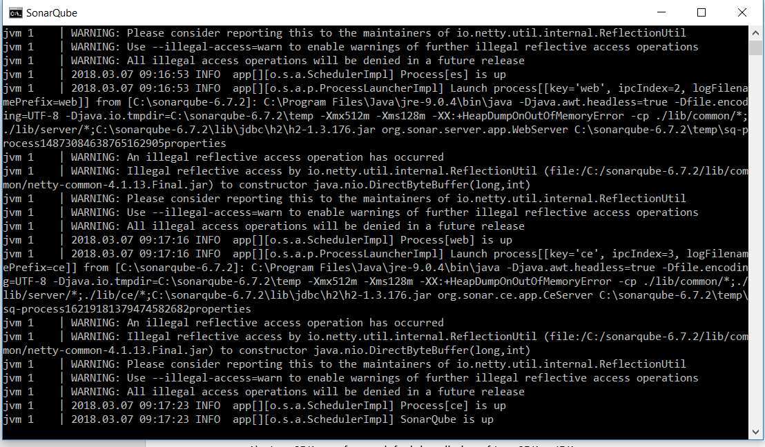 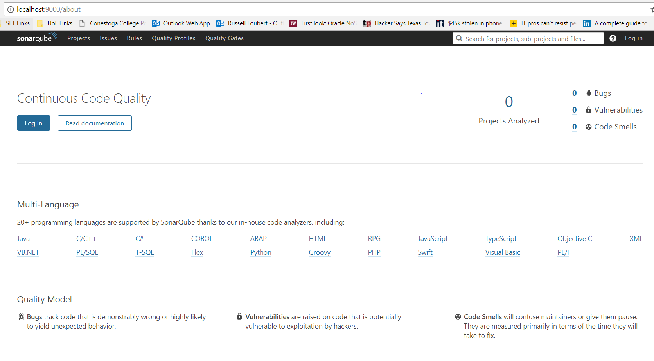

**Fig 1. SonarQube App is running on the left. SonarQube Web Interface default screen is on the right**

1. Login to SonarQube using admin/admin
2. Create a token. In my case, I named the token SETSQ2
3. Run Analysis on your project
   1. Selected C# or VB.NET
   2. Defined a unique project key ‘EMS’
   3. We are reminded to install the Scanner for MSBuild (incl. Path variable)
      1. In this walkthrough, the contents of the MSBuild downloaded package was unzipped to C:\sonarqube-6.7.2\bin
      2. C:\sonarqube-6.7.2\bin was also added to the PATH environment variables
   4. Very Helpful – Copy the Three command lines provided in the window (see below)

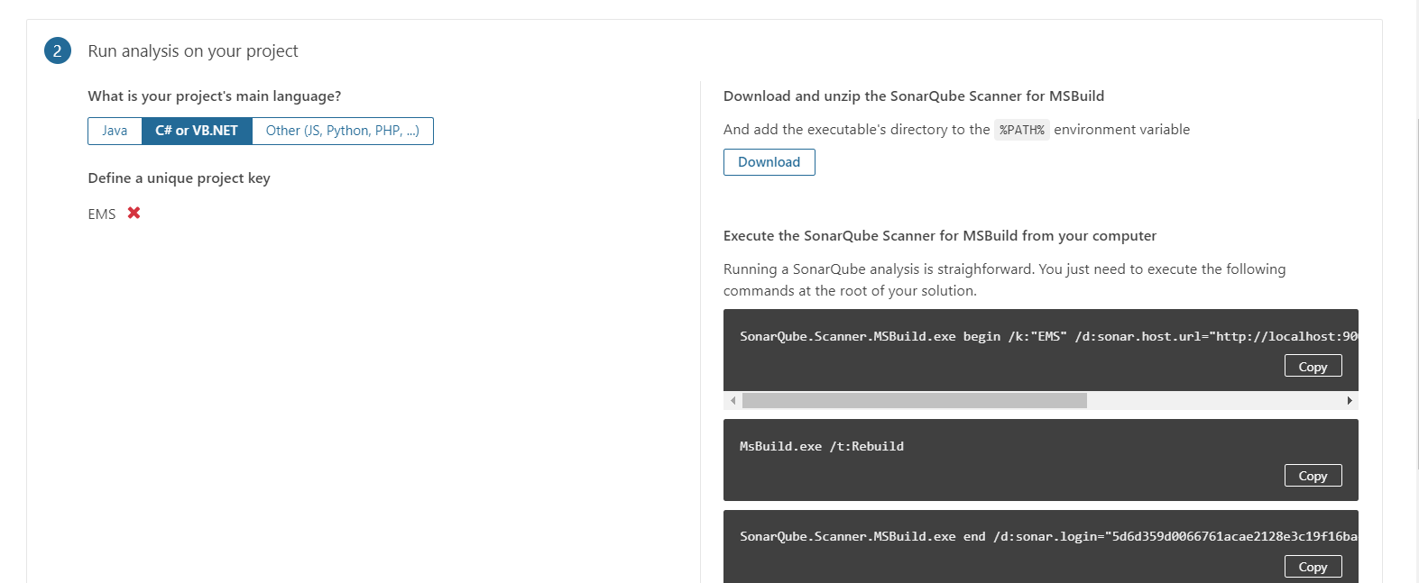

**Fig 2. Important Commands for Analysis During the ‘Tutorial’**

Each of the commands to be run are listed below. Note that my KeyID is provided below here for the Login parameter, and the project name 'EMS' has been specified. This would have to reflect your setup/project, obviously.

* SonarQube.Scanner.MSBuild.exe begin /k:"EMS" /d:sonar.host.url="http://localhost:9000" /d:sonar.login="5d6d359d0066761acae2128e3c19f16bac6b9cb8"
* MsBuild.exe /t:Rebuild
* SonarQube.Scanner.MSBuild.exe end /d:sonar.login="5d6d359d0066761acae2128e3c19f16bac6b9cb8"

NOTE: These Commands should be run from your Visual Studio Developer Command line tool! This allows us easy access to run MSBuild.exe!

NOTE: When you run the commands above, should ensure you have navigated at the command line to the 'root' directory of your project, in this case, it would be the project containing the .sln file.

7) Review Results – Back in the SonarQube web app, refresh your screen and you should have some project scan results to review (see below for an example).

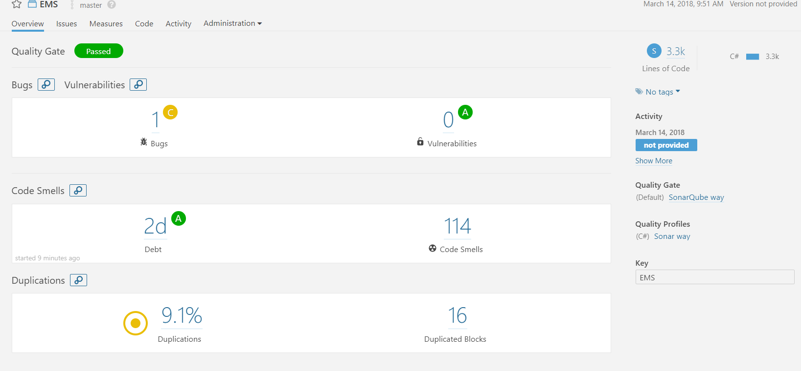

**Fig 3. Results of Analysis are Displayed**