Kimberly Arenas

Lab 1 – Option B Introduction:

The main goal of this lab was to compare all possible combinations of a password generating method with the users real password.

Proposed solution and design  
1. First task was to read a text file containing a list of users, their passwords and a

hashed password.  
a. In order to do this I was first going to convert the text file into a CSV file

and using a library called pandas to then manipulate the user passwords and hashed password using data frames.

1. However, I decided to simply access the text file directly in a method and loop through it and declare to variables. The first variable was for the column with the user password initialized at 1 and the second column with the hash password initialized at 2.
2. Then I created a method that recursively generated all possible combinations of “000”-“9999999” . To do this I first passed four variables in the signature method. First was an empty string, second was the max length needed for the possible combos, third was the variable that stored the user passwords in the text file reader method, and lastly I passed the hashed password variable declared in the text file reader method. Created a base case that states that once the length of the empty string (where the combinations are being stored) is reached then return that empty string.

1. Then created a for loop that generates a range of possible numbers 0-9 ... inside of it:

a. I store the all the possible combos with a variable b. Concatenate user password with the hashed

password and save it to a variable which I called

“concat”  
c. Pass the concat variable to the premade method

hash_with_sha256 and saved it to a variable  
iii. Lastly I created a method that checks if the passwords match with

the generated passwords with a simple if statement and retruns True if they do and false if not.

Kimberly Arenas Experimental results:

In this imagine above I set the maxlength variable to 2 instead of 7 to get a quicker result and little but anything the program ended up finding the matching password and printing out True and ended the program.

Conclusion:

I learned in this lab:  
How to read a txt file in python  
How to recursively generate numbers!

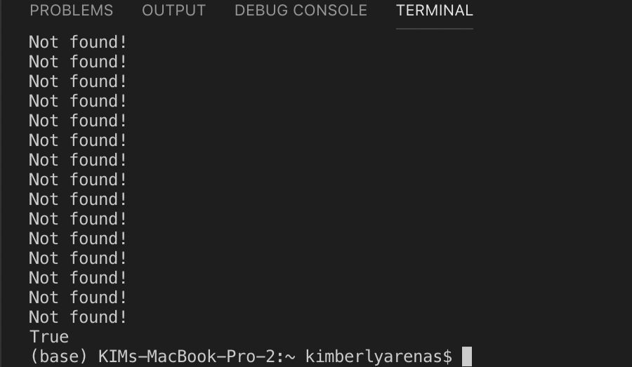 Improved:

page2image19967040

“I certify that this project is entirely my own work. I wrote, debugged, and tested the code being presented, performed the experiments, and wrote the report. I also certify that I did not share my code or report or provided inappropriate assistance to any student in the class.”