Enhancing Your Processes and Flows with Apex
Exercise Guide

Table of Contents
!Exercise Title 2
Template Instructions 2
Intro: Log In 2
Notes: Error! Bookmark not defined.
Notes: Error! Bookmark not defined.
Exercise 1: Create an Apex method that can be called from Flows

Goal:
Learn how to define an Apex class and method for use in a Flow.

Scenario:
Mike, a developer with Universal Containers, needs to log exceptions that are resulting from his commerce Sales process. Mike wishes to utilize a third party system called Loggly for monitoring and tagging the logs. Because the system requires a callout, Mike must integrate Apex into his Sales process, which is implemented through a Process and a Flow.

Tasks:

1. Signup for a Loggly account

2. Configure Loggly for Salesforce

3. Update the FlowLogglyUtil class for use in Flows.
Time:
15 minutes

Instructions:

1. Sign up for a loggly account

A. Go to http://www.loggly.com and sign up for a free account

2. Configure Salesfoce to work with your loggly account

A. Log into Salesforce.

B. Log into http://www.loggly.com with your credentials

C. In your Loggly account, go to Source Setup | Customer Tokens

D. Copy the Customer Token.

E. Back in Salesforce, go to Setup->Custom Metadata Types.

F. Click Manage Records next to Loggly Configuration.

G. Edit the Default Loggly Setting.

H. Copy the Customer Token from Step D. into the Loggly Token field.

I. If needed, copy and Paste the following URL into the Loggly URL field: http://logs-01.loggly.com/bulk/{0}/{1}/bulk/

J. Save the record.

3. Update the FlowLogglyUtil class for use in Flows.

A. Open the FlowLogglyUtil class in the developer console.

B. Add the @InvocableMethod annoation to the log method, specifying “FlowLogglyUtil” for the Name and Label attributes. (See: https://developer.salesforce.com/docs/atlas.en-us.apexcode.meta/apexcode/apex_classes_annotation_InvocableMethod.htm)

C. Invocable methods require a collection rather than primitives. Update the log method and the doCallout method to take a List<String> rather than a String parameter.

D. Save the Apex class.
Exercise 2: Update a flow to handle faults using Apex

Goal:
Learn how Apex can be used for extending the capability of a Flow.

Scenario:
Mike, the developer at Universal Containers, would like to use a combination of declarative and custom functionality for implementing a simple business process where Opportunities, which are marked as Closed Won, are converted into Order records. To implement this requirement, Mike is designing a solution that utilizes Flow, Processes, and Apex and using a mixture of both clicks and code.
Tasks:

1. Open the Order Processing Flow

2. Connect the fault paths to the FlowLogglyUtil element.

3. Save and activate the flow.

Time:
10 minutes

Instructions:

1. Open the Order Processing Flow.

A. In Salesforce, go to Setup->Create->Workflows & Approvals->Flows

B. From the View dropdown, make sure All Flows is selected.

C. Click the “Open” link next to Order Processing Flow.

D. In the Palette on the left had side, find the Apex class you created in Exercise 1, named FlowLogglyUtil, and drag it into the flow.

D. Use “Log Exceptions in Loggly” for the Name.

E. Use “Log_Exceptions_in_Loggly” for the Unique Name.

F. On the Inputs tab, verify there is a single row for assignment elements.

G. Select the messages parameter from the Target dropdown.

H. On the Source dropdown, find the SYSTEM AND GLOBAL VARIABLES list and select $Flow / FaultMessage.

G. On the Outputs tab under Inputs/Outputs, delete any output rows.

The FlowLogglyUtil element should look like the following:

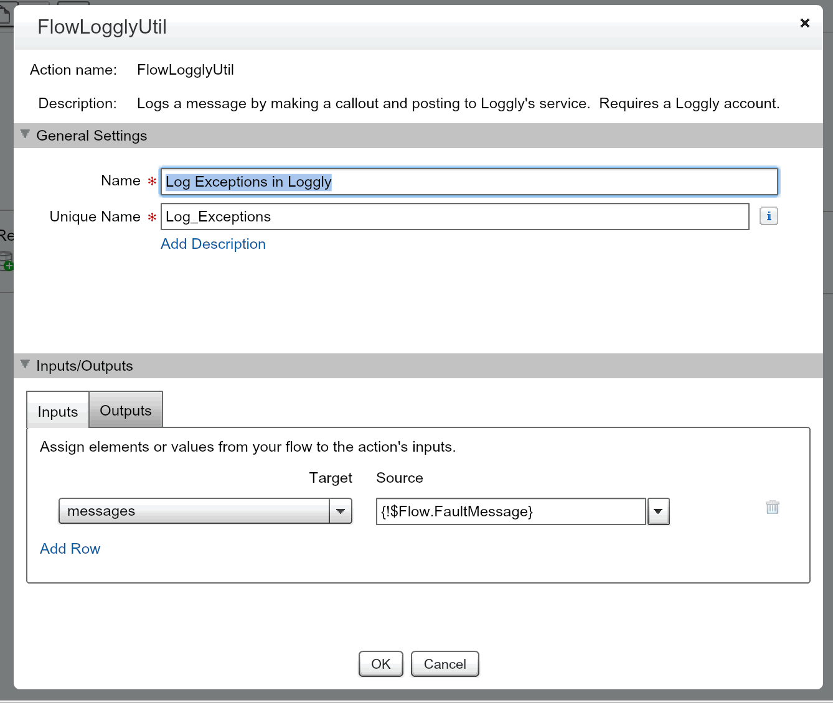

H. Click OK to close the FlowLogglyUtil window.

2. Connect the fault paths to the FlowLogglyUtil element.

Note: Fault paths are connections between elements that are executed when a flow fault occurs. To create a Fault path, two connections need to be made from an element. The second connection is the fault path is denoted with the phrase FAULT. If the first connection is not needed, it can be deleted.

A. Click and drag a connection from Create Order to Log Exceptions in Loggly. This should create a fault path.

B. Click and drag a connection from Lookup Opportunity Line Items to Log Exceptions in Loggly, creating another fault path.

C. Click and drag a connection from Create Order Items to Log Exceptions in Loggly, creating another fault path.

D. Click and drag a connection from the Post to Chatter element, creating the last fault path.

The final flow should look similar to below:

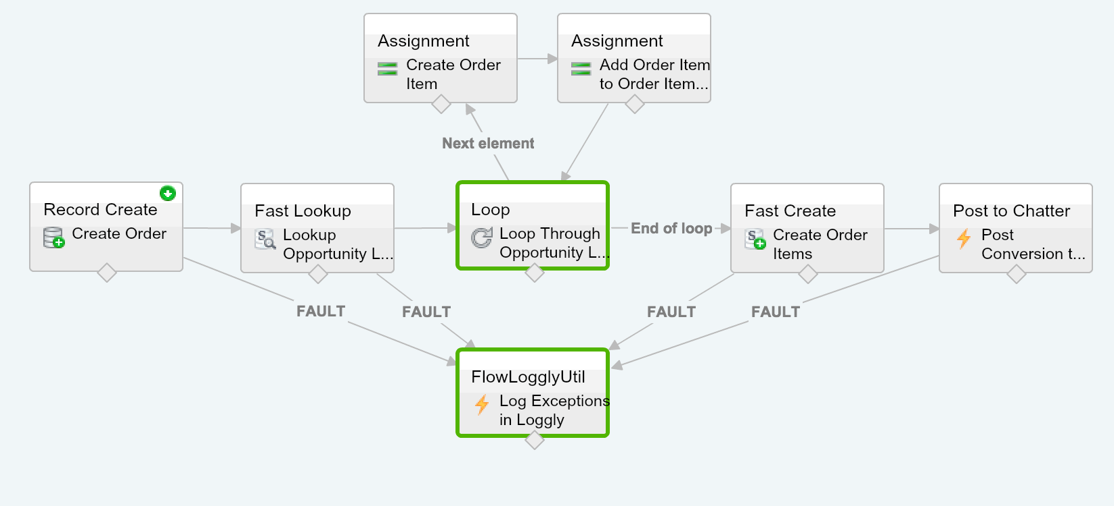

3. Save and Activate the Flow.

A. Click the Save button in the upper left corner.

B. Click the Activate link next to the Order Processing Flow to activate it.
Exercise 3: Create a Process to call the Order Processing flow

Goal:
In this exercise you will learn how to execute Apex in processes as well as learn how flows can be used in conjunction with processes to implement complex logic.

Scenario:
When Opportunities are Closed / Won, Universal containers would like to convert the Opportunities into Orders for invoicing and tracking. Universal Containers would like to record a message in their loggly service for auditing.

Tasks:

1. Create a Process that executes when an Opportunity is updated to Closed / Won.

2. Add an Apex action to the process for logging the Opportunity in Loggly.

3. Save and activate the process.

Time:
10 minutes

Instructions:

1. Create a Process that executes when an Opportunity is updated to Closed / Won.

A. Log into Salesforce.

B. Go to Setup->Create->Workflows & Approvals->Process Builder.

C. Click New.

D. Specify “Convert Cart To Order” for the Process Name.

E. Click on Add Object and specify Opportunity.

F. For the Start the process selection, select when a record is created or edited

F. Click on Add Criteria.

G. Specify “Opportunity Closed Won” for the Criteria Name.

H. Select Conditions are met from the Criteria for Executing Actions list.

I. Add the following conditions:

i. [Opportunity].Won Equals (Boolean type) True.

ii. [Opportunity].Closed Equals (Boolean type) True.

iii. It should look like the image below:

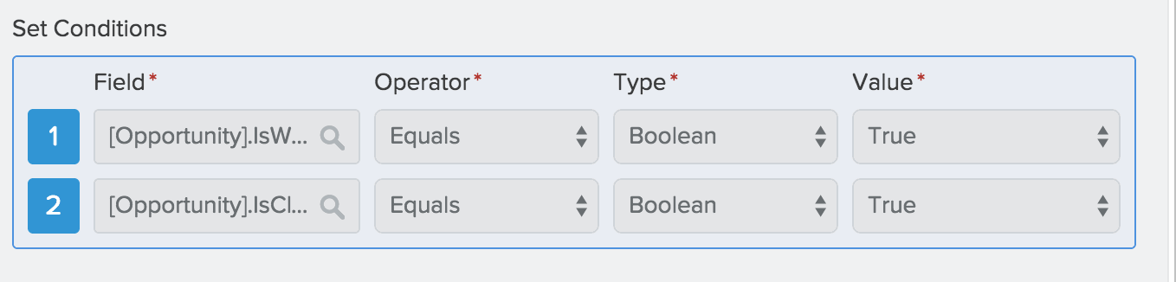

J. Select All of the conditions are met (AND)

K. Click Save.

L. Under Immediate actions, add a new Action.

M. From the Action drop down menu, select Flows.

N. Specify “Convert Cart to Order” for the Action Name.

O. From the Flow drop down, select “Order_Processing_Flow”.

P. Click on Add Row under the Flow Variables section and add a reference to the Opportunity. Before clicking save, it should look like the following:

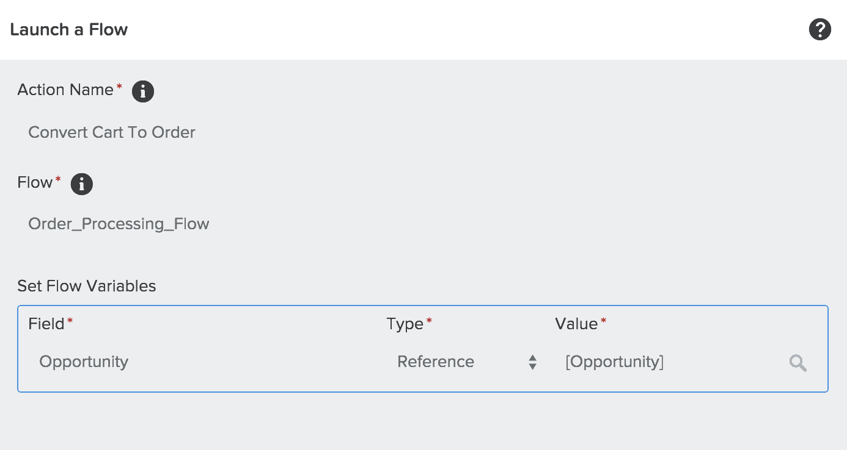

Q. Click Save.

2. Add an Apex action to the Process for logging the Opportunity in Loggly.

A. Under Immediate actions, add a new action.

B. From the Action dropdown, select Apex.

C. Specify “Add a Message To Loggly” for the Action Name.

D. Find the FlowLogglyUtil Apex class.

If you cannot find this Apex class, make sure you have added the InvocableMethod annotation and changed the parameter type to a List of strings (Task 3 and Exercise 1)

E. Click on Add row under Set Apex Variables.

F. Verify messages is selected for the Field column.

G. Change the Type column to Formula.

H. Click on the Build a Formula option and add a formula to the text box. Here’s an example:

[Opportunity].Name + " has been closed. Total Amount: " + Text([Opportunity].Amount)

I. Click the Use this Formula button.

Click Save, fixing any formula errors.

3. Save and Activate the Flow.

Exercise 4: Test the Process, Flow, and InvocableMethod

Goal:
Test that the Apex, Flow, and Process work as expected.

Scenario:
Sarah, a sales rep in Universal Containers has just closed a big deal. Universal’s process converts the Opportunities to Orders. When Sarah marks the Opportunity record as Closed, Won, the Opportunity and its line items will be converted to Orders and Order Item records and linked back to the Opportunity.

If the sales rep closes a deal where a customer has purchased more than 10 of a particular product, then a validation rule prevents that product from being recorded in Salesforce and the exception is logged in Loggly.

Tasks:

1. Create an Opportunity, update its Stage to “Closed/Won” and verify the Flow and Process copy the Opportunity record details to a new Order record.

2. Omit the Opportunity’s Account, testing that a Flow Fault occurs and logs the Fault in Loggly.
Time:
15 minutes

Instructions:

1. Create an Opportunity, update its Stage to “Closed/Won” and verify the Flow and Process copy the Opportunity record details to a new Order record.

A. Update the Opportunity Page Layout and add the Orders related list.

B. Create an Opportunity record:

i. Set the Stage of the Opportunity to “Prospecting”.

ii. Set the Account Name field to an existing or new Account. Failure to do so well result in a fault being thrown from the Flow.

C. Add Opportunity Products to the Opportunity.

D. After saving the Opportunity and adding its Opportunity Products, update the Opportunity’s Stage to Closed/Won.

E. Refresh the Opportunity detail page and look for a new Order record.

F. Verify the Order record also has Order Items matching the Opportunity Products created in step C.

2. Omit the Opportunity’s Account, testing that a Flow Fault occurs and logs the Fault in Loggly.

A. Create an Opportunity record in Salesforce with any Closed Date. Set the Stage of the Opportunity to “Prospecting”. DO NOT set the Account on the Opportunity.

C. Add a Product to the Opportunity.

D. After saving the Opportunity and adding its Opportunity Product, update the Opportunity’s Stage to Closed/Won.

E. Refresh the Opportunity detail page and look for a new Order record. Notice, there was no order record created!

F. Log into loggly the subdomain and username and password you created in the first exercise. Navigate to the dashboard tab at the top of the page and look for an event associated with the flow you just tested.

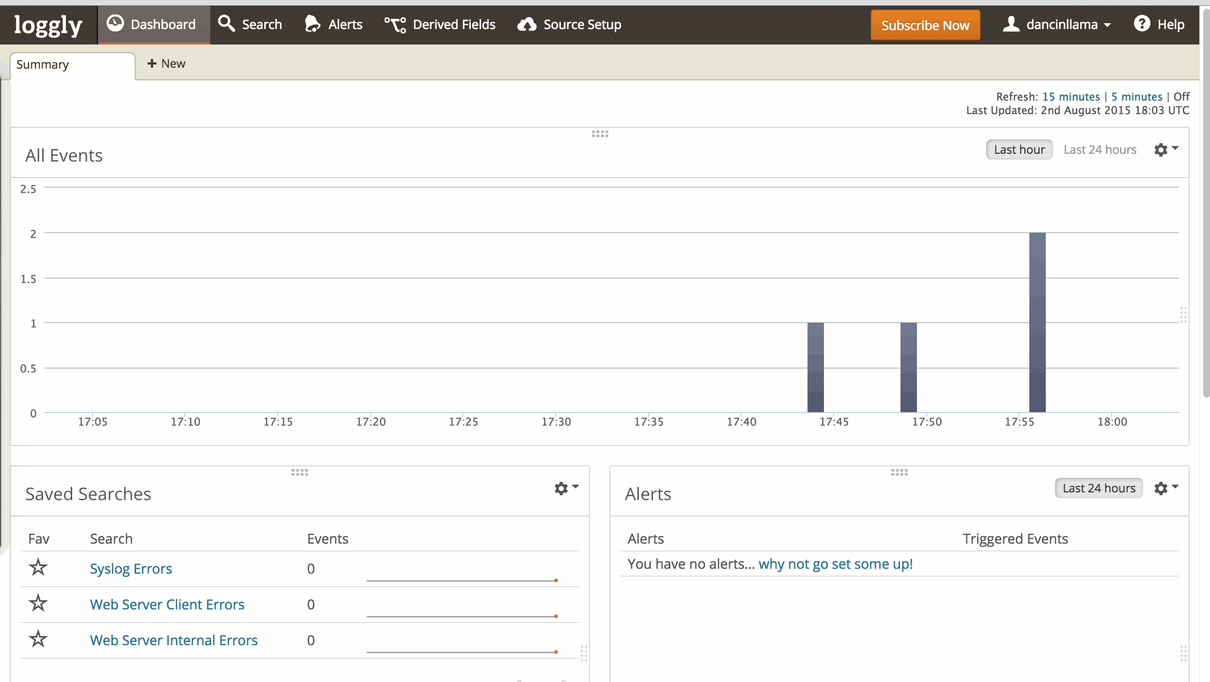

G. Click into the event, and you should see multiple messages. You should see a “Opportunity Closed” message as well as an error message similar to below:

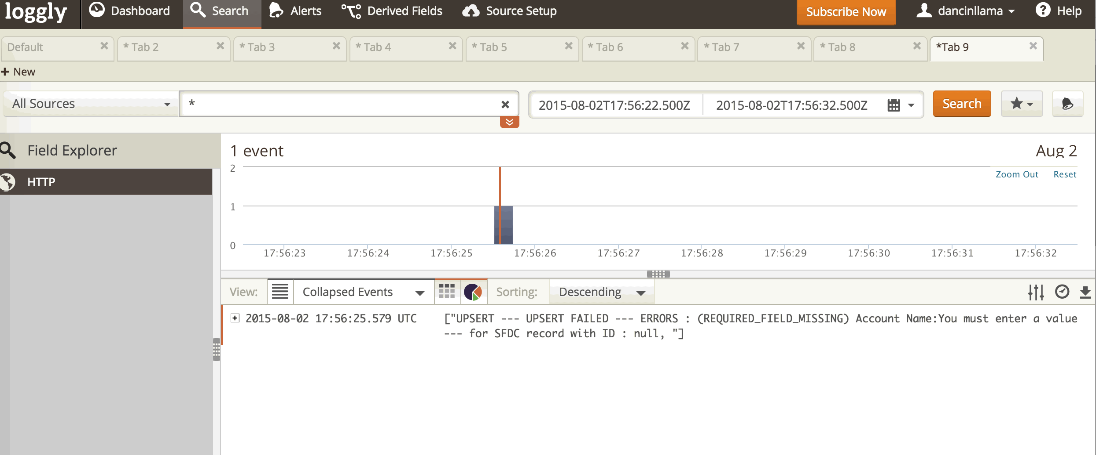

Congratulations, you have just used Apex to enhance your Processes and Flows and are well on your way to transcending both Clicks and Code!

Please note, if you formatted anything in the document without using the styles in the template (for example, using the B (bold) button) that formatting will be removed.

!StandardTable-AllBorders
Content | Content
Content | Content
Content | Content

!StandardTable-NoBorders
Content | Content
Content | Content
Content | Content

!StandardTable-WithHeader
Heading | Heading
Content | Content
Content | Content

