# **Lab 1 – EngSci 311 – Daniel Clark – 343733502**

Output:

1. Verification of both the power and power_w_deflate scripts by on the matrix given in Question 1 and 3 ×3 symmetric positive definite (SPD) matrix with distinct eigenvalues. For the 3 ×3 use either analytic (pen and paper) methods or an independent eigenvalue/eigenvector solver such as numpy.linalg.eig. (I used wolfram alpha)

To Test my ‘power’ function, I created the following test module, to test it with the 2x2 matrix we were given, and a 3x3 SPD matrix which I found online.

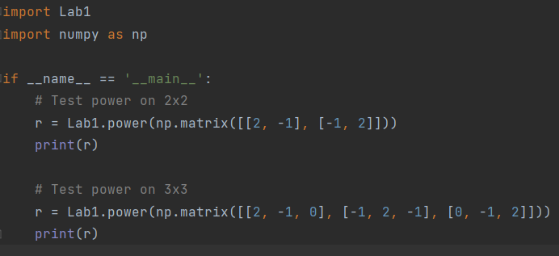

To verify my results from the 2x2 matrix, I calculated the eigenvalues and eigenvectors by hand:

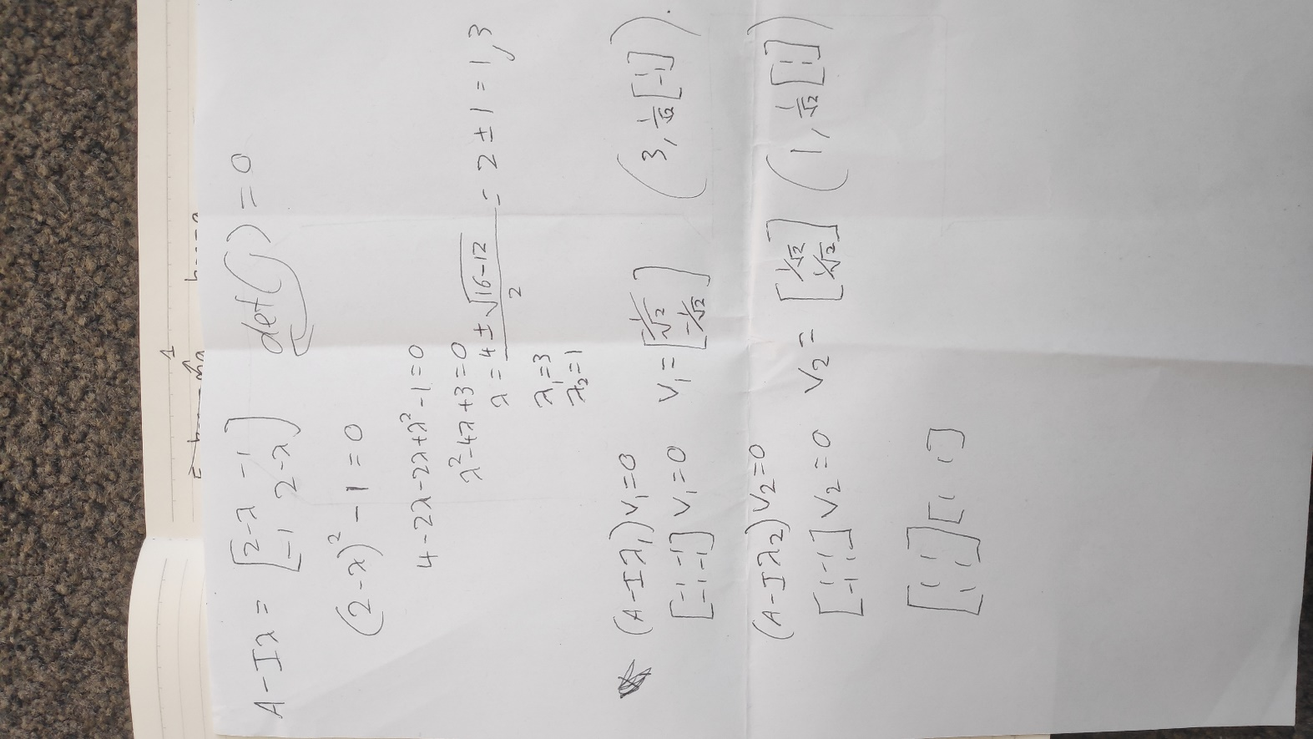

To verify my results from the 3x3 matrix, I used wolfram alpha:

Which gave the following results:

The results for the 2x2 matrix are correct (aside from negligible numerical error) as the eigenvalue given is effectively equal to 3, and the vector is [-1/root(2),1/root(2)], which is simply -1 times the result I found by hand, so is also correct. The results for the 3x3 matrix are also correct, as 3.414=1+root(2), and[ 0.5, -1/root(2), 0.5] is the **normalised** version of eigenvector 1 given by wolfram alpha.

To test the power_w_deflate function, I used the following function call and output printing:

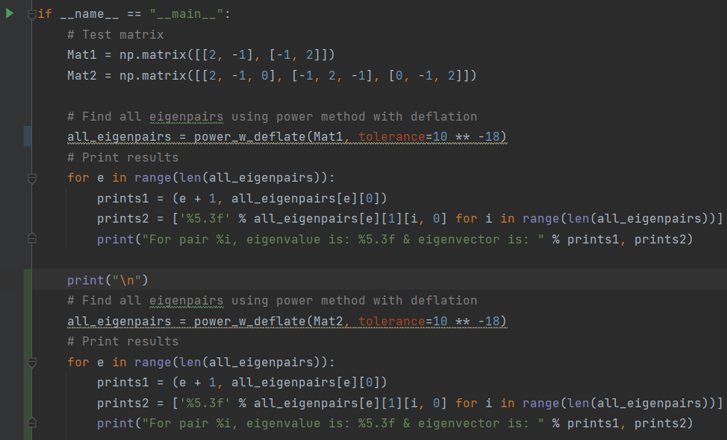

Which gave the following output:

These results are all as expected from the earlier verification, so the functions are working correctly.

1. Display all the natural frequencies and eigenvectors for the case of N = 10 masses with all spring constants equal to 1 (i.e. K1 = K2 = ··· = K10, even though the code should handle arbitrary N and spring constants Ki).

Interpretation:

1. Use a graph to compare the natural frequencies from Question 3 using an independent eigenvalue solver such as numpy.linalg.eig with the natural frequencies you obtained using the power method & deflation for ∆ ∈ {1e−2,1e−4,1e−6,1e−8}, Comment on any trends (Hint: Consider what ∆ represents and also the order in which modes/frequencies are computed).
2. Write one paragraph explaining what the eigenvectors and eigenvalues found in Question 3 represent.

Appendices: