Section 5.5 Schematic Comparison Figures

Figure X.1: Classical Sparse MoE Layer
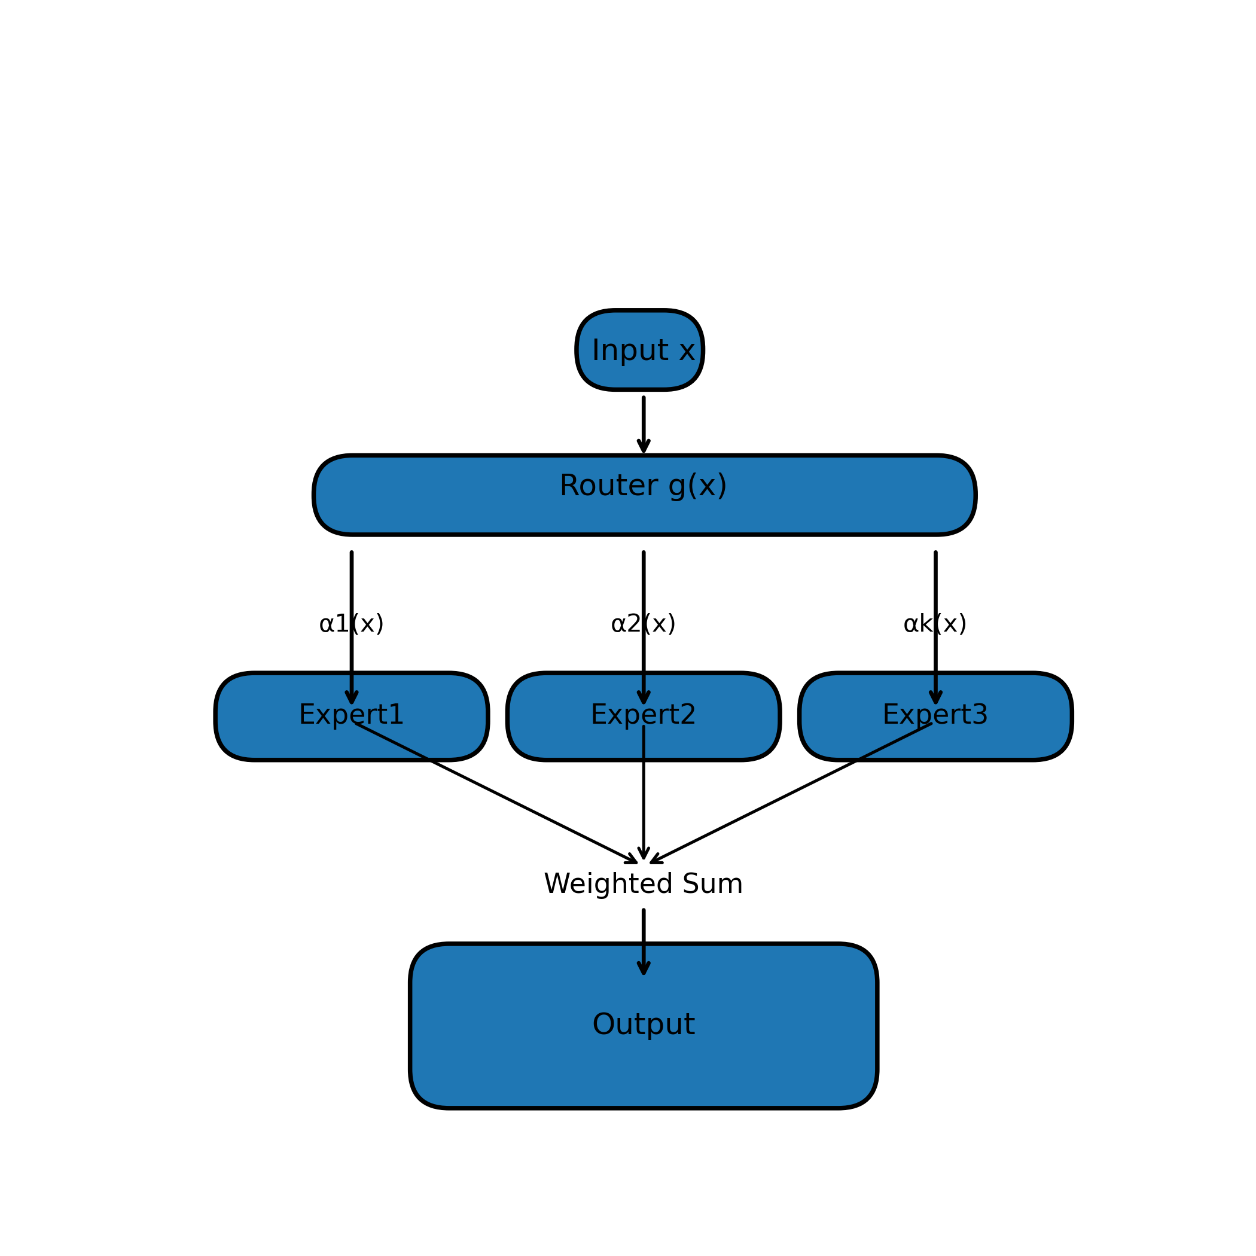

Figure X.2: Multi-LoRA Adapter Structure
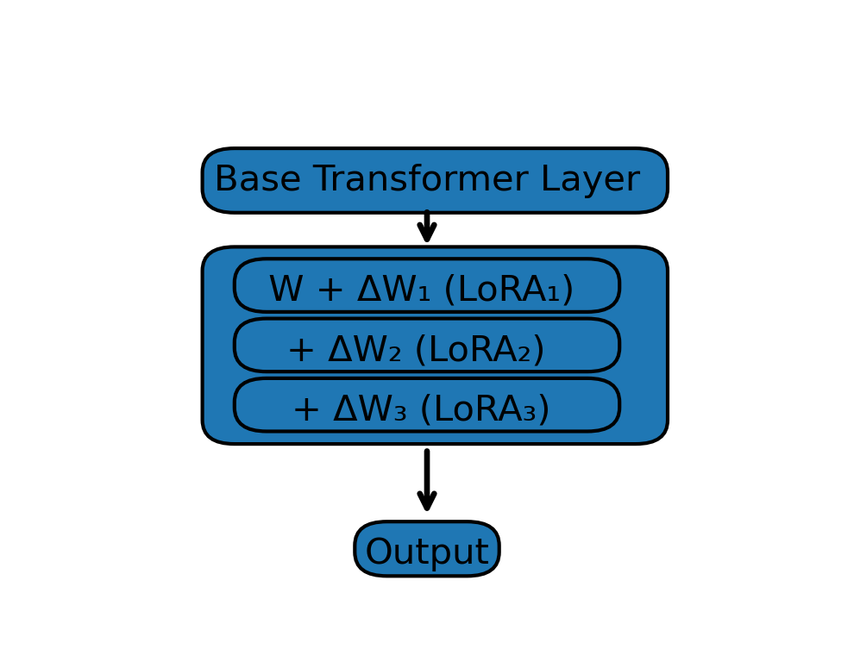

Figure X.3: Residual Modular Experts with Router
