考虑超帧头后的结果：

瑞利信道：
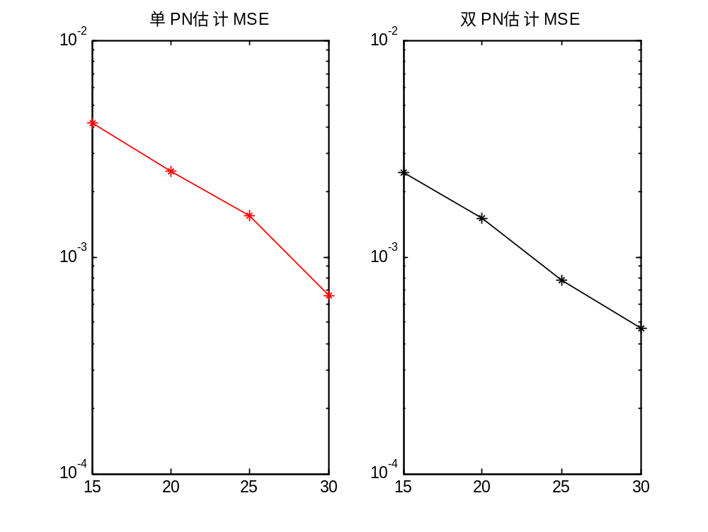

SNR | 单PN | 双PN
15 | 0.0041 | 0.0025
20 | 0.0025 | 0.0015
25 | 0.0016 | 0.0008
30 | 0.0007 | 0.0005

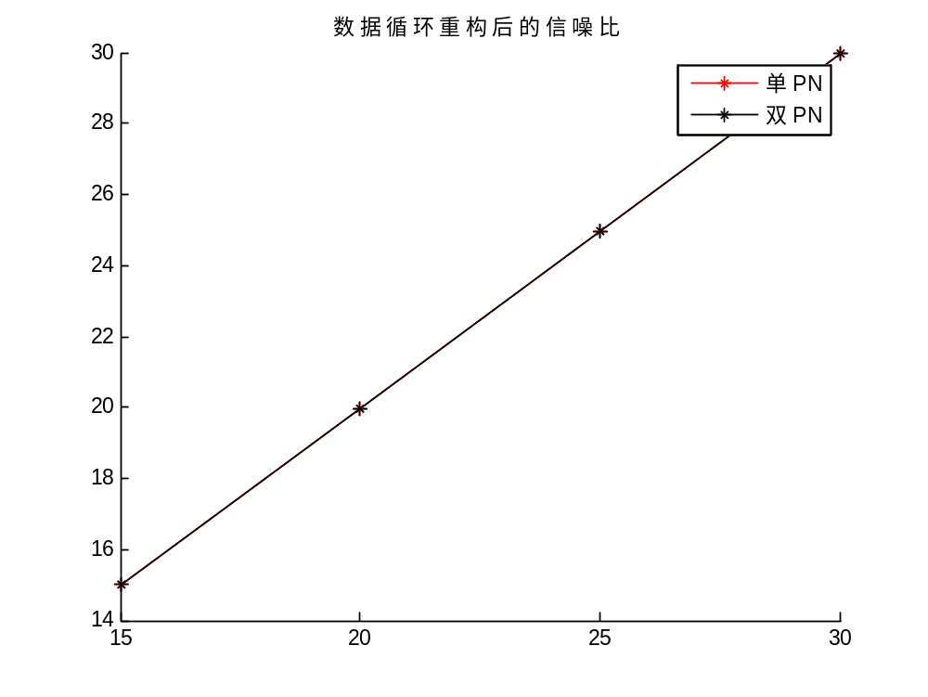
SNR | 单PN | 双PN
15 | 14.9877 | 14.9859
20 | 19.9883 | 19.9848
25 | 24.9883 | 24.9866
30 | 29.9887 | 29.9855

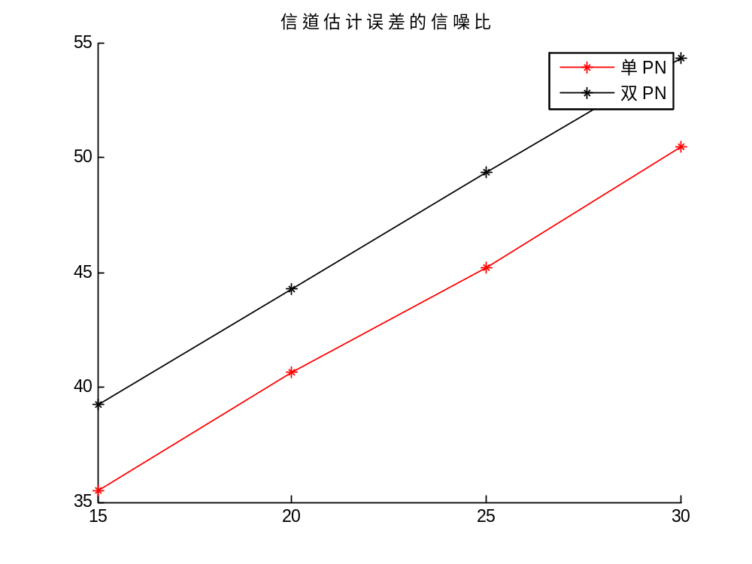
SNR | 单PN | 双PN
15 | 35.4743 | 39.2179
20 | 40.6271 | 44.2967
25 | 45.1794 | 49.3818
30 | 50.4766 | 54.3564

新的方法2
瑞利
SNR | Mse(SPN) | Mse(DPN) | SNR(SPN) | SNR(DPN) | SNR(SPN) | SNR(DPN)
15 | 0.0038 | 0.0025 | 14.9879 | 14.9860 | 37.3672 | 42.3157
20 | 0.0021 | 0.0015 | 19.9884 | 19.9848 | 43.5805 | 47.2803
25 | 0.0011 | 0.0008 | 24.9884 | 24.9866 | 48.1026 | 52.4233
30 | 0.0007 | 0.0005 | 29.9887 | 29.9855 | 52.1305 | 57.4526
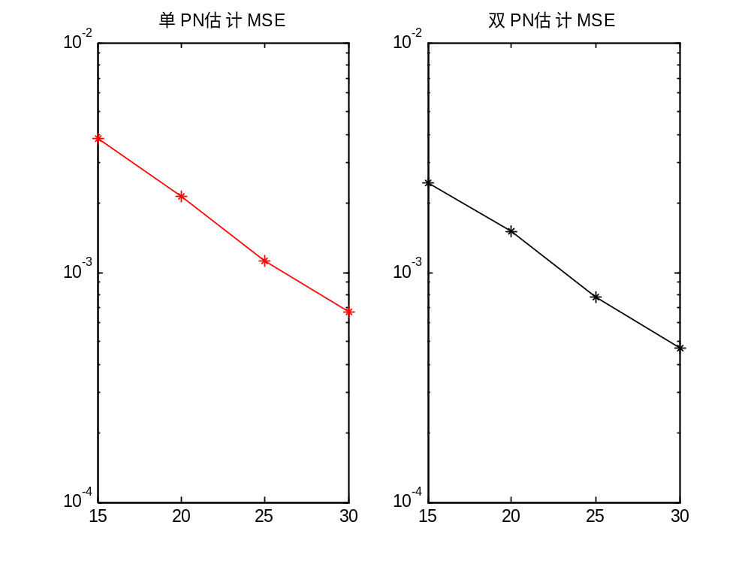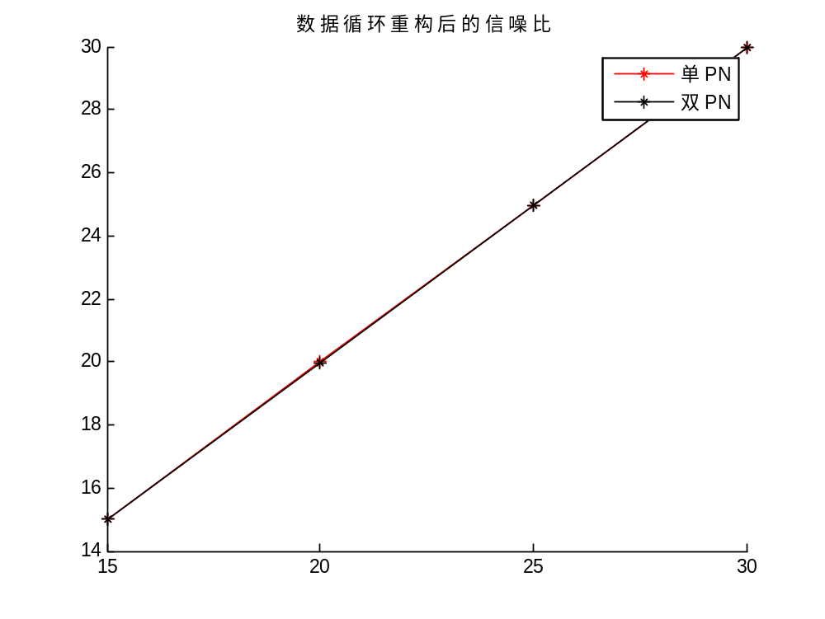
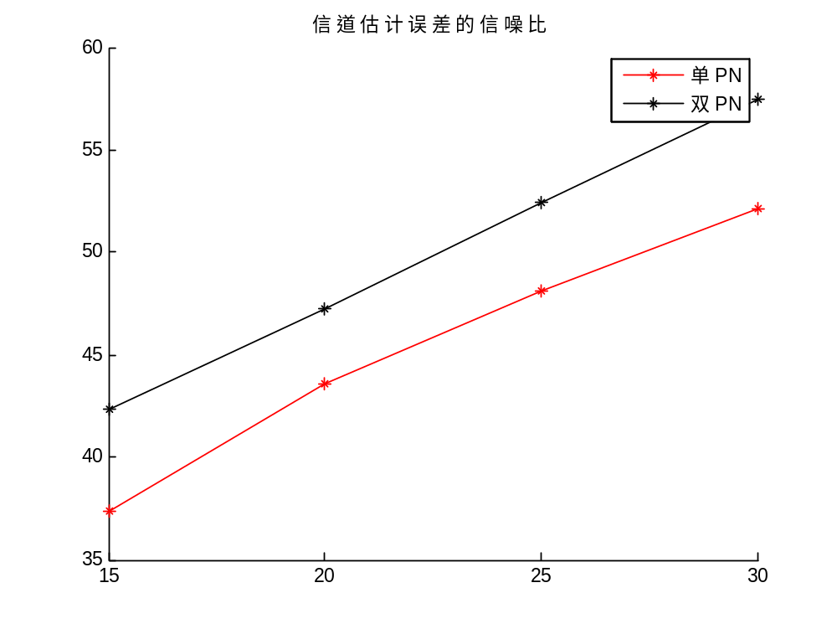
莱斯
SNR | Mse(SPN) | Mse(DPN) | SNR(SPN) | SNR(DPN) | SNR(SPN) | SNR(DPN)
15 | 0.0042 | 0.0024 | 14.9884 | 14.9871 | 38.3699 | 42.4443
20 | 0.0029 | 0.0014 | 19.9897 | 19.9861 | 42.5661 | 47.5684
25 | 0.0020 | 0.0008 | 24.9877 | 24.9855 | 47.7993 | 52.5688
30 | 0.0018 | 0.0004 | 29.9885 | 29.9870 | 52.0581 | 57.5716

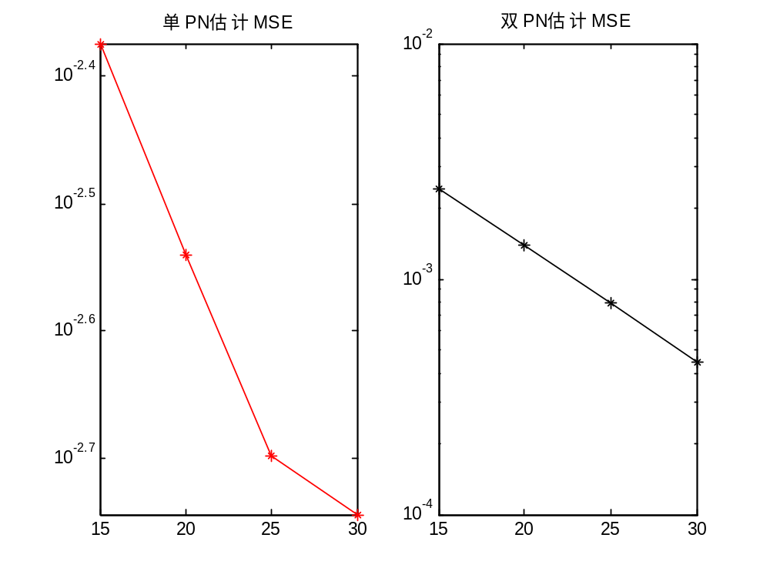
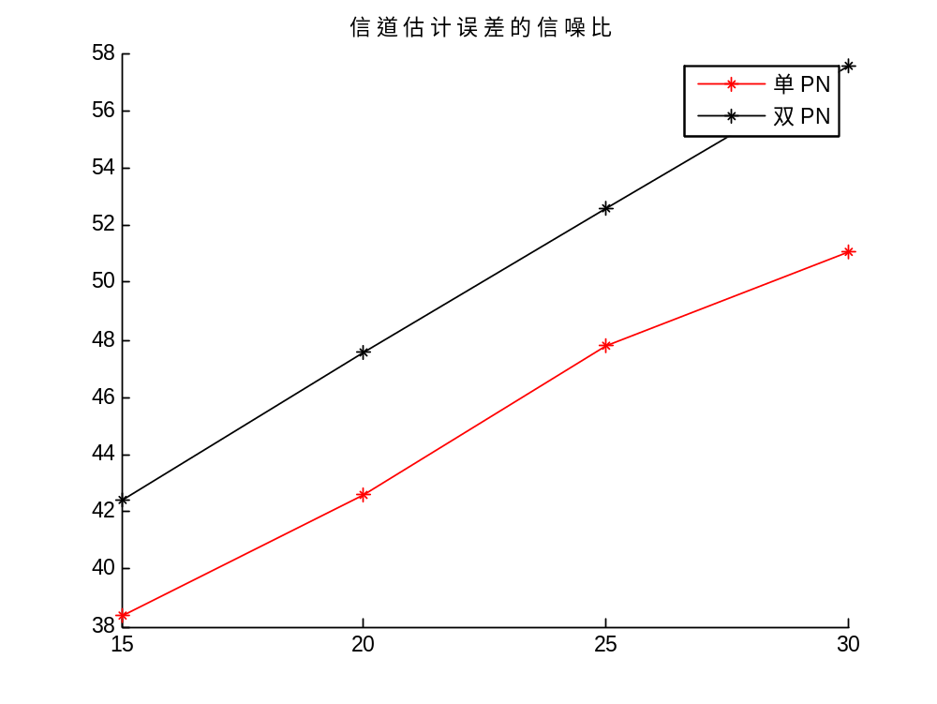

方法二：消除数据干扰，且考虑超帧
Dtv8（在初始信道估计准确的前提下）
SNR | Mse(SPN) | Mse(DPN) | SNR(SPN) | SNR(DPN) | SNR(SPN) | SNR(DPN)
10 | 0.0898 | 0.0083 | 9.9547 | 9.9603 | 22,0201 | 32.3589
15 | 0.0515 | 0.0044 | 14.9557 | 14.9604 | 27.1571 | 37.3467
20 | 0.0464 | 0.0027 | 19.9533 | 19.9595 | 28.9864 | 42.2965
25 | 0.0372 | 0.0015 | 24.9425 | 24.9608 | 29.9278 | 47.3615
30 | 0.0344 | 0.0008 | 29.9089 | 29.9599 | 30.1755 | 52.3660
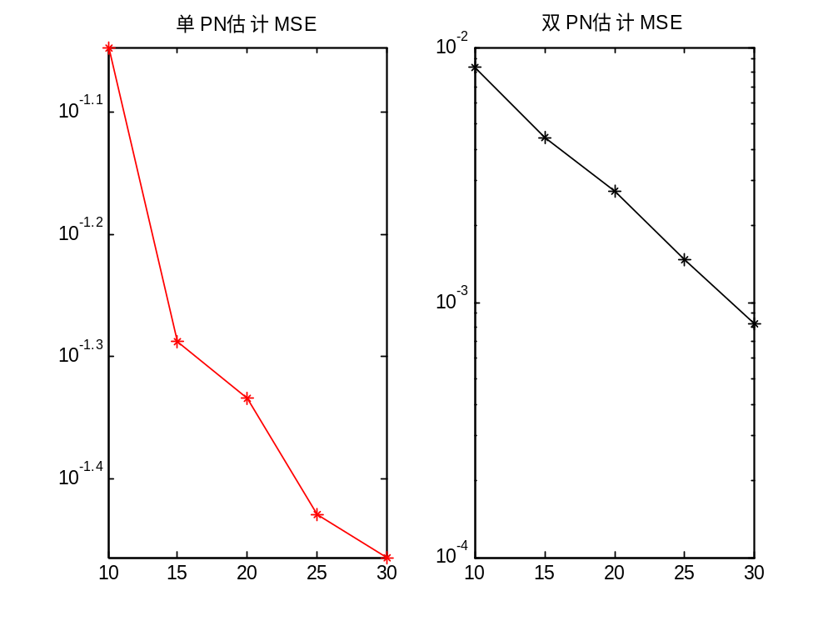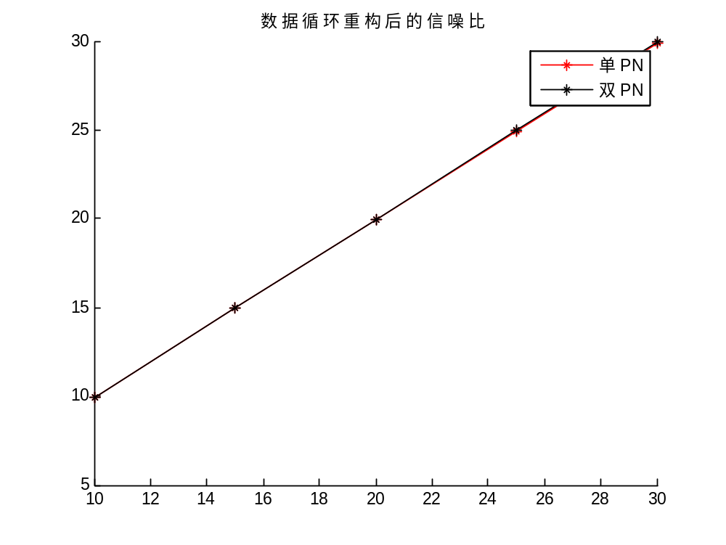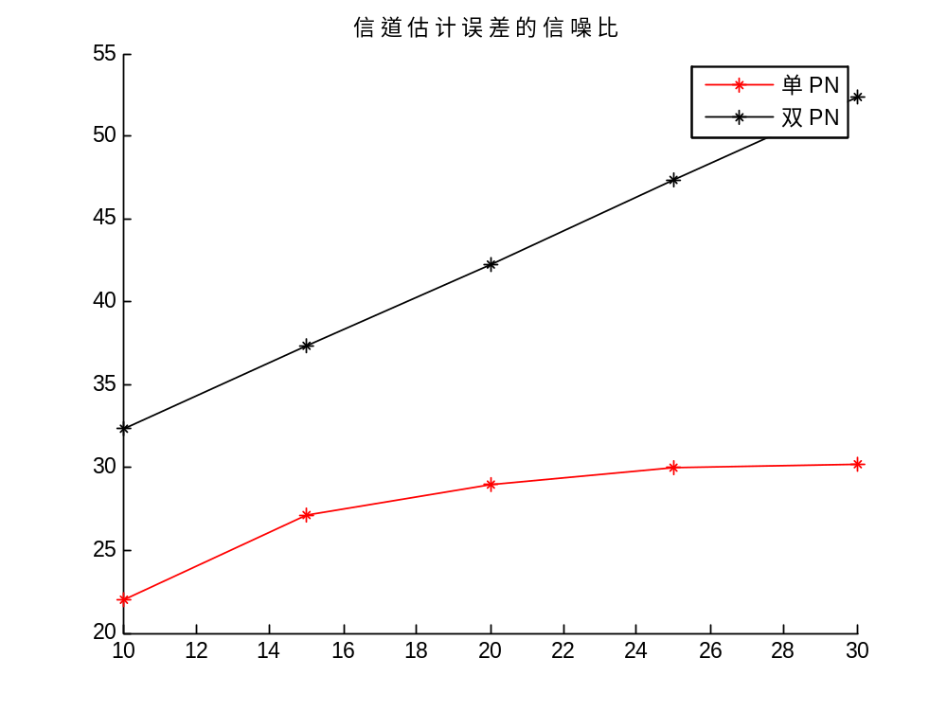
Dtv8
SNR | Mse(SPN) | Mse(DPN) | SNR(SPN) | SNR(DPN) | SNR(SPN) | SNR(DPN)
15 | 0.1765 | 0.0044 | 14.8595 | 14.9604 | 14.3520 | 37.3467
20 | 0.0724 | 0.0027 | 19.9334 | 19.9595 | 22.2375 | 42.2965
25 | 0.0390 | 0.0015 | 24.9330 | 24.9608 | 27.8534 | 47.3615
30 | 0.0343 | 0.0008 | 29.8940 | 29.9599 | 29.1104 | 52.3660

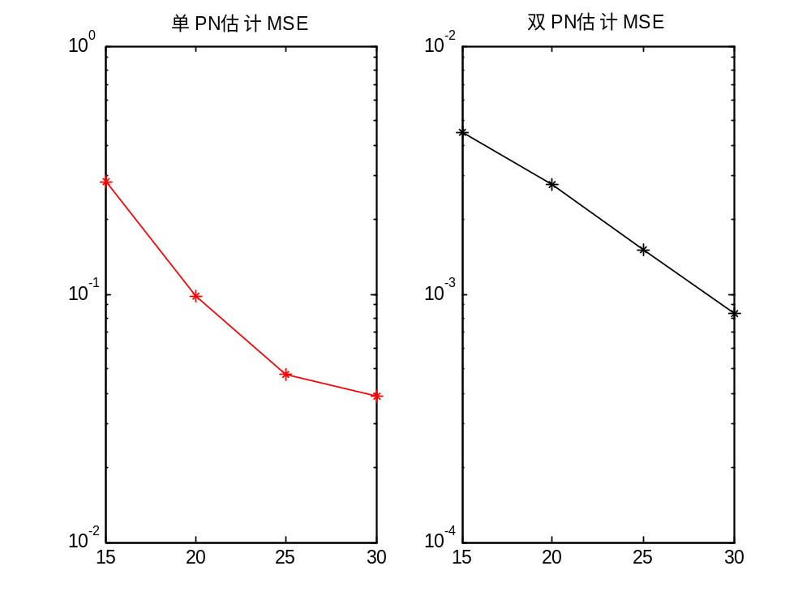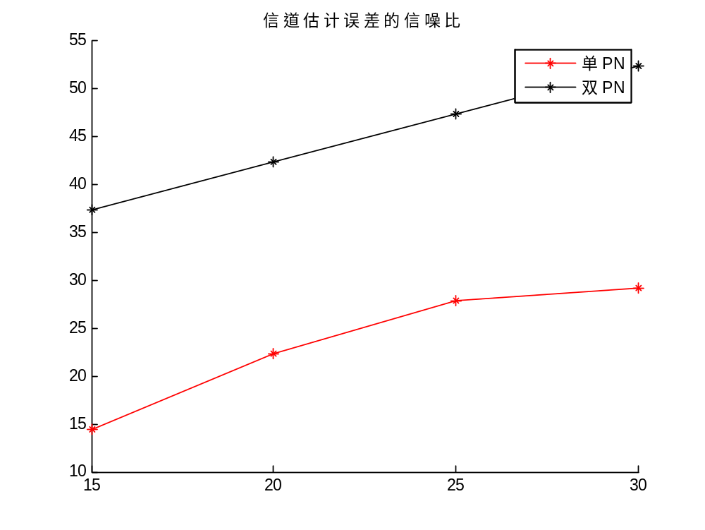
瑞利
SNR | Mse(SPN) | Mse(DPN) | SNR(SPN) | SNR(DPN) | SNR(SPN) | SNR(DPN)
15 | 0.0042 | 0.0025 | 14.9876 | 14.9860 | 37.2064 | 42.3301
20 | 0.0025 | 0.0015 | 19.9882 | 19.9848 | 42.8176 | 47.2911
25 | 0.0024 | 0.0008 | 24.9883 | 24.9866 | 46.7319 | 52.4454
30 | 0.0015 | 0.0005 | 29.9887 | 29.9855 | 51.2136 | 57.4399

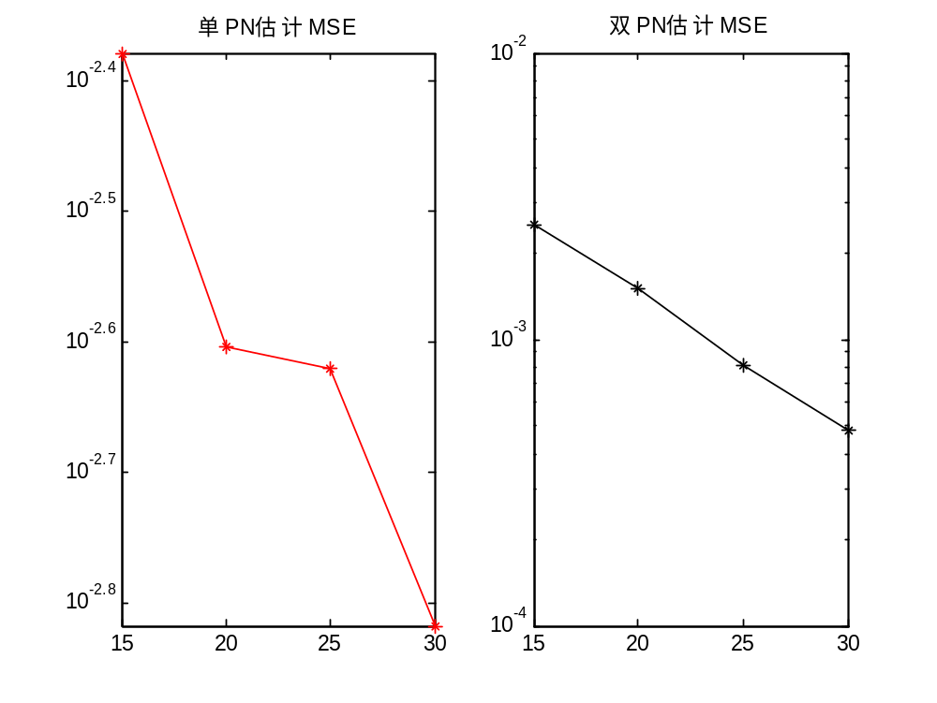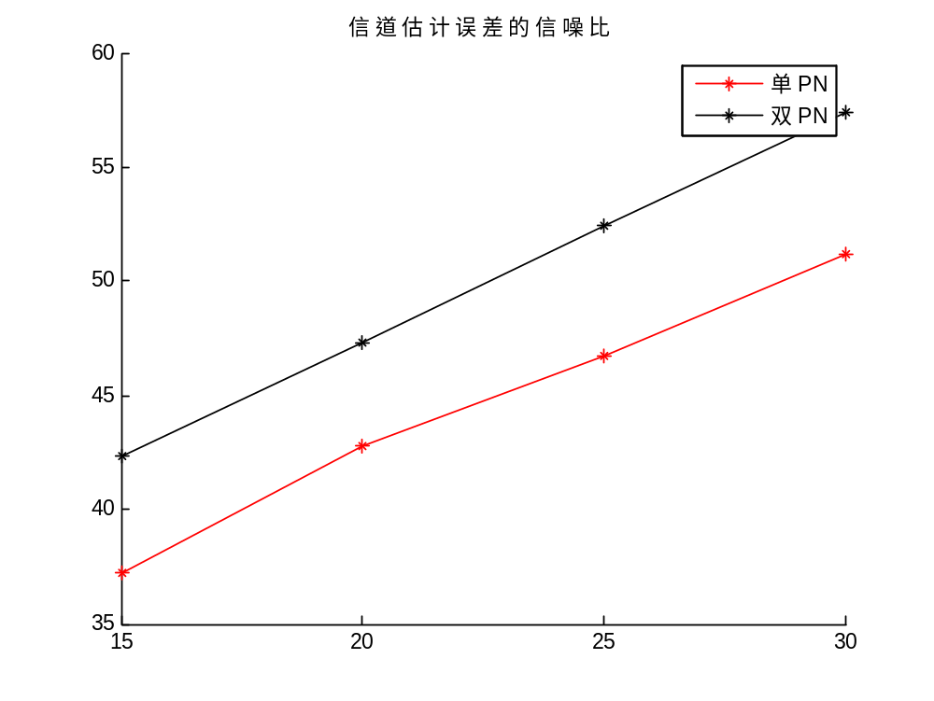
莱斯
SNR | Mse(SPN) | Mse(DPN) | SNR(SPN) | SNR(DPN) | SNR(SPN) | SNR(DPN)
15 | 0.0042 | 0.0024 | 14.9884 | 14.9871 | 38.3897 | 42.4443
20 | 0.0027 | 0.0014 | 19.9898 | 19.9861 | 43.3241 | 47.5684
25 | 0.0020 | 0.0008 | 24.9876 | 24.9855 | 47.6282 | 52.5688
30 | 0.0018 | 0.0004 | 29.9884 | 29.9870 | 50.6889 | 57.5716

