290.Word Pattern
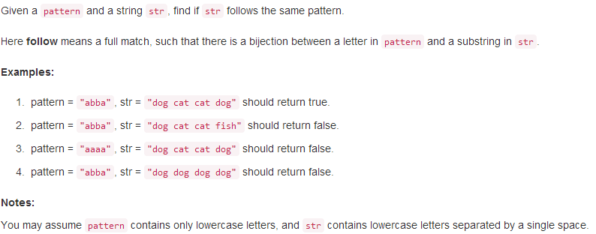
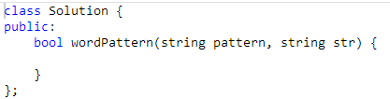
289.Game of Life
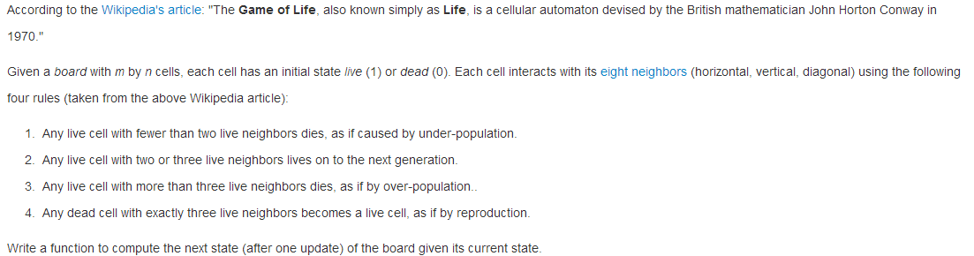
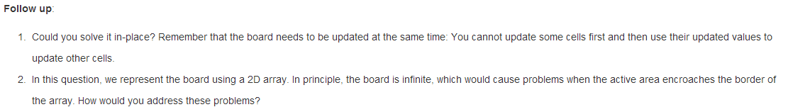
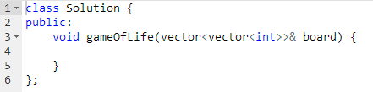
287.Find the Duplicate Number
