难题
5. Longest Palindromic Substring
class Solution {
public:
string longestPalindrome(string s) {

}
};

15. 3Sum
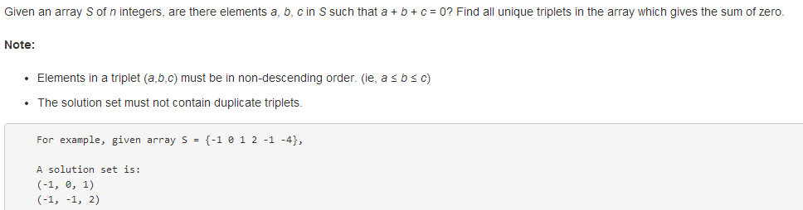
class Solution {
public:
vector<vector<int>> threeSum(vector<int>& nums) {

}
};
16. 3Sum Closest
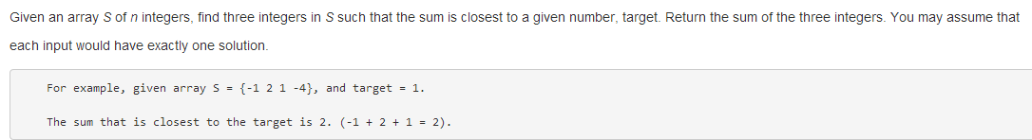
class Solution {
public:
int threeSumClosest(vector<int>& nums, int target) {

}
};
18. 4Sum
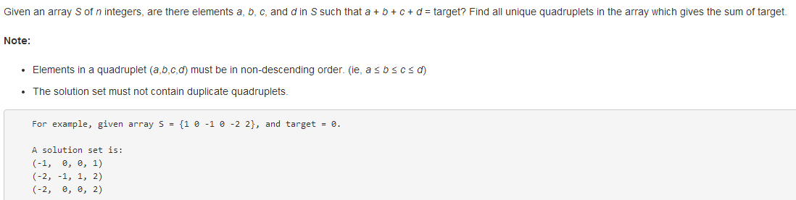
class Solution {
public:
vector<vector<int>> fourSum(vector<int>& nums, int target) {

}
};

11. Container With Most Water
class Solution {
public:
int maxArea(vector<int>& height) {

}
};

114. Flatten Binary Tree to Linked List
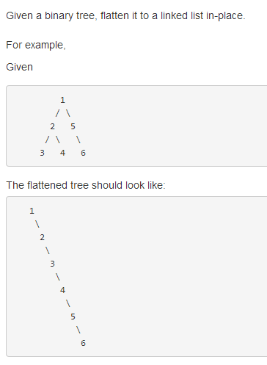
class Solution {
public:
void flatten(TreeNode* root) {

}
};
127. Word Ladder
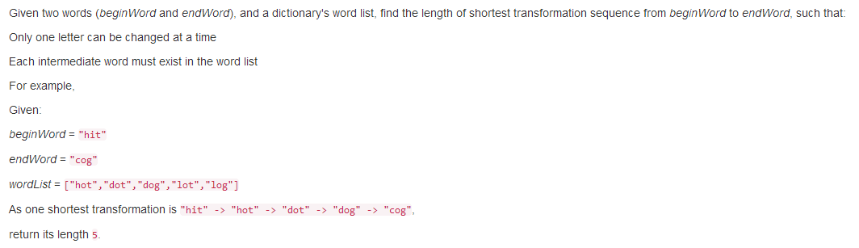
class Solution {
public:
int ladderLength(string beginWord, string endWord, unordered_set<string>& wordList) {

}
};
126. Word Ladder II
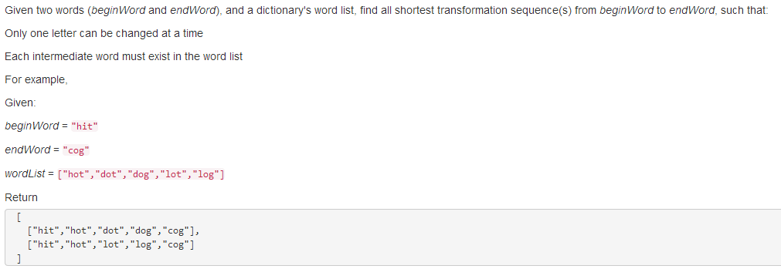
class Solution {
public:
vector<vector<string>> findLadders(string beginWord, string endWord, unordered_set<string> &wordList) {

}
};
138. Copy List with Random Pointer
/**
* Definition for singly-linked list with a random pointer.
* struct RandomListNode {
* int label;
* RandomListNode *next, *random;
* RandomListNode(int x) : label(x), next(NULL), random(NULL) {}
* };
*/
class Solution {
public:
RandomListNode *copyRandomList(RandomListNode *head) {

}
};

146. LRU Cache
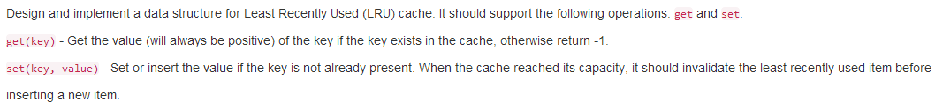
class LRUCache{
public:
LRUCache(int capacity) {

}

int get(int key) {

}

void set(int key, int value) {

}
};
139. Word Break
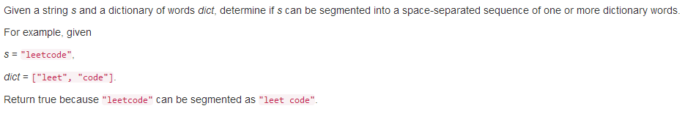
class Solution {
public:
bool wordBreak(string s, unordered_set<string>& wordDict) {

}
};
140. Word Break II
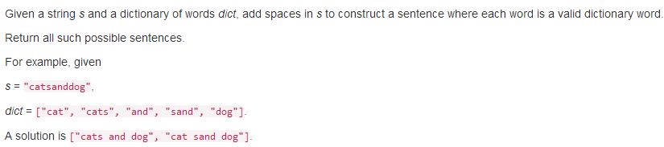
class Solution {
public:
vector<string> wordBreak(string s, unordered_set<string>& wordDict) {

}
};

174. Dungeon Game
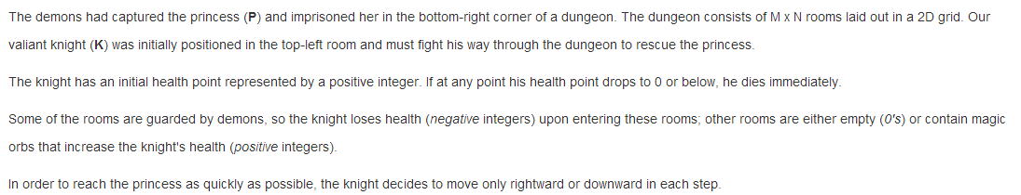
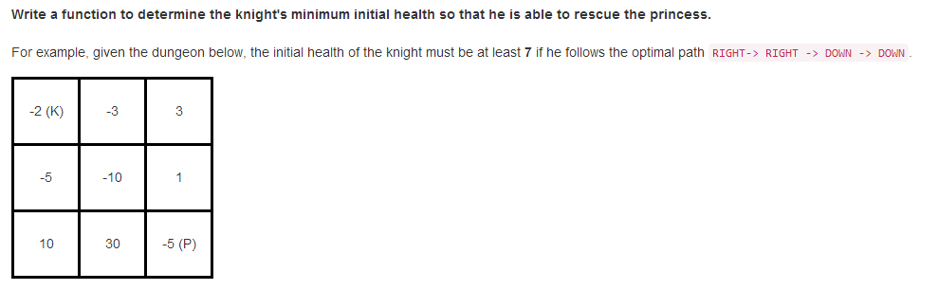
class Solution {
public:
int calculateMinimumHP(vector<vector<int>>& dungeon) {

}
};
214. Shortest Palindrome
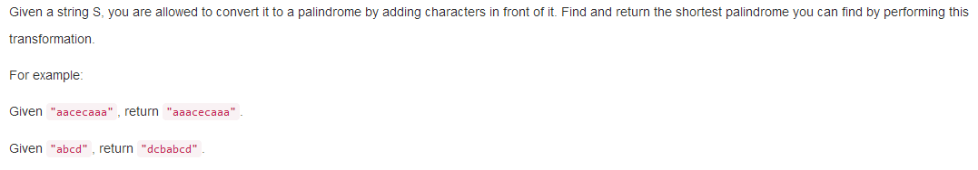
class Solution {
public:
string shortestPalindrome(string s) {

}
};
212. Word Search II
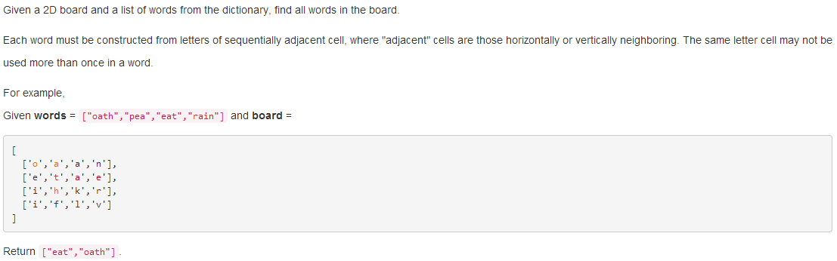
class Solution {
public:
vector<string> findWords(vector<vector<char>>& board, vector<string>& words) {

}
};
210. Course Schedule II
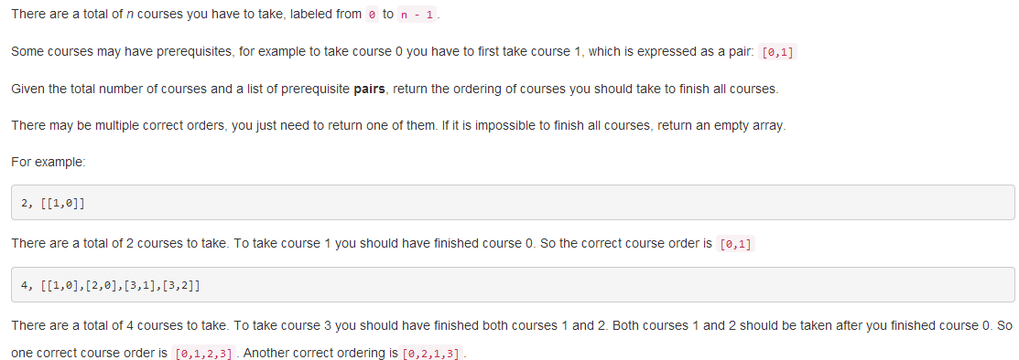
class Solution {
public:
vector<int> findOrder(int numCourses, vector<pair<int, int>>& prerequisites) {

}
};
207. Course Schedule
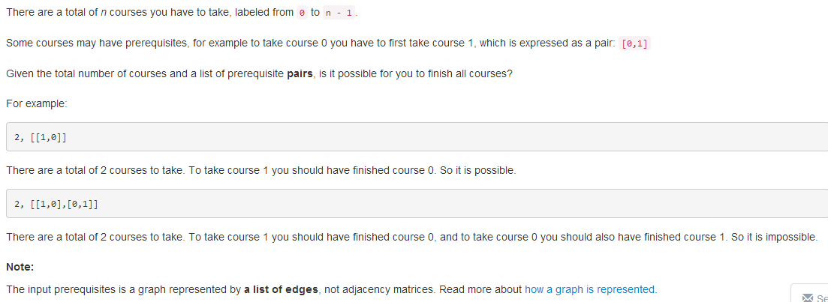
class Solution {
public:
bool canFinish(int numCourses, vector<pair<int, int>>& prerequisites) {

}
};
264. Ugly Number II
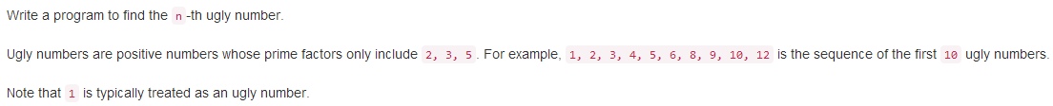
class Solution {
public:
int nthUglyNumber(int n) {

}
};
188. Best Time to Buy and Sell Stock IV
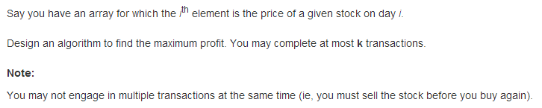
class Solution {
public:
int maxProfit(int k, vector<int>& prices) {

}
};

164. Maximum Gap
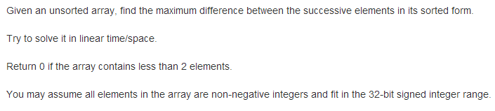
class Solution {
public:
int maximumGap(vector<int>& nums) {

}
};

正在做
56. Merge Intervals
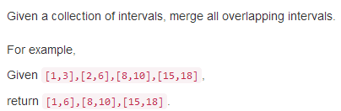
class Solution {
public:
vector<Interval> merge(vector<Interval>& intervals) {

}
};
57. Insert Interval
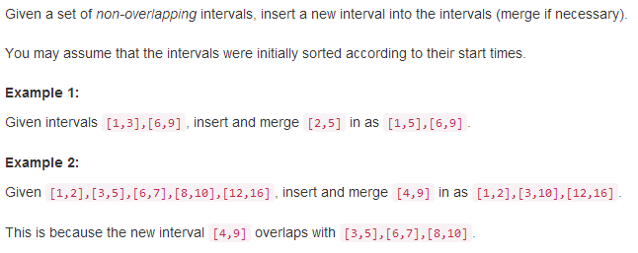
class Solution {
public:
vector<Interval> insert(vector<Interval>& intervals, Interval newInterval) {

}
};
64. Minimum Path Sum
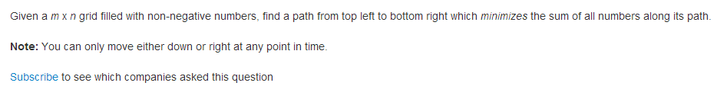
class Solution {
public:
int minPathSum(vector<vector<int>>& grid) {

}
};
66. Plus One
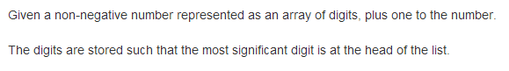
class Solution {
public:
vector<int> plusOne(vector<int>& digits) {

}
};
75. Sort Colors
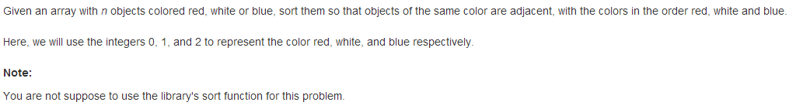
class Solution {
public:
void sortColors(vector<int>& nums) {

}
};
78. Subsets
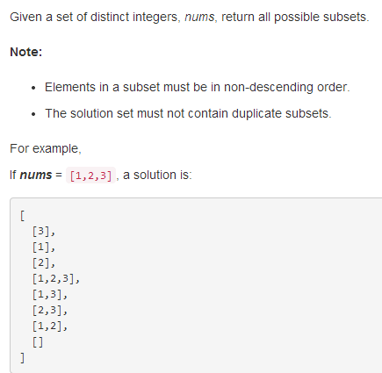
class Solution {
public:
vector<vector<int>> subsets(vector<int>& nums) {

}
};
90. Subsets II
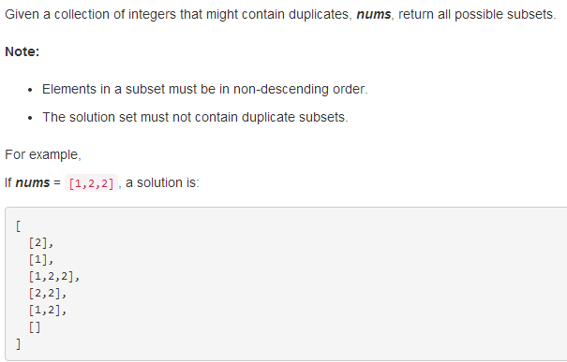
class Solution {
public:
vector<vector<int>> subsetsWithDup(vector<int>& nums) {

}
};

84. Largest Rectangle in Histogram
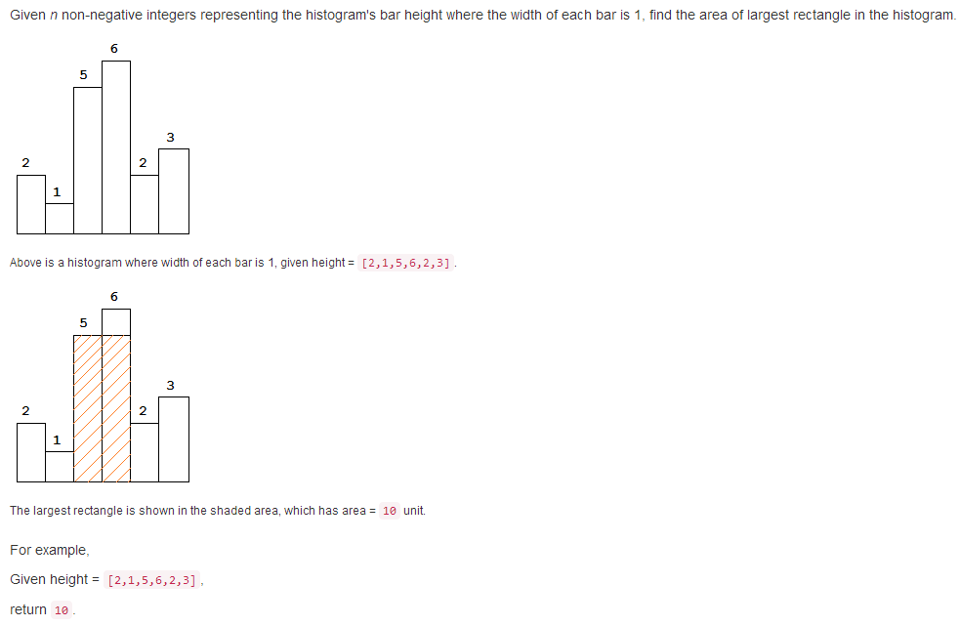
class Solution {
public:
int largestRectangleArea(vector<int>& height) {

}
};
85．Maximal Rectangle
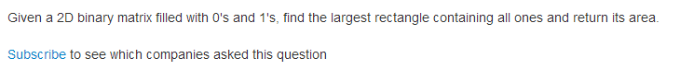
class Solution {
public:
int maximalRectangle(vector<vector<char>>& matrix) {

}
};
128. Longest Consecutive Sequence
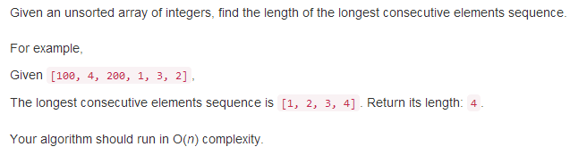
class Solution {
public:
int longestConsecutive(vector<int>& nums) {

}
};
87. Scramble String
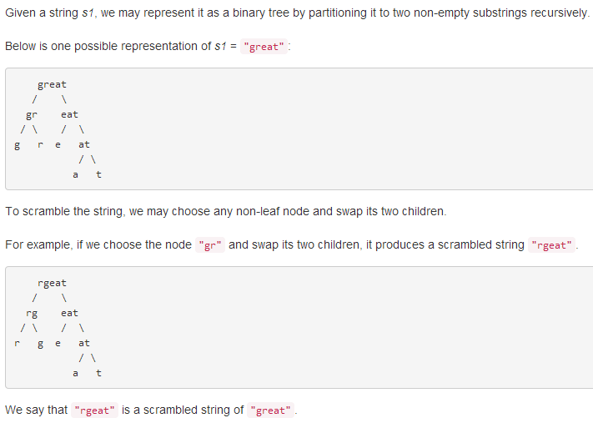
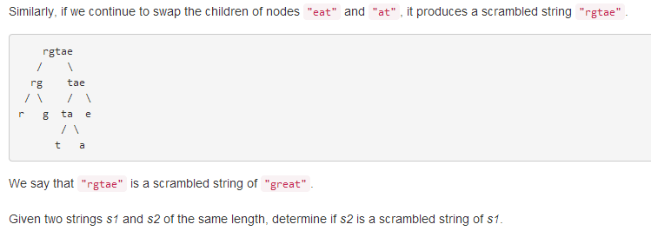
class Solution {
public:
bool isScramble(string s1, string s2) {

}
};
76. Minimum Window Substring
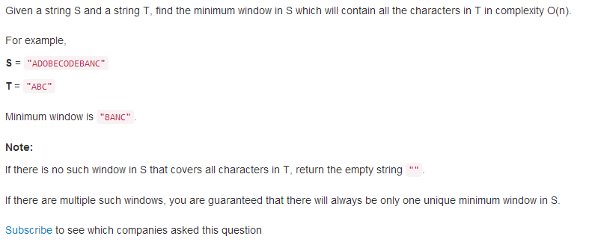
class Solution {
public:
string minWindow(string s, string t) {

}
};

已完成
2015-11-23
63. Unique Paths II
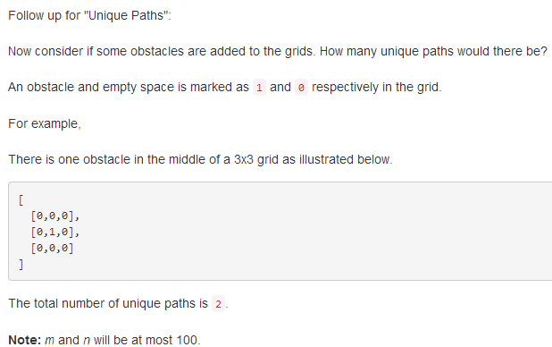
class Solution {
public:
int uniquePathsWithObstacles(vector<vector<int>>& obstacleGrid) {

}
};

62. Unique Paths
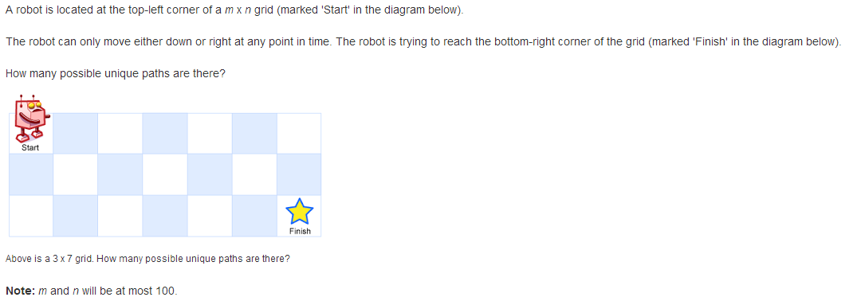
class Solution {
public:
int uniquePaths(int m, int n) {

}
};

48. Rotate Image
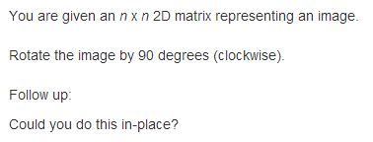
class Solution {
public:
void rotate(vector<vector<int>>& matrix) {

}
};

45. Jump Game II
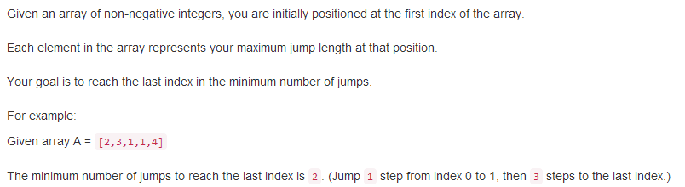
class Solution {
public:
int jump(vector<int>& nums) {

}
};

55. Jump Game
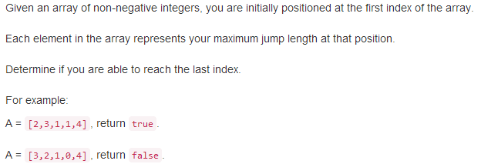
class Solution {
public:
bool canJump(vector<int>& nums) {

}
};

2015-11-22
42. Trapping Rain Water
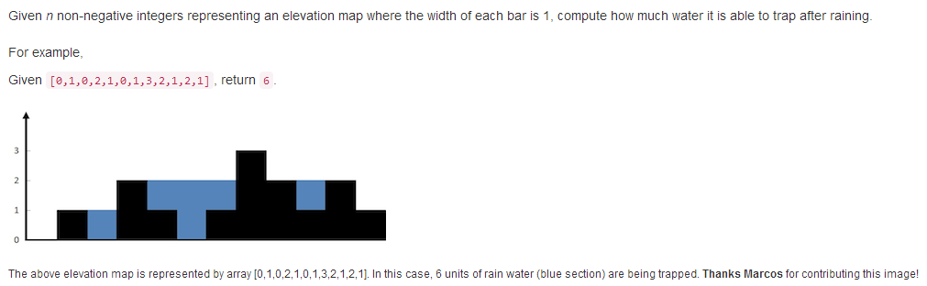
class Solution {
public:
int trap(vector<int>& height) {

}
};

41. First Missing Positive
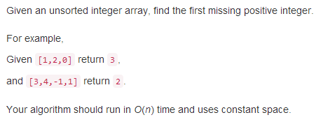
class Solution {
public:
int firstMissingPositive(vector<int>& nums) {

}
};

35. Search Insert Position
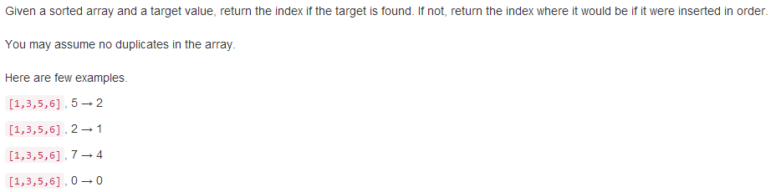
class Solution {
public:
int searchInsert(vector<int>& nums, int target) {

}
};

34. Search for a Range
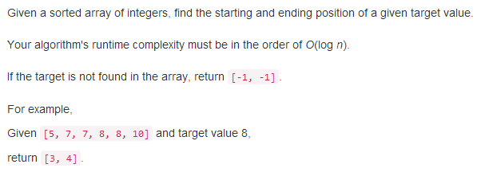
class Solution {
public:
vector<int> searchRange(vector<int>& nums, int target) {

}
};

31. Next Permutation
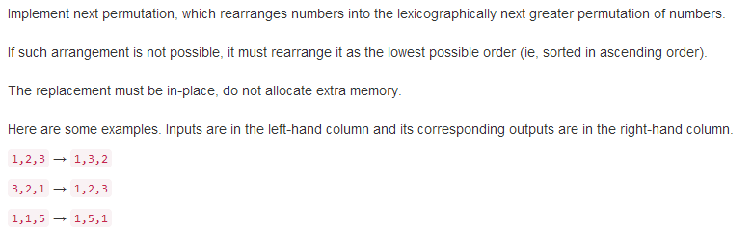
class Solution {
public:
void nextPermutation(vector<int>& nums) {

}
};

12. Integer to Roman
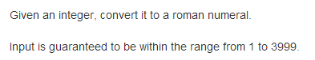
class Solution {
public:
string intToRoman(int num) {

}
};

4. Median of Two Sorted Arrays
class Solution {
public:
double findMedianSortedArrays(vector<int>& nums1, vector<int>& nums2) {

}
};

27. Remove Element
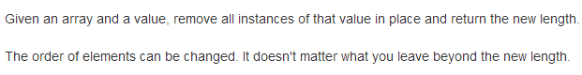
class Solution {
public:
int removeElement(vector<int>& nums, int val) {

}
};

9. Palindrome Number
class Solution {
public:
bool isPalindrome(int x) {

}
};

7. Reverse Integer
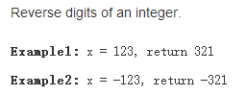
class Solution {
public:
int reverse(int x) {

}
};

6. ZigZag Conversion
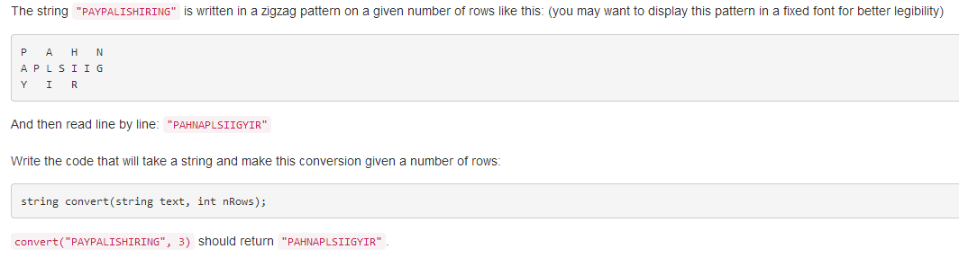
class Solution {
public:
string convert(string s, int numRows) {

}
};

2015-11-21
2. Add Two Numbers
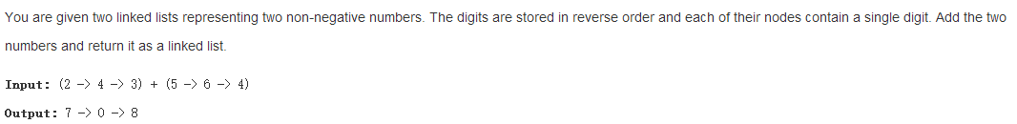
class Solution {
public:
ListNode* addTwoNumbers(ListNode* l1, ListNode* l2) {

}
};

1. Two Sum
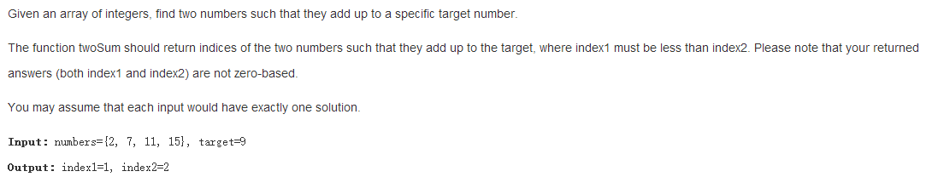
class Solution {
public:
vector<int> twoSum(vector<int>& nums, int target) {

}
};

2015-11-20
43. Multiply Strings
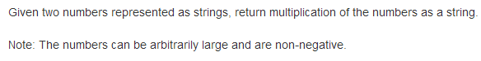
class Solution {
public:
string multiply(string num1, string num2) {

}
};

30. Substring with Concatenation of All Words
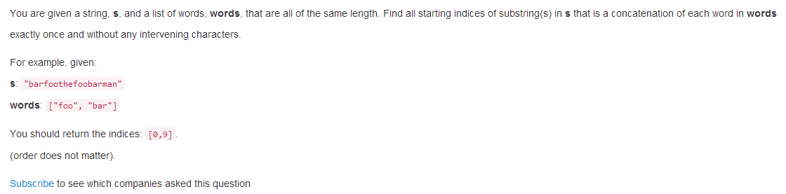
class Solution {
public:
vector<int> findSubstring(string s, vector<string>& words) {

}
};

8. String to Integer (atoi)
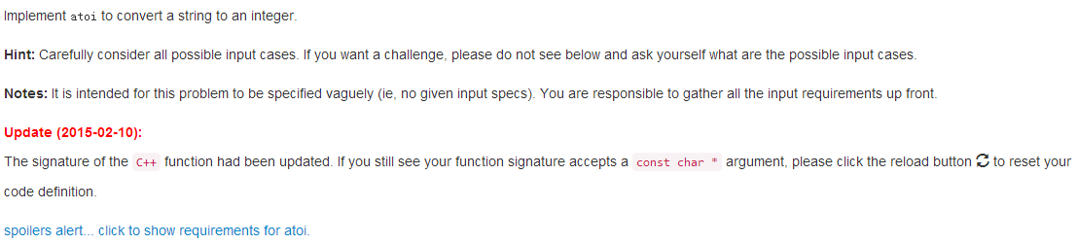
class Solution {
public:
int myAtoi(string str) {

}
};

3. Longest Substring Without Repeating Characters
class Solution {
public:
int lengthOfLongestSubstring(string s) {

}
};

2015-11-19
124. Binary Tree Maximum Path Sum
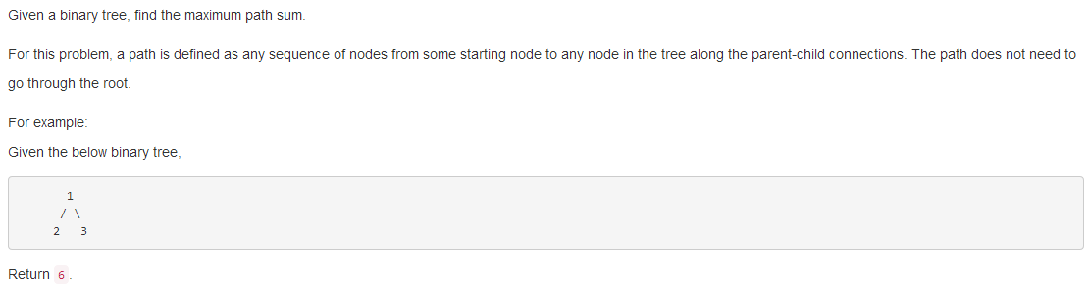
class Solution {
public:
int maxPathSum(TreeNode* root) {

}
};

297. Serialize and Deserialize Binary Tree
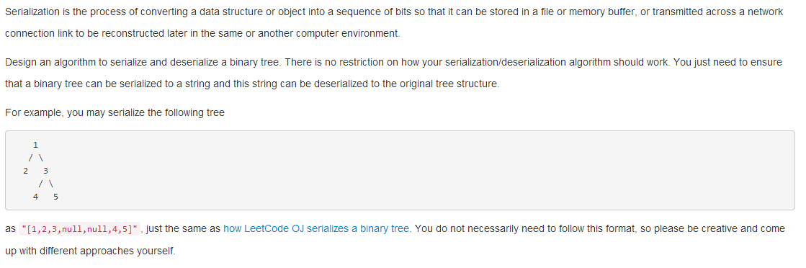
class Codec {
public:

// Encodes a tree to a single string.
string serialize(TreeNode* root) {

}

// Decodes your encoded data to tree.
TreeNode* deserialize(string data) {

}
};

81. Search in Rotated Sorted Array II
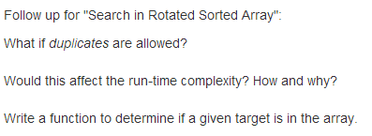
class Solution {
public:
bool search(vector<int>& nums, int target) {

}
};

33. Search in Rotated Sorted Array
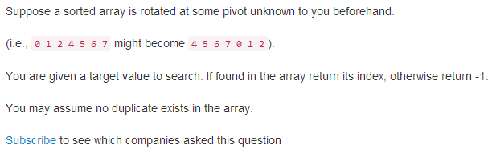
class Solution {
public:
int search(vector<int>& nums, int target) {

}
};

80. Remove Duplicates from Sorted Array II
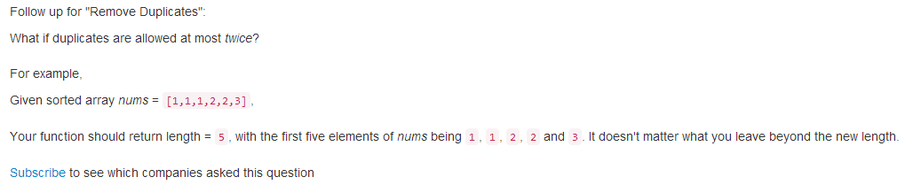
class Solution {
public:
int removeDuplicates(vector<int>& nums) {

}
};
53. Maximum Subarray
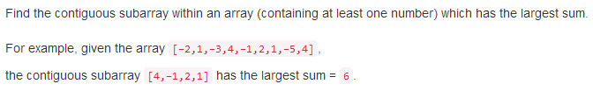
class Solution {
public:
int maxSubArray(vector<int>& nums) {

}
};

88．Merge Sorted Array
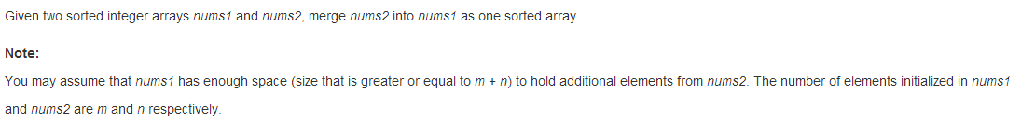
class Solution {
public:
void merge(vector<int>& nums1, int m, vector<int>& nums2, int n) {

}
};

74. Search a 2D Matrix
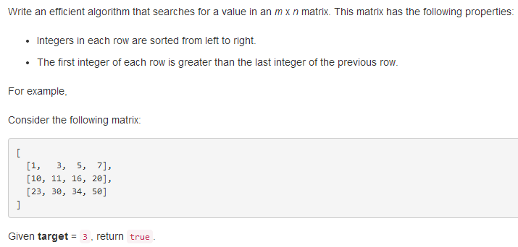
class Solution {
public:
bool searchMatrix(vector<vector<int>>& matrix, int target) {

}
};

73. Set Matrix Zeroes
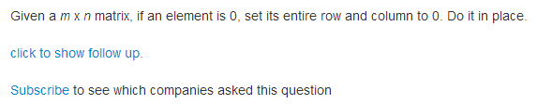
class Solution {
public:
void setZeroes(vector<vector<int>>& matrix) {

}
};

59. Spiral Matrix II
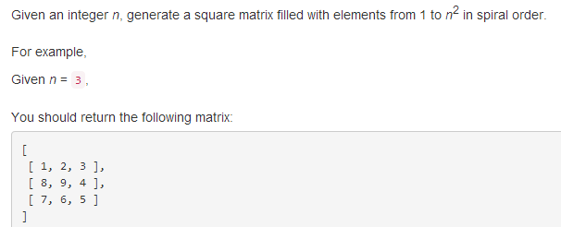
class Solution {
public:
vector<vector<int>> generateMatrix(int n) {

}
};

54. Spiral Matrix
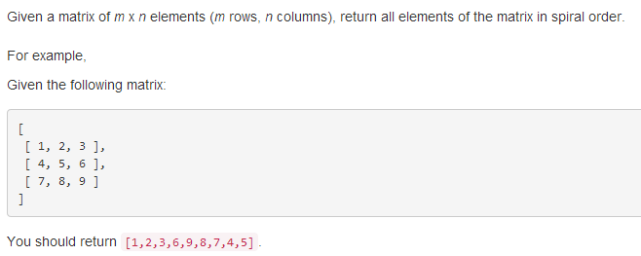
class Solution {
public:
vector<int> spiralOrder(vector<vector<int>>& matrix) {

}
};

2015-11-18
99. Recover Binary Search Tree
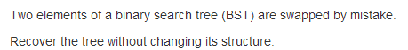
class Solution {
public:
void recoverTree(TreeNode* root) {

}
};

2015-11-12
23. Merge k Sorted Lists
class Solution {
public:
ListNode* mergeKLists(vector<ListNode*>& lists) {

}
};

86. Partition List
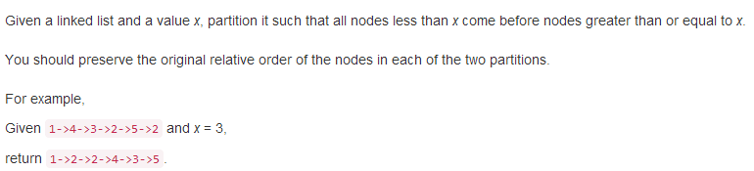
class Solution {
public:
ListNode* partition(ListNode* head, int x) {

}
};

21. Merge Two Sorted Lists
class Solution {
public:
ListNode* mergeTwoLists(ListNode* l1, ListNode* l2) {

}
};

20. Valid Parentheses
class Solution {
public:
bool isValid(string s) {

}
};

19. Remove Nth Node From End of List
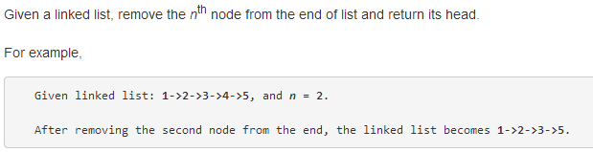
class Solution {
public:
ListNode* removeNthFromEnd(ListNode* head, int n) {

}
};

2015-11-11
82. Remove Duplicates from Sorted List II
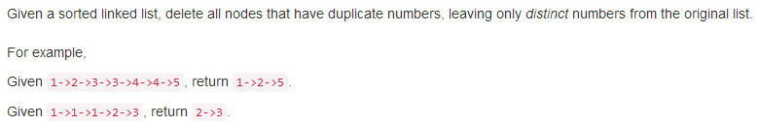
class Solution {
public:
ListNode* deleteDuplicates(ListNode* head) {

}
};

83. Remove Duplicates from Sorted List
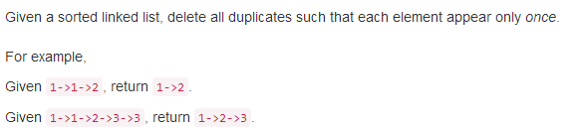
class Solution {
public:
ListNode* deleteDuplicates(ListNode* head) {

}
};

61．Rotate List
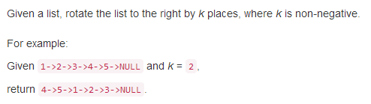
class Solution {
public:
ListNode* rotateRight(ListNode* head, int k) {

}
};

58. Length of Last Word
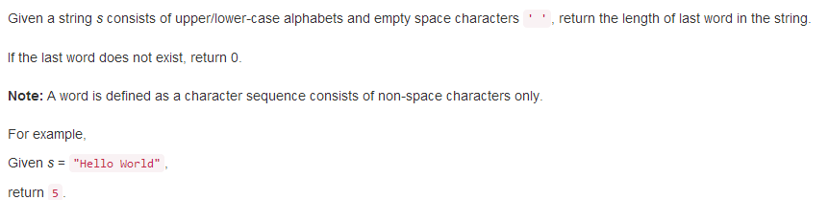
class Solution {
public:
int lengthOfLastWord(string s) {

}
};
2015-11-10
94. Binary Tree Inorder Traversal
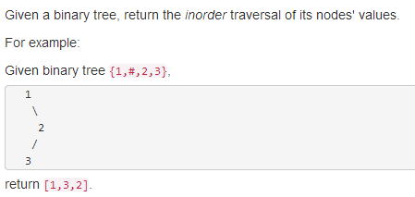
class Solution {
public:
vector<int> inorderTraversal(TreeNode* root) {

}
};

95. Unique Binary Search Trees II
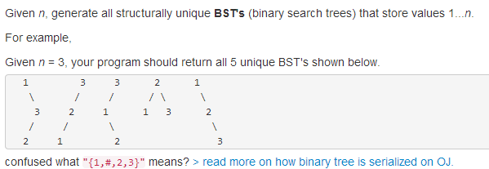
class Solution {
public:
vector<TreeNode*> generateTrees(int n) {

}
};

96. Unique Binary Search Trees
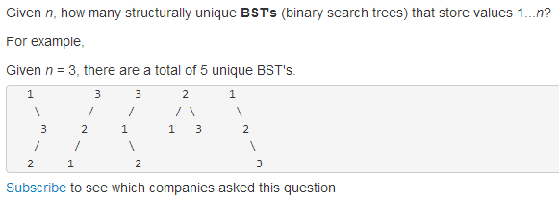
class Solution {
public:
int numTrees(int n) {

}
};

98. Validate Binary Search Tree
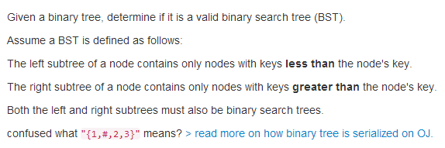
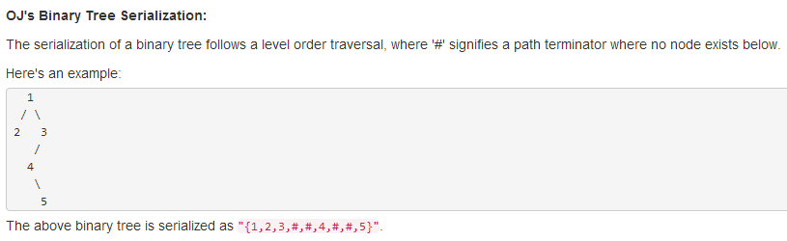
class Solution {
public:
bool isValidBST(TreeNode* root) {

}
};

100. Same Tree
class Solution {
public:
bool isSameTree(TreeNode* p, TreeNode* q) {

}
};

106. Construct Binary Tree from Inorder and Postorder Traversal
class Solution {
public:
TreeNode* buildTree(vector<int>& inorder, vector<int>& postorder) {

105. Construct Binary Tree from Preorder and Inorder Traversal
class Solution {
public:
TreeNode* buildTree(vector<int>& preorder, vector<int>& inorder) {

}
};

104. Maximum Depth of Binary Tree
class Solution {
public:
int maxDepth(TreeNode* root) {

}
};

103. Binary Tree Zigzag Level Order Traversal
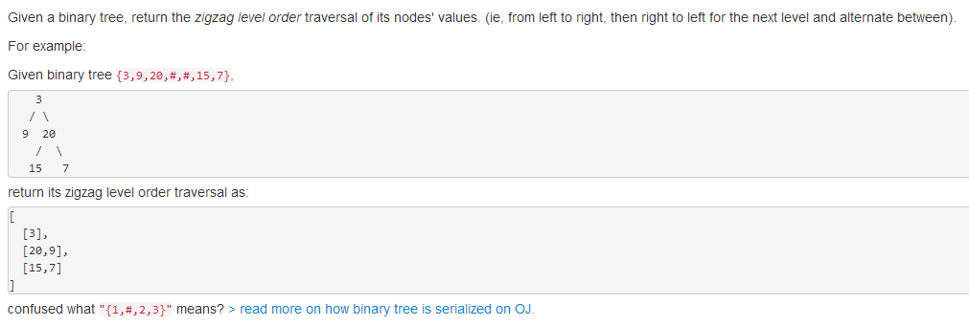
class Solution {
public:
vector<vector<int>> zigzagLevelOrder(TreeNode* root) {

}
};

2015-11-9
107. Binary Tree Level Order Traversal II
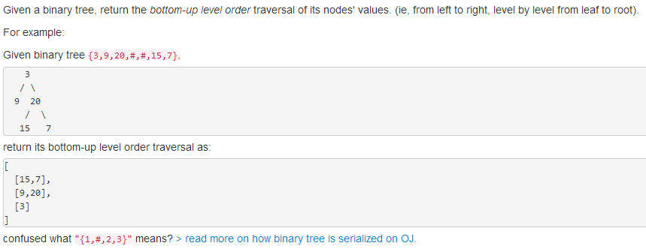
class Solution {
public:
vector<vector<int>> levelOrderBottom(TreeNode* root) {

}
};

102. Binary Tree Level Order Traversal
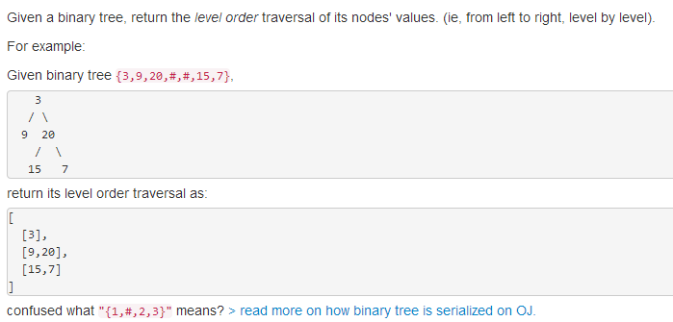
class Solution {
public:
vector<vector<int>> levelOrder(TreeNode* root) {

}
};

101. Symmetric Tree
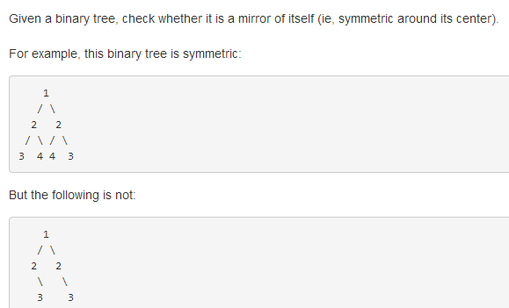
class Solution {
public:
bool isSymmetric(TreeNode* root) {

}
};

108. Convert Sorted Array to Binary Search Tree
class Solution {
public:
TreeNode* sortedArrayToBST(vector<int>& nums) {

}
};

109. Convert Sorted List to Binary Search Tree
class Solution {
public:
TreeNode* sortedListToBST(ListNode* head) {

}
};

110. Balanced Binary Tree
class Solution {
public:
bool isBalanced(TreeNode* root) {

}
};

111. Minimum Depth of Binary Tree
class Solution {
public:
int minDepth(TreeNode* root) {

}
};

113. Path Sum II
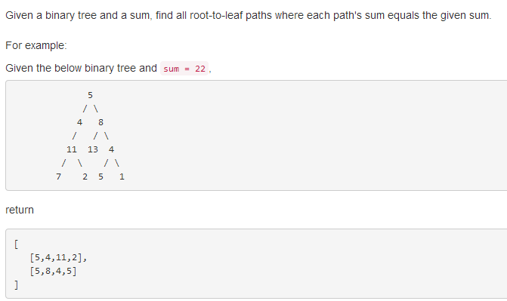
class Solution {
public:
vector<vector<int>> pathSum(TreeNode* root, int sum) {

}
};

112. Path Sum
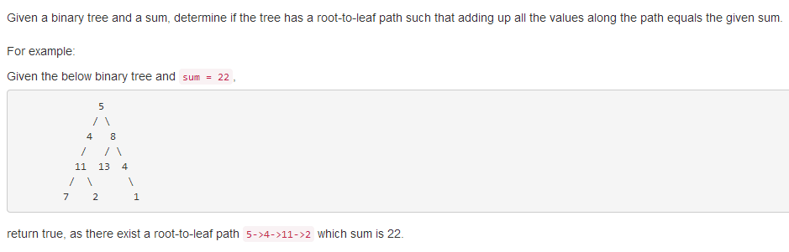
class Solution {
public:
bool hasPathSum(TreeNode* root, int sum) {

}
};

119. Pascal's Triangle II
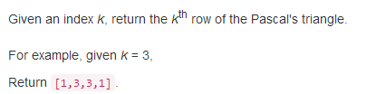
class Solution {
public:
vector<int> getRow(int rowIndex) {

}
};

118. Pascal's Triangle
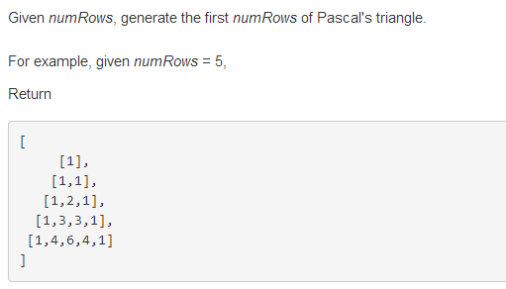
class Solution {
public:
vector<vector<int>> generate(int numRows) {

}
};

120. Triangle
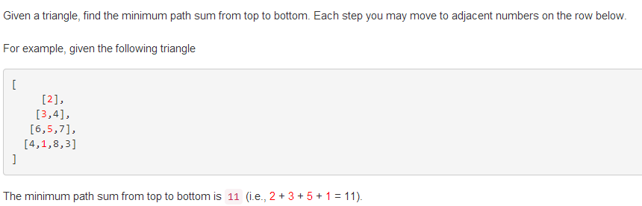
class Solution {
public:
int minimumTotal(vector<vector<int>>& triangle) {

}
};

129. Sum Root to Leaf Numbers
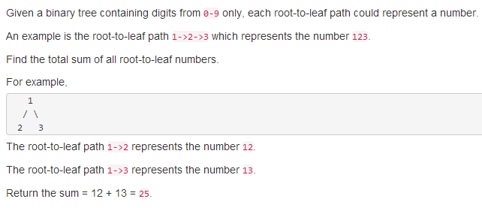
class Solution {
public:
int sumNumbers(TreeNode* root) {

}
};

2015-11-8
130. Surrounded Regions
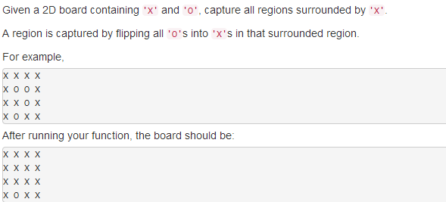
class Solution {
public:
void solve(vector<vector<char>>& board) {

}
};

133. Clone Graph
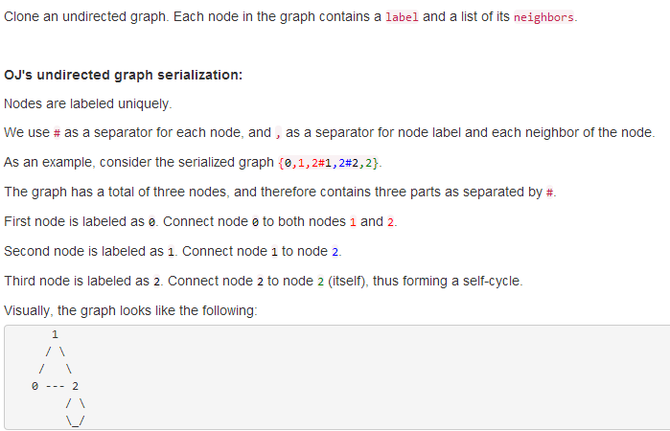
/**
* Definition for undirected graph.
* struct UndirectedGraphNode {
* int label;
* vector<UndirectedGraphNode *> neighbors;
* UndirectedGraphNode(int x) : label(x) {};
* };
*/
class Solution {
public:
UndirectedGraphNode *cloneGraph(UndirectedGraphNode *node) {

}
};

134. Gas Station
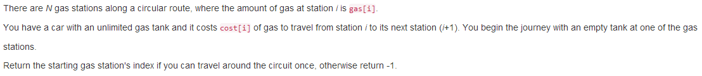
class Solution {
public:
int canCompleteCircuit(vector<int>& gas, vector<int>& cost) {

}
};

125. Valid Palindrome
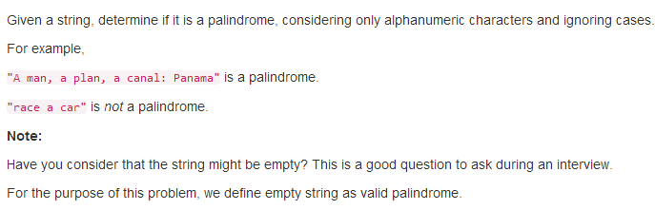
class Solution {
public:
bool isPalindrome(string s) {

}
};

2015-11-7
145. Binary Tree Postorder Traversal
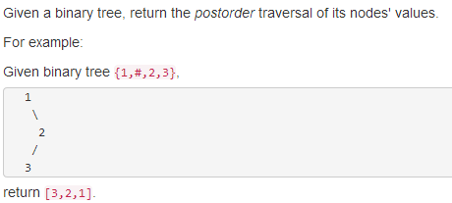
class Solution {
public:
vector<int> postorderTraversal(TreeNode* root) {

}
};

144. Binary Tree Preorder Traversal
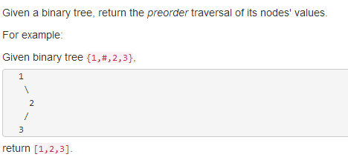
class Solution {
public:
vector<int> preorderTraversal(TreeNode* root) {

}
};

149. Max Points on a Line
class Solution {
public:
int maxPoints(vector<Point>& points) {

}
};

136. Single Number
class Solution {
public:
int singleNumber(vector<int>& nums) {

}
};
137. Single Number II
class Solution {
public:
int singleNumber(vector<int>& nums) {

}
};

141. Linked List Cycle

class Solution {
public:
bool hasCycle(ListNode *head) {

}
};
142. Linked List Cycle II
class Solution {
public:
ListNode *detectCycle(ListNode *head) {

}
};

143. Reorder List
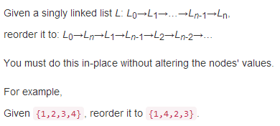
class Solution {
public:
void reorderList(ListNode* head) {

}
};

147. Insertion Sort List
class Solution {
public:
ListNode* insertionSortList(ListNode* head) {

}
};

148. Sort List
class Solution {
public:
ListNode* sortList(ListNode* head) {

}
};

150. Evaluate Reverse Polish Notation
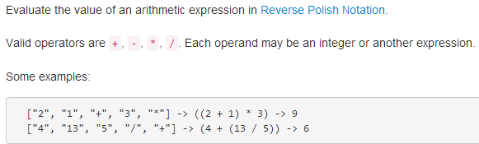
class Solution {
public:
int evalRPN(vector<string>& tokens) {

}
};

2015-11-5
153. Find Minimum in Rotated Sorted Array
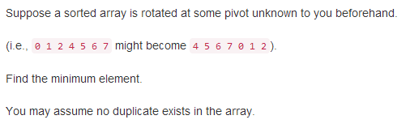
class Solution {
public:
int findMin(vector<int>& nums) {

}
};
154. Find Minimum in Rotated Sorted Array II
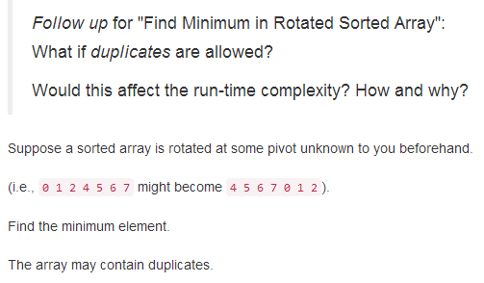
class Solution {
public:
int findMin(vector<int>& nums) {

}
};
155. Min Stack
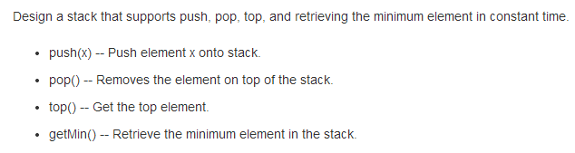
class MinStack {
public:
void push(int x) {

}

void pop() {

}

int top() {

}

int getMin() {

}
};

152. Maximum Product Subarray
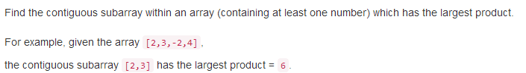
class Solution {
public:
int maxProduct(vector<int>& nums) {

}
};

2015-11-4
173. Binary Search Tree Iterator
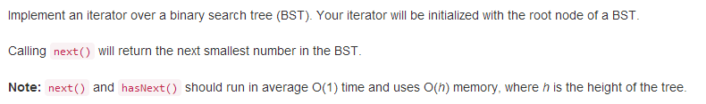
class BSTIterator {
public:
BSTIterator(TreeNode *root) {

}

/** @return whether we have a next smallest number */
bool hasNext() {

}

/** @return the next smallest number */
int next() {

}
};

/**
* Your BSTIterator will be called like this:
* BSTIterator i = BSTIterator(root);
* while (i.hasNext()) cout << i.next();
*/

179. Largest Number
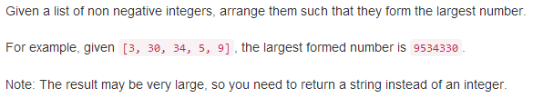
class Solution {
public:
string largestNumber(vector<int>& nums) {

}
};

162. Find Peak Element
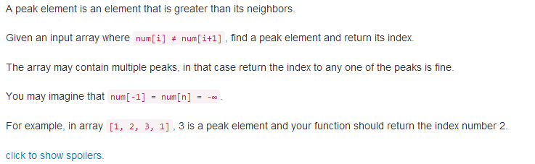
class Solution {
public:
int findPeakElement(vector<int>& nums) {

}
};

160. Intersection of Two Linked Lists
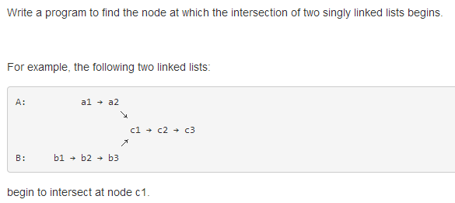
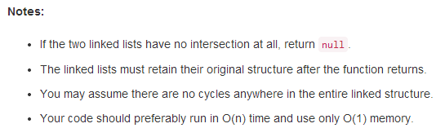
/**
* Definition for singly-linked list.
* struct ListNode {
* int val;
* ListNode *next;
* ListNode(int x) : val(x), next(NULL) {}
* };
*/
class Solution {
public:
ListNode *getIntersectionNode(ListNode *headA, ListNode *headB) {

}
};

165. Compare Version Numbers
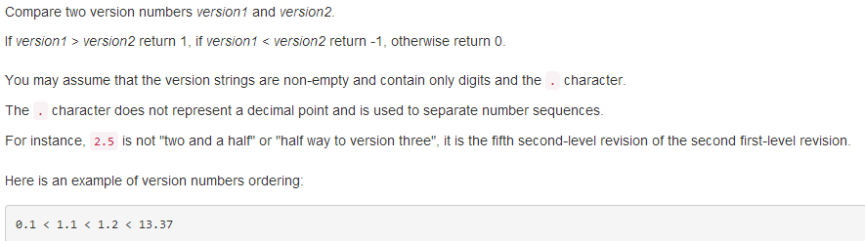
class Solution {
public:
int compareVersion(string version1, string version2) {

}
};

2015-11-3
166. Fraction to Recurring Decimal
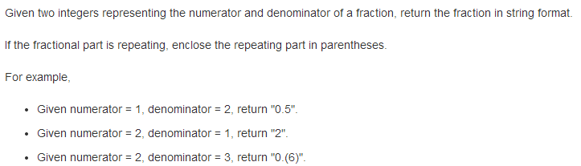
class Solution {
public:
string fractionToDecimal(int numerator, int denominator) {

}
};

168. Excel Sheet Column Title
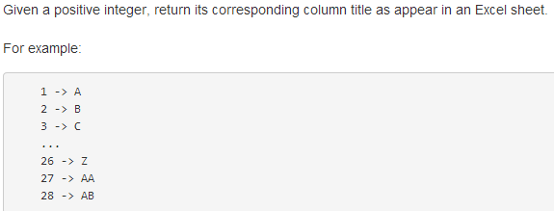
class Solution {
public:
string convertToTitle(int n) {

}
};

169. Majority Element
class Solution {
public:
int majorityElement(vector<int>& nums) {

}
};

171.Excel Sheet Column Number
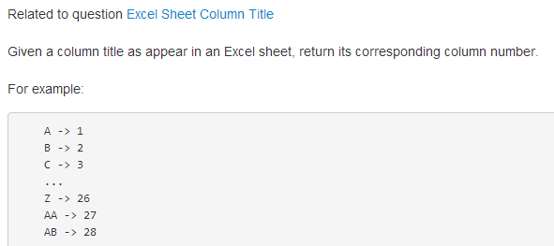
class Solution {
public:
int titleToNumber(string s) {

}
};

172. Factorial Trailing Zeroes
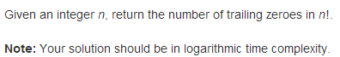
class Solution {
public:
int trailingZeroes(int n) {

}
};

2015-10-30
187. Repeated DNA Sequences
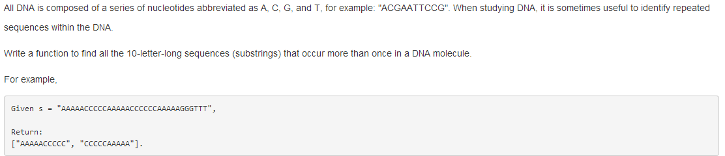
class Solution {
public:
vector<string> findRepeatedDnaSequences(string s) {

}
};

199. Binary Tree Right Side View
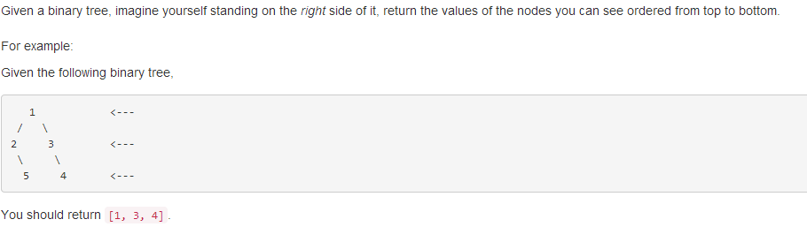
/**
* Definition for a binary tree node.
* struct TreeNode {
* int val;
* TreeNode *left;
* TreeNode *right;
* TreeNode(int x) : val(x), left(NULL), right(NULL) {}
* };
*/
class Solution {
public:
vector<int> rightSideView(TreeNode* root) {

}
};

191. Number of 1 Bits
class Solution {
public:
int hammingWeight(uint32_t n) {

}
};

190. Reverse Bits
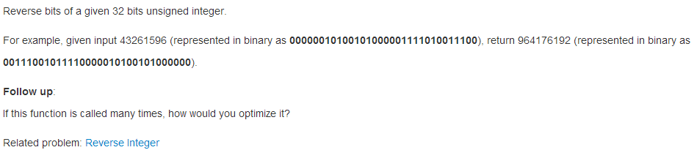
class Solution {
public:
uint32_t reverseBits(uint32_t n) {

}
};

189. Rotate Array
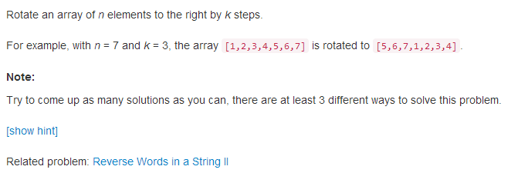
class Solution {
public:
void rotate(vector<int>& nums, int k) {

}
};

2015-10-26
200. Number of Islands
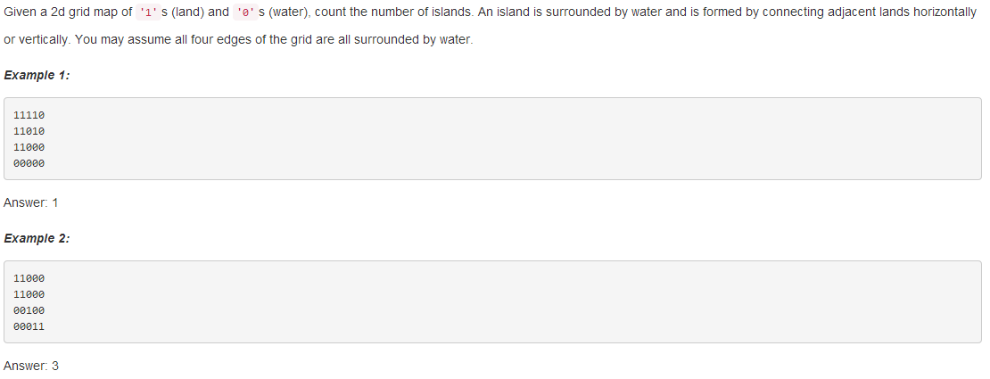
class Solution {
public:
int numIslands(vector<vector<char>>& grid) {

}
};

2015-10-23
201. Bitwise AND of Numbers Range
class Solution {
public:
int rangeBitwiseAnd(int m, int n) {

}
};

2015-10-22
202. Happy Number
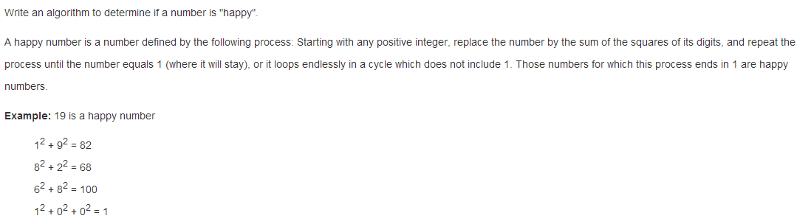
class Solution {
public:
bool isHappy(int n) {

}
};

203. Remove Linked List Elements
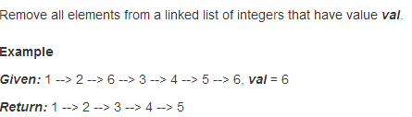
/**
* Definition for singly-linked list.
* struct ListNode {
* int val;
* ListNode *next;
* ListNode(int x) : val(x), next(NULL) {}
* };
*/
class Solution {
public:
ListNode* removeElements(ListNode* head, int val) {

}
};
204. Count Primes
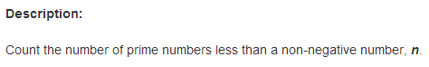
class Solution {
public:
int countPrimes(int n) {

}
};

205. Isomorphic Strings
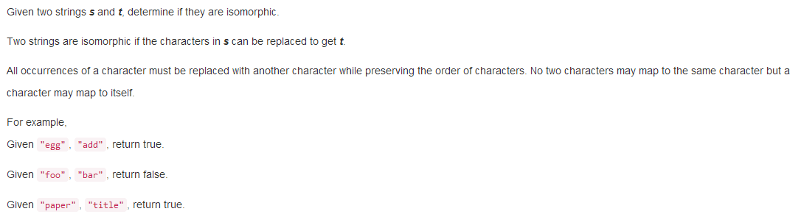
class Solution {
public:
bool isIsomorphic(string s, string t) {

}
};

206. Reverse Linked List
Reverse a singly linked list
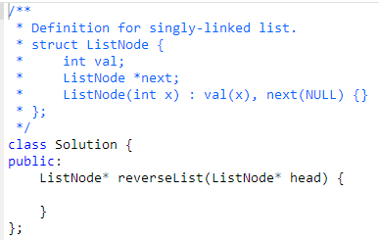

79. Word Search
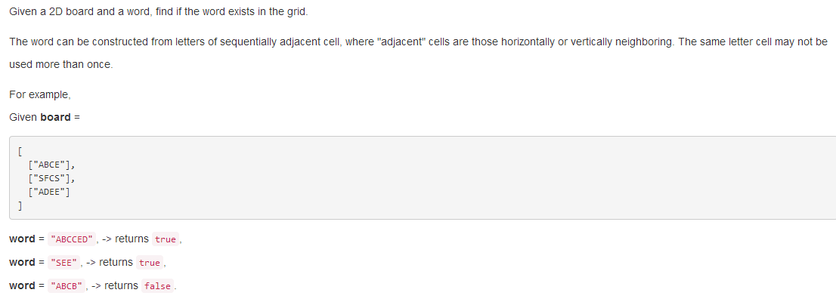
class Solution {
public:
bool exist(vector<vector<char>>& board, string word) {

}
};

208. Implement Trie (Prefix Tree)
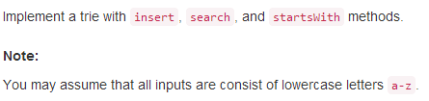
class TrieNode {
public:
// Initialize your data structure here.
TrieNode() {

}
};

class Trie {
public:
Trie() {
root = new TrieNode();
}

// Inserts a word into the trie.
void insert(string word) {

}

// Returns if the word is in the trie.
bool search(string word) {

}

// Returns if there is any word in the trie
// that starts with the given prefix.
bool startsWith(string prefix) {

}

private:
TrieNode* root;
};

// Your Trie object will be instantiated and called as such:
// Trie trie;
// trie.insert("somestring");
// trie.search("key");

209. Minimum Size Subarray Sum
class Solution {
public:
int minSubArrayLen(int s, vector<int>& nums) {

}
};

2015-10-18
211. Add and Search Word - Data structure design
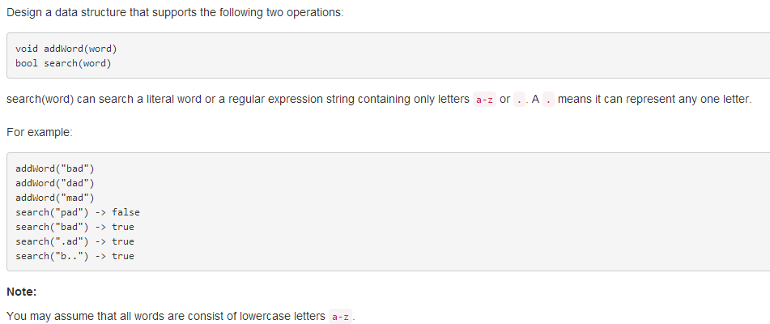
class WordDictionary {
public:

// Adds a word into the data structure.
void addWord(string word) {

}

// Returns if the word is in the data structure. A word could
// contain the dot character '.' to represent any one letter.
bool search(string word) {

}
};

// Your WordDictionary object will be instantiated and called as such:
// WordDictionary wordDictionary;
// wordDictionary.addWord("word");
// wordDictionary.search("pattern");

2015-10-17
213. House Robber II
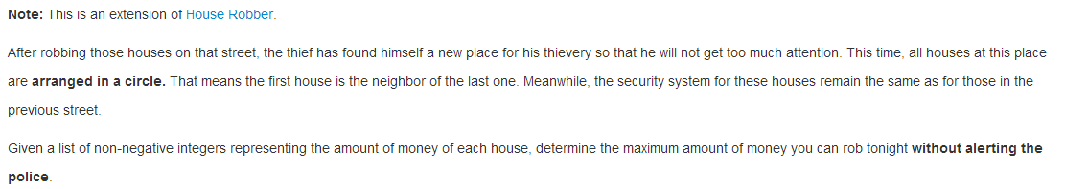
class Solution {
public:
int rob(vector<int>& nums) {

}
};

198. House Robber
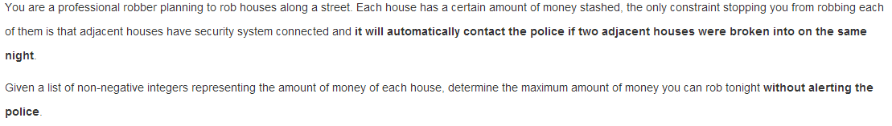
class Solution {
public:
int rob(vector<int>& nums) {

}
};

215. Kth Largest Element in an Array
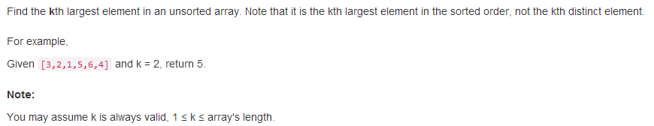
class Solution {
public:
int findKthLargest(vector<int>& nums, int k) {

}
};

218. The Skyline Problem
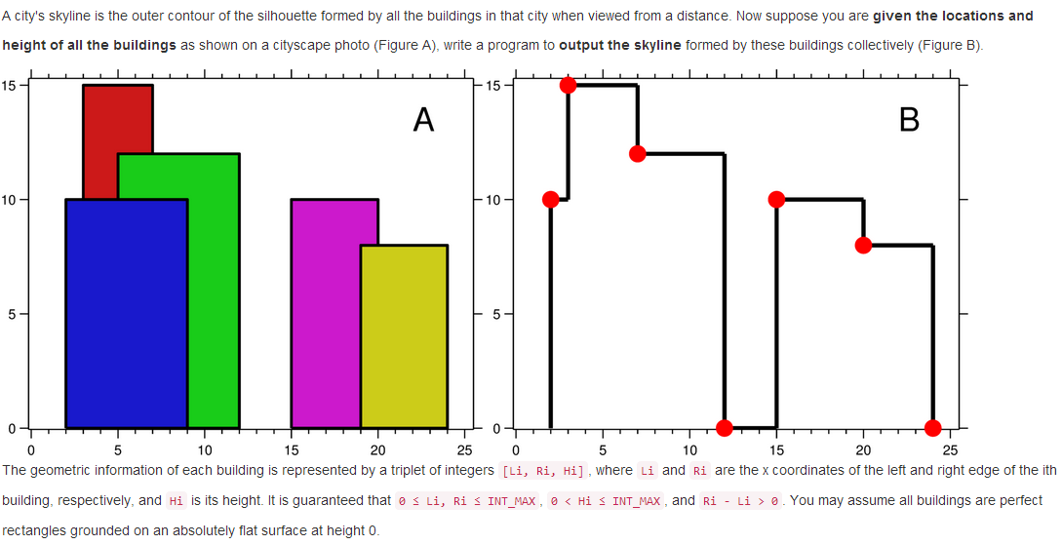
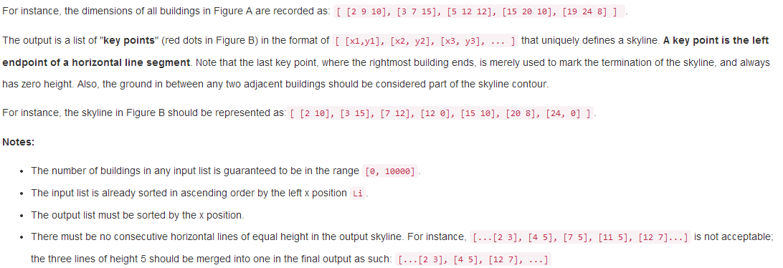
class Solution {
public:
vector<pair<int, int>> getSkyline(vector<vector<int>>& buildings) {

}
};

2015-10-15
216. Combination Sum III
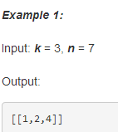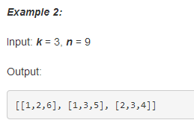
class Solution {
public:
vector<vector<int>> combinationSum3(int k, int n) {

}
};

40. Combination Sum II
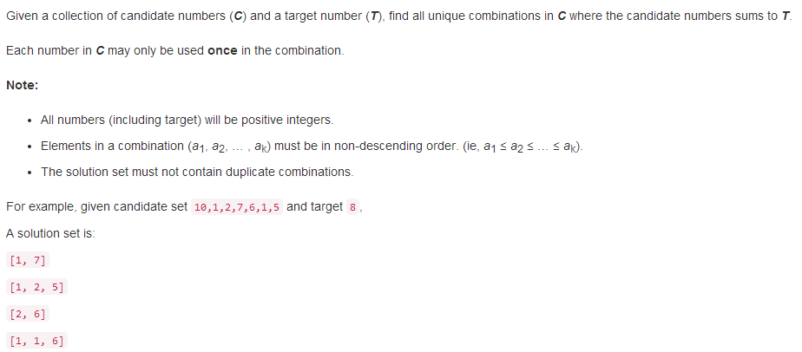
class Solution {
public:
vector<vector<int>> combinationSum2(vector<int>& candidates, int target) {

}
};

39. Combination Sum
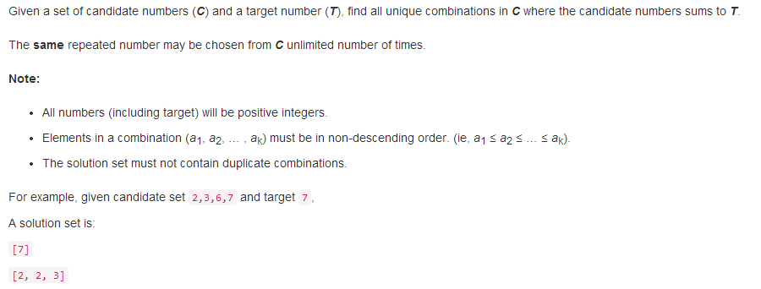
class Solution {
public:
vector<vector<int>> combinationSum(vector<int>& candidates, int target) {

}
};

217. Contains Duplicate
class Solution {
public:
bool containsDuplicate(vector<int>& nums) {

}
};

220. Contains Duplicate III
class Solution {
public:
bool containsNearbyAlmostDuplicate(vector<int>& nums, int k, int t) {

}
};
219. Contains Duplicate II
class Solution {
public:
bool containsNearbyDuplicate(vector<int>& nums, int k) {

}
};

221. Maximal Square
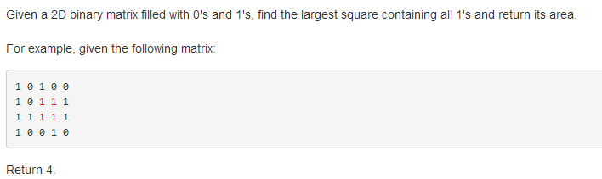
class Solution {
public:
int maximalSquare(vector<vector<char>>& matrix) {

}
};

222. Count Complete Tree Nodes
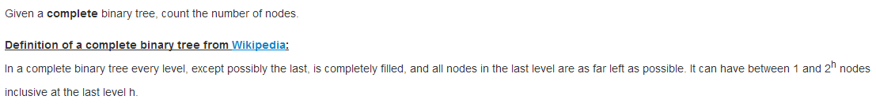
/**
* Definition for a binary tree node.
* struct TreeNode {
* int val;
* TreeNode *left;
* TreeNode *right;
* TreeNode(int x) : val(x), left(NULL), right(NULL) {}
* };
*/
class Solution {
public:
int countNodes(TreeNode* root) {

}
};
223. Rectangle Area
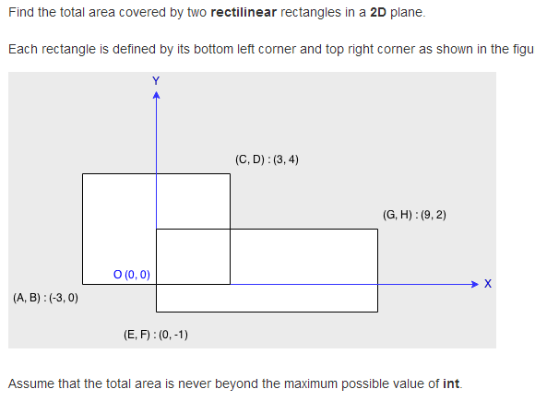
class Solution {
public:
int computeArea(int A, int B, int C, int D, int E, int F, int G, int H) {

}
};

224. Basic Calculator
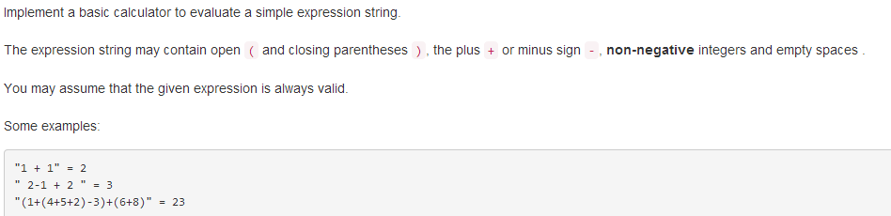
class Solution {
public:
int calculate(string s) {

}
};

2015-10-14
227. Basic Calculator II
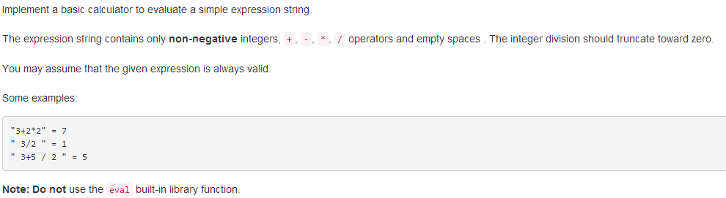
class Solution {
public:
int calculate(string s) {

}
};

226. Invert Binary Tree
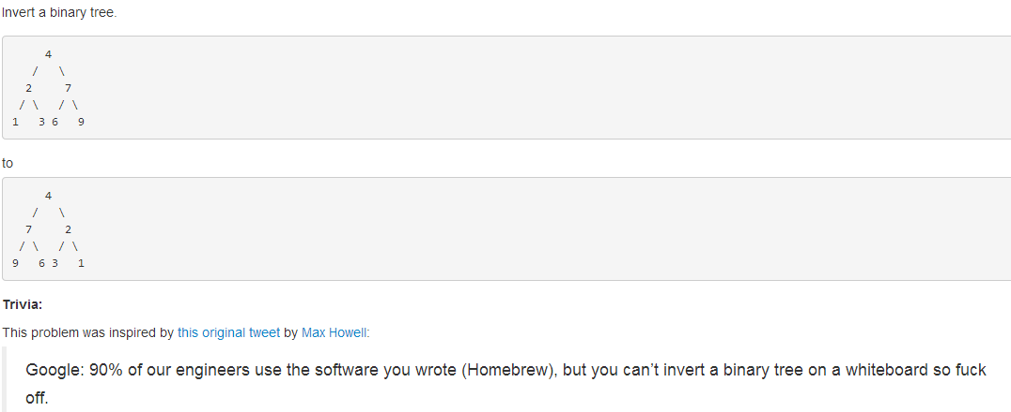
/**
* Definition for a binary tree node.
* struct TreeNode {
* int val;
* TreeNode *left;
* TreeNode *right;
* TreeNode(int x) : val(x), left(NULL), right(NULL) {}
* };
*/
class Solution {
public:
TreeNode* invertTree(TreeNode* root) {

}
};

228. Summary Ranges
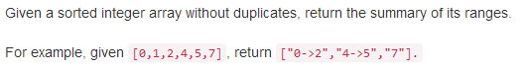
class Solution {
public:
vector<string> summaryRanges(vector<int>& nums) {

}
};
225. Implement Stack using Queues
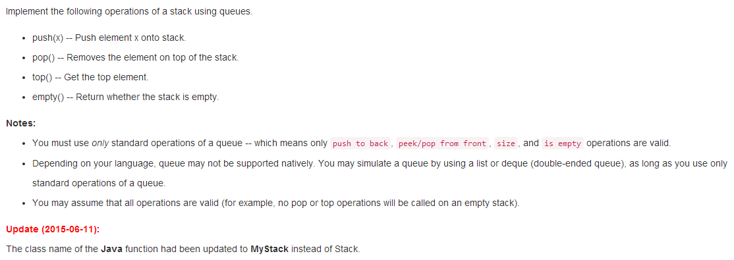
class Stack {
public:
// Push element x onto stack.
void push(int x) {

}

// Removes the element on top of the stack.
void pop() {

}

// Get the top element.
int top() {

}

// Return whether the stack is empty.
bool empty() {

}
};

229. Majority Element II
class Solution {
public:
vector<int> majorityElement(vector<int>& nums) {

}
};
230. Kth Smallest Element in a BST
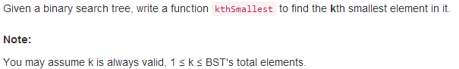
/**
* Definition for a binary tree node.
* struct TreeNode {
* int val;
* TreeNode *left;
* TreeNode *right;
* TreeNode(int x) : val(x), left(NULL), right(NULL) {}
* };
*/
class Solution {
public:
int kthSmallest(TreeNode* root, int k) {

}
};
231. Power of Two
class Solution {
public:
bool isPowerOfTwo(int n) {

}
};

232. Implement Queue using Stacks
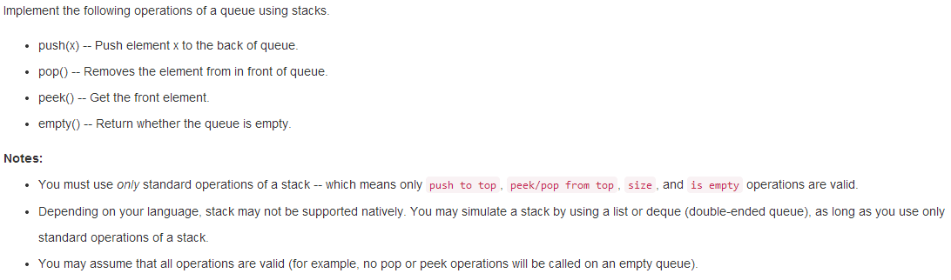
class Queue {
public:
// Push element x to the back of queue.
void push(int x) {

}

// Removes the element from in front of queue.
void pop(void) {

}

// Get the front element.
int peek(void) {

}

// Return whether the queue is empty.
bool empty(void) {

}
};

233. Number of Digit One
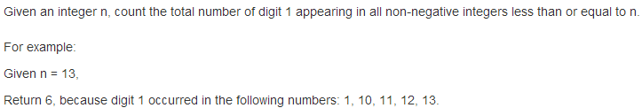
class Solution {
public:
int countDigitOne(int n) {

}
};

234. Palindrome Linked List
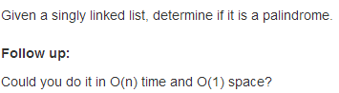
/**
* Definition for singly-linked list.
* struct ListNode {
* int val;
* ListNode *next;
* ListNode(int x) : val(x), next(NULL) {}
* };
*/
class Solution {
public:
bool isPalindrome(ListNode* head) {

}
};
236. Lowest Common Ancestor of a Binary Tree
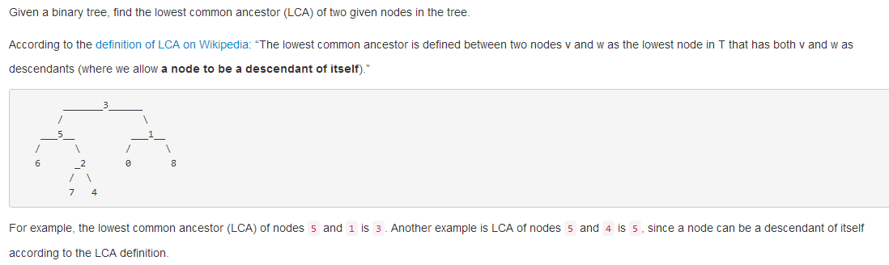
/**
* Definition for a binary tree node.
* struct TreeNode {
* int val;
* TreeNode *left;
* TreeNode *right;
* TreeNode(int x) : val(x), left(NULL), right(NULL) {}
* };
*/
class Solution {
public:
TreeNode* lowestCommonAncestor(TreeNode* root, TreeNode* p, TreeNode* q) {

}
};
238. Product of Array Except Self
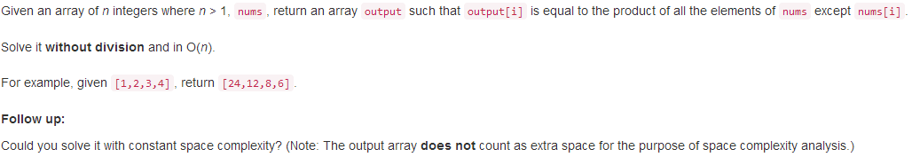
class Solution {
public:
vector<int> productExceptSelf(vector<int>& nums) {

}
};

2015-10-13
237. Delete Node in a Linked List
/**
* Definition for singly-linked list.
* struct ListNode {
* int val;
* ListNode *next;
* ListNode(int x) : val(x), next(NULL) {}
* };
*/
class Solution {
public:
void deleteNode(ListNode* node) {

}
};

239. Sliding Window Maximum
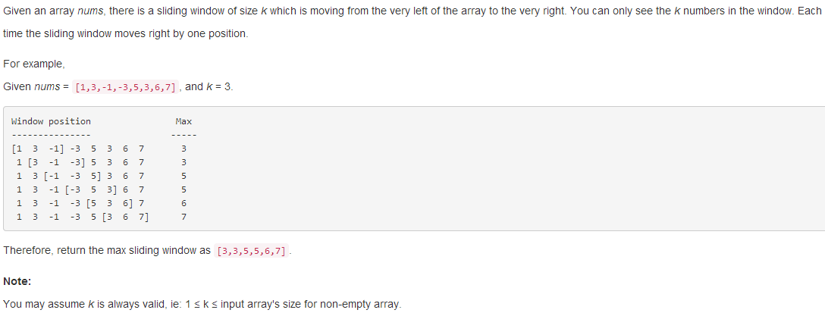
class Solution {
public:
vector<int> maxSlidingWindow(vector<int>& nums, int k) {

}
};

240. Search a 2D Matrix II
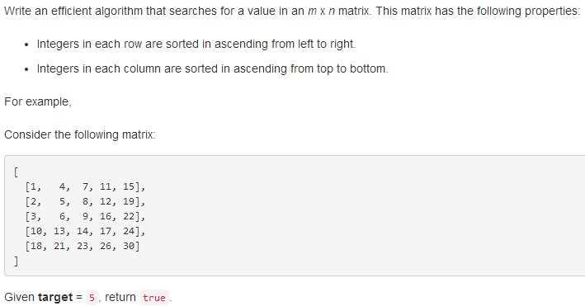
class Solution {
public:
bool searchMatrix(vector<vector<int>>& matrix, int target) {

}
};

241. Different Ways to Add Parentheses
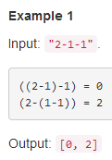
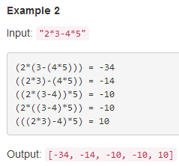
class Solution {
public:
vector<int> diffWaysToCompute(string input) {

}
};
242. Valid Anagram
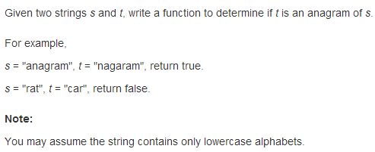
class Solution {
public:
bool isAnagram(string s, string t) {

}
};

257. Binary Tree Paths
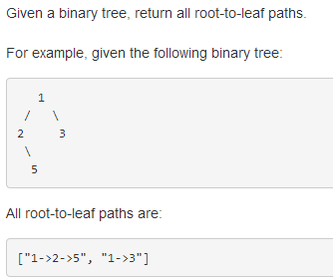
/**
* Definition for a binary tree node.
* struct TreeNode {
* int val;
* TreeNode *left;
* TreeNode *right;
* TreeNode(int x) : val(x), left(NULL), right(NULL) {}
* };
*/
class Solution {
public:
vector<string> binaryTreePaths(TreeNode* root) {

}
};
258. Add Digits
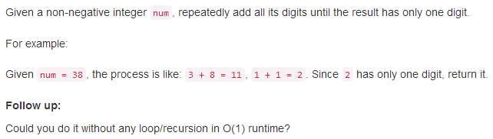
class Solution {
public:
int addDigits(int num) {

}
};

260. Single Number III
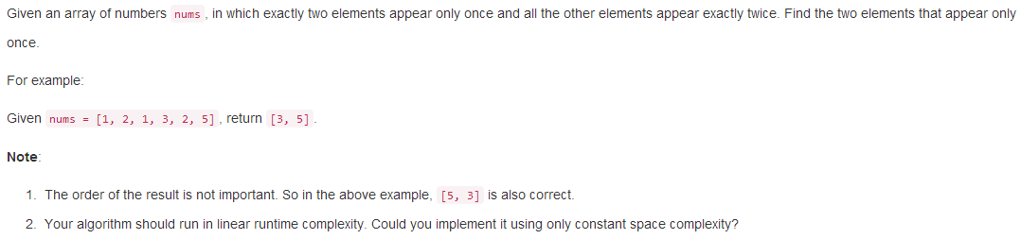
class Solution {
public:
vector<int> singleNumber(vector<int>& nums) {

}
};
263. Ugly Number
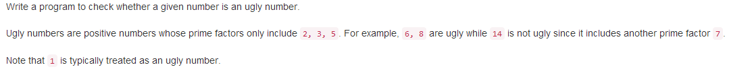
class Solution {
public:
bool isUgly(int num) {

}
};

273. Integer to English Words
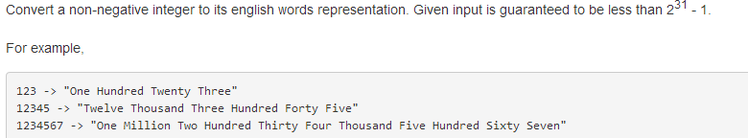
class Solution {
public:
string numberToWords(int num) {

}
};

2015-10-12
268. Missing Number
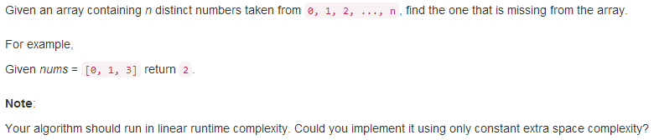
class Solution {
public:
int missingNumber(vector<int>& nums) {

}
};
275. H-Index II
class Solution {
public:
int hIndex(vector<int>& citations) {

}
};

274. H-Index
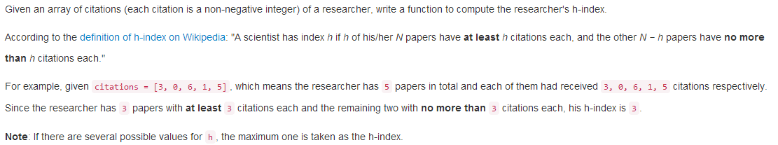
class Solution {
public:
int hIndex(vector<int>& citations) {

}
};

278. First Bad Version
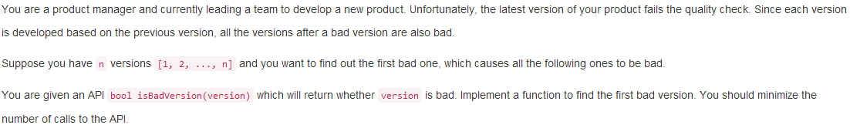
// Forward declaration of isBadVersion API.
bool isBadVersion(int version);

class Solution {
public:
int firstBadVersion(int n) {

}
};
279. Perfect Squares
class Solution {
public:
int numSquares(int n) {

}
};

282.Expression Add Operators
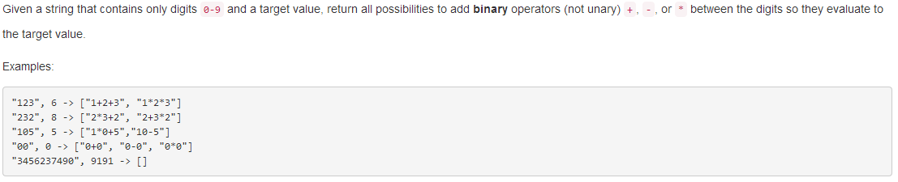
class Solution {
public:
vector<string> addOperators(string num, int target) {

}
};

283.Move zeros
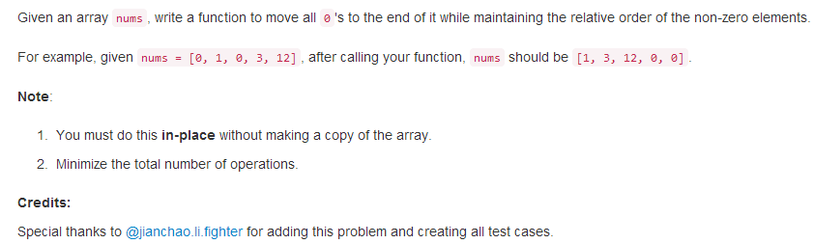
class Solution {
public:
void moveZeroes(vector<int>& nums) {

}
};

284.Peeking Iterator
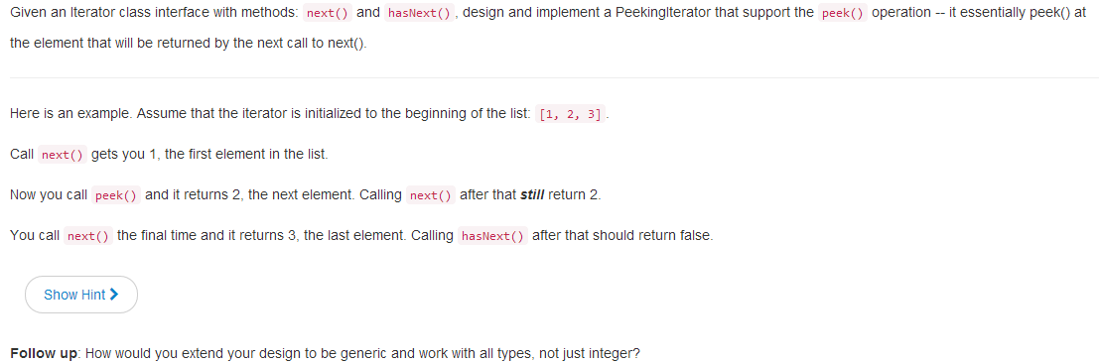
// Below is the interface for Iterator, which is already defined for you.
// **DO NOT** modify the interface for Iterator.
class Iterator {
struct Data;
Data* data;
public:
Iterator(const vector<int>& nums);
Iterator(const Iterator& iter);
virtual ~Iterator();
// Returns the next element in the iteration.
int next();
// Returns true if the iteration has more elements.
bool hasNext() const;
};

class PeekingIterator : public Iterator {
public:
PeekingIterator(const vector<int>& nums) : Iterator(nums) {
// Initialize any member here.
// **DO NOT** save a copy of nums and manipulate it directly.
// You should only use the Iterator interface methods.

}

// Returns the next element in the iteration without advancing the iterator.
int peek() {

}

// hasNext() and next() should behave the same as in the Iterator interface.
// Override them if needed.
int next() {

}

bool hasNext() const {

}
};
2015-10-11
290.Word Pattern
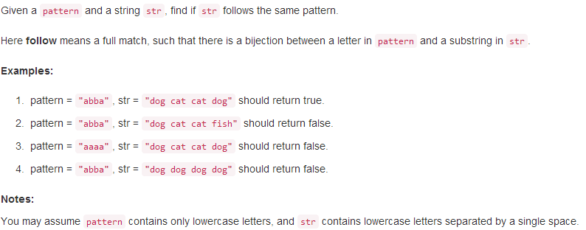
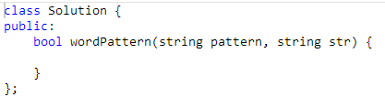
289.Game of Life
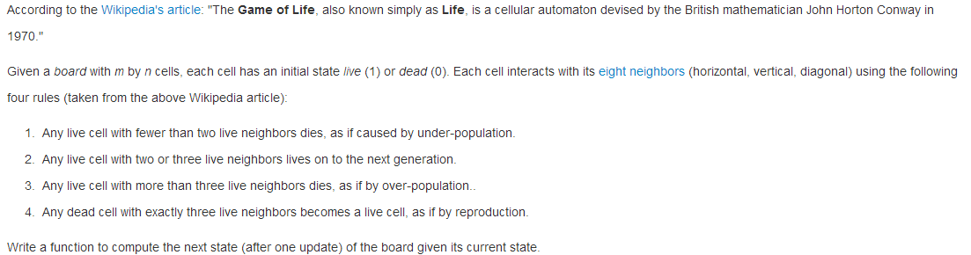
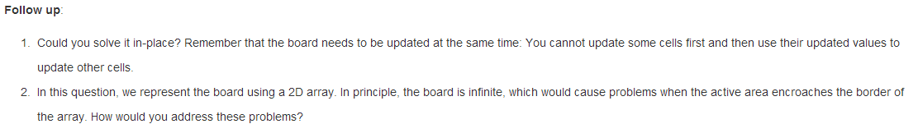
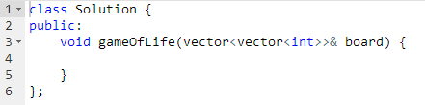
287.Find the Duplicate Number
