题目2：The price is wrong
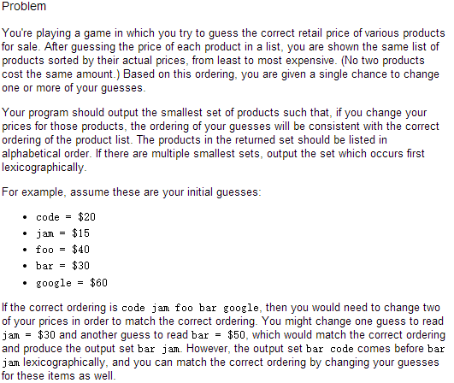
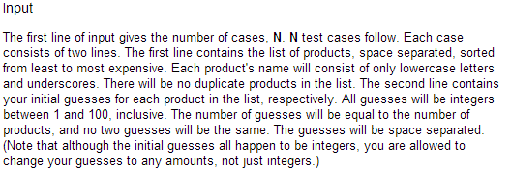
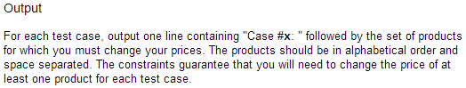
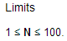
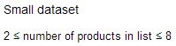
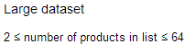
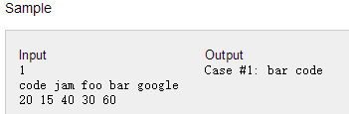
code jam foo bar google
20 15 40 30 60
code jam foo bar google
20 15 40 50 60
code jam foo bar google
20 70 40 30 60
code jam foo bar google
20 70 40 50 60
code jam foo bar google
60 30 40 15 20
code jam foo bar google
60 40 30 20 15
bar code foo google jam
20 15 40 30 60
jam google foo code bar
20 15 40 30 60
foo bar
3 2
code jam
3 2
needle hair curtain knee fowl book
86 96 8 89 50 26
girl garden scissors tail
57 14 31 6
chain window brake picture gun library finger
90 83 15 60 5 52 26
sail wire floor
81 82 36
umbrella brick stocking
98 90 23
glove jewel trousers frame knee
60 51 17 14 10
skin lock knot ant seed plane
85 8 100 69 32 84

题目3：Random Route
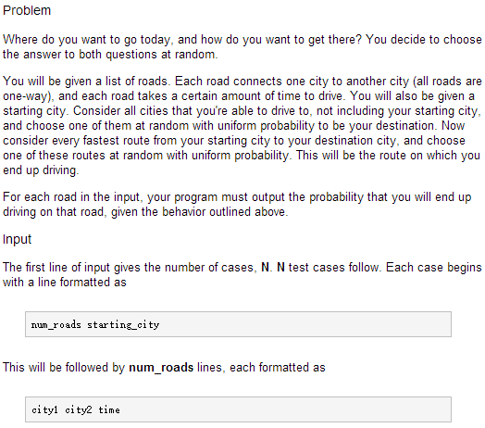
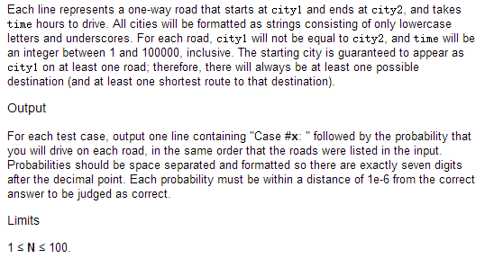
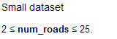
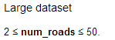
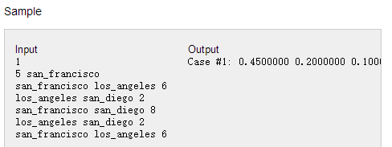
5 san_francisco
san_francisco los_angeles 6
los_angeles san_diego 2
san_francisco san_diego 8
los_angeles san_diego 2
san_francisco los_angeles 6
1 new_york_city
new_york_city chicago 1
2 houston
houston phoenix 1
houston phoenix 1
2 philadelphia
philadelphia san_antonio 1
philadelphia san_antonio 2
2 dallas
dallas san_jose 2
san_jose dallas 1
2 detroit
jacksonville indianapolis 2
detroit jacksonville 1
2 columbus
columbus austin 2
columbus memphis 1
10 a
e f 1
d e 2
c d 3
b c 4
a b 5
a b 5
b c 4
c d 3
d e 2
e f 1

问题4：Hexagon Game
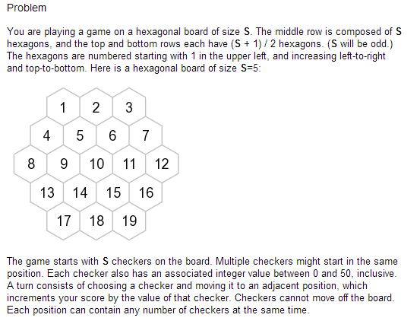
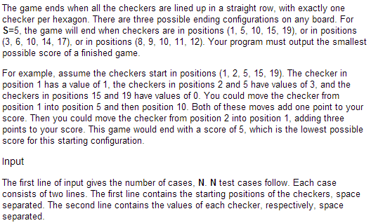
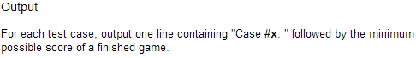
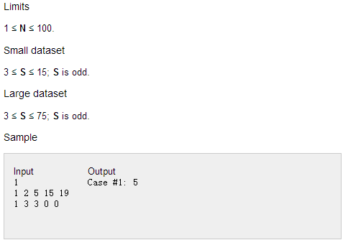
1 2 5 15 19
1 3 3 0 0
1 2 5 15 19
0 3 3 0 0
1 2 5 15 19
2 3 3 0 0
1 1 1 1 1
0 1 2 3 4
2 2 2 2 2
0 1 2 3 4
10 10 10 10 10
0 1 2 3 4
1 1 1 1 1
1 1 1 1 1
10 10 10 10 10
1 1 1 1 1
2 3 5 7 11
0 0 0 0 0
161 20 120 15 97 110 63 53 29 165 113 12 44 13 104
33 15 33 15 15 15 37 37 33 37 15 15 15 33 15
7 26 17 6 43 16 43 53 59
19 9 16 21 16 1 21 26 29
124 38 106 72 92 29 90 42 21 108 81 69 36
7 3 43 43 3 34 43 21 34 39 23 7 21
27 11 37 34 27 34 21
30 30 30 32 45 32 30

