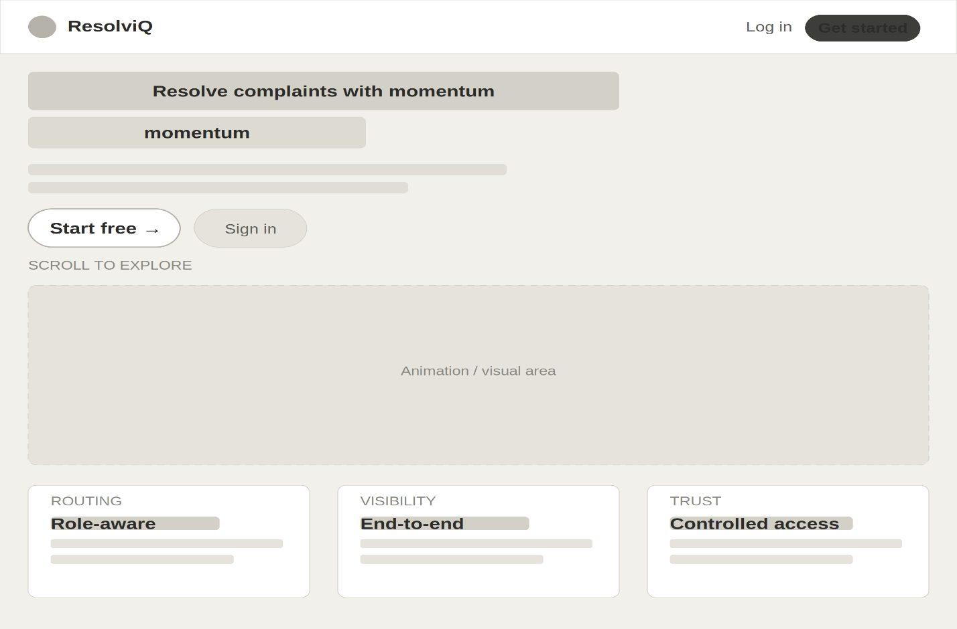
INDEX PAGE:

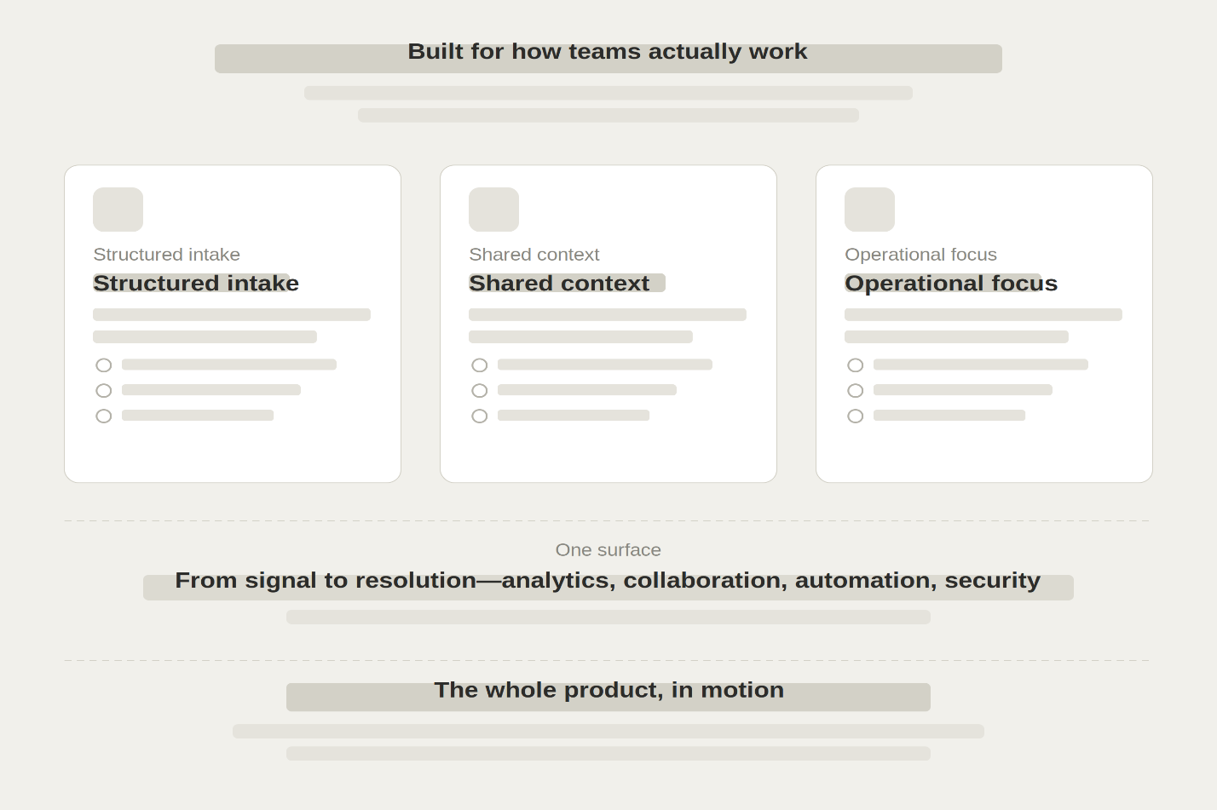
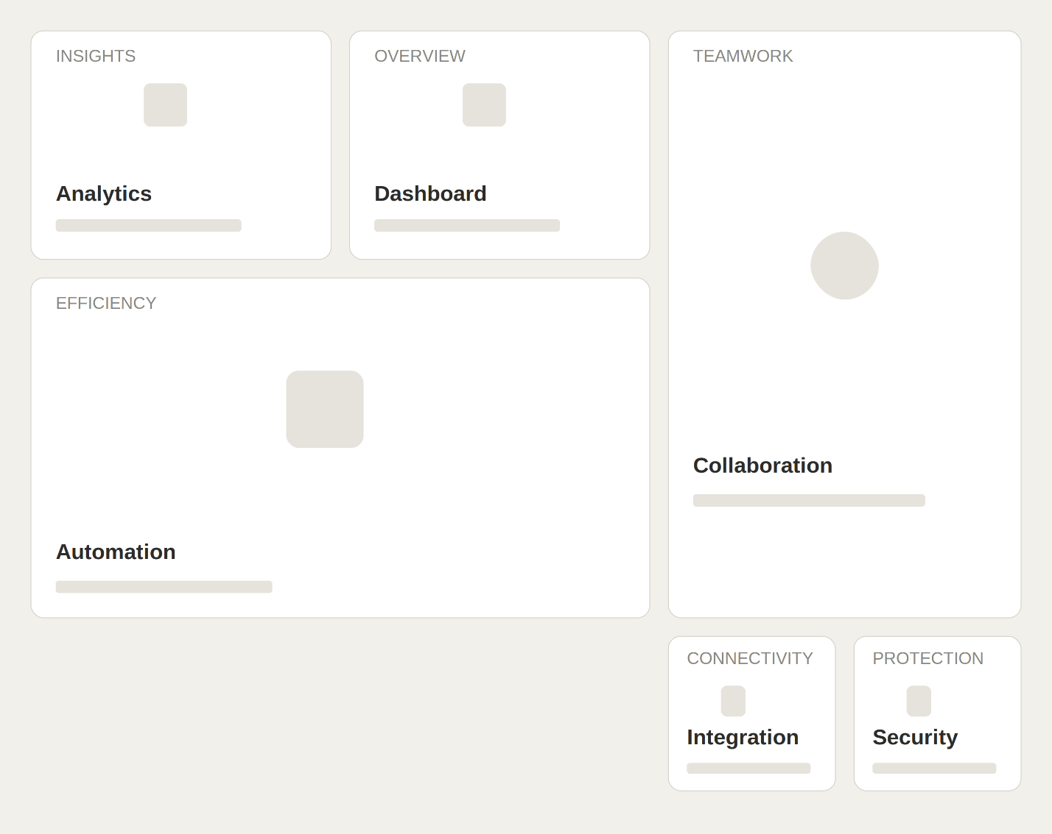
INDEX PAGE (BENTO BOX)
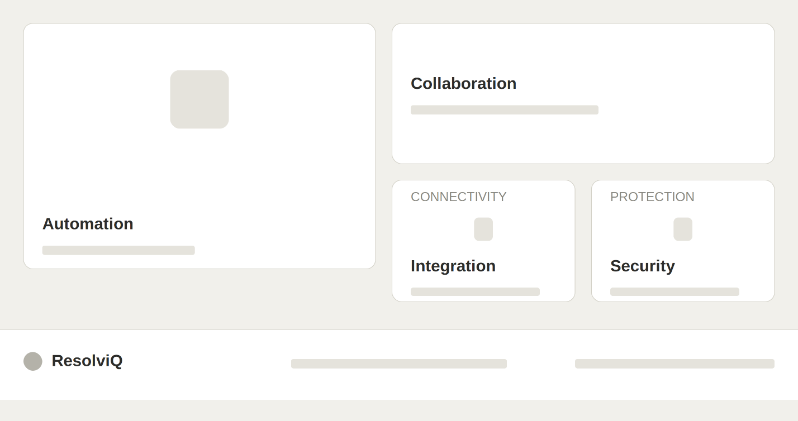
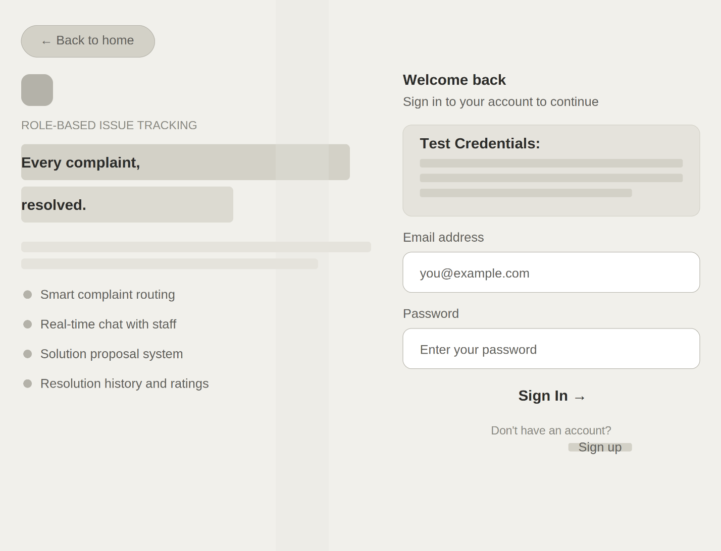
LOGIN PAGE:

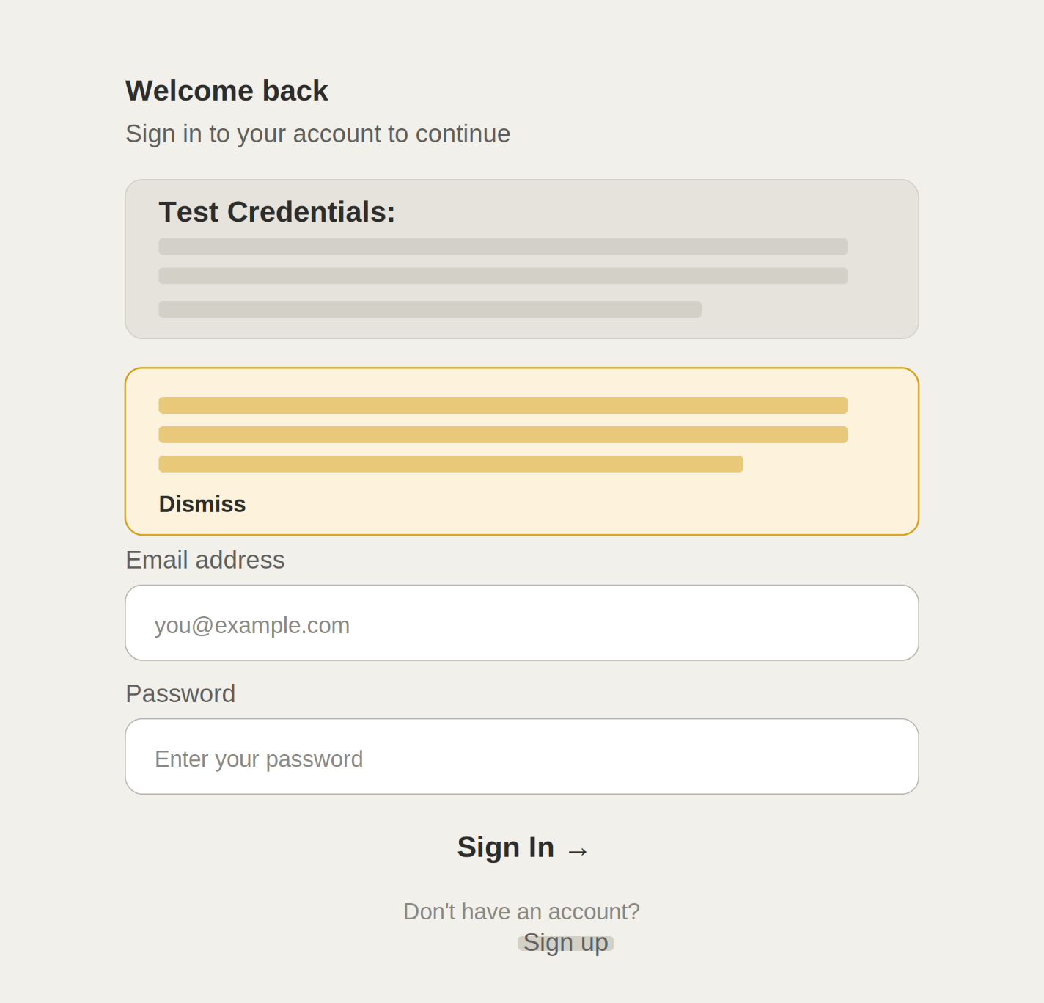
LOGIN PAGE WARNING

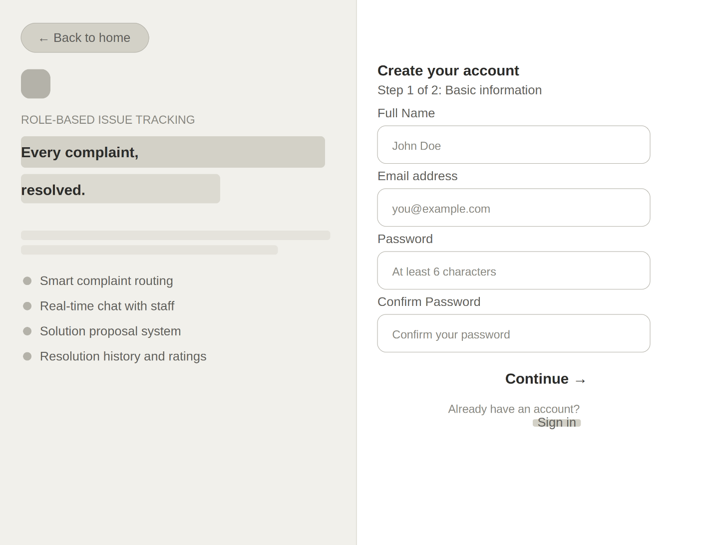
SIGNUP PAGE STEP-1:

SIGNUP PAGE STEP-2:
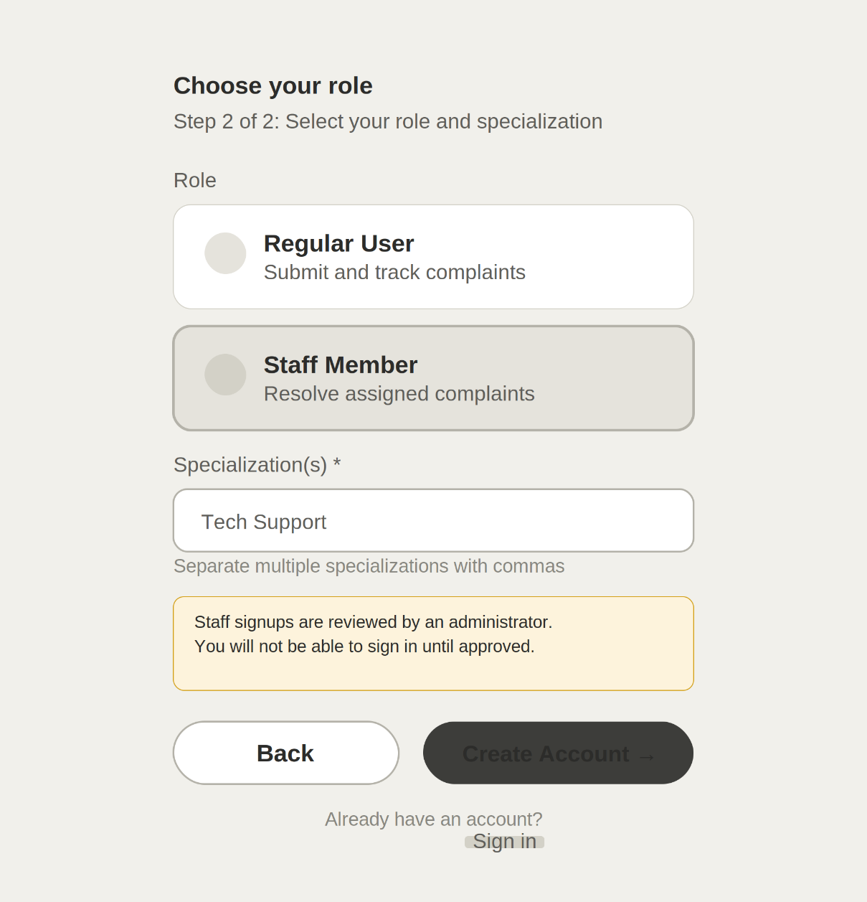

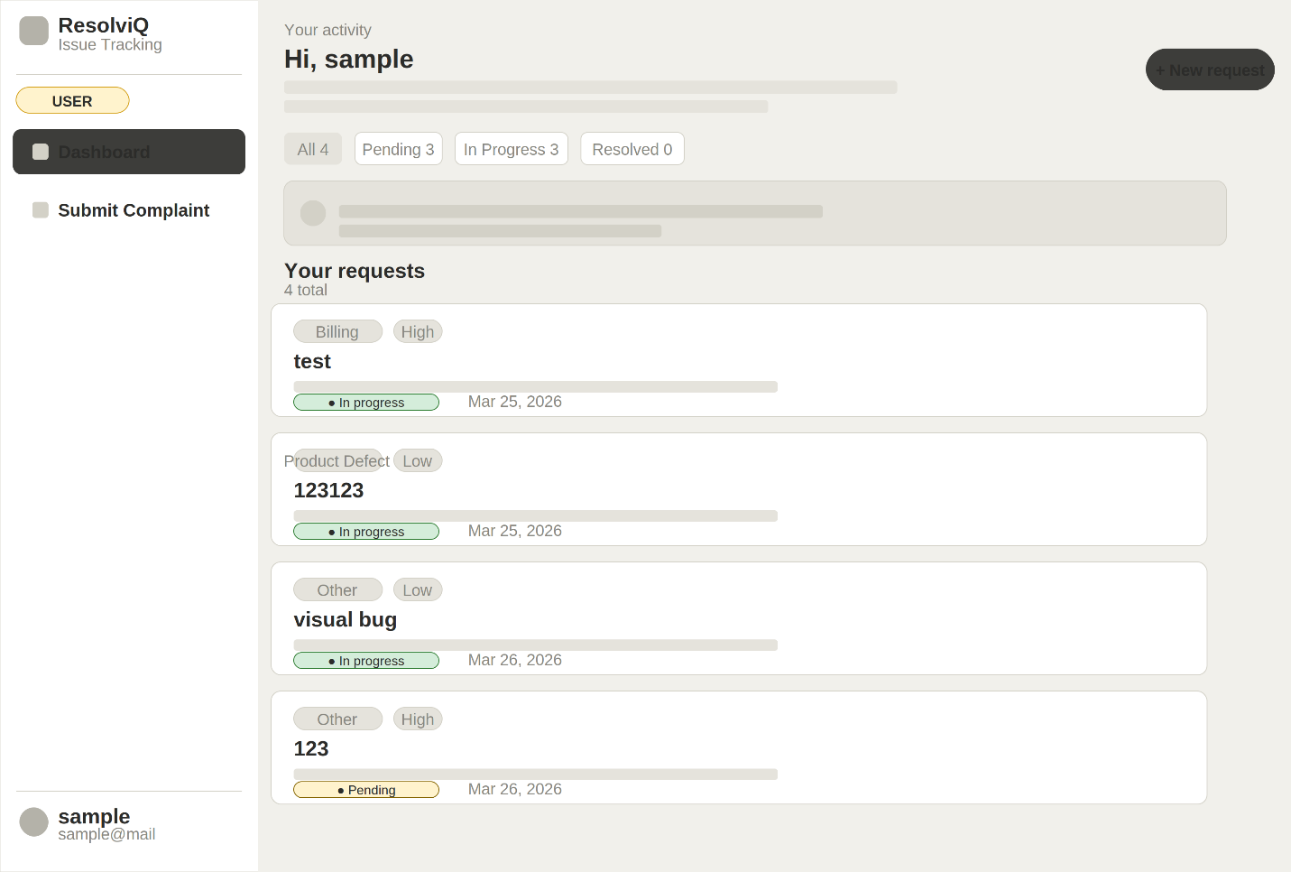
USER DASHBOARD:

USER DASHBOARD (COMPLAINT APPLICATION FORM STEP-1):
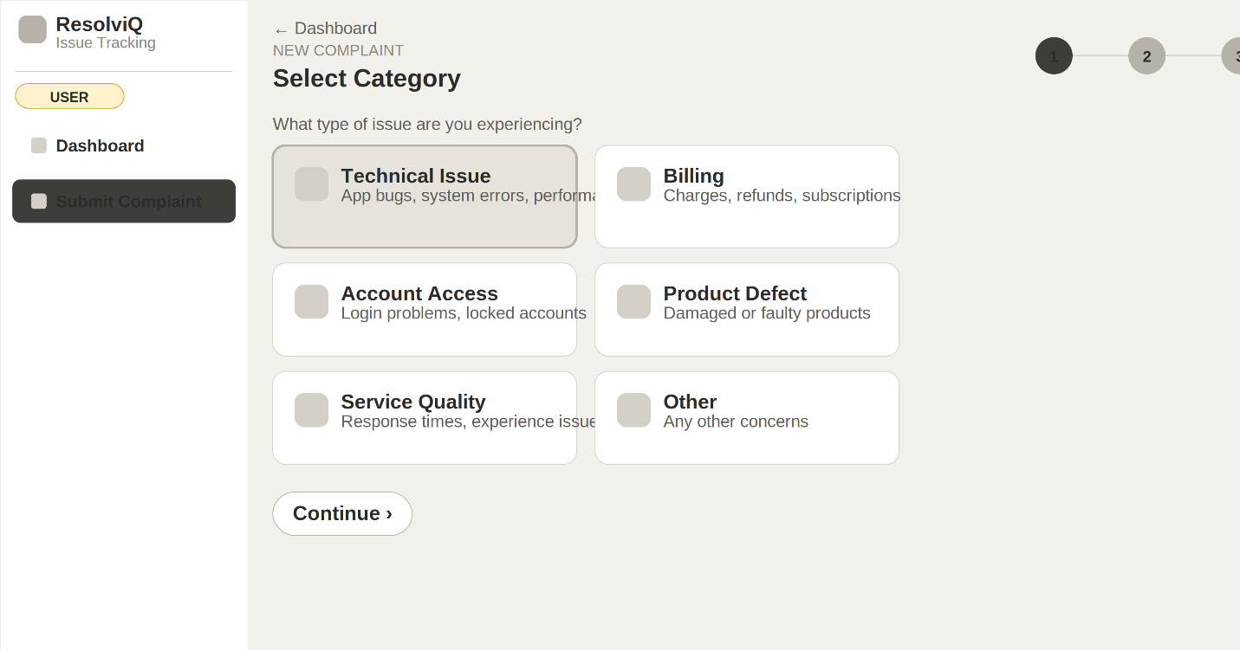

USER DASHBOARD (COMPLAINT APPLICATION FORM STEP-2):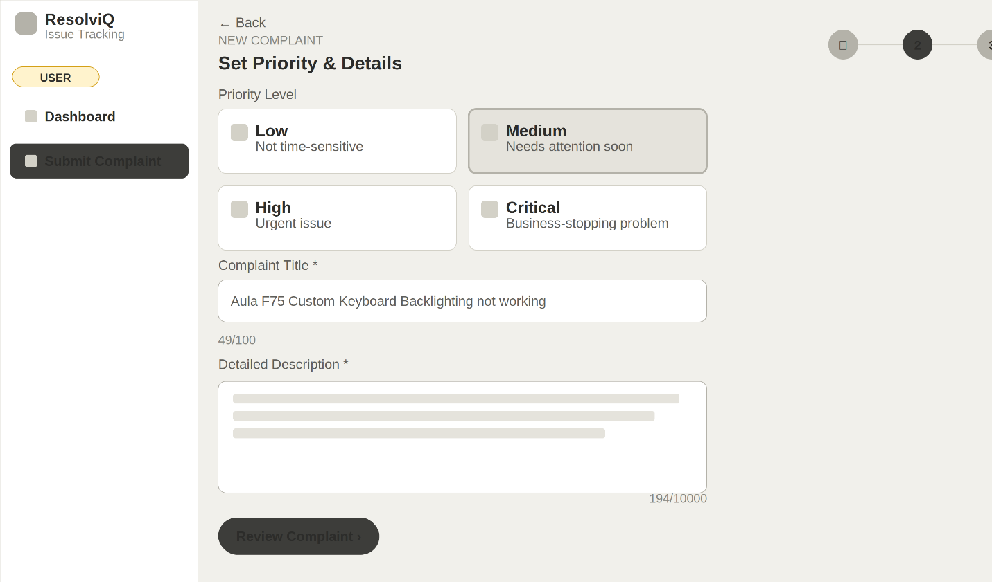

USER DASHBOARD (COMPLAINT APPLICATION FORM STEP-3):
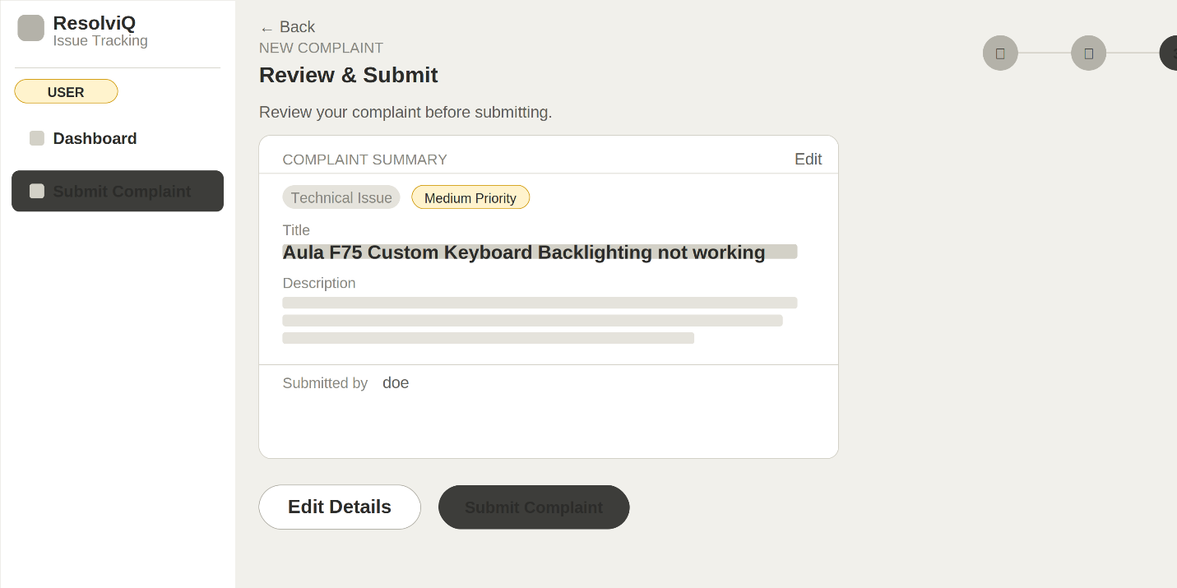
USER (COMPLAINT APPLICATION FORM SUCCESSFUL):
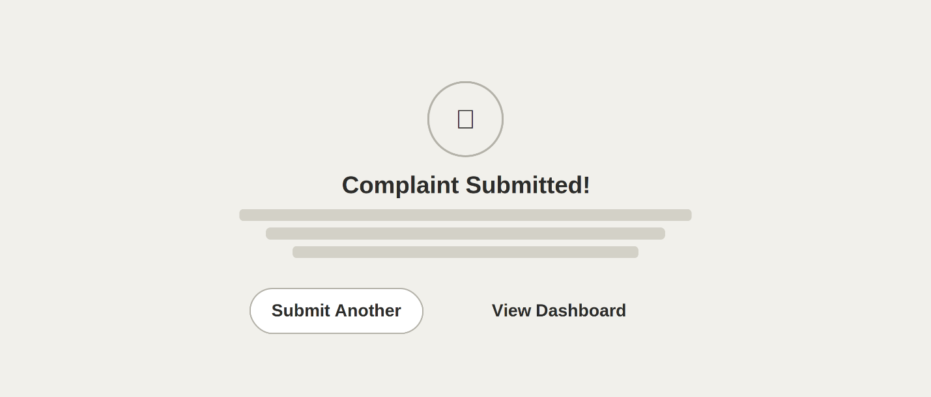

USER COMPLAINT TROUBLESHOOTING LIVE-CHAT WITH STAFF
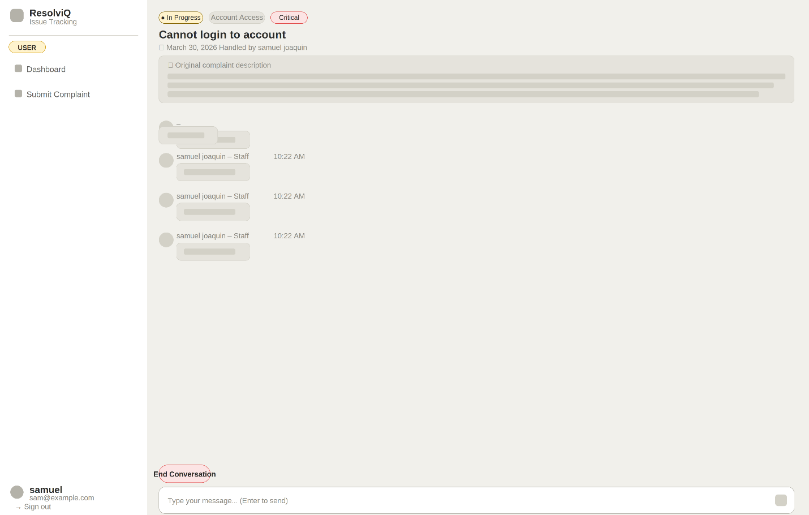
USER CHAT:

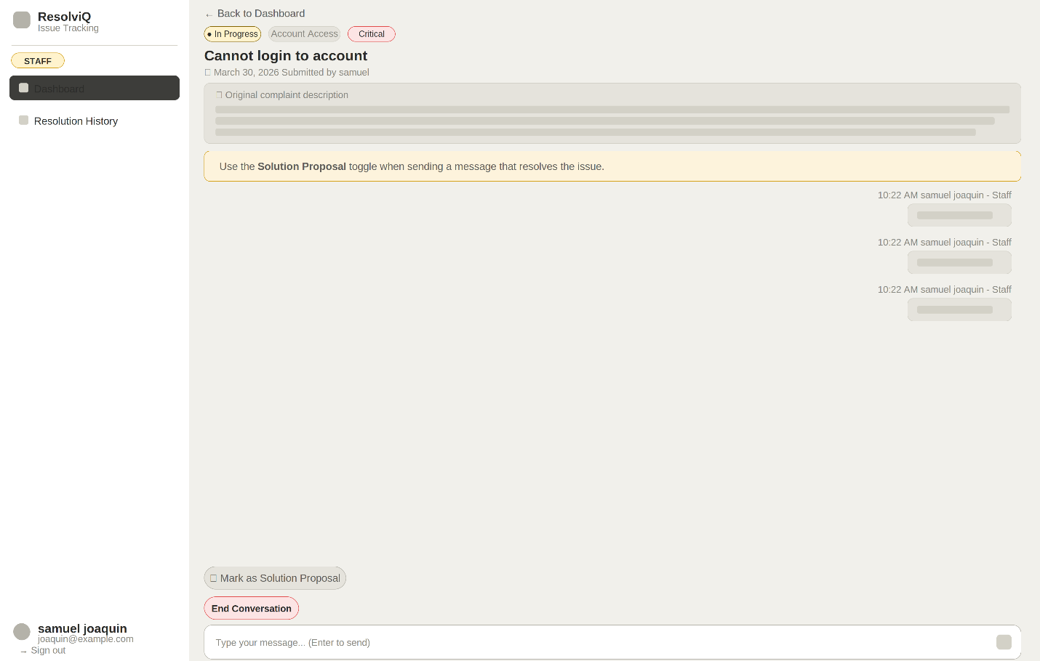
STAFF CHAT:

USER RATING FOR STAFF RESOLUTION:

SOLUTION PROPOSAL:
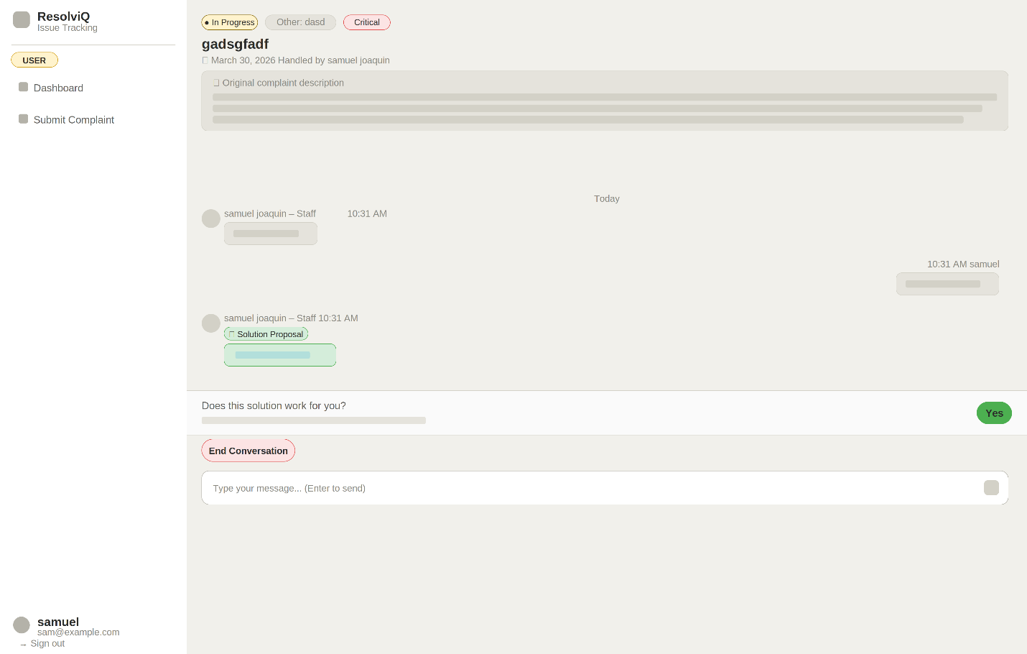

SOLUTION ACCEPTED (USER):
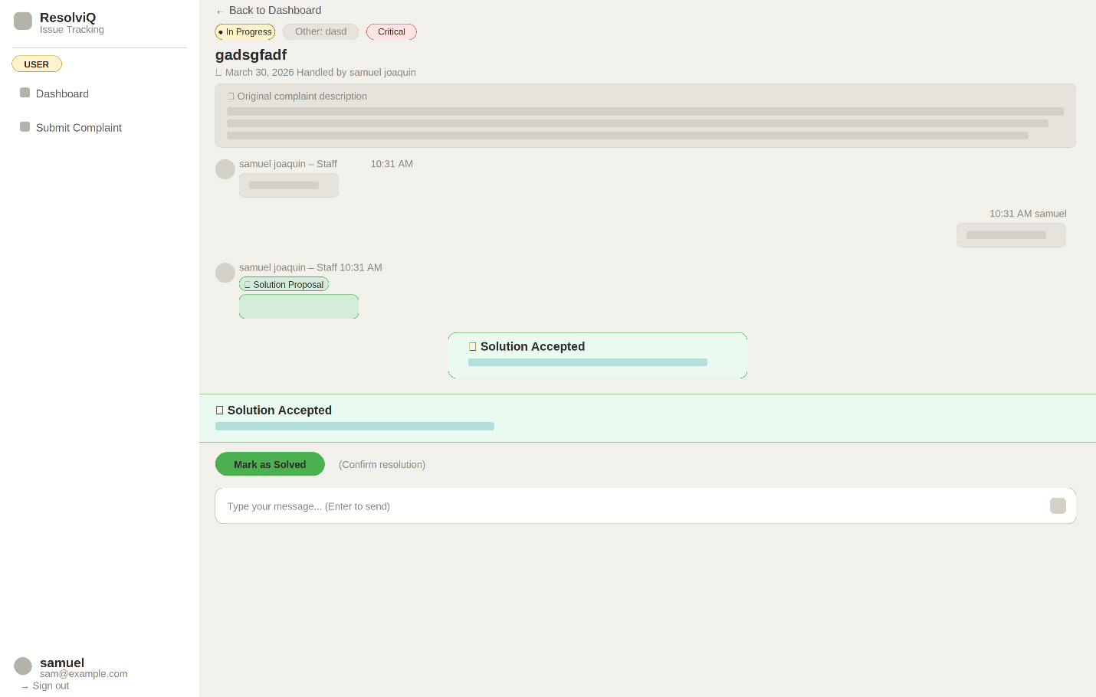

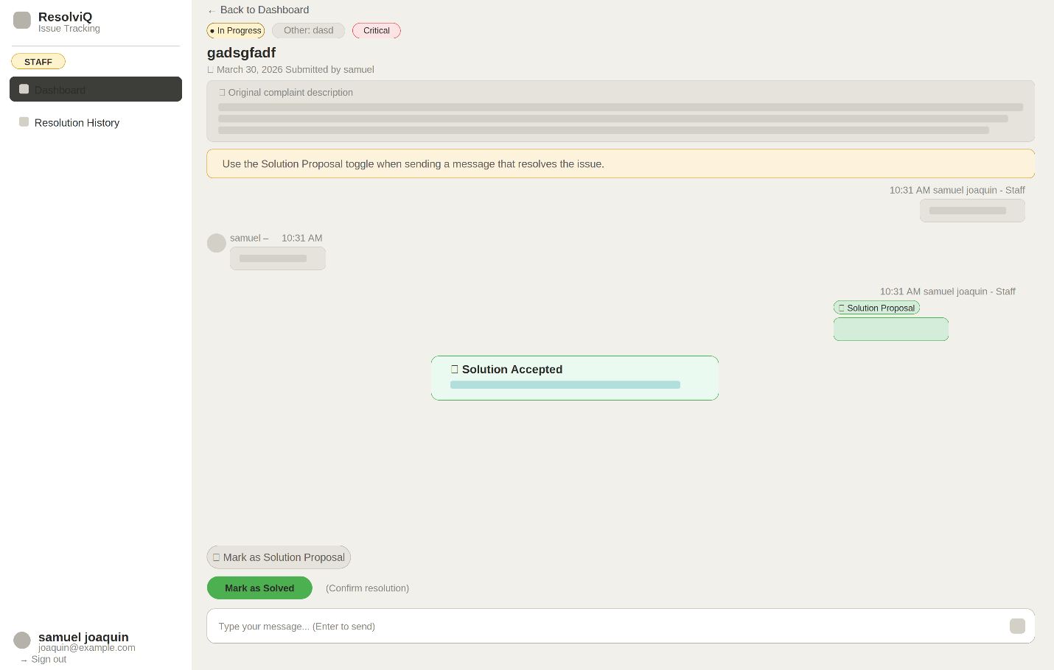
SOLUTION ACCEPTED (STAFF):

MARK AS SOLVED:
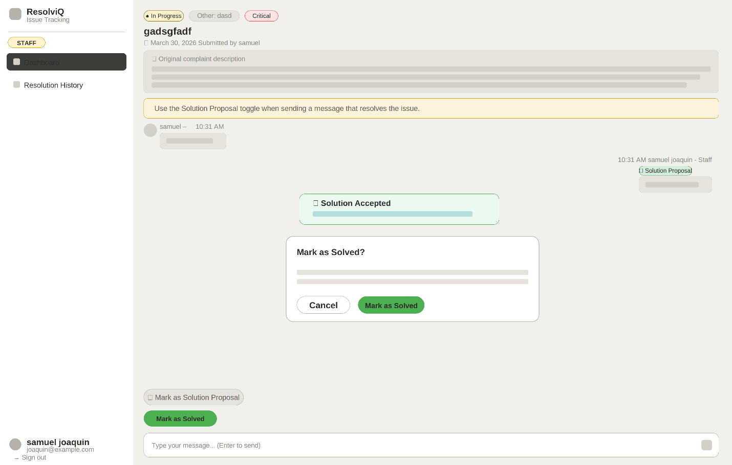

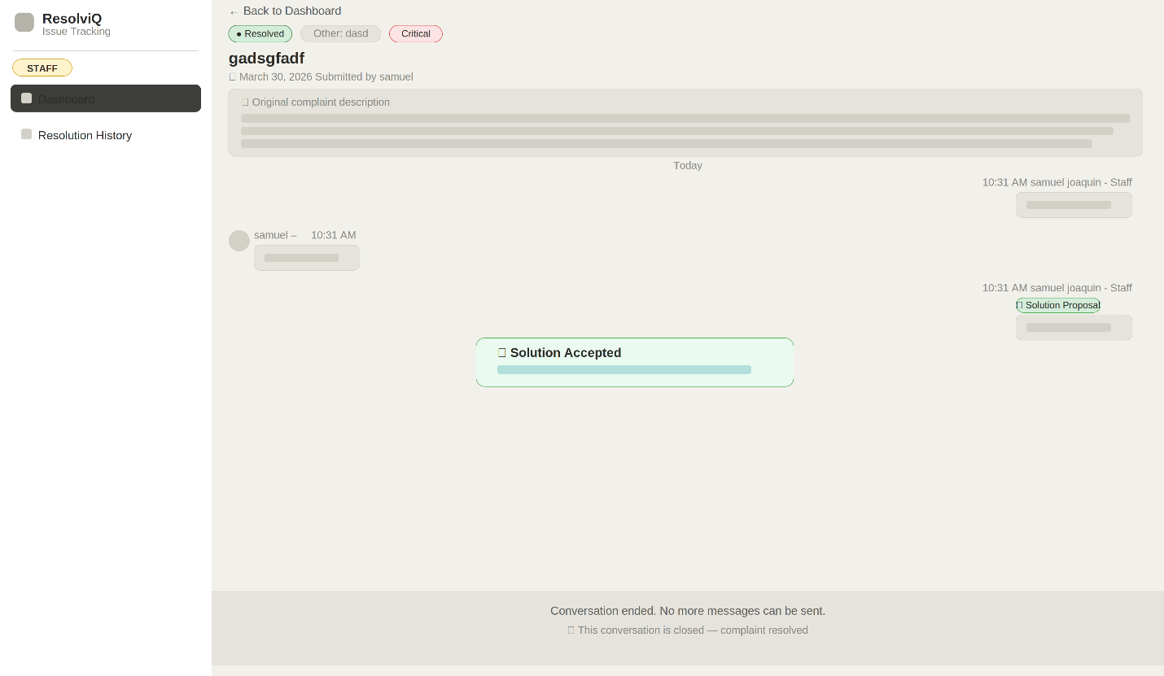
CHAT RESOLVED:

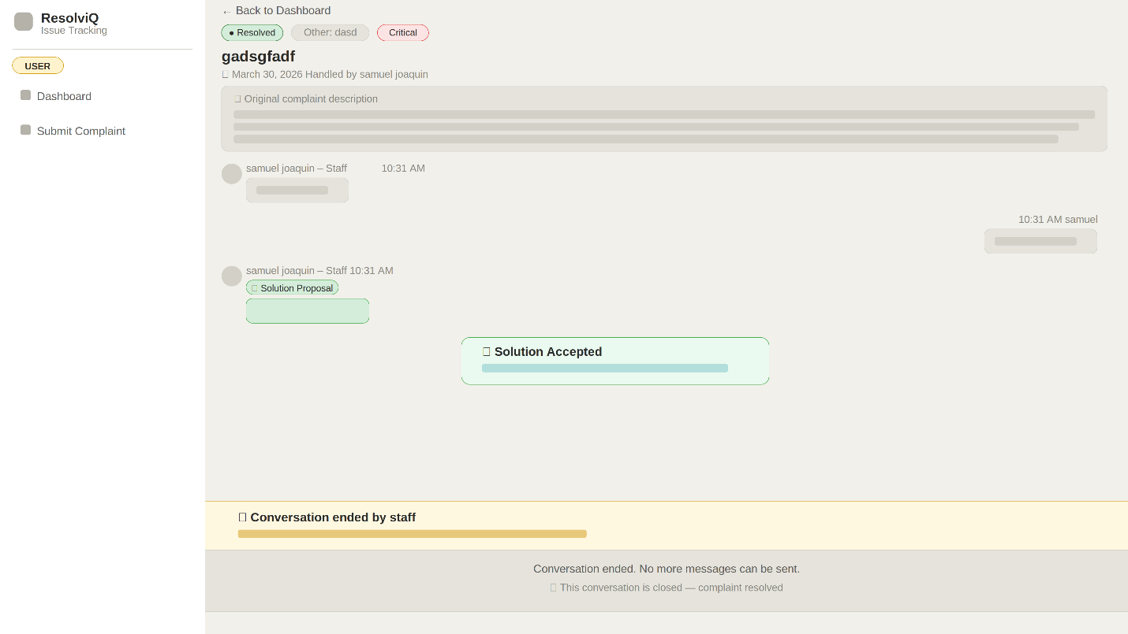

STAFF CHAT (END CONVERSTION):
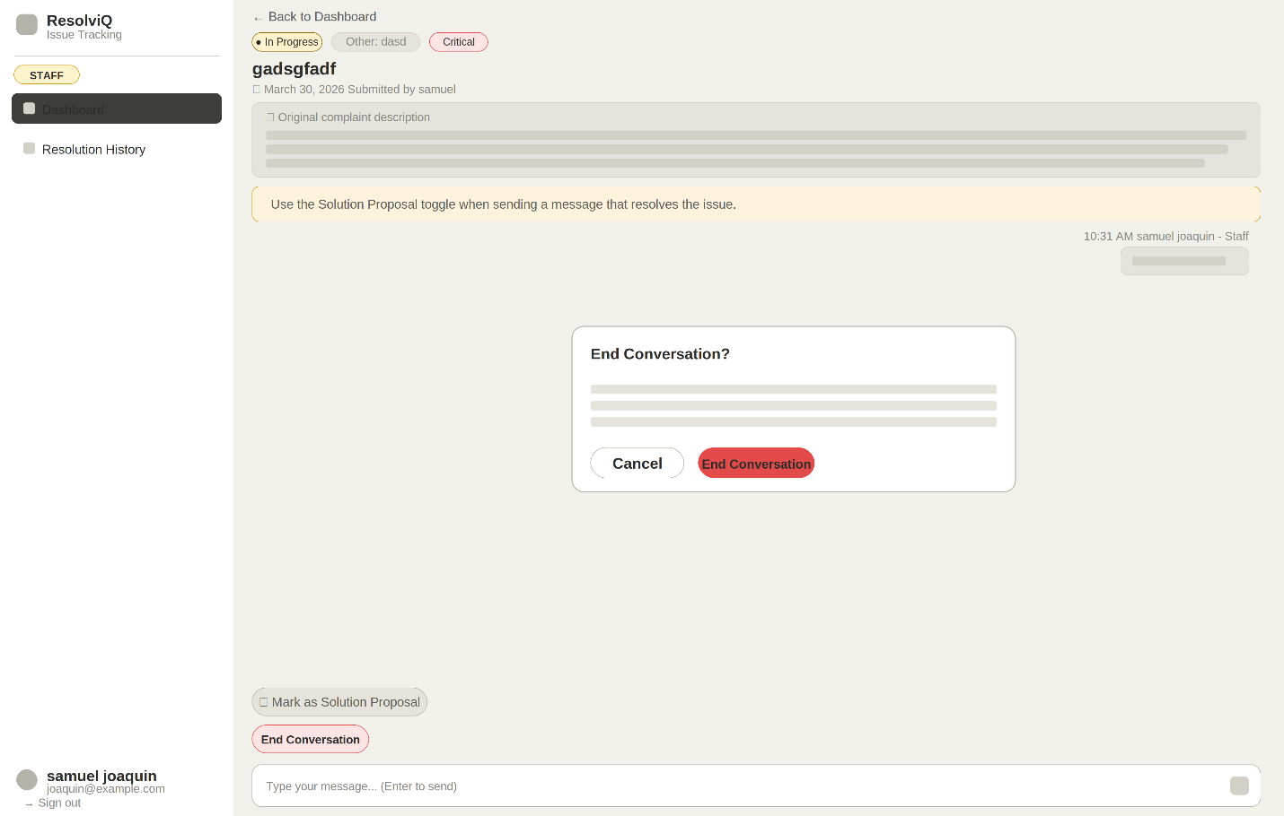

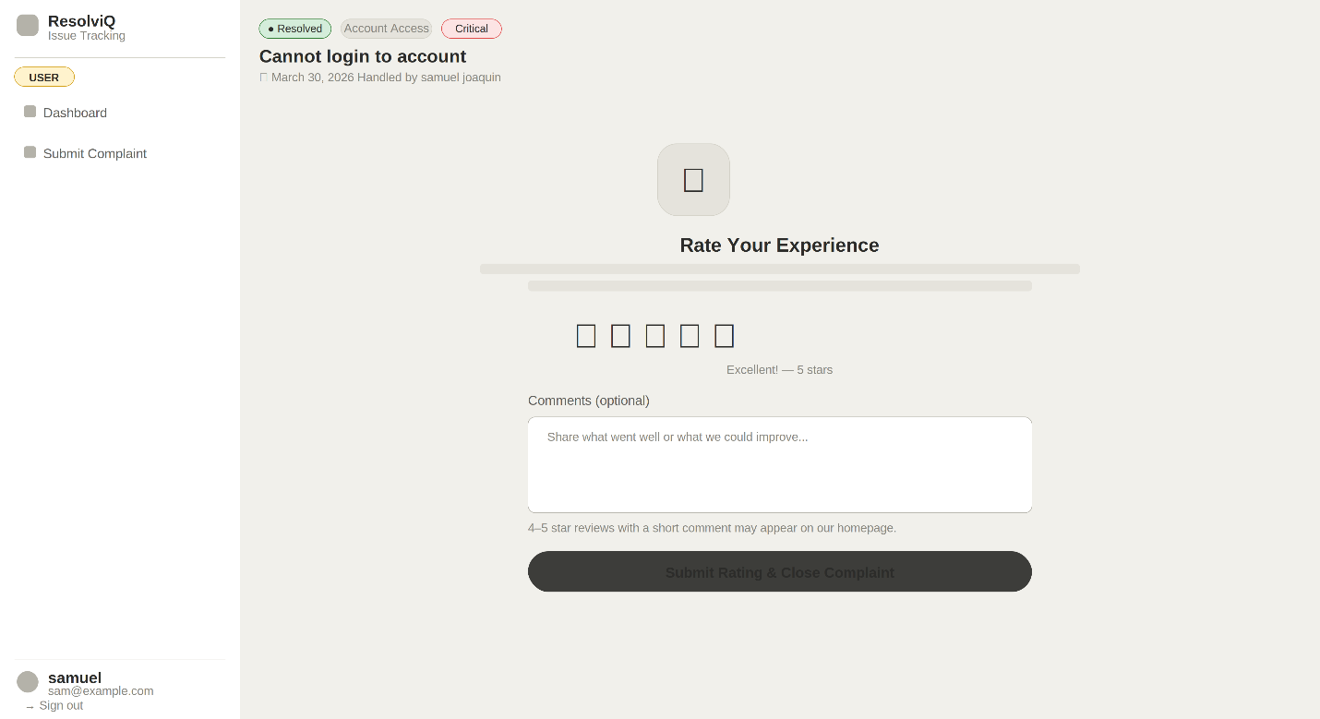
USER STAFF RATING:

STAFF DASHBOARD:
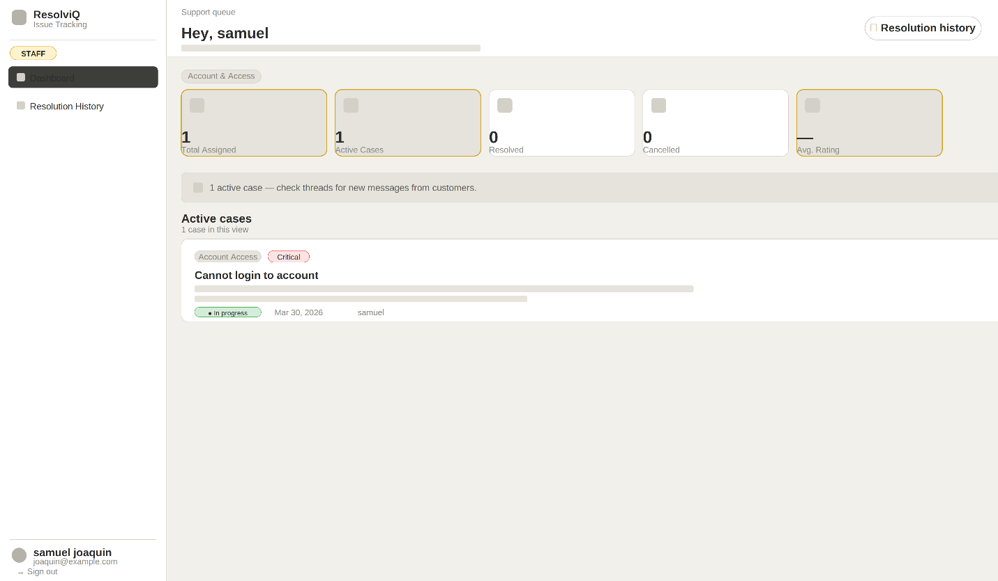
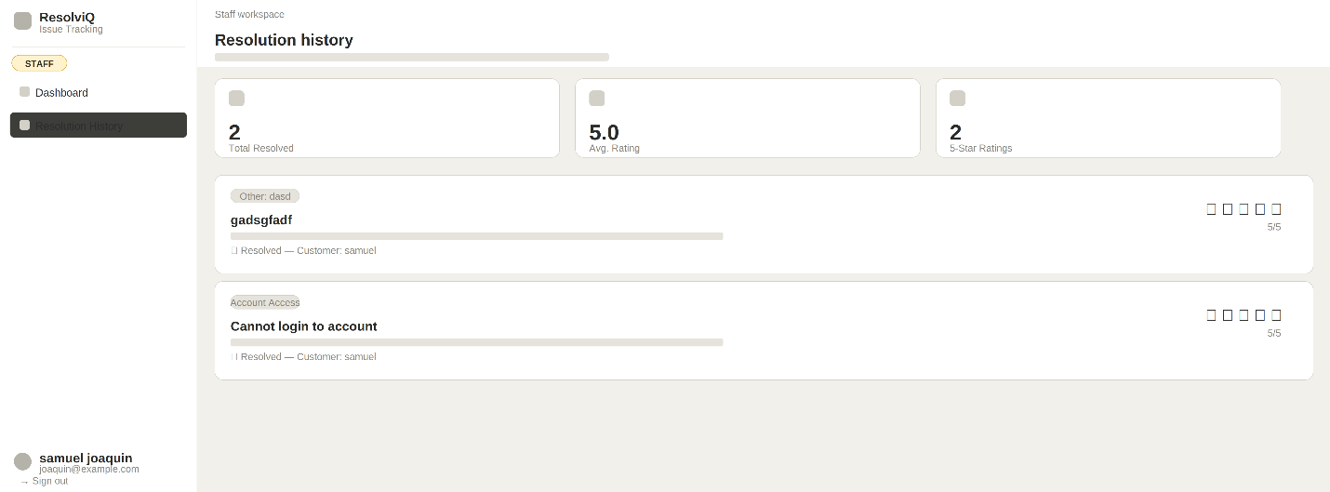

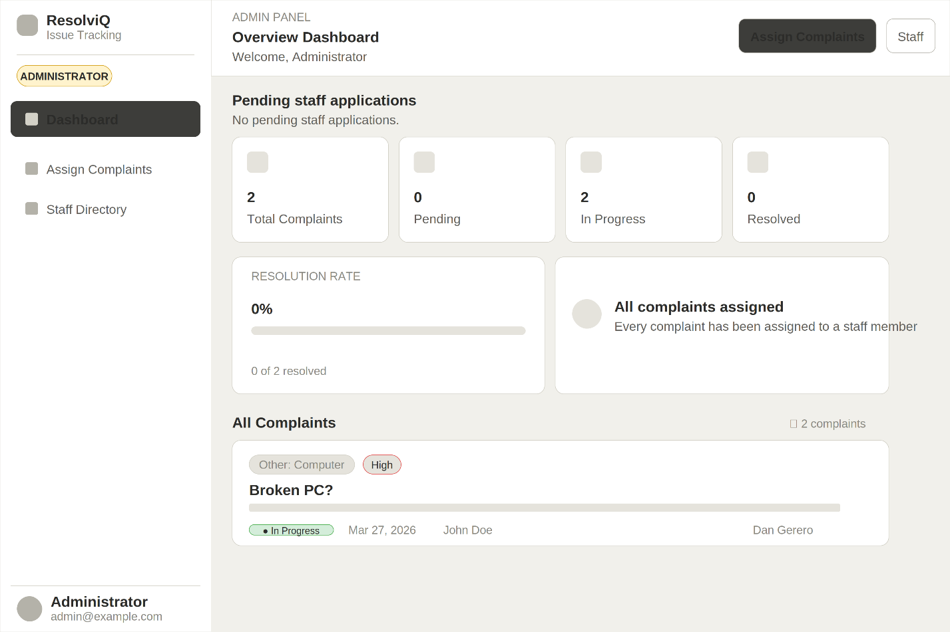
ADMIN DASHBOARD:

ADMIN DASHBOARD (ASSIGNING COMPLAINTS):
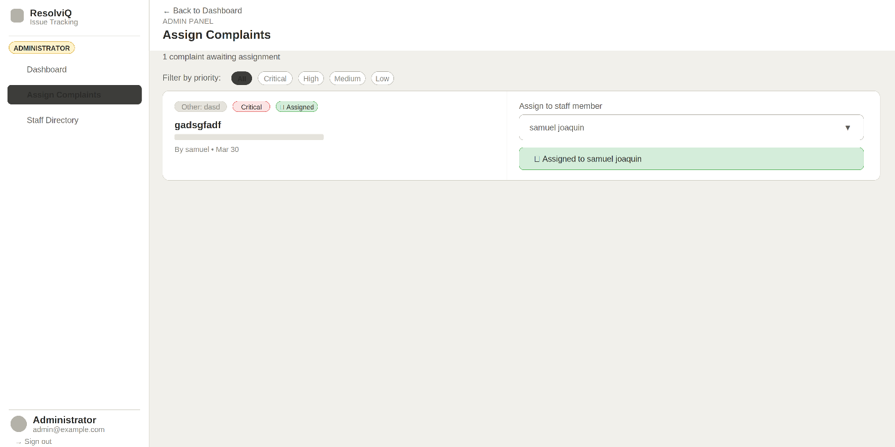

ADMIN DASHBOARD (STAFF DIRECTORY):
