DOCUMENTATION

ASSIGNMENT 2

STUDENT: …Deac Dan Cristian…
GROUP: 3

CONTENT

1. Objective 3
2. Problem analysis, scenarios, use cases 3
3. Design 3
4. Implementation 3
5. Results 3
6. Conclusions 3
7. Bibliography 3

Assignment objectives
The primary objective of this project is a queue management system. It should manage a list of clients in a series of servers and put the client in the Queue with the least waiting time.
Secondary objectives:
-User Interface to input the data required for the simulation of the project.
-Simulation manager
-Scheduler
-Creating text file to keep logs of the events every second
-Synchronize the threads
-Stop simulation – kill threads
-Generate Client list based on inputs
-Update the user interface with the results of the program

Problem analysis, scenarios, use cases
The program will be able to take a set of inputs from the keyboard in several textfields provided by the user interface. Then it will generate a list of clients with random attributes based on the values given in the GUI.
The Scheduler will look at each client’s generated arrival time and will sort the list so that when the client arrives, they have to be but in an appropriate queue. The appropriate queue will be determined by the amount a client would have to wait until it will come his / her time to get served. Therefore if there is one person with an atrocious waiting time alone in a queue, while other queues are stacked, but the waiting times are less than the queue with one guy that has a long waiting time, the client will be put to the longer queue, by the number of clients, but shorter in terms of time till being served.

One of the trickier parts of the project proved to be stopping the simulation and all the threads created by the program. Eventually an attribute that worked like a flag: “notExit” proved to be the best way.
public boolean notExit = true;

public void run() { // Simulation manager
int currentTime = 0;
//System.out.printf("Simulation started.\n");
while(currentTime < timeLimit && notExit){ // <----
…
}

public void run(){ // Server
while(notExit){
…
}

These would be controlled in the simulation manager by the following function:
public void exitApp(){
for(Server s : scheduler.getServers()){
s.notExit = false;
}
this.notExit = false;
thread.interrupt();
}

Use cases:
This kind of application is useful in day to day scenarios where it is required to manage resources. In this instance the resource is time. Each task needs to be completed as fast as possible, therefore the best waiting time is calculated and based on it. The task is being sent to the shortest queue by time.
Step by step functionality:
-take a list of clients, and sort it by their arrival time.
-iterate through the client list, and when current time is equal to a client’s arrival time, it gets dispatched to the scheduler
-scheduler goes through the list of servers and computes the minimum waiting times for each server, then adds the current task to that one queue.
- this is repeated till the simulation current time reaches the time limit..

Design
Class diagram:
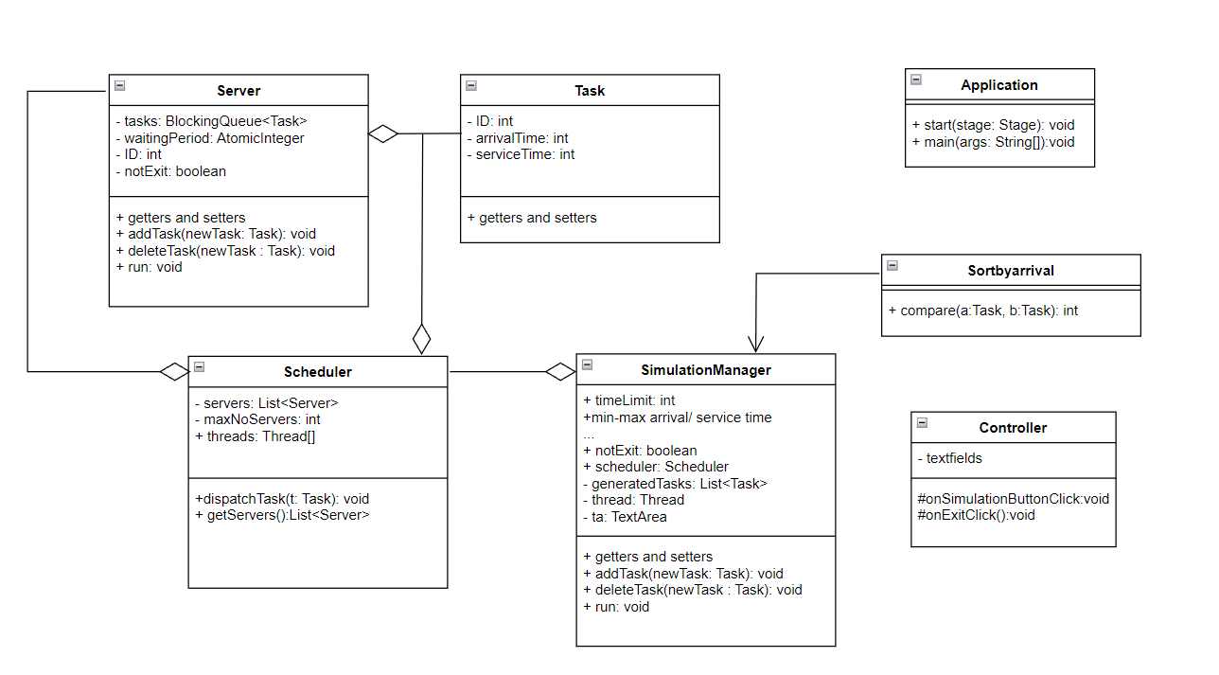Package diagram: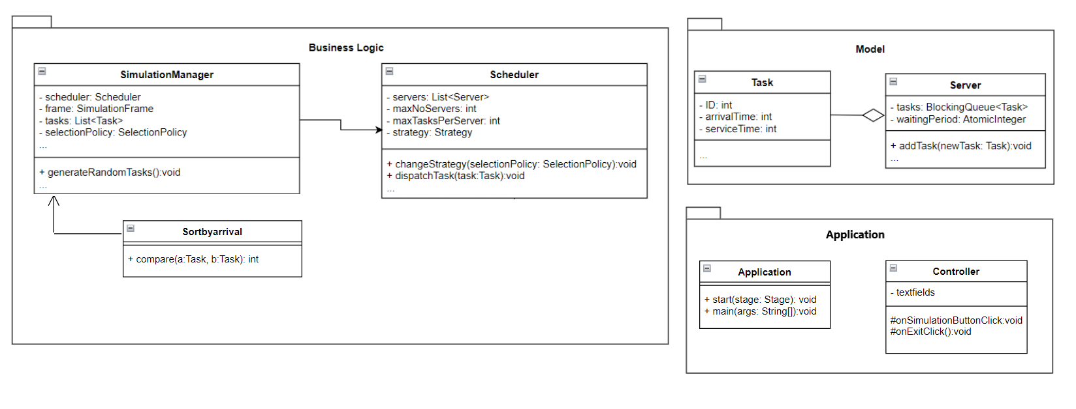Interface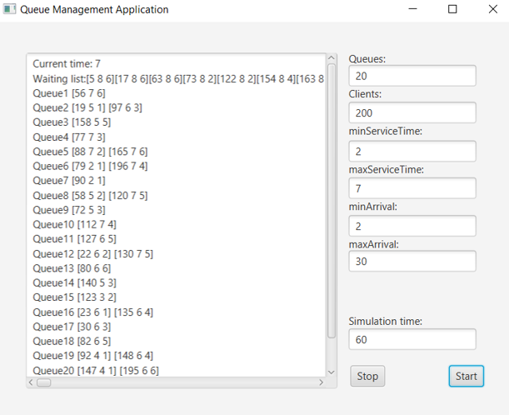

Implementation
In Simulation Manager, the most important method is the run method, as there the clients are iterated and dispatched:
public void run() {
int currentTime = 0;
//System.out.printf("Simulation started.\n");
while(currentTime < timeLimit && notExit){
Iterator itr = generatedTasks.iterator();
while(itr.hasNext()){
Task t = (Task)itr.next();
if((t).getArrivalTime() == currentTime){
scheduler.dispatchTask(t);
itr.remove();
}
}
currentTime++;
…

Also here are present the output functionalities of the program. Here the log.txt file gets updated as well as the text area of the interface:
String outputString = "Current time: " + currentTime + "\n" + stri + "\n" + str +"\n";
ta.setText(outputString);
//System.out.println(str);
try {
Files.write(Paths.get("log.txt"), outputString.getBytes(), StandardOpenOption.APPEND);
}catch(IOException e){
System.out.println("Error writing to file.");
e.printStackTrace();
}

Task generator( simulation manager ):
private void generateNRandomTasks(){
for(int i = 1; i <= numberOfClients; i++){
generatedTasks.add(new Task(i, (int)Math.floor(Math.random()*(maxArrival-minArrival+1)+minArrival),
(int)Math.floor(Math.random()*(maxProcessingTime-minProcessingTime+1)+minProcessingTime)));
}
Collections.sort(generatedTasks, new Sortbyarrival());
}

Worth to be mentioned here is that the “for” is generating the tasks with the attributes required, randomized between max arrival, min arrival, same with service / processing time, and after that the list gets sorted using the Collections.sort method. For this a rule is created in the class Sortbyarrival();
import java.util.Comparator;
public class Sortbyarrival implements Comparator<Task> {
public int compare(Task a, Task b){
return a.getArrivalTime() - b.getArrivalTime();
}
}

Controller:
@FXML
protected void onSimulationButtonClick() {
gen = new SimulationManager(output, Integer.parseInt(simt.getText()),Integer.parseInt(maxs.getText()),Integer.parseInt(mins.getText()),Integer.parseInt(maxar.getText()),Integer.parseInt(minar.getText()),Integer.parseInt(Queues.getText()),Integer.parseInt(Clients.getText()));
Thread t = new Thread(gen);
//t.setDaemon(true);
t.start();
}
@FXML
protected void onExitClick() {
//System.out.println("Stopping...");
if(gen != null){
gen.exitApp();
}
}

These two methods are responsible for the buttons that are on the interface

Results
Given the following set of inputs:
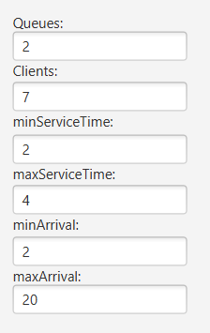
The log file will contain the following set of data:
Current time: 1
Waiting list:[6 2 2][4 5 3][3 7 2][7 7 2][2 10 4][5 11 2][1 13 2]
Queue1
Queue2

Current time: 2
Waiting list:[4 5 3][3 7 2][7 7 2][2 10 4][5 11 2][1 13 2]
Queue1 [6 2 2]
Queue2

Current time: 3
Waiting list:[4 5 3][3 7 2][7 7 2][2 10 4][5 11 2][1 13 2]
Queue1 [6 2 1]
Queue2

Current time: 4
Waiting list:[4 5 3][3 7 2][7 7 2][2 10 4][5 11 2][1 13 2]
Queue1
Queue2

Current time: 5
Waiting list:[3 7 2][7 7 2][2 10 4][5 11 2][1 13 2]
Queue1
Queue2 [4 5 3]

Current time: 6
Waiting list:[3 7 2][7 7 2][2 10 4][5 11 2][1 13 2]
Queue1
Queue2 [4 5 2]

Current time: 7
Waiting list:[2 10 4][5 11 2][1 13 2]
Queue1 [3 7 2] [7 7 2]
Queue2 [4 5 1]

Current time: 8
Waiting list:[2 10 4][5 11 2][1 13 2]
Queue1 [3 7 1] [7 7 2]
Queue2

Current time: 9
Waiting list:[2 10 4][5 11 2][1 13 2]
Queue1 [7 7 2]
Queue2

Current time: 10
Waiting list:[5 11 2][1 13 2]
Queue1 [7 7 1]
Queue2 [2 10 4]

Current time: 11
Waiting list:[1 13 2]
Queue1 [5 11 2]
Queue2 [2 10 3]

Current time: 12
Waiting list:[1 13 2]
Queue1 [5 11 1]
Queue2 [2 10 2]

Current time: 13
Waiting list:
Queue1 [1 13 2]
Queue2 [2 10 1]

Current time: 14
Waiting list:
Queue1 [1 13 1]
Queue2

Current time: 15
Waiting list:
Queue1
Queue2

Conclusions
This project required implementation of a multithreaded java application. A good understanding of threads was required to complete this assignment, as well as thread synchronization and management.
In addition, working with output and logfiles and understanding how to trouble shoot a complicated output and how to properly display it to understand the capability of the application.

Bibliography
PT2021-2022_Assignment_2.pdf (dsrl.eu)
FUNDAMENTAL PROGRAMMING TECHNIQUES (dsrl.eu) // some code taken from here
Of course, the one and only: Stack Overflow - Where Developers Learn, Share, & Build Careers
Honorable mentions: GeeksforGeeks | A computer science portal for geeks

