The PROG8125 Structured Design Method uses the fill in the blank section below as part of its process.

Step 1:

Identify and break down elements needed for the solution into three areas:

3. Output

* Print temperature in LCD display
* Print temperature value through Serial port (vcn)
* Flash RGB led following the color code for the temperature.

2. Processing

1. Read the sensor voltage with ADC
2. Convert digitalVoltage to analogVoltage
3. Convert analogVoltage to Temperature value.
4. Check what is the range of temperature that the thermistor value is at.

1. Input Needed

Thermistor (MCP9700AE) voltage.

uint16_t digitalVoltage

Step 2

Identify what you don’t know or know how to do.

1. How to convert digital voltage to analog voltage?
2. How to convert analog voltage to temperature using MCP9700AE?

Step 3:

Find out/figure out what you don’t know or know how to do.

1. For this it is required to know the resolution of the ADC

adcResolution = (VrefMax - VrefMin)/(2pow(12))  
adcResolution = (3600mv - 0 mv)/(2pow(12))  
adcResolution = 0.87890625

So this value can be multiply into the digital voltage

analogVoltage = adcResolution * digitalVoltage

1. To get the temperature was required to look into the MCP9700AE datasheet. Knowing that the temperature factor is 10 mv/C and using the following figure

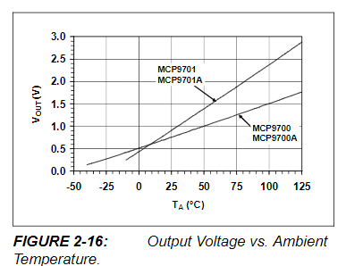 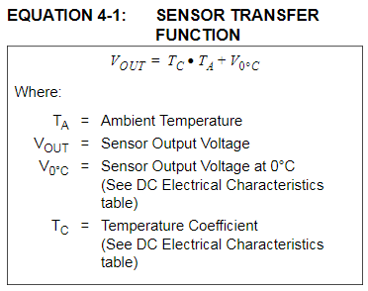

The relation between the temperature in celsius and the voltage in mV is:

Temperature = (analogVoltage/10) – 50 - calibration

After testing the sensor compared to my apartment temperature the calibration value used is -8.

**Schematic**

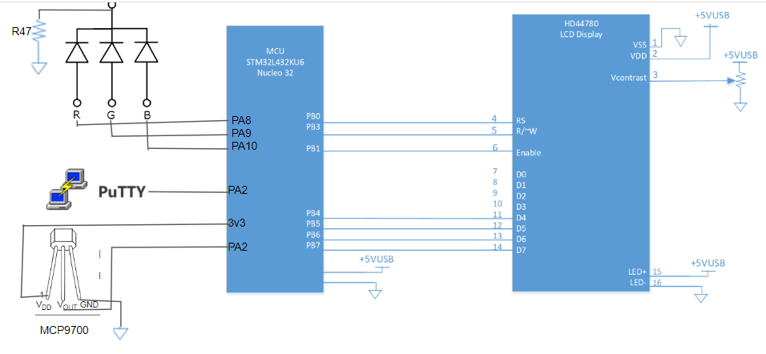

**Circuit**

