Step 1:

Identify and break down elements needed for the solution into three areas:

1. Input Needed

Push buttons (PB) state (pressed = 0 or Not pressed = 1)

Int8_t pushContains []

pushContains [0] = PB 1

pushContains [0] = PB 2

pushContains [0] = PB 3

pushContains [0] = PB ok

Pin of the debit card

Char pin[4]

3. Output

LCD display and serial port communication.

The output depends on the stage:

1. Print “welcome”
2. Print the price entered and print instructions of PBs to user.
3. Print instructions
4. Print instructions and shows with “*” every time a digit of the pin is entered.
5. Print “processing…”

Print only through serial port:

If pin is correct or incorrect and if the account has funds.

1. Print “Transaction cancelling”

2. Processing

Every time a PB is pressed:

1. Read the PBs and know which one was pressed.
2. Check if a PB was pressed if not, keep waiting until is pressed.

Main process

To design a debit card reader machine, the process is split into 6 stages that are not necessary in the following order:

1. Welcome screen:

Waiting for user to press ok.

Go to next stage.

1. Accept the price

Waiting for user to press ok (PB 1) to go to next stage or cancel (PB 2) to go to stage 6.

1. Checking or Saving

Check what kind of account the user has: checking (PB 1) or Saving (PB2)

Go to next stage.

1. Enter Pin

Wait until user provide the pin for the card using PBs 1,2 and 3.

Wait until user presses PB ok.

Go to the next stage.

1. Check pin

Process for 10s.

If pin is incorrect go to stage 6 or if is correct go to stage 1.

1. Transaction cancelling

Process for 10 seconds and go to stage 1.

Step 2

Identify what you don’t know or know how to do.

1. How to connect the pushbuttons in PullUp configuration
2. How to read if 1 out of 4 push buttons (PB) were pressed?
3. How to know which PB was pressed?
4. How to convert the pin that is an array to a single integer variable?
5. How to clear the print buffer variable?
6. How to convert an integer to a char value?
7. Problem with pins PA5 and PA6, I was not able to make them work for the push buttons when I was reading multiple buttons.

Step 3:

Find out/figure out what you don’t know or know how to do.

1. 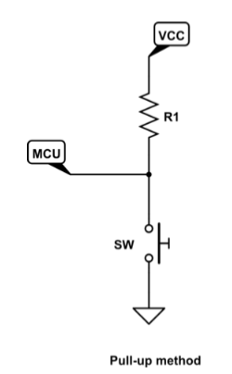
2. Using the debounced code.
3. Using a while loop that checks the value of every PB and confirmed that the specific button was pressed depending on the max and min variables.  
   while(pushContains[button] && button < numberOfButtons)

{

pushContains[button] = deBounceReadPin(buttonsPin[button], port, mode);

button ++;

if(button == numberOfButtons) // restart the variable button

{

button = 0;

}

}

Find out/figure out what you don’t know or know how to do.

1. Saving the pin number in a char array so I could use the function atoi(“string”) to convert it to a single integer.
2. Using the function memset(“string”,char value to fill,size of the char array);

For this case can be used like this memset(printBuffer,' ',16);

1. It is required to add to the integer variable “+ 0”and it becomes a char value.
2. Instead of using pin PA5 and PA6 I used pin PA7 and pin PA8 and this solved the problem.

**Schematic**

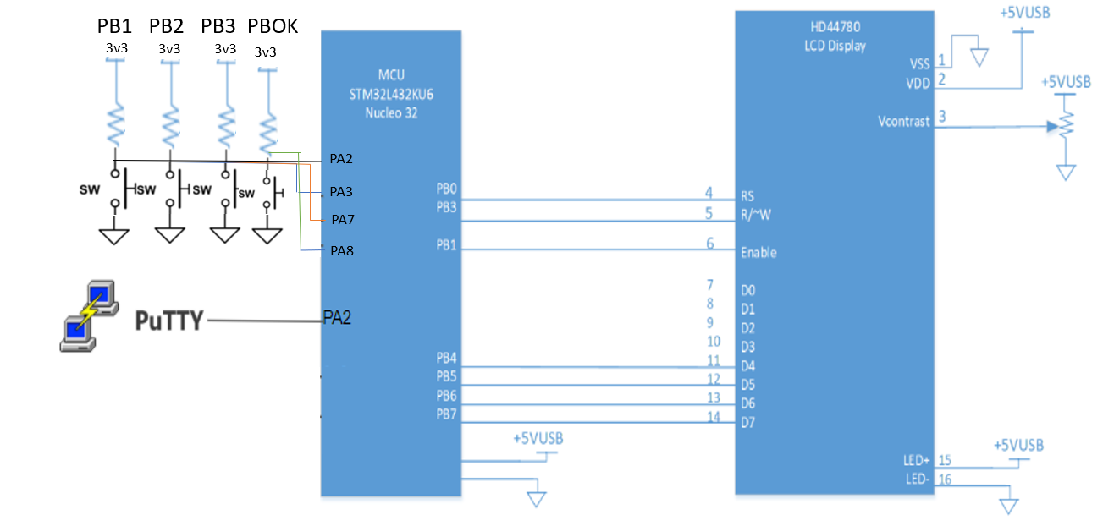

**Circuit**

