Step 1:

Identify and break down elements needed for the solution into three areas:

1. Input Needed

GPS data that is one string with the data divided by comas. This is received through serial port:  
char * stringData

Push buttons (PB) state (pressed = 0 or Not pressed = 1)

Int8_t pushContains []

pushContains [0] = PB 1

pushContains [0] = PB 2

pushContains [0] = PB 3

pushContains [0] = PB 4

3. Output

LCD display and serial port communication.

The output depends on the stage:

1. Print “Retrieving Data…”
2. Print “Processing Data…”
3. Print “1)Time,2)Latitu,3)Longi,4)Altitu”
4. Print Time in format hh mm ss.ss
5. Print Latitude in format d m dd
6. Print Longitude in format d m dd
7. Print Altitude in meters.

2. Processing

Every time a PB is pressed:

1. Read the PBs and know which one was pressed.
2. Check if a PB was pressed if not, keep waiting until is pressed.

Main process

To process and get the specific information from GPS data such as time, latitude, longitude, and altitude. The process is split into 7 stages that are not necessary in the following order:

1. Retrieving Data:

Get the GPS data through the serial port and store it in a variable (stringData).

Go to next stage.

1. Processing Data

stringData is processed and split it. Record the data in the 4 different variables like time, latitude, longitude, and altitude.  
Go to next stage

1. Task Selection

Waits for push button (PB) to be pressed and go to the specific stage depending on this.

PB1 pushed: Go to stage 4.  
PB2 pushed: Go to stage 5.  
PB3 pushed: Go to stage 6.  
PB4 pushed: Go to stage 7.

1. Time

Give format to the time and print it.

Go to the next stage 3.

1. Latitude

Give format to the latitude and print it.

Go to the next stage 3.

1. Longitude

Give format to the latitude and print it.

Go to the next stage 3.

1. Altitude

Give format to the Altitude and print it.

Go to the next stage 3.

Step 2

Identify what you don’t know or know how to do.

1. How to split or break a string?
2. How to convert a variable from string to integer or float.
3. How to give time format (hh mm ss.ss) to an integer.
4. How to give latitude/longitude format (d m dd) to an integer.
5. Why after using atof the decimals change?

Step 3:

Find out/figure out what you don’t know or know how to do.

1. Using the function char* strtok(“string”,delim that is the reference to split it).
2. Using the functions atoi() for getting an integer and atof() for getting a float.
3. After converting the string to float, I followed the next steps to store the hours, minutes and seconds in different variables:  
   int hours = time/10000;  
   int minutes = (time - (hours*10000))/100;

Float seconds = (time - (hours*10000)-(minutes*100));

1. After converting the string to float, I followed the next steps to store the degrees, minutes and decimal in different variables:  
   degrees = latitude/100;

minutess = latitude - (degrees*100);

decimal = (latitude - ((degrees*100)+minutess))*10000;

1. I haven’t found out how why is this happening, the latitude and altitude decimal values got modified after using atof.

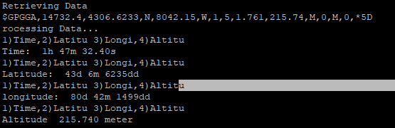

**Schematic**

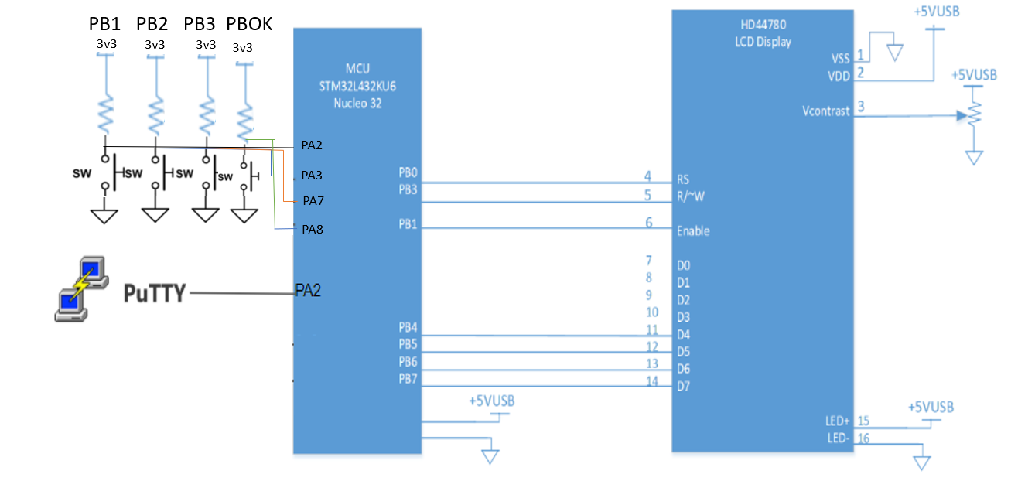

**Circuit**

