**Hands-on 11A**

Course: CIS 3347-1

Submitted to University of Houston

College of Technology

Information and Logistics Technology

by

Dan Doan

Cell Phone: 832-566-3079

April 6, 2021

Instructor: Dr. Ron Viseh

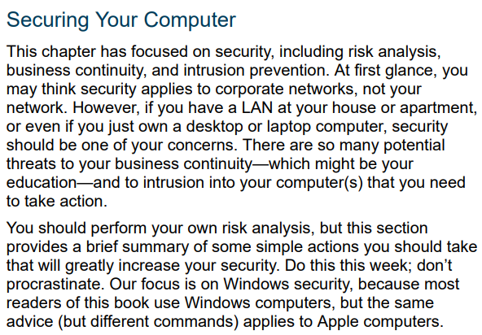

*Figure 1.* Business Data Communications’ on how to secure your compure (FitzGerald, Dennis & Durcikova).

# Perform risk analysis for your home network.

At home I have 3 main users, me and my parents. There are about up to 10 machines that could use the internet that all 3 of us uses. Ranges from tablets, iPhone, PC and laptop. Because of that I’ve tried my best to prevent any type of intrusion for my Wi-Fi network. I’ve recently encounter problems where people would intrude into my network in order to download illegal movies and then in turn get me DMCA strike from my ISP. And due to that here are the things I’ve done to prevent anymore future intrusion. Changing my default Wi-Fi password, the admin password to a super long one, my ISP email/username and password, enable access control (which is the reason I believe that the intruder stopped being able to join), and finally run anti-virus scan every now and then. I believe there are more ways I can do to protect and secure my network but for now I believe there is no need for that.

# Prepare a disaster recovery plan for your home network.

For a recovery plan, I don’t really have much setup. All of my usual school data I upload them to my google drive, which is the only important items in my PC, the rest are for entertainment purposes.

# Research antivirus and antispyware software that you can purchase for your home network.

I believe there are a few applications that help with this. I’ve personally use HitmanPro and BitDefender and I found them useful for searching and scanning for any virus/bad application on my computer (HitmanPro & Bitdefender, 2021). For the whole network I believe there is a application named Private Internet Access and Glasswire that allow the user to track all and everything that is going in and out of your network so you can see who or what is slowing down the network and then terminate it if you wanted to (Private Internet Access & Glasswire, 2021).

**My assessment on securing my network.**

Data is important. And to protect it we need good software and method to do so. I appreciate the book giving steps for the reader on how to secure one’s network. I would recommend a short read for everyone since data is bound to be lost at any moments.

All questions are from FitzGerald, Dennis, Durcikova Business Data Communication.

# References

FitzGerald, J., Dennis, A., & Durcikova, A. (2021). Chapter 1. In *Business data communications and networking*. Hoboken, NJ: Wiley.

Glasswire. (n.d.). Personal firewall & network monitor. Retrieved April 06, 2021, from https://www.glasswire.com/

HitmanPro. (n.d.). HitmanPro and HitmanPro.Alert. advanced malware Scanning, detection and removal tools. Retrieved April 06, 2021, from https://www.hitmanpro.com/en-us.aspx

BitDefender. (n.d.). Global leader in cybersecurity. Retrieved April 06, 2021, from https://www.bitdefender.com/

Private Internet Access. (2010, August 10). Private internet access anonymous vpn. Retrieved April 06, 2021, from https://www.privateinternetaccess.com/