**Hands-on 11C**

Course: CIS 3347-1

Submitted to University of Houston

College of Technology

Information and Logistics Technology

by

Dan Doan

Cell Phone: 832-566-3079

March 30, 2021

Instructor: Dr. Ron Viseh

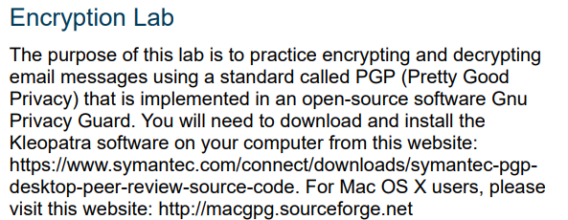

*Figure 1.* Business Data Communications’ Encryption lab on what we’re going to use on today’s lab (FitzGerald, Dennis & Durcikova).

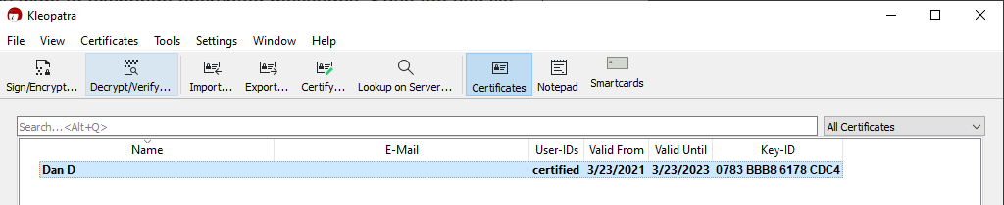

*Figure 2.* Kleopatra screenshot of my own certificate (Kleopatra, 2021).

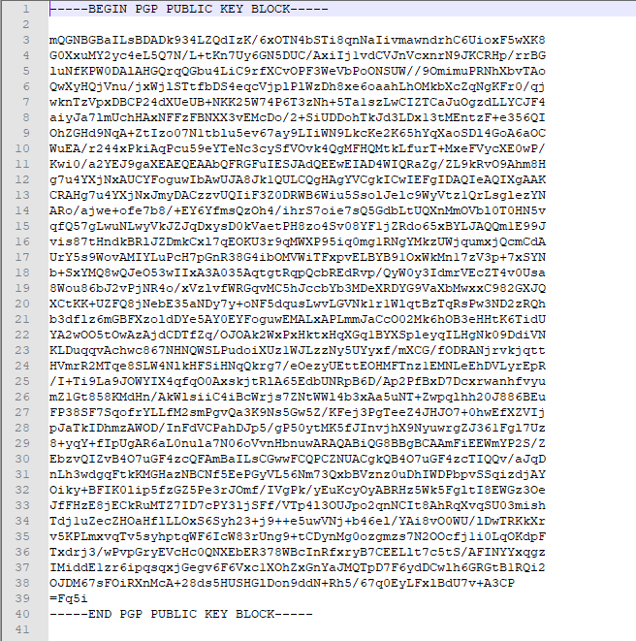

*Figure 3.* Notepad++ of my PGP Public key block created from Kleopatra (Kleopatra, 2021 and Notepad++, 2021).

# Create your PGP key pair using Kleopatra. Post the asc file of your public key on a server/class website as instructed by your professor.

I created the PGP key and will upload/submit it as a zip file for the assignment purpose.

-----BEGIN PGP PUBLIC KEY BLOCK-----

mQGNBGBaILsBDADk934LZQdIzK/6xOTN4bSTi8qnNaIivmawndrhC6UioxF5wXK8

G0XxuMY2yc4eL5Q7N/L+tKn7Uy6GN5DUC/AxiIj1vdCVJnVcxnrN9JKCRHp/rrBG

luNfKPW0DAlAHGQrqQGbu4LiC9rfXCvOPF3WeVbPoONSUW//9OmimuPRNhXbvTAo

QwXyHQjVnu/jxWjlSTtfbDS4eqcVjplPlWzDh8xe6oaahLhOMkbXcZqNgKFr0/qj

wknTzVpxDBCP24dXUeUB+NKK25W74P6T3zNh+5Ta1szLwCIZTCaJuOgzdLLYCJF4

aiyJa7lmUchHAxNFFzFBNXX3vEMcDo/2+SiUDDohTkJd3LDx13tMEntzF+e356QI

OhZGHd9NqA+ZtIzo07N1tblu5ev67ay9LIiWN9LkcKe2K65hYqXaoSDl4GoA6aOC

WuEA/r244xPkiAqPcu59eYTeNc3cySfVOvk4QgMFHQMtkLfurT+MxeFVycXE0wP/

Kwi0/a2YEJ9gaXEAEQEAAbQFRGFuIESJAdQEEwEIAD4WIQRaZg/ZL9kRvO9Ahm8H

g7u4YXjNxAUCYFoguwIbAwUJA8Jk1QULCQgHAgYVCgkICwIEFgIDAQIeAQIXgAAK

CRAHg7u4YXjNxJmyDACzzvUQIiF3Z0DRWB6Wiu5SsolJelc9WyVtz1QrLsglezYN

ARo/ajwe+ofe7b8/+EY6YfmsQzOh4/ihrS7oie7sQ5GdbLtUQXnMmOVbl0T0HN5v

qfQ57gLwuNLwyVkJZJqDxysD0kVaetPH8zo4Sv08YF1jZRdo65xBYLJAQQm1E99J

vis87tHndkBRlJZDmkCxl7qEOKU3r9qMWXP95iq0mg1RNgYMkzUWjqumxjQcmCdA

UrY5s9WovAMIYLuPcH7pGnR38G4ibOMVWiTFxpvELBYB91OxWkMn17zV3p+7xSYN

b+SxYMQ8wQJeO53wIIxA3A035AqtgtRqpQcbREdRvp/QyW0y3IdmrVEcZT4v0Usa

8Wou86bJ2vPjNR4o/xVzlvfWRGqvMC5hJccbYb3MDeXRDYG9VaXbMwxxC982GXJQ

XCtKK+UZFQ8jNebE35aNDy7y+oNF5dqusLwvLGVNk1r1WlqtBzTqRsPw3ND2zRQh

b3dflz6mGBFXzoldDYe5AY0EYFoguwEMALxAPLmmJaCcO02Mk6hOB3eHHtK6TidU

YA2wOO5tOwAzAjdCDTfZq/OJOAk2WxPxHktxHqXGq1BYXSpleyqILHgNk09DdiVN

KLDuqqvAchwc867NHNQWSLPudoiXUz1WJLzzNy5UYyxf/mXCG/fODRANjrvkjqtt

HVmrR2MTqe8SLW4NlkHFSiHNqQkrg7/eOezyUEttEOHMFTnz1EMNLeEhDVLyrEpR

/I+Ti9La9JOWYIX4qfqO0AxskjtRlA65EdbUNRpB6D/Ap2PfBxD7Dcxrwanhfvyu

mZ1Gt858KMdHn/AkWlsiiC4iBcWrjs7ZNtWWl4b3xAa5uNT+Zwpqlhh20J886BEu

FP38SF7SqofrYLLfM2smPgvQa3K9Ns5Gw5Z/KFej3PgTeeZ4JHJO7+0hwEfXZVIj

pJaTkIDhmzAWOD/InFdVCPahDJp5/gP50ytMK5fJInvjhX9NyuwrgZJ361Fgl7Uz

8+yqY+fIpUgAR6aL0nula7N06oVvnHbnuwARAQABiQG8BBgBCAAmFiEEWmYP2S/Z

EbzvQIZvB4O7uGF4zcQFAmBaILsCGwwFCQPCZNUACgkQB4O7uGF4zcTIQQv/aJqD

nLh3wdgqFtkKMGHazNBCNf5EePGyVL56Nm73QxbBVznz0uDhIWDPbpvSSqizdjAY

Oiky+BFIK0lip5fzGZ5Pe3rJOmf/IVgPk/yEuKcyOyABRHz5Wk5FgltI8EWGz3Oe

JfFHzE8jECkRuMTZ7ID7cPY3ljSFf/VTp4l3OUJpo2qnNCIt8AhRqXvqSU03mish

Tdj1uZecZHOaHflLLOxS6Syh23+j9++e5uwVNj+b46el/YAi8vO0WU/lDwTRKkXr

v5KPLmxvqTv5syhptqWF6IcW83rUng9+tCDynMg0ozgmzs7N2OOcfj1i0LqOKdpF

Txdrj3/wPvpGryEVcHc0QNXEbER378WBcInRfxryB7CEELlt7c5tS/AFINYYxqgz

IMiddE1zr6ipqsqxjGegv6F6Vxc1XOhZxGnYaJMQTpD7F6ydDCwlh6GRGtB1RQi2

OJDM67sFOiRXnMcA+28ds5HUSHGlDon9ddN+Rh5/67q0EyLFxlBdU7v+A3CP

=Fq5i

-----END PGP PUBLIC KEY BLOCK-----

(from Kleopatra, 2021)

# Import the certificate (public key) of your professor to Kleopatra. Send your instructor an encrypted message that contains information about your favorite food, hobbies, places to travel, and so on.

I was unable to find any public key from the professor, even with the link provided in the assignment’s note.

# Your professor will send you a response that will be encrypted. Decrypt the email and print its content so that you can submit a hard copy in class.

**My assessment on PGP and encryption in general.**

Encryption is always an important aspect when you’re using the internet. Making sure your message gets through using application such as Kleopatra is one example of correctly and securely communicating with an important person or to write an extremely important email. Overall thoughts are that it’s important to look up how a person can securely talk to someone else on the internet without being spied upon. It’s nice for the book to talk about this topic.

All questions are from FitzGerald, Dennis, Durcikova Business Data Communication.

# References

FitzGerald, J., Dennis, A., & Durcikova, A. (2021). Chapter 1. In *Business data communications and networking*. Hoboken, NJ: Wiley.

Kleopatra. (n.d.). Secure email and file encryption with gnupg for windows. Retrieved March 30, 2021, from https://www.gpg4win.org/

Notepad++. (n.d.). What is notepad++. Retrieved March 30, 2021, from https://notepad-plus-plus.org/