**Hands-on 5E**

Course: CIS 3347-1

Submitted to University of Houston

College of Technology

Information and Logistics Technology

by

Dan Doan

Cell Phone: 832-566-3079

March 2, 2021

Instructor: Dr. Ron Viseh

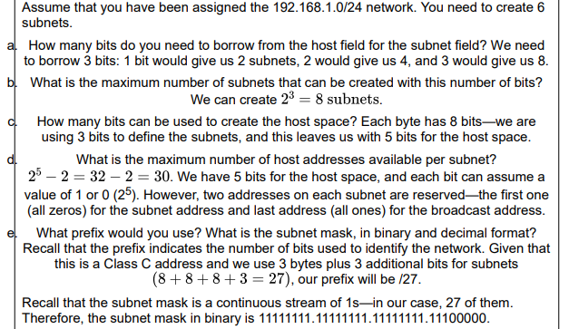

*Figure 1.* Business Data Communication’s steps on how to handle hands-on activity 5E.

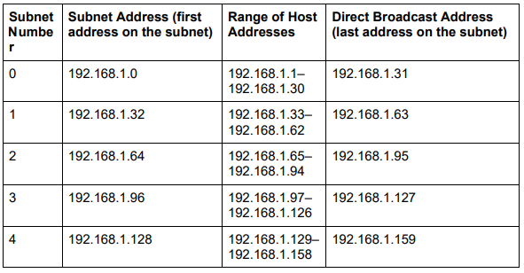

*Figure 2.* Business Data Communication’s chart on subnet number and their host range table.

# Assume that you have been assigned 192.168.111.129/28.

# How many bits are borrowed to create the subnet field?

To get started, using Figure 1 as a guide, this means that the regular IP address is 192.168.111.129 and the subnet mask in binary is 11111111.11111111.11111111.11110000 which include 28 ones and 4 zeros, 28 zeros hence the division symbol followed by the number 28 in the given IP address. Which then give this address a mask of 192.168.111.240 in decimal terms. When counting the last byte of us using 4 bits, there are 4 bits that we borrowed to create the subnet field.

# What is the maximum number of subnets that can be created with this number of bits?

The max number of subnets that can be created with this bits is 2^4 or 16 maximum number of subnets.

# How many bits can be used to create the host space?

There are 4 bits left that can be used for the host space when looking at the last byte.

# What is the maximum number of hosts addresses available per subnet?

The max number of host addresses per subnet is 2^4 or again 16, then -2 since the first and last one is reserved so only 14 per subnets.

# What is the subnet mask, in binary and decimal format?

As said in the first question, the subnet mask in binary is 11111111.11111111.11111111.11110000 and the binary of this is 182.168.111.240.

# 

*Figure 3.* Business Data Communication’slast few steps on hands-on activity 5E.

Complete the following table and calculate the subnet that this address is on and define all the other subnets (the range of host addresses on the subnet and the directed broadcast address on the subnet).

|  |  |  |  |
| --- | --- | --- | --- |
| Subnet Number | Subnet Address (first address on subnet) | Range of Host Address | Direct Broadcast Address (last address on subnet) |
| 0 | 192.168.111.0 | 192.168.111.1-192.168.111.14 | 192.168.111.15 |
| 1 | 192.168.111.16 | 192.168.111.7-192.168.111.30 | 192.168.111.31 |
| 2 | 192.168.111.32 | 192.168.111.33-192.168.111.46 | 192.168.111.47 |
| 3 | 192.168.111.48 | 192.168.111.49-192.168.111.62 | 192.168.111.63 |
| 4 | 192.168.111.64 | 192.168.111.65-192.168.111.78 | 192.168.111.79 |
| 5 | 192.168.111.80 | 192.168.111.81-192.168.111.94 | 192.168.111.95 |
| 6 | 192.168.111.96 | 192.168.111.97-192.168.111.110 | 192.168.111.111 |
| 7 | 192.168.111.112 | 192.168.111.113-192.168.111.126 | 192.168.111.127 |
| 8 | 192.168.111.128 | 192.168.111.129-192.168.111.142 | 192.168.111.143 |
| 9 | 192.168.111.144 | 192.168.111.145-192.168.111.158 | 192.168.111.159 |
| 10 | 192.168.111.160 | 192.168.111.160-192.168.111.174 | 192.168.111.175 |
| 11 | 192.168.111.176 | 192.168.111.177-192.168.111.190 | 192.168.111.191 |
| 12 | 192.168.111.192 | 192.168.111.193-192.168.111.206 | 192.168.111.207 |
| 13 | 192.168.111.208 | 192.168.111.209-192.168.111.222 | 192.168.111.223 |
| 14 | 192.168.111.224 | 192.168.111.225-192.168.111.238 | 192.168.111.239 |
| 15 | 192.168.111.240 | 192.168.111.241-192.168.111.254 | 192.168.111.255 |

**My assessment on using Wireshark.**

My usage of Wireshark was very confusing at first, since I was trying to find HTTP GET packet using HTTPS websites instead of HTTP websites. Some users might be also confused when doing the same thing as me. Design wise since HTTPS is supposed to encrypt the traffic, HTTPS module is doing a great job at it and Wireshark is also doing it’s job with being unable to access the GET packet on a HTTPS website.

The Wireshark application itself would also be great when the user is trying to find what type of packets and such he/she is sending and receiving whenever they surf the web and want to poke and find out what is going in and out of their network.

# References

CYBER EDU. (2020, February 24). What is the OSI Model? Retrieved January 27, 2021, from https://www.forcepoint.com/cyber-edu/osi-model#:~:text=In%20the%20OSI%20reference%20model,Session%2C%20Presentation%2C%20and%20Application.

FitzGerald, J., Dennis, A., & Durcikova, A. (2021). Chapter 1. In *Business data communications and networking*. Hoboken, NJ: Wiley.

Wireshark (2021). *Go deep*. Retrieved January 27, 2021, from https://www.wireshark.org/