**Hands-on 5E**

Course: CIS 3347-1

Submitted to University of Houston

College of Technology

Information and Logistics Technology

by

Dan Doan

Cell Phone: 832-566-3079

March 2, 2021

Instructor: Dr. Ron Viseh

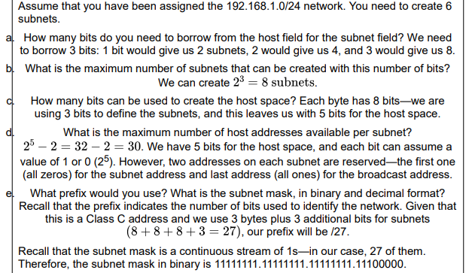

*Figure 1.* Business Data Communication’s steps on how to handle hands-on activity 5E (FitzGerald, Dennis & Durcikova, 2021).

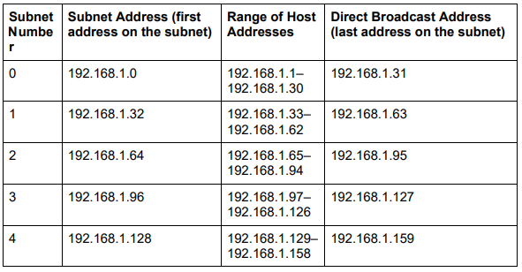

*Figure 2.* Business Data Communication’s chart on subnet number and their host range table (FitzGerald, Dennis & Durcikova, 2021).

# Assume that you have been assigned 192.168.111.129/28.

# How many bits are borrowed to create the subnet field?

To get started, using Figure 1 as a guide, this means that the regular IP address is 192.168.111.129 and the subnet mask in binary is 11111111.11111111.11111111.11110000 which include 28 ones and 4 zeros, 28 zeros hence the division symbol followed by the number 28 in the given IP address. Which then give this address a mask of 192.168.111.240 in decimal terms. When counting the last byte of us using 4 bits, there are 4 bits that we borrowed to create the subnet field.

# What is the maximum number of subnets that can be created with this number of bits?

The max number of subnets that can be created with this bits is 2^4 or 16 maximum number of subnets.

# How many bits can be used to create the host space?

There are 4 bits left that can be used for the host space when looking at the last byte.

# What is the maximum number of hosts addresses available per subnet?

The max number of host addresses per subnet is 2^4 or again 16, then -2 since the first and last one is reserved so only 14 per subnets.

# What is the subnet mask, in binary and decimal format?

As said in the first question, the subnet mask in binary is 11111111.11111111.11111111.11110000 and the binary of this is 182.168.111.240.

# 

*Figure 3.* Business Data Communication’slast few steps on hands-on activity 5E (FitzGerald, Dennis & Durcikova, 2021).

Complete the following table and calculate the subnet that this address is on and define all the other subnets (the range of host addresses on the subnet and the directed broadcast address on the subnet).

|  |  |  |  |
| --- | --- | --- | --- |
| Subnet Number | Subnet Address (first address on subnet) | Range of Host Address | Direct Broadcast Address (last address on subnet) |
| 0 | 192.168.111.0 | 192.168.111.1-192.168.111.14 | 192.168.111.15 |
| 1 | 192.168.111.16 | 192.168.111.7-192.168.111.30 | 192.168.111.31 |
| 2 | 192.168.111.32 | 192.168.111.33-192.168.111.46 | 192.168.111.47 |
| 3 | 192.168.111.48 | 192.168.111.49-192.168.111.62 | 192.168.111.63 |
| 4 | 192.168.111.64 | 192.168.111.65-192.168.111.78 | 192.168.111.79 |
| 5 | 192.168.111.80 | 192.168.111.81-192.168.111.94 | 192.168.111.95 |
| 6 | 192.168.111.96 | 192.168.111.97-192.168.111.110 | 192.168.111.111 |
| 7 | 192.168.111.112 | 192.168.111.113-192.168.111.126 | 192.168.111.127 |
| 8 | 192.168.111.128 | 192.168.111.129-192.168.111.142 | 192.168.111.143 |
| 9 | 192.168.111.144 | 192.168.111.145-192.168.111.158 | 192.168.111.159 |
| 10 | 192.168.111.160 | 192.168.111.160-192.168.111.174 | 192.168.111.175 |
| 11 | 192.168.111.176 | 192.168.111.177-192.168.111.190 | 192.168.111.191 |
| 12 | 192.168.111.192 | 192.168.111.193-192.168.111.206 | 192.168.111.207 |
| 13 | 192.168.111.208 | 192.168.111.209-192.168.111.222 | 192.168.111.223 |
| 14 | 192.168.111.224 | 192.168.111.225-192.168.111.238 | 192.168.111.239 |
| 15 | 192.168.111.240 | 192.168.111.241-192.168.111.254 | 192.168.111.255 |

# What subnet is 192.168.111.129 on?

According to the table above I just made, 192.168.111.129 is on subnet number 8, which ranges between 128 and 143 as the last bytes.

# A junior network administrator is trying to assign 192.168.111.127 as a static IP address for a computer on the network but is getting an error message. Why?

He is getting an error because the IP address he is trying to assign is reserved for direct broadcast address of that subnet which is subnet 7 according to my table above.

# Can 192.168.111.39 be assigned as an IP address?

Yes, 192.168.111.39 is in the range of subnet level 2, which covers between 33 and 46 as the last bytes and it is not reserved for anything else.

**My assessment on subnet.**

My usage of the book to answer the questions given, finding out subnet addresses, the range of host address, and finding out the direct broadcast address was very simple actually if everything I did was correct. I am still not sure about everything since I just now learned about it. But if everything is correct, then it went very smoothly, after struggling a bit to understand the steps, I figured I just followed the example step by step and did everything I could.

All questions are from FitzGerald, Dennis, Durcikova Business Data Communication.

# References

FitzGerald, J., Dennis, A., & Durcikova, A. (2021). Chapter 1. In *Business data communications and networking*. Hoboken, NJ: Wiley.