**Hands-on 5F**

Course: CIS 3347-1

Submitted to University of Houston

College of Technology

Information and Logistics Technology

by

Dan Doan

Cell Phone: 832-566-3079

March 2, 2021

Instructor: Dr. Ron Viseh

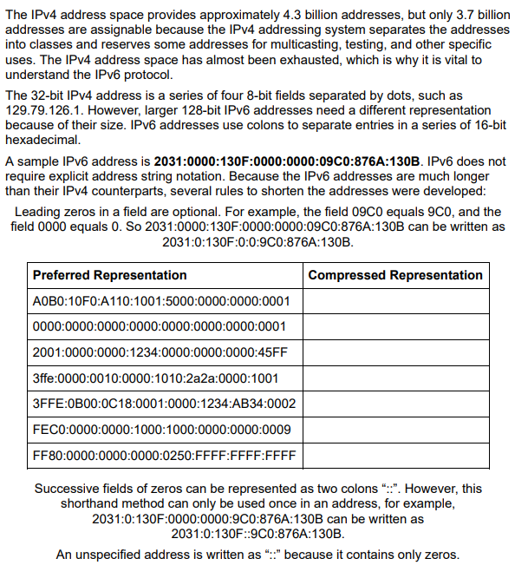

*Figure 1.* Business Data Communication’s steps on how to handle hands-on activity 5F, with rules and such for the reader to follow (FitzGerald, Dennis & Durcikova, 2021).

# Use the preceding guidelines to compress the following IPv6 addresses into the shortest forms possible.

I will attempt to convert from preferred representation to compressed by following the rules such that the starting zeros can be removed, a field of zeros can be reduced to just one, and if there are successive fields of zero, it will be represented as :: (double colon).

|  |  |
| --- | --- |
| Preferred Representation | Compressed Representation |
| A0B0:10F0:A110:1001:5000:0000:0000:0001 | A0B0:10F0:A110:1001:5000::1 |
| 0000:0000:0000:0000:0000:0000:0000:0001 | ::1 |
| 2001:0000:0000:1234:0000:0000:0000:45FF | 2001:0:0:1234::45FF |
| 3ffe:0000:0010:0000:1010:2a2a:0000:1001 | 3ffe:0:10:0:1010:2a2a:0:1001 |
| 3FFE:0B00:0C18:0001:0000:1234:AB34:0002 | 3FFE:B00:C18:1:0:1234:AB34:2 |
| FEC0:0000:0000:1000:1000:0000:0000:0009 | FEC0::1000:1000:0:0:0009 |
| FF80:0000:0000:0000:0250:FFFF:FFFF:FFFF | FF80::250:FFFF:FFFF:FFFF |

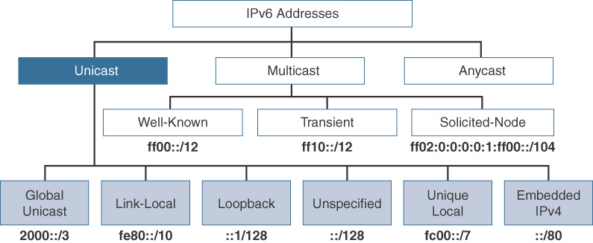

*Figure 2.* Shows three type of addresses unicast, multicast, and anycast, with the unicast being the equivalent to IPv4 public addresses (Ciscopress, 2017).

# Research on the Internet which Ipv6 addresses are routable on the Internet.

After doing a few webpage reading searches, Ciscopress said that global unicast is a type of routable address in the IPv6 internet, which is similar to a public IPv4 address.

**My assessment on compressing IPv6 addresses.**

My usage of the steps given and following them to compress the given Ipv6 address were very simple and easy, if they are correct. There were only a few rules you have to follow, and I am sure everyone can do it.

All questions are from FitzGerald, Dennis, Durcikova Business Data Communication.

# References

Cisco Press. (2017, October 3). IPv6 Address Representation and Address Types. Retrieved March 03, 2021, from https://www.ciscopress.com/articles/article.asp?p=2803866&seqNum=4

FitzGerald, J., Dennis, A., & Durcikova, A. (2021). Chapter 1. In *Business data communications and networking*. Hoboken, NJ: Wiley.