**U.S. Publishing Company**

**MEMORANDUM**

TO: C. Tangeman

FROM: Huynh Doan

DATE: September 17, 2020

SUBJECT: Draft Analysis

Our early access reviewers and some editors have already read and have left me some of their problems with the early draft. We want everyone to be happy and be understanding of the final draft so a revision will be made. This report will state what issues I got from the emails and what was good about it, then I will be using them to improve our current draft of the instruction on how to make a chocolate souffle.

**Strength**

The few things that reviewers and editors were happy on were how detailed and precise the instructions were. They noted that it wasn’t too long or too short to not give enough information. They were also contented with the structure of the whole draft, but also noted that some part could look better.

**Weaknesses**

One of the many weaknesses that were heavily implied on was the lack of images. Most of them wanted at least some image so they can see what their product should be looking like. Another large issue was the spelling and grammar structure of some of the sentences. One other reviewer recommended us to move the “Things to Consider” section to the top of the page so that they can see if they already have the part before reading the whole instruction. Another also complained about how they were not told earlier that they needed just egg yolks alone and not egg whites. Other small issues that I have noted: no time given, better header, weird instruction at some part or not so clear, and the order of the tips section.

**Recommendations from me**

From the issues I got, we should proofread the draft a few times so that it makes sense. A solution could be testing the instruction with a few employees and ask them to rate if it makes sense or not. The tips section should be moved under whichever steps it is related to, so that the reader can read it right away instead of at the end or even incorporated into the text. We should also move the “Things to Consider” section next to or right under the ingredient section and rename it to “Equipments”. Lastly, more detail on the ingredient part, bigger and bolder header for visual, and for the biggest issue, more images will be added for clarity.

**Concern**

If there is any concern or any question that you might have please give me a call or email me, I will be waiting for your response.

How to Make a Chocolate Soufflé

Souffles have a reputation for being variable, but they're totally simple to make. Even the most novice cook will be able to make the perfect souffle on their first attempt. Using a few staple ingredients, you can whip up a dessert that's guaranteed to impress at a dinner party but is also great for a casual supper.

Yield 4 servings

Prep: 30 minutes

Total: 1 hour

# Ingredients

* 1.5 tablespoon (22.5g) of melted butter
* 6 ounces (170 g) of dark chocolate, preferably bittersweet and 70% cacao
* 2 tablespoons (30ml) of freshly brewed black coffee
* 2 teaspoons (10ml) of vanilla extract
* 5 large eggs for 3 egg yolks and 5 egg whites
* 1 teaspoon (5g) kosher salt
* 10 tablespoons (121g) of white sugar
* Extra: Any type of powder for finishing
* Extra: Whipped crème if desired

# Equipments

* Saucepan
* Glass bowl
* Knife
* Chopping board
* Wooden spoon
* Mixing bowl
* Whisk or electric beater
* Ramekins
* Rubber spatula
* Baking tray

**Batter**

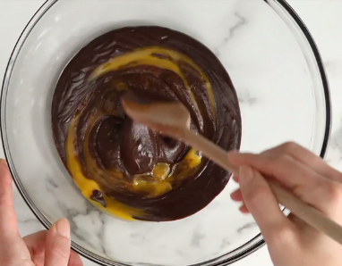**1****. Combine the chocolate, butter, and coffee in a large glass bowl.** Choose a high-quality dark chocolate, as this will be the main flavor of your finished soufflé. Chop 6 ounces (170 g) chocolate into small pieces and transfer to a bowl with 1 tablespoon (15g) butter and 2 tablespoons (30ml) freshly brewed coffee.

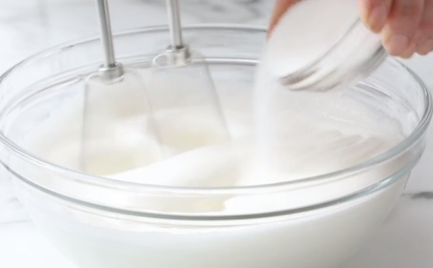**2****. Melt the chocolate mixture over a double boiler.** Fill the bottom of a saucepan with around 1/4 cup of water and bring it to a slight simmer. Put the glass bowl with the chocolate over the saucepan, making sure to keep the bottom of the bowl out of the water. Let the chocolate melt and combine with the other ingredients, stirring occasionally until smooth.

**3****. Stir in the vanilla extract and egg yolks**. Pour 2 teaspoons (10ml) of vanilla extract into the melted chocolate mixture, stirring until it is fully incorporated. Take the chocolate off the heat and beat in the yolks of 3 large eggs. Once everything is fully combined, place the bowl back on the double-boiler and turn the heat as low as it can go.

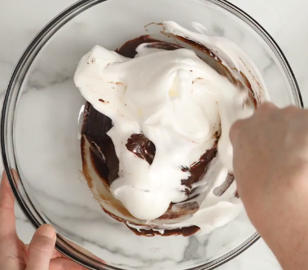**4****. Whip the egg whites and salt in a new bowl until soft and airy**. In a different bowl, use a whisk or electric beater to begin whipping 5 egg whites and 1 teaspoon (5g) of salt into a soft meringue. Beat them only until they begin taking in some air, become white in color, and the whole mixture looks lighter. Repeat with white sugar for 7 tablespoons (85g) with one tablespoon at a time.

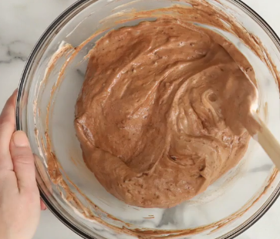**5. Stir 1/3 of the meringue mixture into the chocolate base.** Use a rubber spatula or a large wooden spoon to transfer around 1/3 of the meringue mixture to the bowl containing the chocolate base. Stir the meringue and chocolate together until the chocolate becomes lighter, in both color and texture, and the two are fully combined.

**6. Fold the remaining meringue into the chocolate.** Transfer the rest of the egg whites to the chocolate bowl. Use long, slow strokes with a rubber spatula or large wooden spoon to the lift the chocolate up and fold the egg whites into it. Keep folding the egg whites into the chocolate until they are just combined.

If you overmix your soufflé batter, you’ll knock out a lot of the air and stop the soufflés from rising fully.

**Cooking the Soufflé**

Preheat your oven to 425 °F (218 °C). While this won’t be the temperature your souffle cooks at, it will give them a blast of extra hot air just as they go in the oven. This will help expand the egg whites and make your soufflé rise more evenly.

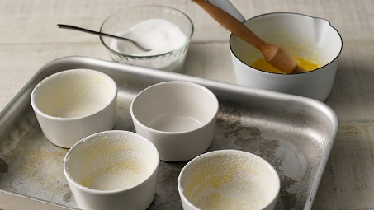

**1. Grease your ramekins with butter and coat them with sugar.** Use a pastry brush or something similar to cover the entire inside of your ramekins with melted butter. Once they are greased, add a teaspoon or two of white, granulated sugar to each ramekin. Rotate the ramekins so that they are coated in sugar and pour the excess out.

**2. Pour the mixture evenly between the ramekins.** Slightly overfill each ramekin with the soufflé batter, so that the mixture is just above the top of the ramekin. Use a knife or other flat utensil to quickly scrape any excess batter off the top and back into the bowl, giving your soufflé a perfectly level top.

**3. Put the soufflés in the oven and lower the temperature to 400 °F (204 °C).** Lowering the temperature immediately after putting the soufflés in the oven will give them a blast of hot air needed to kickstart their rising without burning the tops. Place the ramekins on a baking tray to make taking them out easier and leave them to cook for around 14 minutes.

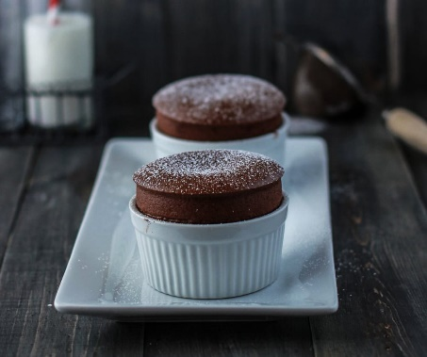

**5. Remove the soufflés from the oven and serve immediately.** Extra:Once the souffle has cooled, dust the top with a little chosen powder for some extra sweetness and flavor.

Extra: Use a spoon to make a small hole in the center of the soufflé and add a dollop of whipped cream or crème anglaise before serving. This will help balance out some of the dense chocolate flavor of the soufflé.

**6. Enjoy!**

**Warning**

Do not open the oven while the soufflés are cooking. The change in temperature can halt the rising of the soufflés and make them start sinking instead.

As soon as the soufflés are removed from the oven, they will begin to sink. Take them off the baking tray and serve them as soon as possible to keep them very light and airy.

Refferences

<https://www.marthastewart.com/868486/chocolate-souffle>

https://www.bbc.co.uk/food/recipes/mary_berrys_lovely_lemon_73914