**Project 08 Arguable Claim Email (25 points)**

Write an arguable claim email after readingchapter 14 Emailsin your textbook.However, you also need to study writing the arguable claim letter section that is described on pages (355-358). The sample letter is on *page 357*. In addition, I have posted a “Sample Claim Letter” in the Handouts folder on Blackboard.

The sample letters use the correct organizational strategy used for an arguable claim letter, but do not copy them exactly. Just use them as a models. A general recommendation for emails is to keep your paragraphs no longer than seven sentences in length (this paragraph is 6 lines).

**Use the information below to write your email:**

**Background Information**

You work for the Academy of American Poets, a non-profit organization. The AAP has received an erroneous bill from a longstanding business client, and you have been trying to investigate the issue for the last two weeks. You are writing one last email in an attempt to solve this problem.

**The Problem**

In January, the Academy of American Poets held a poetry reading in honor of National Poetry Month at the downtown YMCA in New York City. Since the inception of National Poetry Month in 2010, the YMCA has provided its space at a reduced rate of $1,500 A week after the event, the Y billed the Academy $2,250 for use of the facility without notifying the Academy ahead of time regarding the price increase. Since the Academy works on a limited budget, such a price increase could prevent the Academy from using the space in the future.

* As an employee of the Academy of American Poets, you have been in contact with Ryan Nichols, events coordinator at the downtown Y, and his superior, Sue Harrington.
* You will be writing your email to Jane Breitenbach, Sue Harrington’s superior—the last person who could possibly help you with this issue.

**Email Instructions:** Points for my grading are based on this bullet pointed list below. Read them closely:

* Use the **Background Information** for the basis of your email, but you have **creative flexibility** with the interpretation of those facts. You should expand and elaborate in any area where it assists your argument. For example, you may expand upon the content of your interaction with Ryan Nichols and Sue Harrington, and/or describe your feelings about the event space and the service the YMCA provided.
* You may add any supporting details that you think are important to help persuade the reader about the situation.
* Include adequate reasoning, explanations, and details.
* **Length:** Write aclaim email that is between 5-7 paragraphs in length and written in correct business tone.
* **Recipient address:** [sbreteinbach@outlook.com](mailto:sbreteinbach@outlook.com)
* **Your address:** Use your UH outlook email or a fake one.
* Because your request is an arguable claim, organize the letter using an **indirect pattern** (as defined in Chapter 15). [indirect vs. direct]
* Write a specific **action statement** for use in the letter. Define the purpose of the letter by deciding what you want the reader to do when he or she has finished reading the letter.
* An additional strategy for a letter such as this would also include appeals to ETHOS (values and beliefs) of the intended audience (the YMCA), as you try to connect with and persuade them.
* **Attachments:** List any documents you would (hypothetically) include with the email to support your argument. (In a letter this is called the enclosure).

**Begin your email below:**

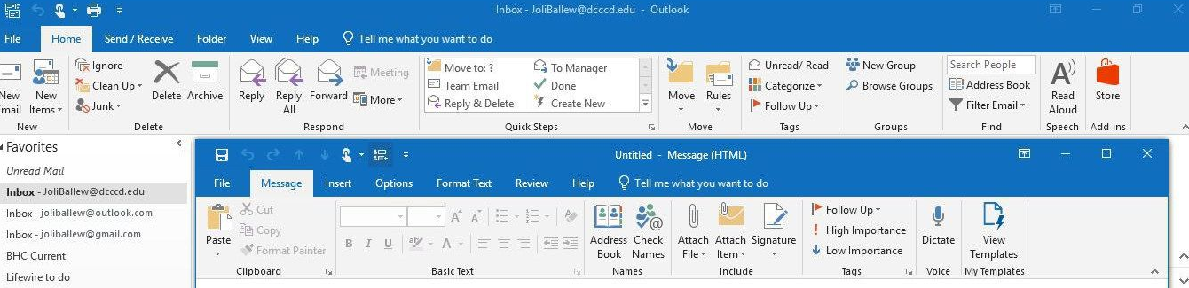

**To:**  [sbreteinbach@outlook.com](mailto:sbreteinbach@outlook.com)

**From:** hndoan2@stu.uh.edu

**Subject:** YMCA downtown last notice from AAP

**Attachment:** Emails with Ryan Nichols and Sue Harrington

Dear Ms. Breitenbach,

My organization, the Academy of American Poets, has been a long business partner with the downtown YMCA in New York City. The Y is a valuable partner that have been with us since the inception of National Poetry Month in 2010. For the past years, many issues have surfaced and been resolved in an orderly manner. Having said that, we are concerned about the most recent bill we received from the Y and we wish for it to be fixed.

Two weeks ago, we were given a bill for the 2020 Academy of American Poets poetry reading event in honor of the National Poetry Month at the downtown Y in New York. The bill amount stated that $2,250 were due.

For the past 10 years, the price has been a gracious $1,500 dollars per invoice for the lease of the elegant space in the downtown Y. This price increase was very unforeseen, and we were not given a notice beforehand about the changes.

We only calculated the usual price into our limited budget and with the unexpected change, we might not be able to return to the downtown YMCA space in the future.

I have been exchanging emails with the event coordinator, Ryan Nichols, about this unexpected issue. His only defense was that he forgot to tell us and now he no longer has a say about the bill, he then recommended us to contact his superior, which I did. His superior, Sue Harrington, also say she cannot change the bill, because the invoice was already sent. No results have surface from the exchanges of emails for the past 2 weeks.

In short, we would like to continue our business with the downtown YMCA and the only way to continue is insisting that we will only be charged for the considerate $1,500 dollars. We really appreciate the courtesy of the low cost to lease out the Y every year and the space that it provided to us. And if you will indeed charge us for only $1,500 this time, I will make sure to incorporate the increased price into our future budget so no issues will come up from this again and continues the excellence relationship between our nonprofit company.

If you would like to contact me personally, my contact number is 832-xxx-xxxx extension 2, if not, you can reply to this email. We would like to resolve this issue by the end of this month.

Sincerely,

Dan Doan

Manager, Accounting