# Software Assessment 3 – Space Game

## Year 12 – 2020

## NESA: 32523064

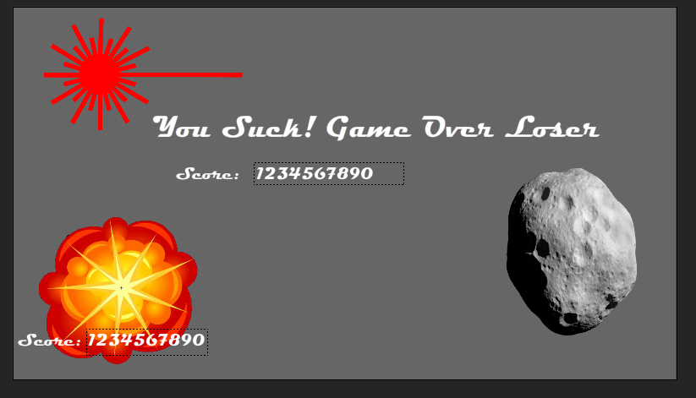

Contents

Software Assessment 3 – Space Game 1

Year 12 – 2020 1

NESA: 32523064 1

Design Specifications 3

Log book 3

Gantt chart 6

Context Diagram 7

Data Dictionary 7

Storyboard 8

Test Report 8

Evaluation of solution 8

Maintenance Projection 8

# Design Specifications

Developer Specifications

* Screen size (1920*1080)
* Font
* Computer Specs

User Specifications

* No extra lives
* Will have arrow key controls
* Help menu included with instructions

# Log book

|  |  |  |  |  |
| --- | --- | --- | --- | --- |
| **Date /Time** | **Description of progress** | **Tasks achieved** | **Issues- stumbling blocks** | **References** |
| 10/6/20 | Added 400 stars to make the background look like its scrolling | Added Stars | Making the stars properly teleport back to the top |  |
| 12/6/20 | Added 3 asteroids which will be obstacles for the ship | Added asteroids | So far, they don’t hit the spaceship |  |
| 14/6/20 | Added working ship boundaries | Ship boundaries | Getting the boundary to work correctly next with the spaceship |  |
| 28/6/20 | The stars will spawn in with variable sizes making the background more realistic | More realistic stars |  |  |
| 28/6/20 | Using a tween engine called tween nano | Adds cool animation when the ship appears on the screen | Had to download the tween engine code and add it inside the root folder of the .fla file |  |
|  |  |  |  |  |
| **mmDate /Time** | **Description of progress** | **Tasks achieved** | **Issues- stumbling blocks** | **References** |
| 29/6/20 | Putting the stars and asteroids in an array that will allow me to setup collisions with the asteroids | Created arrays instead of spawning the same child individually, encapsulates the two groups so that my collision detecting isn’t stupid. | I have 3 separate variable names that are very similar and it makes the code a bit confusing. |  |
| 30/6/20 | Added collision detecting with the spaceship and asteroids.  The whole game is coming together and is looking decent now. | Spaceship collides with asteroids. | Took a very long time to make the collisions work properly. In the process I broke my boundaries but later found that I had commented out the initialiser in the OnAdd function. |  |
| 1/6/20 | Attempted to make the asteroids spawn more random. |  | My asteroids spawn in a very similar pattern despite using a math.random to determine their starting and reset points. |  |
| 3/7/20 | Added random asteroids by using a timer and math.random for different speeds | Variable speed asteroids  More random falling positions | Can’t remove them when the game is over anymore |  |
| 3/7/20 | Added Start screen, help screen, back button, screen graphics, end screen. | Complete UI | Linking the buttons |  |
| 3/7/20 | Removed all the event listeners when the game finishes, cleaned up the code for the Asteroids | Cleaner code | Figuring out how to use a remove event listener |  |

<https://help.adobe.com/en_US/FlashPlatform/reference/actionscript/3/flash/events/Event.html>

|  |  |  |  |  |
| --- | --- | --- | --- | --- |
| 3/7/20 | Created github git | Github |  |  |
| 3/7/20 | Initialising the directory, adding the files, choosing the commit msg. | github |  |  |
| 3/7/20 | Committing changes with asteroid and adding comments in main stage | github |  |  |
|  |  |  |  |  |

# Gantt chart

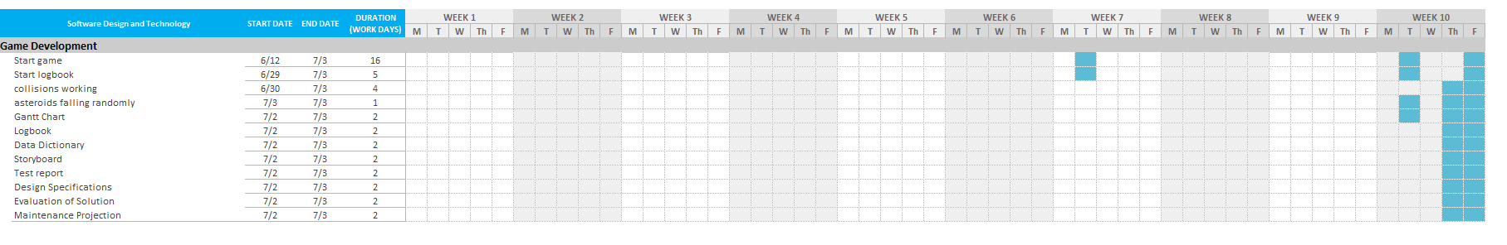

# Context Diagram

☹

# Data Dictionary

|  |  |  |
| --- | --- | --- |
| **Data item (variables)** | **Data Types ( sort data types together)** | **Description (of what the variable does)** |
| rightPressed | Boolean | Changes between true/false depending on if the user is pressing the right arrow down |
| leftPressed | Boolean | Changes between true/false depending on if the user is pressing the left arrow down |
| upPressed | Boolean | Changes between true/false depending on if the user is pressing the up arrow down |
| downPressed | Boolean | Changes between true/false depending on if the user is pressing the down arrow down |
| speed | integer | Sets the speed for the spaceship, also manipulated by the boundary testing to stop the spaceship moving off the screen. |
| direction | String | Posts the ships direction, used by boundary testing to allow the ship to move if it travels in a direction other than the wall it just hit. |
| hitObj | boolean | Used by collision testing to determine if the ship has hit an asteroid |
| asteroidCount | Integer | Used to count the number of asteroids in the game inside the collision test function |
|  |  |  |
|  |  |  |
|  |  |  |
|  |  |  |
|  |  |  |
|  |  |  |
|  |  |  |

# Storyboard

☹

# Test Report

|  |  |  |
| --- | --- | --- |
| Computer | User | Comment |
| My Home PC | Me, Mum, Ryan | Asteroids come too fast and randomly-Mum  Game is very smooth but boring - Ryan |
| School PC | Me | Computer is laggy and annoying |
|  |  |  |

# Evaluation of solution

My spaceship game is a very simple game that has a score. I did start working on shooting and the proper explosion when the spaceship got hit however, I was unable to finish those.

# Maintenance Projection

Because Animate is using flash, which is depreciated already, the long-term maintenance is questionable as more and more of as3 is phased out. However, keeping the program working shouldn’t be a big issue as its pretty simple.