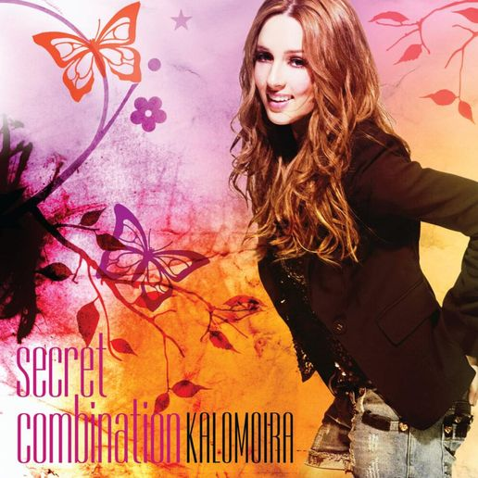
Kalomira
Secret Combination

[Verse 1]
Can you see it?
Can you see it?
You have to discover me
What goes wrong when I am cryin'
Or what I want when I'm smilin'
Can you feel it?
Can you feel it?
That I'm not a little girl
You're misunderstanding my way (my way)
And all the rules that I like to play
[Chorus]
My secret combination
It's a mystery for you
Use your imagination
I'm not easy but I'm true
My secret combination
Boy, you have to try it hard
To win a destination
In the center of my heart
My secret combination
It's a mystery for you
Use your imagination
I'm not easy but I'm true
My secret combination
Boy, you have to try it hard
To win a destination
In the center of my heart

[Verse 2]
An open book
An open book
Well, I'm sorry, I am not
Sometimes I'm actin' like a lady
Sometimes woman, sometimes baby
[Chorus]
My secret combination
It's a mystery for you
Use your imagination
I'm not easy but I'm true
My secret combination
Boy, you have to try it hard
To win a destination
In the center of my heart
My secret combination
It's a mystery for you
Use your imagination
I'm not easy but I'm true
My secret combination
Boy, you have to try it hard
To win a destination
In the center of my heart
[Chorus]
My secret combination
It's a mystery for you
Use your imagination
I'm not easy but I'm true
My secret combination
Boy, you have to try it hard
To win a destination
In the center of my heart
[Outro]
To win a destination
In the center of my heart

