1. Logo



Style Guide

1. Color schema

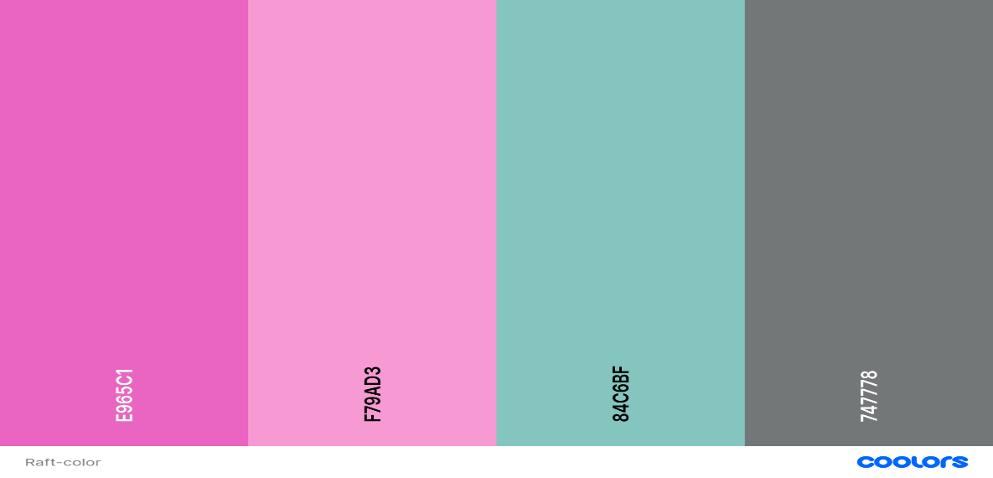

Primary Secondary Accent 1 Accent 2

1. Typography

Headings: Libre Baskerville Bold 700 and regular 400

Body: Roboto Regular 400 and Medium 500

1. URL link to your colour palette that you designed in coolors.co

https://coolors.co/visualizer/e965c1-f79ad3-84c6bf-747778