**TRADING JOURNAL**

* Who you are? And What’s your motivation for forex trading?

I'm a young man with big ambitions about the life, I think that I'm not the kind of person made for work from 9 to 5 every day, and earn some money to spend in trash, I believe that I was made for work hard for me and my family, I was made for being a businessman, an investor and not an employee. My real dream isn't to be a rich man, my real dream is to be a man with no worries about money, and I want to spend my time wisely sharing with my family, my wife and someday with my children.

* Market views and philosophy

The forex market, in my opinion, is one of the most important markets on the economic environment, it affects directly the other markets like the stock market, the futures, the binary options, etc. It’s a very big ocean of opportunities and the retail traders (as me), we are littles fishermen trying to fight against the big fishing companies. In the middle of all this always exist an opportunity to become a profitable trader if we are disciplined, working with proper risk management and applying our trading plan exactly as it was developed. All this journey is a never ended learning path, where we must evolve according to the flow of the market that it is finally the constant variable in our stairway to heaven.

* Observations of the market

For some time, I've been tracking the forex market, I've been developing a trading plan according to some indicators and clues about how to trade accordingly with probabilities. Now, I have a structured plan with some rules to accomplish always to open a trade position. The rules are the following:

- Review the Parabolic SAR indicator, this must show two or three dots in the same direction that we want to take.

- Review the moving average of 25, when the candle closes above or below this must coincide with the direction showed for the parabolic SAR.

- The first MACD line must cross the 0 lines in the same direction of the other indicators, on the second MACD must be a cross between the fast and the slow lines accordingly with the direction mentioned before.

In addition to this, the analysis must be translated to other timeframes in order to establish the best entry for the position, also, take into account the fundamental analysis where we must to beware with the major economic releases that increase the volatility on some currencies during the day, can make big movements on few time and can blow our position in minutes.

In the next images, I show how to implement the trading strategy in some pairs.

USDCAD, 90 pips profit,6 hours into the trade, 20 hours planning the entry.

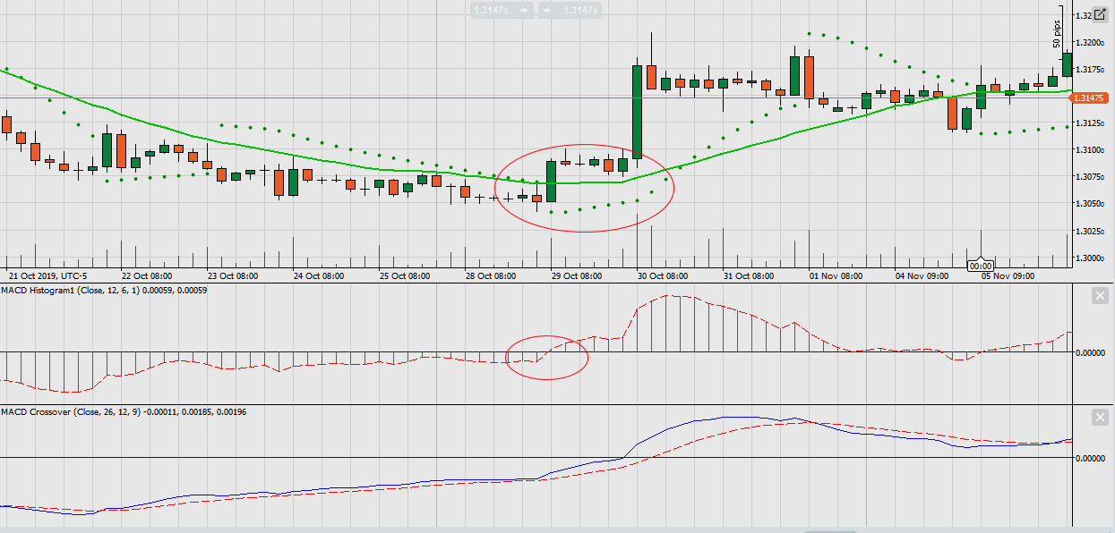

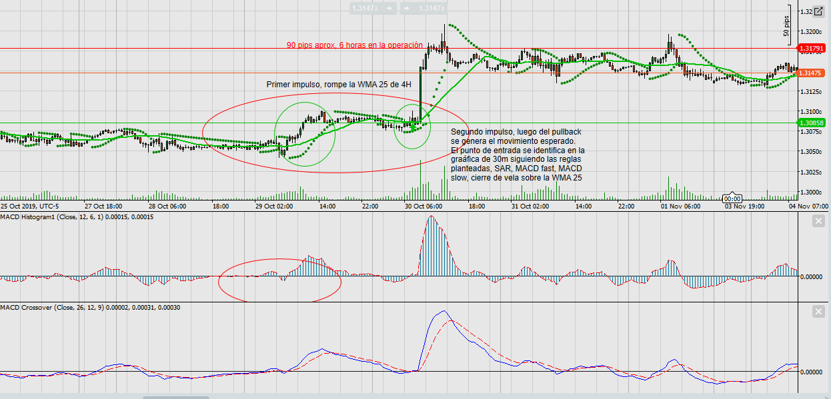

GBPUSD, 60-100 pips profit, 15-20 hours into the trade, 16-22 hours planning the entry.

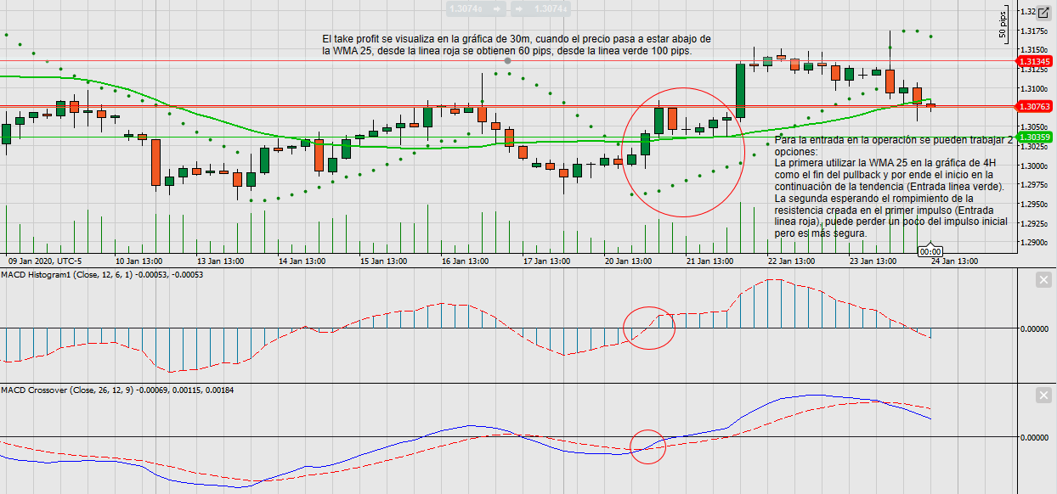

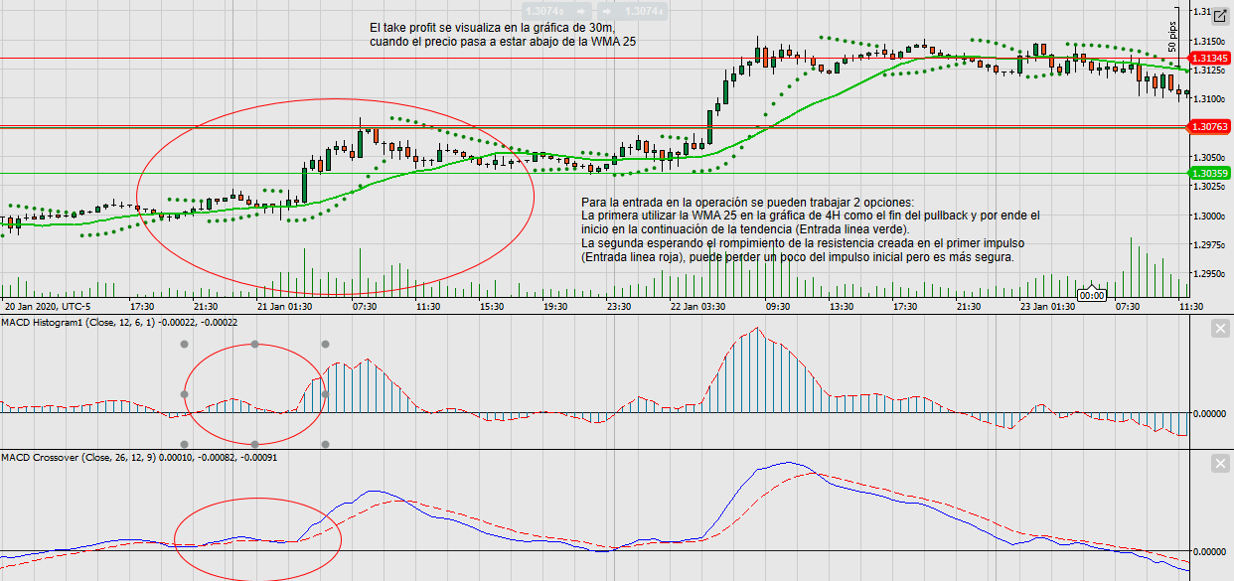

EURUSD, 80-140 pips profit, 44-72 hours into the trade, 8-16 hours planning the entry

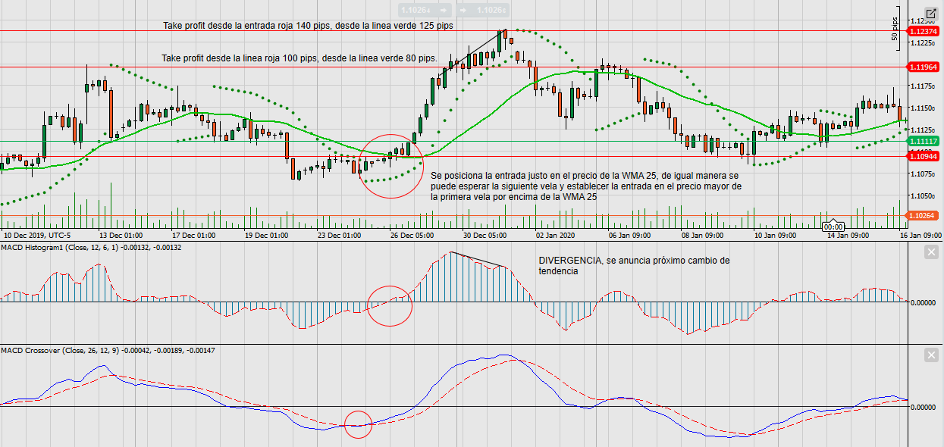

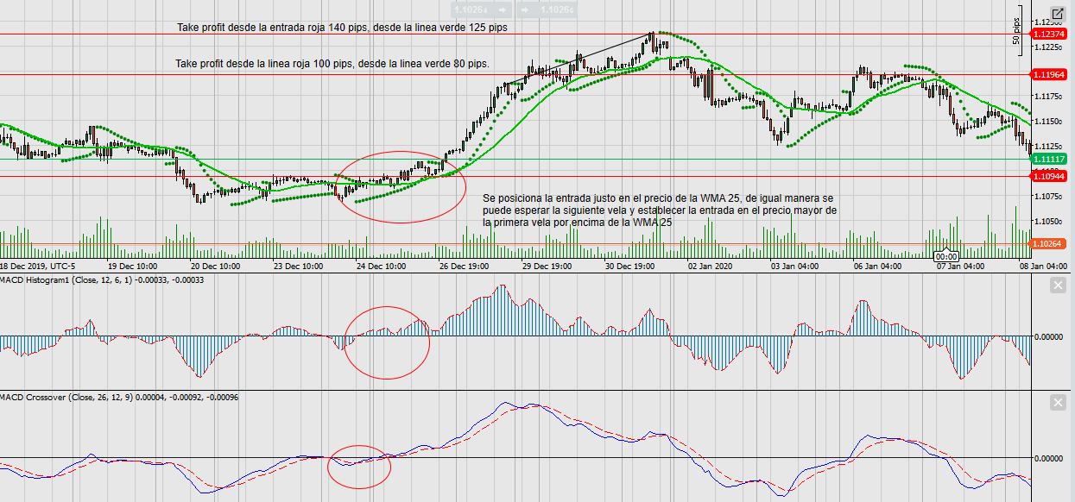

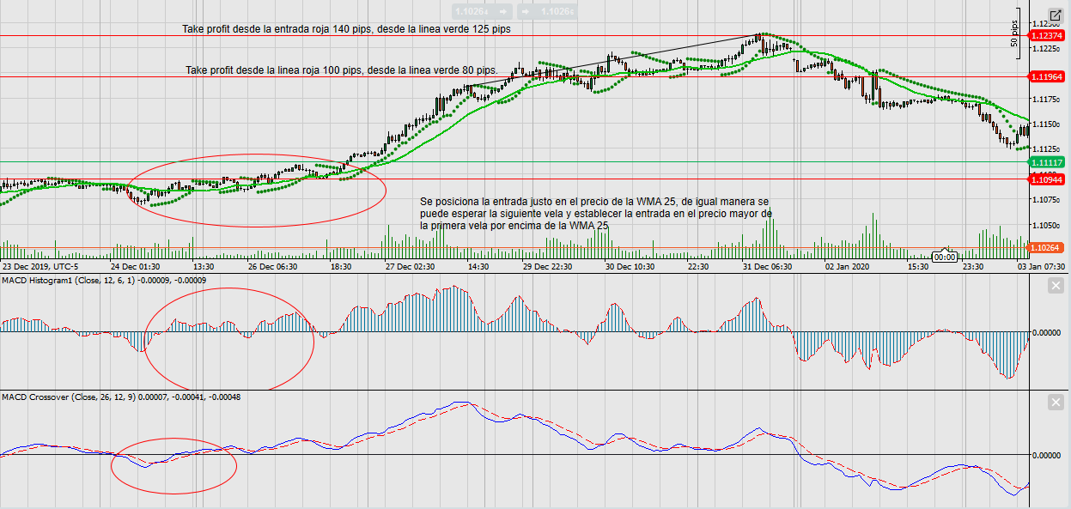

* Trading mistakes and missed opportunities
* Performance statistics

Along the time that I've been trading, my investment has been around 4000 dollars, my biggest goal is to earn this amount of money in a lapse of 1 year, divided into four stages, 1000 dollars for each quarter of 2020. This means that the profit per month must be around 350 dollars, the profit per week must be 87.5 dollars and the profit per day must be 17.5 dollars. Obviously, as my trading strategy its a kind of swing trading, it is better to track my progress based on a weekly timeframe or a monthly timeframe not daily.

**WEEK #4, JANUARY 2020**

*Sunday, January 26, 2020*

# Trade: 1

Pair:

Analysis:

Potential trading area:

Entry trigger:

Position size:

Trade retrospective:

# Trade: 2

Pair:

Analysis:

Potential trading area:

Entry trigger:

Position size:

Trade retrospective:

# Trade: 3

Pair:

Analysis:

Potential trading area:

Entry trigger:

Position size:

Trade retrospective: