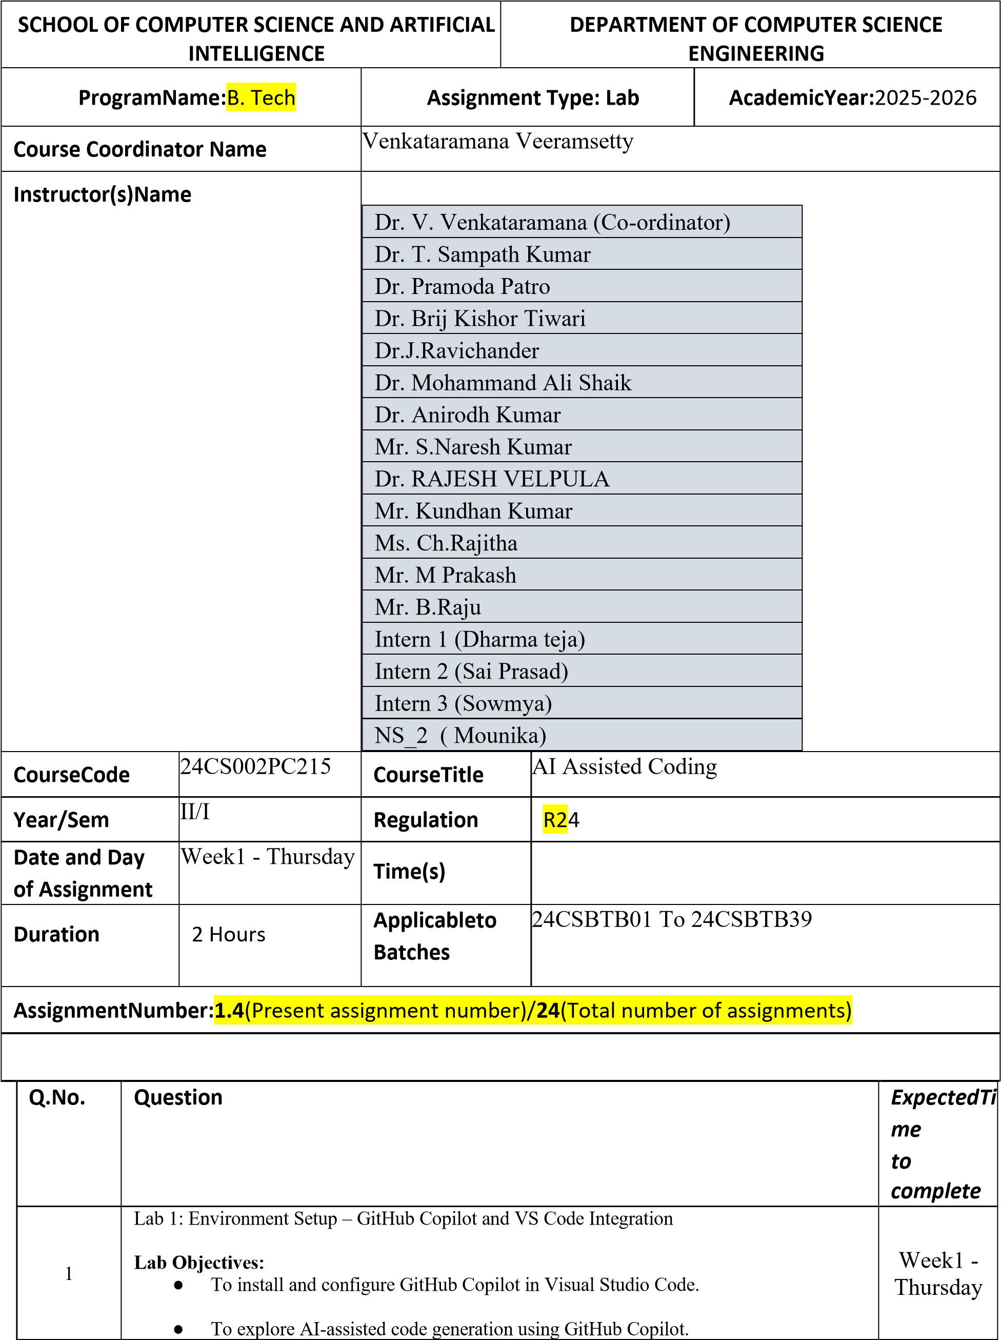

|  |  |  |  |  |
| --- | --- | --- | --- | --- |
|  | * To analyze the accuracy and effectiveness of Copilot's code suggestions.      * To understand prompt-based programming using comments and code context       **Lab Outcomes (LOs):**  After completing this lab, students will be able to:     * Set up GitHub Copilot in VS Code successfully.      * Use inline comments and context to generate code with Copilot.      * Evaluate AI-generated code for correctness and readability.      * Compare code suggestions based on different prompts and programming styles.       **Task Description #1**   * Install and configure GitHub Copilot in VS Code. Take screenshots of each step.   **Expected Output #1**   * Successfully install and activate GitHub Copilot in VS Code. Include screenshots showing installation, authentication via GitHub, and an example suggestion from Copilot**.**     **Task Description #2**   * A function in Python that returns the maximum of three numbers using GitHub Copilot. Use an appropriate comment as a prompt.   **Expected Output #2**   * Python function that takes three inputs and returns the largest value. Include the code and output.     **Task Description #3**   * Use GitHub Copilot to create a recursive Python function that calculates the factorial of a number.   **Expected Output #3**   * Python function for factorial using recursion with input and output examples.     **Task Description #4**   * Prompt GitHub Copilot to create a class named Student with attributes name, roll_no, and marks. Add a method to display student details.   **Expected Output #4**   * Python class definition with an initializer and a display method. Include object creation and output.     **Task Description #5**   * Ask GitHub Copilot to generate a Python function that takes a string as input and returns the frequency of each word. **Expected Output #5** * Python function that returns word frequency using a dictionary. Provide sample input and output.         **Note: Report should be submitted a word document for all tasks in a single document with prompts, comments & code explanation, and output and if required, screenshots**      **Evaluation Criteria:** | | |  |
|  | **Criteria** | **Max Marks** |  |  |
| Install and configure GitHub Copilot in VS Code  (Task #1) | 0.5 |
| Python function that takes three inputs and returns the largest value (Task #2) | 0.5 |
| Python function for factorial using recursion (Task #3) | 0.5 |
| Python class definition with an initializer and a display method (Task #4) | 0.5 |
| Function that returns word frequency using a dictionary (Task #5) | 0.5 |
| **Total** | **2.5 Marks** |

# Task Description #2

**•** A function in Python that returns the maximum of three numbers using GitHub Copilot. Use an appropriate comment as a prompt.

# Expected Output #2

* Python function that takes three inputs and returns the largest value. Include the code and output.

Prompt: create a function using python which compares the three numbers and returns the largest number by taking the input form the console.

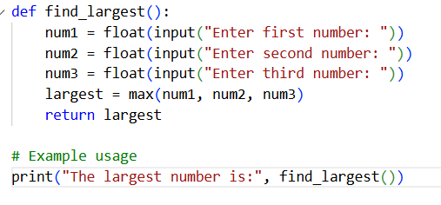

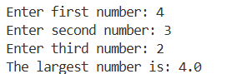

**Task Description #3**

* Use GitHub Copilot to create a recursive Python function that calculates the factorial of a number.

# Expected Output #3

**•** Python function for factorial using recursion with input and output examples

Prompt:create a recursive python function which calculates the factorial of given a number by taking the input form the console.

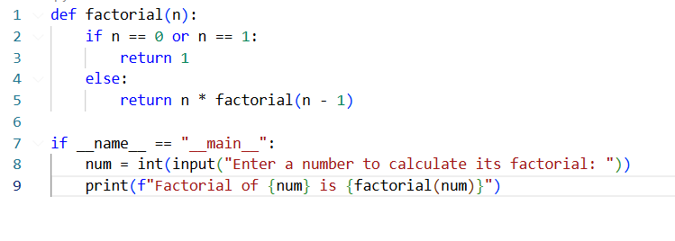

# 

# Task Description #4

**•** Prompt GitHub Copilot to create a class named Student with attributes name, roll_no, and marks. Add a method to display student details.

# Expected Output #4

* Python class definition with an initializer and a display method. Include object creation and output.

Prompt: create a class named Student with attributes name, roll_no, and marks. Add a method to display student details by taking input form the console for ‘n’ no.of student .

Python class definition with an initializer and a display method. Include object creation and output.

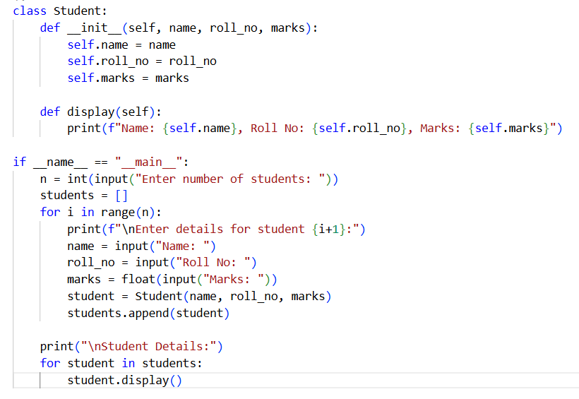

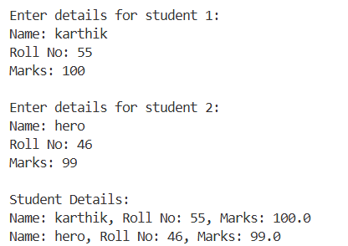

**Task Description #5**

* Ask GitHub Copilot to generate a Python function that takes a string as input and returns the frequency of each word.

# Expected Output #5

**•** Python function that returns word frequency using a dictionary. Provide sample input and output.

Prompt: create a python function which takes a string as input form the console and return the frequency of each word using the a dictionary

