G-MART
INTRODUCTION:
"Welcome to our G-Mart, your one-stop shop for all your grocery needs! With our user-friendly interface and wide selection of high-quality products, we aim to make your grocery shopping experience convenient and enjoyable. Whether you're looking for fresh produce, pantry staples, or household essentials, our app has you covered. Explore our virtual aisles, add items to your cart with ease, and have your groceries delivered right to your doorstep. Experience the future of grocery shopping with our Grocery Web App today!"
DESCRIPTION:
our basic G-Mart web! Our app is designed to provide a seamless online shopping experience for customers, making it convenient for them to explore and purchase a wide range of products. Whether you are a tech enthusiast, a fashionista, or a homemaker looking for everyday essentials, our app has something for everyone. With user-friendly navigation and intuitive design, our grocery-webapp app allows customers to browse through various categories, view product details, add items to their cart, and securely complete the checkout process. We prioritize user satisfaction and aim to
provide a smooth and hassle-free shopping experience. For sellers and administrators, our app offers robust backend functionalities. Sellers can easily manage their product listings, inventory, and orders, while administrators can efficiently handle customer inquiries, process payments, and monitor overall app performance. With a focus on security and privacy, our grocery-webapp app ensures that customer data is protected, transactions are secure, and personal information remains confidential. We strive to build trust with our customers and provide a safe platform for online shopping. We are excited to have you on board and look forward to providing you with a delightful shopping experience. Happy shopping with our grocery-webapp!

SCENARIO BASED CASE STUDY:
Scenario: Priya is a busy professional with a demanding schedule who values convenience and efficiency in her daily life. She enjoys cooking with fresh ingredients but often finds it difficult to visit grocery stores regularly due to time constraints.
Our Team’s Solution – G-Mart: To address challenges faced by users like Priya, our team designed and developed G-Mart, a full-stack e-commerce platform that redefines the grocery shopping experience. The solution provides:
- User Registration & Authentication: Secure account creation and login to protect user privacy.
- Product Listings: A structured catalog with categories and filters for easy navigation.
- Personalized Recommendations: Intelligent suggestions based on purchase history and preferences.
- Convenient Delivery Options: Flexible scheduling and express delivery services.
- Secure Payment Gateway: Multiple payment methods including credit/debit cards and digital wallets.
- Order Tracking: Real-time updates on order status for transparency and peace of mind.
- Customer Support: Dedicated assistance to resolve queries and ensure user satisfaction.
Outcome: Through our team’s G-Mart platform, users like Priya can enjoy the convenience of fresh, high-quality groceries delivered directly to their doorstep. This solution saves time, reduces hassle, and empowers users to focus on what matters most—preparing healthy meals and spending quality time with loved ones.
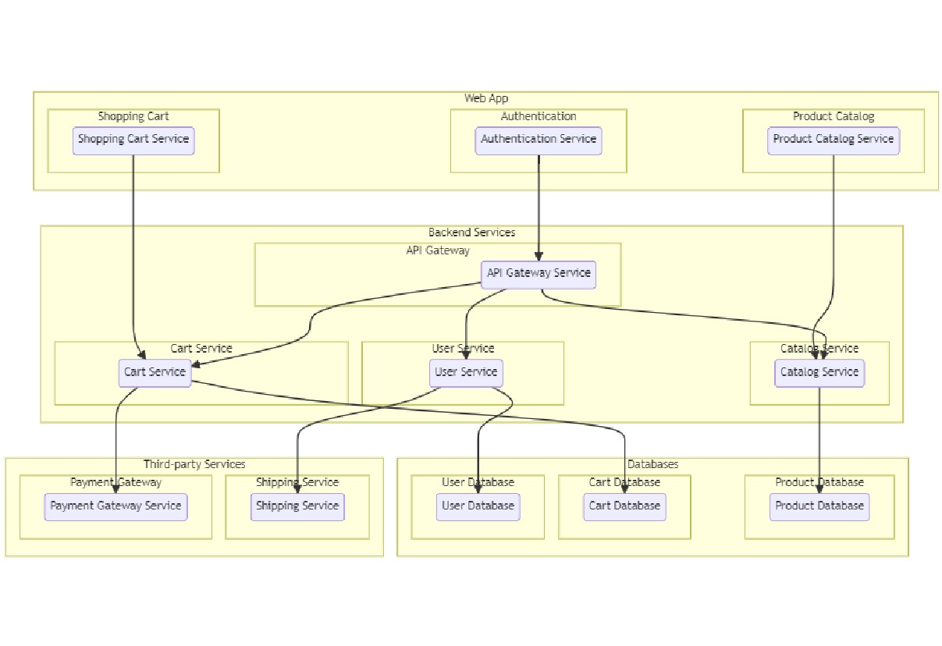
TECHNICAL ARCHITECTURE :-
The technical architecture of an flower and gift delivery app typically involves a client-server model, where the frontend represents the client and the backend serves as the server. The frontend is responsible for user interface, interaction, and presentation, while the backend handles data storage, business logic, and integration with external services like payment gateways and databases. Communication between the frontend and backend is typically facilitated through APIs, enabling seamless data exchange and functionality.

ER DIAGRAM:
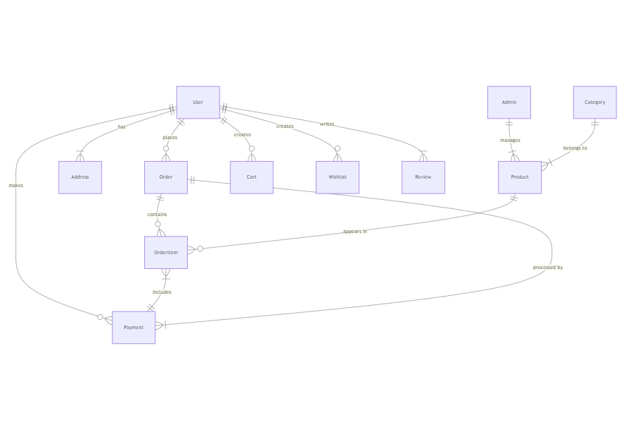
The Entity-Relationship (ER) diagram for an flower and gift delivery app visually represents the relationships between different entities involved in the system, such as users, products, orders, and reviews. It illustrates how these entities are related to each other and helps in understanding the overall database structure and data flow within the application.

KEY FEATURES OF G-MART
- Product Catalog G-Mart offers an extensive product catalog organized into categories and subcategories. Users can easily search, browse, and filter products based on their preferences, making it effortless to find the items they need.
- Shopping Cart and Checkout The platform includes a robust shopping cart feature that allows users to add products, review their selections, and proceed to checkout. The checkout process supports multiple secure payment options, ensuring a smooth transaction experience.
- Product Reviews and Ratings Customers can provide feedback and rate products, helping other users make informed purchasing decisions. This feature fosters trust and builds a sense of community among users.
- Order Tracking Once an order is placed, users can track its status in real time. Updates on order processing, shipping, and delivery provide transparency and peace of mind.
- Admin Dashboard Administrators have access to a comprehensive dashboard to manage products, inventory, orders, and customer information. The dashboard also provides insights into sales performance, stock levels, and customer analytics, enabling efficient business operations.
- Order Management G-Mart manages the complete order lifecycle, including placement, tracking, and status updates. Users can view their order history, track shipments, and request returns or cancellations.
- Search and Filtering Users can search for products using keywords and apply filters such as price range, brand, or customer ratings to refine results and quickly locate desired items.

PRE REQUISITES:

- Create a new Angular project:
- Choose or create a directory where you want to set up your Angular project.
- Open your terminal or command prompt.
- Navigate to the selected directory using the cd command.
- Create a new Angular project by running the following command: ng new client Wait for the project to be created:
- The Angular CLI will generate the basic project structure and install the necessary dependencies
- Navigate into the project directory:
- After the project creation is complete, navigate into the project directory by running the following command: cd client
- Start the development server:
- To launch the development server and see your Angular app in the browser, run the following command: ng serve / npm start
- The Angular CLI will compile your app and start the development server.
- Open your web browser and navigate to http://localhost:4200 to see your Angular app running.
- You have successfully set up Angular on your machine and created a new An- gular project. You can now start building your app by modifying the generated project files in the src directory.
- Please note that these instructions provide a basic setup for Angular. You can explore more advanced configurations and features by referring to the official Angular documentation: https://angular.io
- HTML, CSS, and JavaScript: Basic knowledge of HTML for creating the structure of your app, CSS for styling, and JavaScript for client-side interactivity is essential.
- Database Connectivity: Use a MongoDB driver or an Object-Document Mapping (ODM) library like Mongoose to connect your Node.js server with the MongoDB database and perform CRUD (Create, Read, Update, Delete) operations.
- Front-end Framework: Utilize Angular to build the user-facing part of the application, including products listings, booking forms, and user interfaces for the admin dashboard.
- Version Control: Use Git for version control, enabling collaboration and tracking changes throughout the development process. Platforms like GitHub or Bitbucket can host your repository.
- Git: Download and installation instructions can be found at: https://git-scm.com/downloads
- Development Environment: Choose a code editor or Integrated Development Environment (IDE) that suits your preferences, such as Visual Studio Code, Sublime Text, or WebStorm.
- Visual Studio Code: Download from https://code.visualstudio.com/download
- Sublime Text: Download from https://www.sublimetext.com/download
- WebStorm: Download from https://www.jetbrains.com/webstorm/download
- To Connect the Database with Node JS go through the below provided link:
- Link: https://www.section.io/engineering-education/nodejs- mongoosejs-mongodb/

ROLE BASED ACCESS:
Roles of Admin and User can be defined for an online G-Mart web application
Admin Role:
1-Admin Role:
- Responsibilities: The admin role has full control and administrative privileges over the system.
- Permissions:
  - Manage: Admins can add, edit, and delete shop information along with products.
  - Manage product bookings: Admins can view and manage all product bookings made by users and agents, including canceling or modifying product bookings.
  - Manage users: Admins can create, edit, and delete user accounts, as well as manage their roles and permissions.
  - Generate reports: Admins have access to generate reports and analytics on product booking details, booking counts, and sales reports.

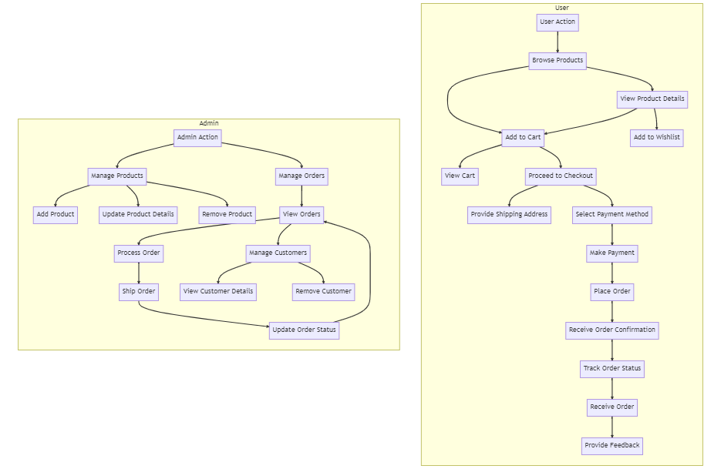
User Role:
2-User Role:
- Responsibilities: Users are the customers of the online shopping web application who can search for products, and make product bookings.
- Permissions:
  - View products: Users can search for products, based on interest.
  - Product bookings: Users can select products that are available and complete the order process.
  - Manage product booking: Users can view their own product order bookings, modify booking details, track booking details, and cancel their bookings
  - Manage cart: Users can view their cart details and modify them if needed.

PROJECT FLOW
- Frontend Development
- Backend Development
- Integration
Demo link:- https://drive.google.com/file/d/1xL1R6IV1HiZwHoWGQ_MxzZVvJAaVdbs8/view?usp=sharing
Use the code in:-
https://drive.google.com/drive/folders/1eHqMNFOSdLlgTDnsMXV6nba-BHLl4iDj?usp=sharing
or follow the videos below for better understanding.

MILESTONE 1: PROJECT SETUP AND CONFIGURATION:
- Install required tools and software:
  - Node.js.
  - MongoDB.
  - Create-react-app.
- Create project folders and files:
  - Client folders.
  - Server folders.
- Install Packages:
Frontend npm Packages
  - Axios.
  - React-Router –dom.
  - Bootstrap.
  - React-Bootstrap.
  - React-icons.
Backend npm Packages
  - Express.
  - Mongoose.
  - Cors

Reference Link:-
https://drive.google.com/drive/folders/1v41J4aWWP-kDldf5lrO8uuwyFwaRKFcO?usp=sharing

MILESTONE 2: BACKEND DEVELOPMENT:
  - Setup express server
        - Create index.js file in the server (backend folder).
        - Create a .env file and define port number to access it globally.
        - Configure the server by adding cors, body-parser.
  - User Authentication:
      - Create routes and middleware for user registration, login, and logout.
      - Set up authentication middleware to protect routes that require user authentication.
  - Define API Routes:
      - Create separate route files for different API functionalities such as users orders, and authentication.
      - Define the necessary routes for listing products, handling user registration and login, managing orders, etc.
      - Implement route handlers using Express.js to handle requests and interact with the database.
  - Implement Data Models:
      - Define Mongoose schemas for the different data entities like products, users, and orders.
      - Create corresponding Mongoose models to interact with the MongoDB database.
      - Implement CRUD operations (Create, Read, Update, Delete) for each model to perform database operations.
  - User Authentication:
      - Create routes and middleware for user registration, login, and logout.
      - Set up authentication middleware to protect routes that require user authentication.
  - Error Handling:
    - Implement error handling middleware to catch and handle any errors that occur during the API requests.
    - Return appropriate error responses with relevant error messages and HTTP status codes.

Reference Link:-
https://drive.google.com/drive/folders/1kcjT-jk6EXcyR59FJ9z3oALRslnjhaa7?usp=sharing

MILESTONE 3: DATABASE:

- Configure MongoDB:
  - Install Mongoose.
  - Create database connection.
  - Create Schemas & Models.

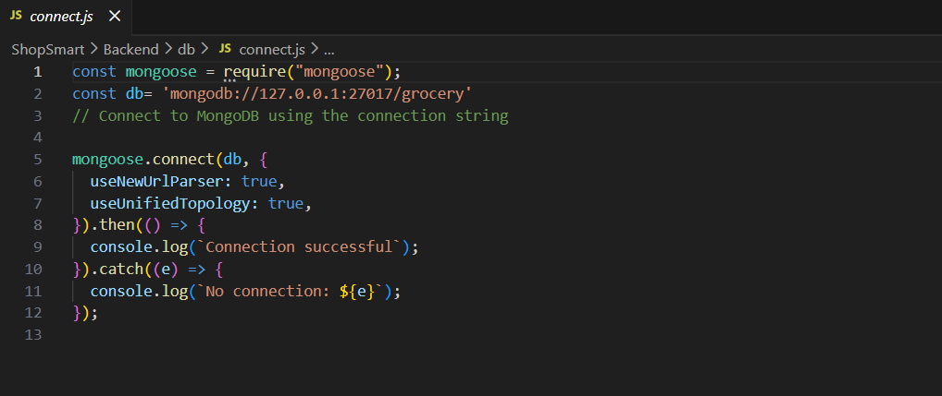
- Connect database to backend:

Now, make sure the database is connected before performing any of the actions through the backend. The connection code looks similar to the one provided below.

3.Configure Schema:
Firstly, configure the Schemas for MongoDB database, to store the data in such pattern. Use the data from the ER diagrams to create the schemas. The schemas are looks like for the Application.
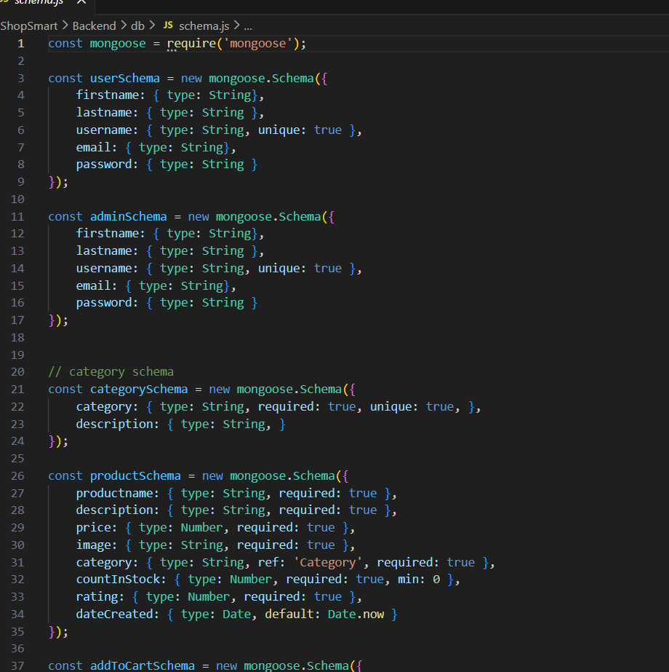

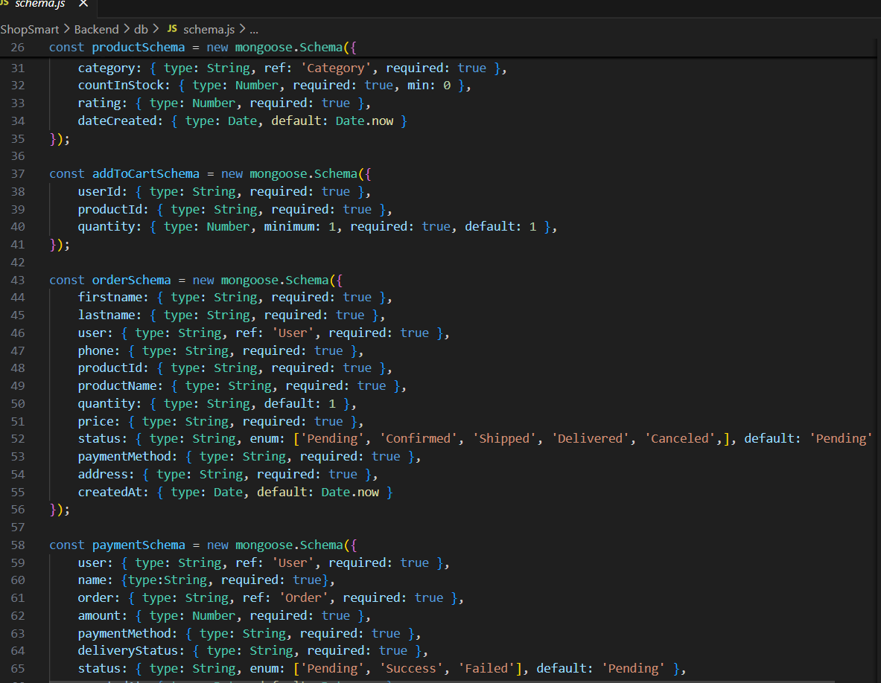
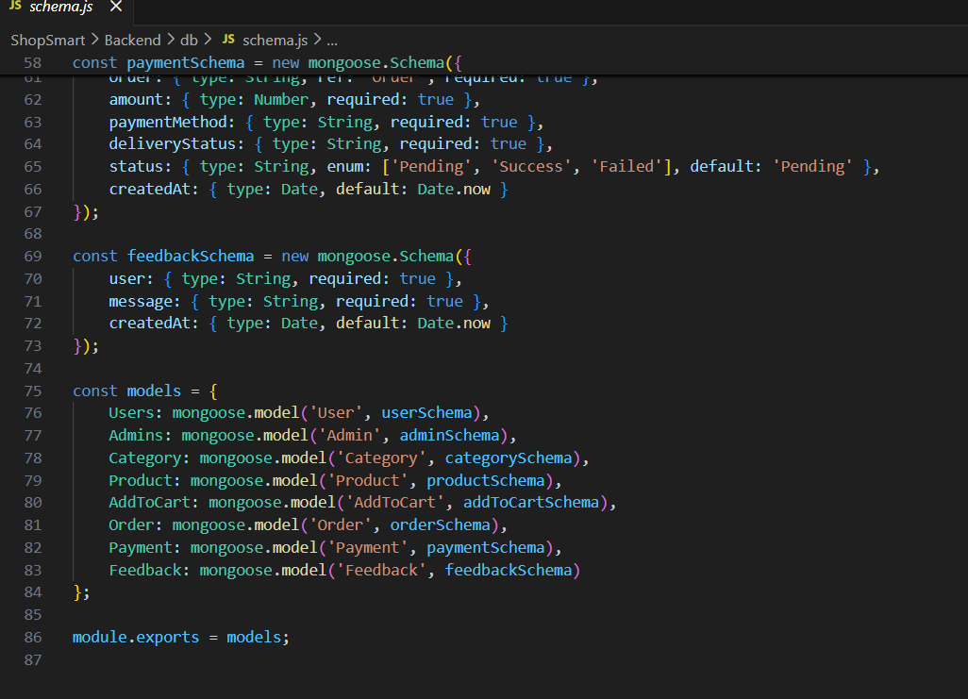
MILESTONE 4: FRONTEND DEVELOPMENT

1. Setup React Application
- Create React application
- Configure routing using React Router
- Install required frontend libraries
2. Design UI Components
- Create reusable components
- Implement layout and styling
- Add navigation (Navbar, Footer)
3. Implement Frontend Logic
- Integrate frontend with backend APIs
- Implement data binding and state management
- Handle authentication and protected routes

MILESTONE 5: PROJECT IMPLEMENTATION
After completing the development of all modules, the G-Mart application is executed as a complete system to verify its functionality and performance.
In this phase, the entire project is run to:
- Test the end-to-end workflow of the application
- Identify and fix bugs or errors
- Validate frontend and backend integration
- Ensure database operations work correctly
- Check user authentication, product listing, cart, and order functionalities
Finally, a complete review of the G-Mart application is performed to confirm that all features work as expected and the system is ready for submission and demonstration.

LANDING PAGE:
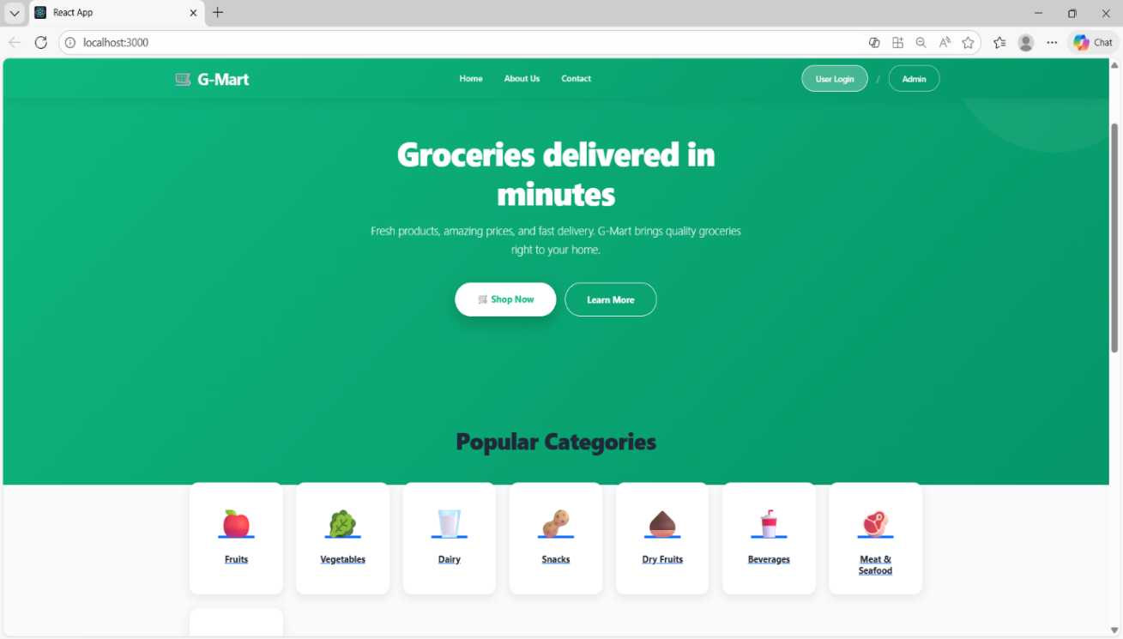

LOGIN PAGE:
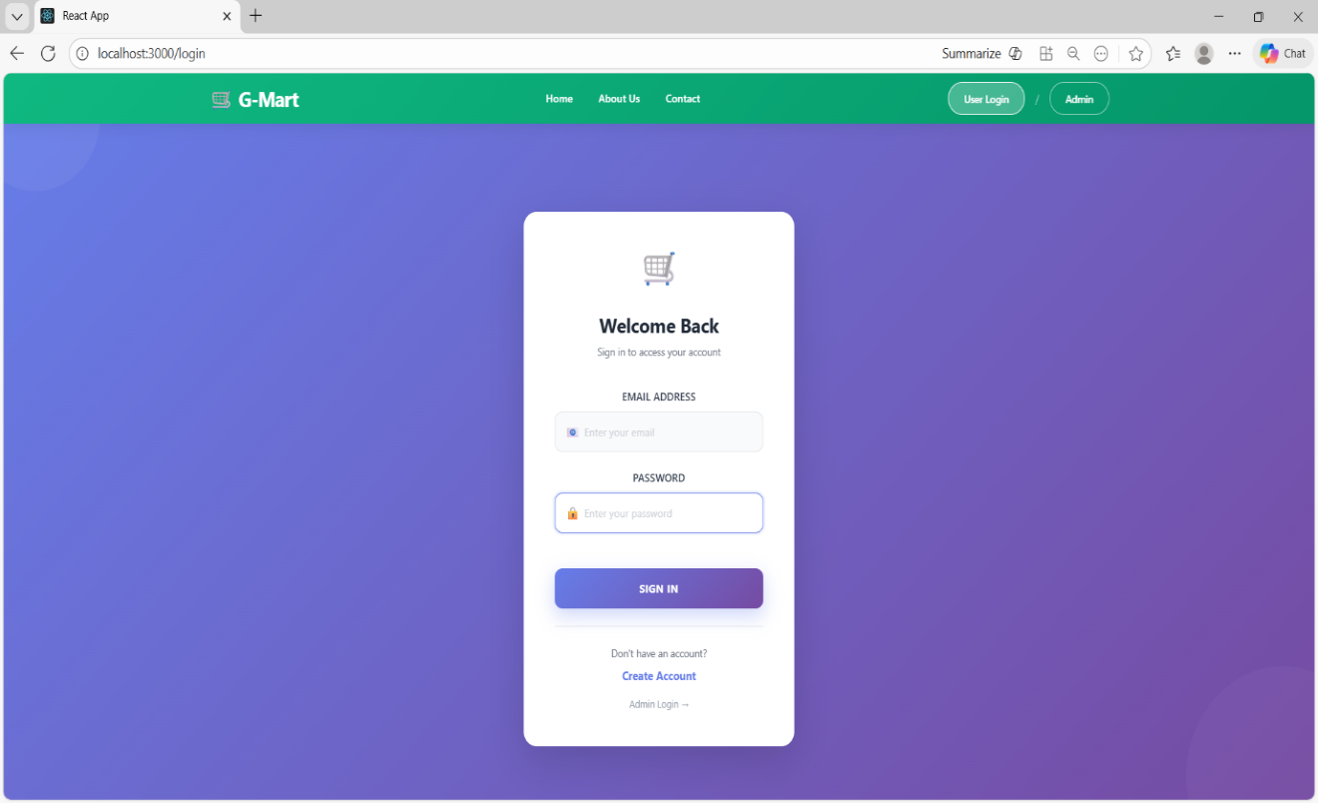

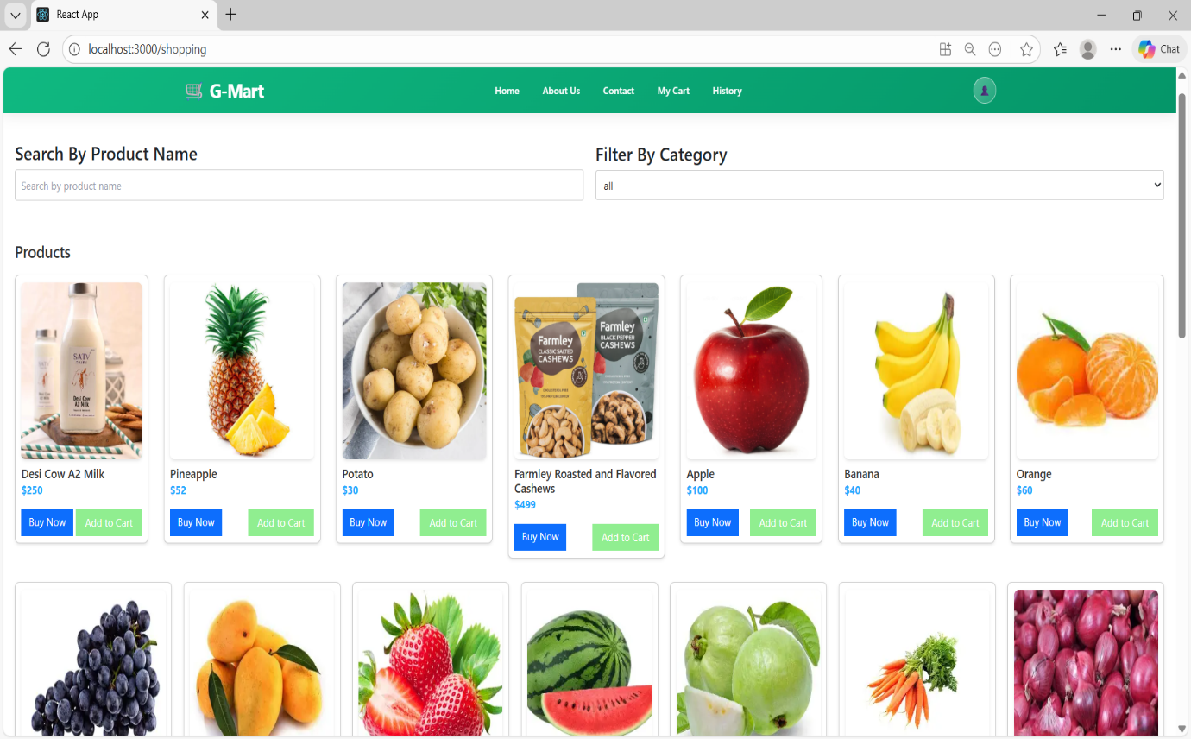
ITEMS PAGE:

MY CART:

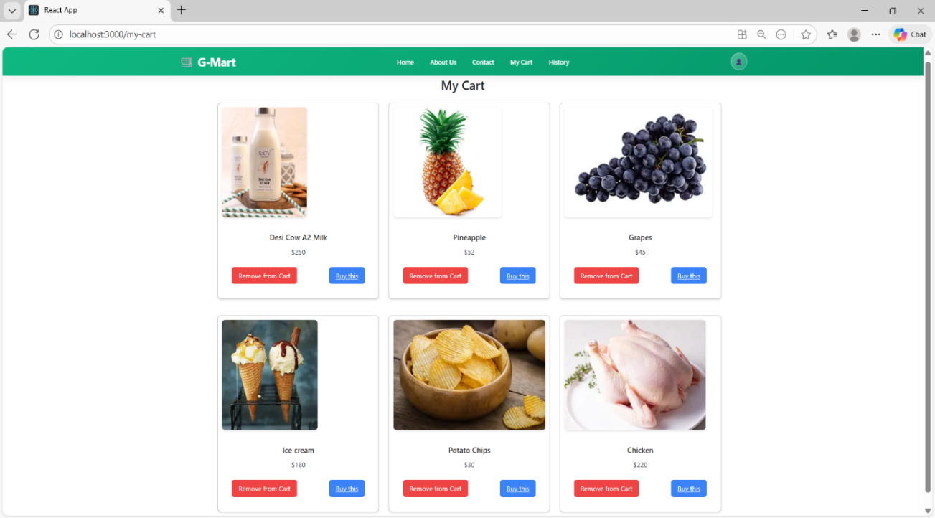

MY ORDERS PAGE:
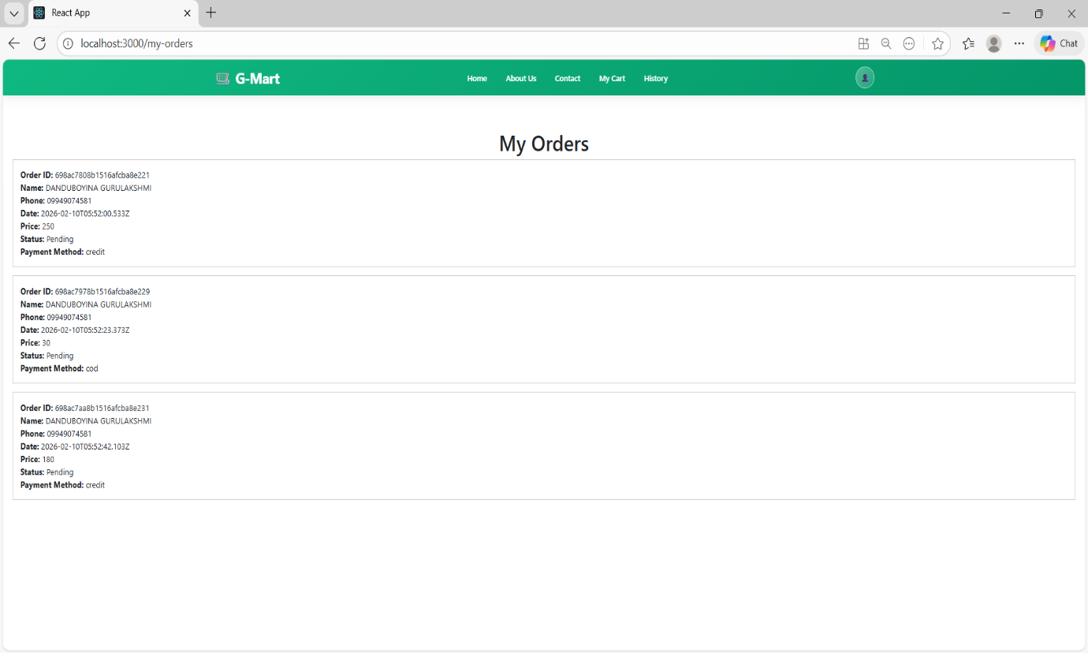

MY HISTORY PAGE:
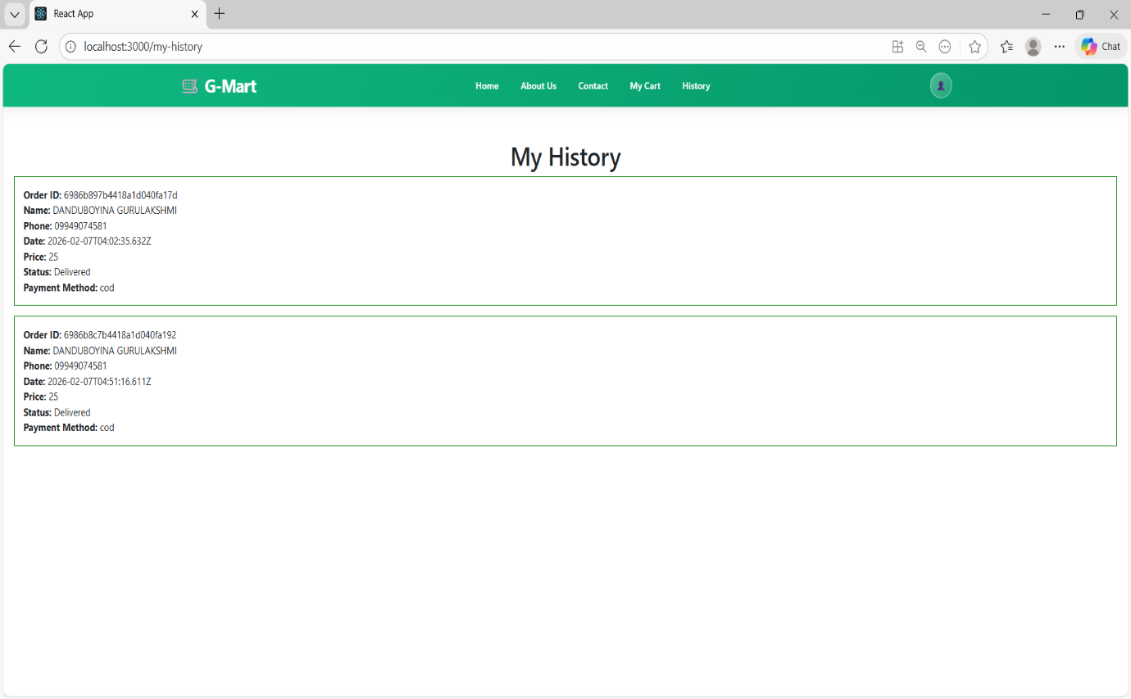

PLACE ORDER PAGE:

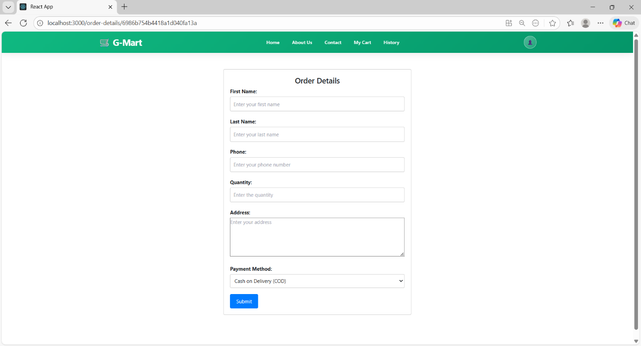

ADMIN DASHBOARD PAGE:

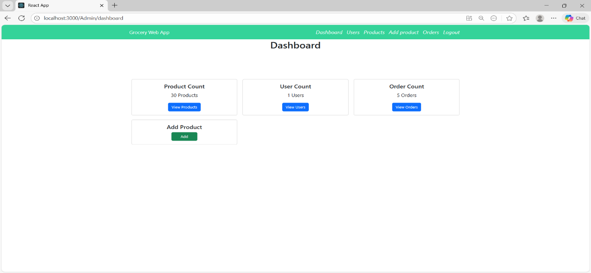

USERS PAGE:

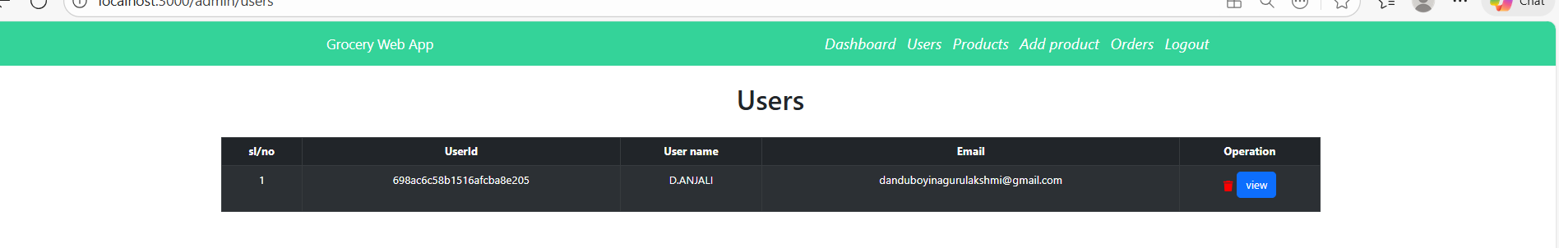
ADD PRODUCT PAGE:

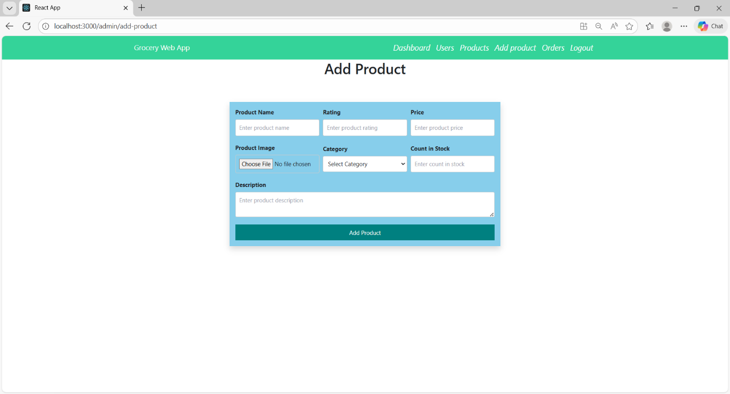

ADMIN ORDERS PAGE:

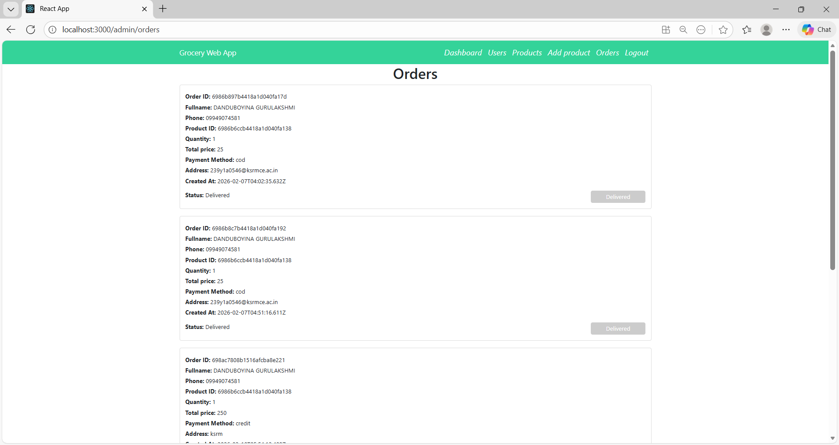

The demo of the app is available at:

https://drive.google.com/drive/folders/1eHqMNFOSdLlgTDnsMXV6nba-BHLl4iDj

