# Assessment Parameters

* Complete flow of the application with exception handling -70%
* Comments/best practice, coding standards- 10%
* Execution of the application (Output) – 20%
* Screen Shot should be submitted along with the solution
* The solution(Project) created by the trainee should have the name like AppName_Empid Ex:ABCCorp_675467
* Code with compilation errors will not be considered for evaluation

Create an online application to register the local business firm with Municipal Corporation. Design the web application for the same using Servlets and JSP.

Find the architecture as follows:

activate.jsp

activated.jsp

errorpage.jsp

C:\Program Files\Microsoft Office\MEDIA\CAGCAT10\j0195384.wmf

Index.jsp

**<<DAO>>**

RegisterDAO

**<<Service>>**

RegisterService

**<<Controller>>**

RegisterController

home.jsp

success.jsp

register.jsp

DB

1. Design the index.jsp which invokes the RegistrationController to retrieve home page. The home page consists of two links, one to register a firm and another to activate the account. Please refer the screenshot shown below: 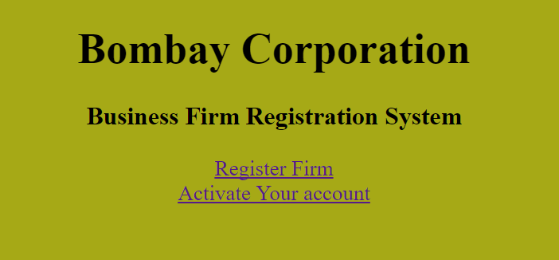

* Once “Register Firm” link is clicked, navigate to “register.jsp” page.
* Once “Activate Your Account” link is clicked, navigate to “activate.jsp” page.

2. Design “register.jsp” page as shown below:

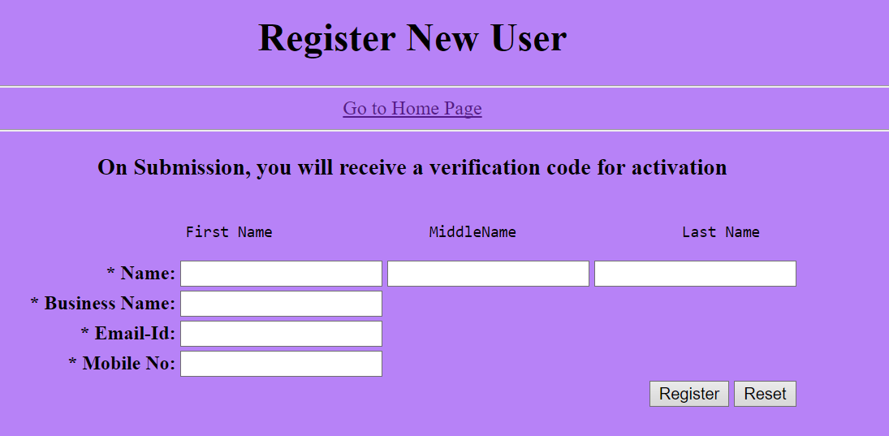

***Perform the following task in the screen designed as above:***

* Insert the data in database. The firm_id in table should be generated using sequence. The isActive value for a new firm registered should be ‘N’.
* Also generate the activation code, which is valid for current session and display the same. Activation code is any random number above 10000. Don’t store the activation number in database, rather it should be persisted in current session. Along with activation code, store the email id both in session and database for checking while activating the account. Refer to the table for more details.
* Display the success page as shown below.

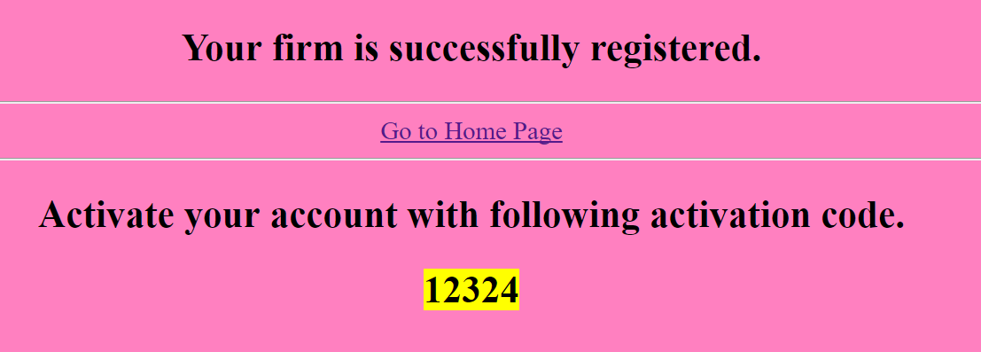

* **Mark Distribution: [40]**

|  |  |
| --- | --- |
| Displaying the form as per the given UI | 5 |
| Validation for required fields | 5 |
| Generating activation code and storing it in session | 8 |
| Use of MVC pattern to implement functionality | 7 |
| Identifying & processing the correct SQL statement for inserting firm details into database. | 10 |
| Displaying the registration success page and home link as per the given UI | 5 |

3. When user select the link to activate the account from home page, display the activation form as given below.

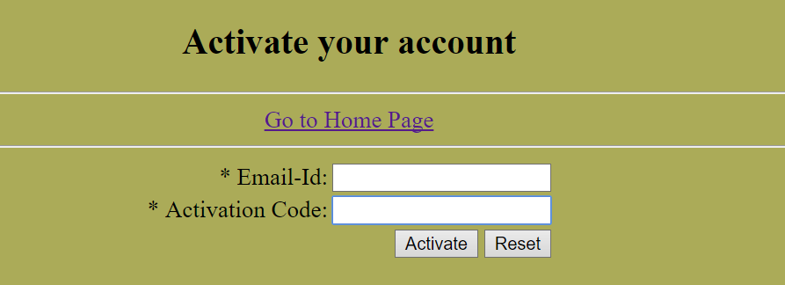

4. Activation code should be currently valid activation code in session. The email id should be the email used for registration for that user. Validate the activation code and email, upon successful validation update the isActive value in database to ‘Y’. Refer to the required column and table for more details.

5. Display the activation success page to user with the message **“Your account activated successfully on <dd-mm-yyyy hh:mm:ss>.**”



6. In case of any exceptions during runtime, throw user defined exception as ‘**FirmException**’ and redirect control to errorpage (say errorpage.jsp).

* **Mark Distribution: [25]**

|  |  |
| --- | --- |
| Displaying the activation form as per the given UI | 5 |
| Validation for required fields and field values (email and activation code should match with session values) | 6 |
| Exception handling with common error page | 2 |
| Identifying and processing the correct SQL statement for activating firm into database. | 9 |
| Displaying success message as per the given format | 3 |

1. Ensure the usage of MVC pattern with Layered Architecture.

**(5 marks)**

**TableScript:**

CREATE TABLE FIRMS_MASTER(firm_id NUMBER(8) PRIMARY KEY, owner_name VARCHAR2(100), business_name VARCHAR2(100),

email VARCHAR2(80) UNIQUE, mobile_no VARCHAR2(10),

isactive CHAR(1));

CREATE SEQUENCE seq_firm_master;