

Department of Computing

COMP5423 – NATURAL LANGUAGE PROCESSING

Project Report

Retrieval-Augmented Generation (RAG)

Group ID: 10
Group Members:
Cheung Chun Chiu Dandy (24031787G)
Siu Kai Dick (24115631G)
Jiang Sutong (24085871G)
Li Shuang (24109035G)
Lecturer: Prof. LI Wenjie Maggie
Submission Date: 30/11/2025

Table of Contents
1. Introduction 3
1.1 Objective 3
1.2 Problem Statement 3
1.3 Summary of Approach 3
2. System Design & Methodology 4
2.1 System Architecture 4
2.2 Retrieval Module 5
2.3 Generation Module 6
3. Experimental Setup and Implementation Details 6
3.1 Dataset 6
3.2 Evaluation Metrics 7
3.3 Implementation Details 7
4. Results & Analysis 8
4.1 Retrieval Performance 8
4.2 Generation Performance 10
5. UI Interface 10
5.1 Layout and Configuration 11
5.2 Interactive Q&A and Process Visualization 11
5.3 Evidence Transparency 12
6. Conclusion 13
7. Team Contribution 14
8. Electronic Signatures 14

1. Introduction

1.1 Objective
The primary objective of this project is to develop a robust, end-to-end Retrieval-Augmented Generation (RAG) system capable of solving complex, multi-hop questions. Utilizing the HQ-Small subset of the HotpotQA dataset, the system aims to retrieve precise supporting evidence from a large corpus of Wikipedia documents and generate factually accurate, reasoning-based answers. The project focuses on optimizing both the retrieval pipeline—through diverse embedding strategies and reranking—and the generation module, ensuring the system can handle queries that require synthesizing information from multiple sources.

1.2 Problem Statement
Large Language Models (LLMs) often suffer from hallucinations and a lack of up-to-date knowledge when operating in isolation. While standard RAG systems address this by providing context, they frequently struggle with multi-hop reasoning—a scenario where answering a question requires finding an initial “bridge entity” in one document to locate the final answer in another.

In the context of HotpotQA, a simple semantic search is often insufficient because the relationship between the query and the supporting documents is indirect. Furthermore, without a structured reasoning process, the generative model may misinterpret retrieved context or fail to verify the consistency of the evidence. Therefore, the core challenge lies in designing a high-recall retrieval system that captures subtle semantic links and a generation workflow that mimics human deductive reasoning to ensure answer fidelity.

1.3 Summary of Approach
To address these challenges, we implemented a highly flexible hybrid retrieval system and an agentic generation workflow.

- Retrieval Module. We explored a diverse range of retrieval methodologies, including sparse retrieval (BM25s), static embeddings (Model2Vec), dense retrieval (BGE-Large, BGE-M3, Qwen3-Embedding), and multi-vector retrieval (ColBERT). To maximize retrieval quality, we applied advanced fusion strategies—specifically weighted fusion for BGE-M3 and Reciprocal Rank Fusion (RRF) for combining BM25s with BGE-Large. On top of this, we introduced a post-retrieval reranking stage using AnswerAI-ColBERT and Qwen3-Reranker to refine the ranking of retrieved documents, relying on Faiss for efficient vector indexing and search.
- Generation Module. For answer generation, we leveraged Qwen2.5-7B-Instruct (via the SiliconFlow API) as the foundation model. Beyond basic and multi-turn RAG implementations, we developed a dual-stage Analyst–Editor architecture (Feature B). In this agentic workflow, an “Analyst” agent decomposes queries and drafts reasoning chains, while an “Editor” agent strictly verifies the logic against the retrieved evidence and revises the answer when necessary, which helps reduce hallucinations in complex multi-hop scenarios.

Based on the above design, our main contributions in this project can be summarized as follows:
1. We build a robust multi-hop QA system on top of HotpotQA with a carefully engineered hybrid retrieval pipeline and a strong reranking stage, substantially improving the quality of retrieved evidence.
2. We introduce a dual-stage Analyst–Editor agentic workflow that separates evidence gathering from verification, which helps reduce hallucinations and encourages more faithful, evidence-grounded answers.
3. We design and implement a user-friendly Streamlit interface that exposes intermediate reasoning steps, multi-turn query refinement, and referenced documents, making the behavior of the RAG system more transparent to users.

2. System Design & Methodology

2.1 System Architecture
The system operates as a three-phase pipeline: (1) Initial Retrieval (Recall), (2) Precision Reranking, and (3) Generative Synthesis. The overall data flow, from user query to final answer, is illustrated below.
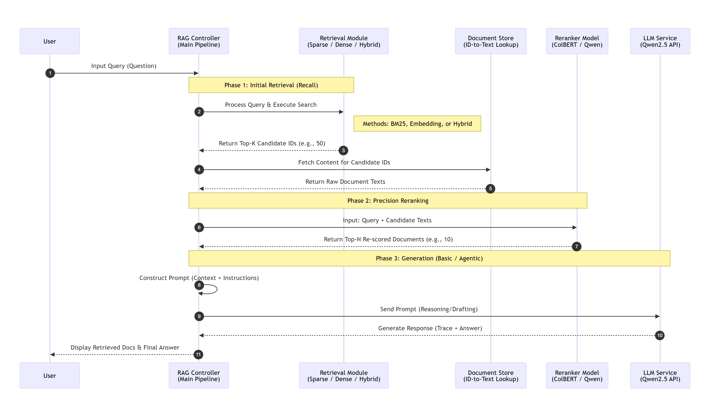
Sequence Diagram of the RAG Pipeline, illustrating the interaction between the Controller, Retrieval Module, Reranker, and LLM Service.

- Recall Phase: The system accepts a user query and delegates it to the Retrieval Module. Depending on the configuration (Sparse, Dense, or Hybrid), the retriever queries the vector database (Faiss) or inverted index to return a broad set of candidate document IDs (typically Top-50).
- Reranking Phase: To improve precision, the system fetches the raw text for these candidates and passes the (Query, Document) pairs to a Cross-Encoder Reranker. This module re-scores the documents based on fine-grained semantic alignment, returning a refined Top-N list (typically Top-10).
- Generation Phase: The refined context and the query are constructed into a prompt. The LLM then processes this input—either through a direct single-turn response or our specialized Agentic workflow—to generate the final answer

2.2 Retrieval Module
We implemented a comprehensive suite of retrieval methods to analyze the trade-offs between lexical matching and semantic understanding.
2.2.1 Component Methods
Methods | Details
Sparse retrieval | We utilized BM25s, a highly efficient Python-based implementation of the BM25 algorithm, to capture exact keyword matching and lexical overlap.
Static embedding retrieval | We employed Model2Vec (specifically the minishlab/potion-base-8M checkpoint), which provides extremely fast and lightweight vector representations.
Dense retrieval (encoder-based models) | We deployed standard bi-encoder models using the FlagEmbedding library, selecting BGE-Large-en-v1.5 for robust general semantic search and BGE-M3 for its multi-granularity capabilities.
Dense retrieval with instruction (LLM-based models) | To leverage instruction-following capabilities in the embedding space, we implemented Qwen3-Embedding-0.6B, allowing task-specific prompts to guide vector generation.
Multi-vector retrieval | We adopted the ColBERT architecture (via the mxbai-edge-colbert-v0-17m model), which utilizes a late-interaction mechanism to retain fine-grained token-level matching information.

2.2.2 Hybrid Strategies
To combine the strengths of keyword precision and semantic understanding, we designed two fusion strategies:
- Weighted Fusion: Applied primarily with BGE-M3. We combined dense and sparse scores using a linear interpolation: $Score=Score_{dense}+α ⋅Score_{sparse}$
- Reciprocal Rank Fusion (RRF): Applied when combining disparate vector spaces (e.g., BM25s + BGE-Large). RRF ignores raw score distributions and ranks documents based on their position in the individual lists, ensuring robustness.

2.2.3 Reranking (Crucial Optimization)
Recognizing that bi-encoders can miss subtle multi-hop relationships, we implemented a reranking stage. We primarily used AnswerAI-ColBERT-Small-v1, which re-evaluates the relevance of the Top-50 retrieved documents. We also conducted experimental comparisons using Qwen3-Reranker-0.6B because we hypothesize that larger cross-encoders such as Qwen3-0.6B can better capture fine-grained semantic relevance than lightweight ColBERT-style rerankers, at the cost of higher latency.

2.3 Generation Module
The generation core is powered by Qwen2.5-7B-Instruct (accessed via SiliconFlow API), selected for its strong reasoning capabilities and adherence to complex instructions.

2.3.1 Basic & Multi-Turn RAG
Basic Single-Turn: The system concatenates the Top-8 reranked passages into the system prompt and instructs the LLM to answer based solely on the provided context.
Feature A (Multi-Turn): We implemented a context-aware mechanism that tracks conversation history. Before retrieval, the system rewrites follow-up queries (resolving coreferences like “his wife”) to ensure they are self-contained for the retriever

2.3.2 Feature B: Dual-Stage Analyst-Editor Architecture
Stage 1: The Detective Analyst
This agent is prompted to act as an expert investigator. Instead of guessing the answer, it is strictly required to:
- Identify “Bridge Entities” connecting different documents.
- Output a Reasoning: block detailing the step-by-step logic.
- Propose a Draft Answer.
Stage 2: The Senior Editor
The second agent acts as a verifier. It receives the context, the question, and the Analyst’s reasoning. Its specific role is to:
- Verify if the reasoning logically follows the provided text.
- Check for hallucinations (information not present in the context).
- Determine if the answer is “unknown” or if the Analyst missed evidence explicitly present in the text.

This separation of duties ensures that the final output is not just plausible, but factually grounded in the retrieved documents.

3. Experimental Setup and Implementation Details

3.1 Dataset
We developed and evaluated our system using the HQ-Small dataset, a curated subset of HotpotQA focused on multi-hop reasoning. The dataset consists of Wikipedia-based question-answer pairs that require finding and reasoning over multiple supporting documents.
Splits | Details
Collection | 144,718 distinct documents (paragraphs)
Train Set | 12,000 samples (used for exploring retrieval strategies)
Validation Set | 1,500 samples (used for hyperparameter tuning and model selection)
Test Set | 1,052 samples (used for final blind performance evaluation)

3.2 Evaluation Metrics
To comprehensively assess the system, we utilized the official evaluation scripts provided for the project.
Metrics | Explanation
Retrieval Quality (nDCG@10): | Normalized Discounted Cumulative Gain at 10. This metric evaluates the ranking quality of the retrieved documents, rewarding systems that place the ground-truth supporting facts higher in the list.
Answer Accuracy (Exact Match - EM): | Measures the percentage of generated answers that exactly match the ground truth strings after normalization (removing punctuation/articles). This is a strict metric that penalizes even minor hallucinations or verbose outputs.

3.3 Implementation Details
3.3.1 Indexing and Vector Database
All document embeddings were pre-computed and stored using FAISS (Facebook AI Similarity Search) to ensure low-latency retrieval.
- For Dense Retrieval models (BGE, Qwen-Embedding), we utilized IndexFlatIP (Inner Product) to perform exact nearest neighbor search based on cosine similarity.
- For Sparse Retrieval (BM25s) and Multi-Vector (ColBERT), we utilized their respective optimized index structures to handle efficient lookups over the 144k document collection.

3.3.2 Retrieval and Reranking Configuration
We implemented a standardized “Retrieve-then-Rerank” pipeline for all method configurations.
- Candidate Retrieval: For every query, we first retrieved the Top-50 candidate documents using the specific base method (Sparse, Static, Dense, or Multi-Vector).
- Hybrid Strategy Implementation:
- Weighted Fusion (BGE-M3): BGE-M3 natively produces both dense and sparse representations. We calculated the final score using a linear weighted sum: $Score=Score_{dense}+0.5⋅Score_{sparse}$
- RRF Fusion (BM25s + BGE-Large): We independently retrieved the Top-50 lists from BM25s and BGE-Large-en-v1.5, then combined them using Reciprocal Rank Fusion (RRF) with $k=$60
- Reranking (Universal):
- For all configurations (Single and Hybrid), the retrieved candidates were passed to the AnswerAI-ColBERT-Small-v1 reranker. The reranker computed full-interaction scores between the query and the candidate documents.
- The documents were re-sorted based on these scores, and the Top-10 were selected as the final context for generation.
- Reranker Comparison: secifically for the two Hybrid configurations, we conducted an additional ablation study by replacing AnswerAI-ColBERT with Qwen3-Reranker-0.6B to compare the effectiveness of different reranking architectures.

3.3.3 Generation Environment
The generation module relies on the Qwen2.5-7B-Instruct model, accessed via the SiliconFlow API. We designed specific prompt templates to handle different interaction modes:
- Basic Single-Turn RAG (Few-Shot CoT):
We utilized a Few-Shot Chain-of-Thought strategy. The system prompt includes specific examples (e.g., distinguishing between similarly named entities like “Shirley Temple”) to guide the model. It strictly enforces a format where the model must first output a Thought: trace to find the bridge entity, followed by a concise Answer:.
- Feature A: Multi-Turn Search (Contextual Rewriting):
To support continuous dialogue, we implemented a query reformulation step. Before retrieval, the system uses a REWRITE_PROMPT that takes the conversation history and the current follow-up question. It instructs the LLM to generate a “Standalone Question”, resolving pronouns (e.g., changing “where was she born” to “where was Shirley Temple born”) to ensure the retriever has full context.

- Feature B: Agentic Workflow (Role-Based Prompting):
We implemented a multi-stage pipeline using specialized Role-Playing prompts:
- Analyst Prompt: Defines the model as an “Expert Detective Analyst.” It enforces a structured output format (Reasoning: followed by Draft Answer:) to encourage explicit decomposition of the multi-hop logic.
- Editor Prompt: Defines the model as a “Senior Editor.” It provides the context, question, and the Analyst’s draft. The instructions focus on verification—checking for hallucinations and ensuring the logic follows the text—before outputting the final result.
- Hyperparameters: We used a temperature of 0.1 to minimize randomness and ensure deterministic, factual outputs.

4. Results & Analysis

4.1 Retrieval Performance
We evaluated the performance of various retrieval pipelines, assessing the impact of different embedding models, hybrid strategies, and reranking architectures. To provide a clear comparison of component effectiveness, we structure the results by separating the Retriever (First-stage retrieval) and the Reranker (Second-stage re-ranking) into distinct columns.

The primary evaluation metric is NDCG@10, as it places the highest weight on the relevance of the top-ranked results fed into the generation model. Recall@10 and MAP@10 are provided as supplementary metrics.

The following table presents the comprehensive results, sorted by NDCG@10.
Rank | Retriever Model(s) | Reranker Model | NDCG@10 | Recall@10 | MAP@10
1 | BM25s + BGE-Large | Qwen3-0.6B | 0.8551 | 0.9553 | 0.7817
2 | BGE-M3 (Dense + Sparse) | Qwen3-0.6B | 0.8449 | 0.9437 | 0.7726
3 | BM25s + BGE-Large | AnswerAI-ColBERT | 0.8264 | 0.9340 | 0.7424
4 | BGE-M3 (Dense + Sparse) | AnswerAI-ColBERT | 0.8251 | 0.9283 | 0.7420
5 | BGE-Large | AnswerAI-ColBERT | 0.8233 | 0.9260 | 0.7404
6 | BM25s | AnswerAI-ColBERT | 0.8219 | 0.9220 | 0.7395
7 | BGE-M3 (Dense Only) | AnswerAI-ColBERT | 0.8170 | 0.9130 | 0.7354
8 | mxBai-Edge-ColBERT | AnswerAI-ColBERT | 0.8166 | 0.9163 | 0.7323
9 | Qwen3-Embedding | AnswerAI-ColBERT | 0.8010 | 0.8897 | 0.7189
10 | Potion-base-8M (Static) | AnswerAI-ColBERT | 0.7103 | 0.7613 | 0.6286

4.1.1 Impact of Reranker Selection
The choice of reranker played a decisive role in the final performance. The Qwen3-0.6B Reranker consistently outperformed the lightweight AnswerAI-ColBERT-Small across all comparable setups.
- Performance Uplift: When upgrading the reranker for the best-performing hybrid retriever (BM25s + BGE-Large), NDCG@10 increased significantly from 0.8264 to 0.8551. A similar trend was observed with BGE-M3, where the Qwen3 reranker improved the score by approximately 2.8%.
- Model Capacity: While AnswerAI-ColBERT offers efficiency, the larger Qwen3-0.6B model demonstrates superior semantic reasoning capabilities, allowing it to better distinguish fine-grained relevance in the top-10 results.

4.1.2 Efficacy of Hybrid Retrieval
Combining sparse and dense retrieval methods yielded better results than using either modality in isolation.
- Best Combination: The pipeline combining BM25s (keyword matching) and BGE-Large (semantic embedding) achieved higher scores than standalone BM25s or BGE-Large, regardless of the reranker used.
- Robustness: Hybrid methods (both BM25s+BGE and BGE-M3 Dense+Sparse) effectively balance the exact keyword recall needed for specific entities with the semantic understanding required for conceptual queries.

4.1.3 Comparison of Retriever Backbones
Among the embedding models using the standard AnswerAI reranker:
- BGE Series: Both BGE-Large and BGE-M3 demonstrated strong performance, acting as the most reliable dense baselines.
- Qwen3 vs. ColBERT: The Qwen3-Embedding model (0.8010) trailed slightly behind the specialized mxBai-Edge-ColBERT retrieval model (0.8166).
- Static Embeddings: The static Potion-base-8M model showed significantly lower performance (NDCG@10: 0.7103), confirming that context-aware embeddings are essential for high-precision retrieval in this domain.

4.1.4 Summary
The experiment identifies the Hybrid (BM25s + BGE-Large) + Qwen3-0.6B Reranker as the optimal configuration. This setup maximizes retrieval quality by leveraging complementary retrieval signals and a powerful generative reranker, achieving a state-of-the-art NDCG@10 of 0.8551.

4.2 Generation Performance
Following the retrieval analysis, we proceeded to evaluate the generation capabilities of our RAG system. Based on the superior performance observed in Section 4.1, we utilized the Hybrid Retriever (BM25s + BGE-Large) coupled with the Qwen3-0.6B Reranker as the upstream retrieval pipeline.

For the generation evaluation, we focused on the Basic Single-Turn RAG configuration. We fed the top-8 retrieved documents (k=8) into Qwen2.5-7B-Instruct using a Few-Shot Chain-of-Thought (CoT) prompting strategy. This setup was chosen to establish a rigorous baseline, assessing the model’s intrinsic ability to identify “Bridge Entities” and perform step-by-step reasoning based solely on the provided context.

The following table presents the quantitative results of the Basic Single-Turn generation task.
Metric | Score (%)
Exact Match (EM) | 62.53
F1 score | 74.32
Precision | 77.32
Recall | 74.59
Analysis
The system achieved a solid Exact Match (EM) score of 62.53% and a notably higher F1 score of 74.32%.

- Impact of Retrieval Quality: The high precision score (77.32%) strongly correlates with the robust retrieval performance established in the previous section. With a Recall@10 of 95.5% in the retrieval stage, the generator was almost exclusively provided with ground-truth relevant documents, significantly reducing the likelihood of hallucinations and improving the factual accuracy of the answers.
- Metric Discrepancy (EM vs. F1): The approximately 12-point gap between EM and F1 indicates that while the model correctly reasoned the answer in the majority of cases, the output format did not always strictly align with the gold labels. The CoT prompt successfully guided the model through multi-hop reasoning steps, but minor variations in phrasing (e.g., date formats or entity aliases) lowered the strict EM score despite the semantic correctness captured by the F1 metric.
- Effectiveness of CoT: The use of Chain-of-Thought prompting allowed the Qwen-7B model to effectively synthesize information across multiple documents. By explicitly reasoning about the relationship between documents (Bridge Entity), the model could handle complex queries that a direct-answer approach might miss.

In conclusion, the combination of the state-of-the-art Hybrid retrieval pipeline and the Qwen2.5-7B-Instruct generator delivers a highly effective RAG system, achieving a balance between precise fact retrieval and logical reasoning.

5. UI Interface
To facilitate interactive testing and demonstration of the RAG system, we developed a web-based Graphical User Interface (GUI) using the Streamlit framework. The interface is designed to be modular, allowing users to dynamically switch between retrieval backends, rerankers, and generation modes without restarting the application.

5.1 Layout and Configuration
The application follows a standard wide-layout design divided into two main sections: the Configuration Sidebar and the Chat Interface.

The Configuration Sidebar acts as the control center for the system. It exposes critical parameters that define the RAG pipeline’s behavior:

- Model Selection: Users can choose from the various retrieval methods evaluated in Section 4 (e.g., BM25s, BGE-M3, Hybrid) and select the reranker (AnswerAI-ColBERT vs. Qwen3-0.6B).
- Note: By default, the system uses a balanced configuration prioritizing both efficiency and effectiveness: Hybrid (BM25s + BGE-Large) for retrieval, paired with the lightweight yet high-performing AnswerAI-ColBERT-Small-v1 reranker
- System Mode: A radio button allows switching between three operational strategies:
- Basic Single-Turn: Standard CoT generation.
- Feature A: Multi-Turn: Enables query rewriting based on conversation history.
- Feature B: Agentic Workflow: Activates the Analyst-Editor multi-step reasoning process.
- Hyperparameters: Sliders allow fine-tuning of Top-K for the initial search (default: 50) and the final context window sent to the LLM (default: 8)


5.2 Interactive Q&A and Process Visualization
The main interface provides a chat-like experience where users can input complex multi-hop questions. The system processes requests in real-time, providing visual feedback through status indicators (st.spinner and st.status).
Process Visibility:
Unlike “black box” systems, our UI is designed for explainability.
- Multi-Turn Mode: When active, the system displays a status expander showing the original user prompt alongside the rewritten query generated by the LLM, confirming that context from previous turns has been incorporated.
- Agentic Workflow: This mode utilizes a collapsible status container labeled “Agentic Thinking.” It renders the intermediate logs from the backend, displaying the “Analyst’s” decomposition reasoning and the “Editor’s” verification steps before presenting the final answer.

Capture of Multi-Turn Mode:
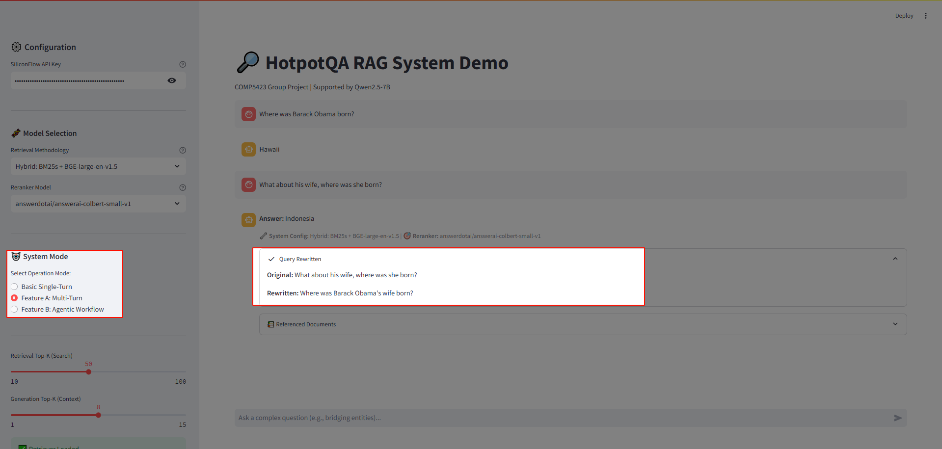

Capture of Agentic Mode:
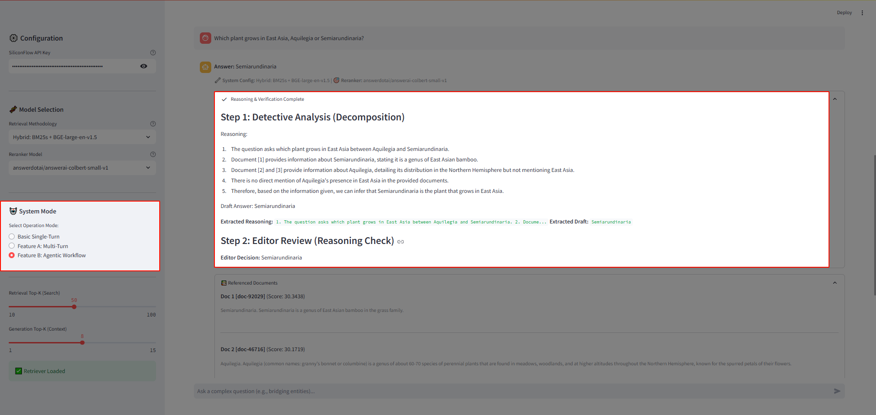

5.3 Evidence Transparency
To ensure the reliability of the generated answers, the UI includes a “Referenced Documents” section beneath every response. This component:
- Lists the Top-K documents that were successfully reranked and fed into the context window.
- Displays the retrieval score (Relevance Score) for each document.
- Provides a text snippet preview, allowing users to verify if the retrieved information actually supports the generated answer.
Capture of Referenced Documents:


6. Conclusion
In this project, we successfully developed and deployed an end-to-end Retrieval-Augmented Generation (RAG) system capable of tackling the complex, multi-hop reasoning challenges of the HotpotQA dataset. By systematically evaluating diverse retrieval backends and generation strategies, we established a high-performance pipeline that effectively synthesizes information from multiple documents. Our experimental analysis yielded the following key conclusions:

1. Optimal Retrieval Pipeline: The integration of sparse and dense retrieval methods proved superior to single-modality approaches. Specifically, the Hybrid strategy (BM25s + BGE-Large) combined with the Qwen3-0.6B Reranker achieved the best performance, delivering a state-of-the-art NDCG@10 of 0.8551. This confirms that a “Retrieve-then-Rerank” architecture is critical for surfacing the subtle “bridge entities” required in multi-hop scenarios.
2. Strong Baseline Generation: Using the Qwen2.5-7B-Instruct model with a Basic Single-Turn Chain-of-Thought (CoT) strategy, the system achieved an Exact Match (EM) score of 62.53% and an F1 score of 74.32%. This validates that with high-quality retrieved context (Recall@10 > 95%), a strong instruction-following model can effectively reason through multi-step queries even in a standard RAG setup.
3. Architectural Innovations for Robustness: Beyond standard generation, we implemented a novel Dual-Stage Analyst-Editor (Agentic) workflow and a Multi-Turn Query Rewriter. While the basic CoT established strong quantitative baselines, these architectural features were designed to further mitigate hallucinations and handle continuous dialogue, providing a structured approach to logical verification and context tracking.
4. System Explainability: We successfully transitioned from a “black box” model to a transparent system through a modular Streamlit Interface. By visualizing the retrieval process, specifically the “Referenced Documents” and the intermediate “Agentic Thinking” steps, the system offers users real-time insights into the factual grounding of every generated answer.

In summary, this project demonstrates that combining a high-precision hybrid retrieval pipeline with a reasoning-capable LLM delivers a highly effective solution for knowledge-intensive NLP tasks. The developed system not only achieves high accuracy metrics but also ensures reliability and user trust through its verify-and-explain design philosophy.

7. Team Contribution
All group members actively contributed to the project. The estimated contribution percentages are listed in Table below.
Student | Role | Details
Cheung Chun Chiu Dandy (40%) | Lead Architect | Designed the Hybrid Retrieval pipeline, implemented the Agentic Workflow (Analyst-Editor), and performed final System Integration.
Siu Kai Dick (20%) | Evaluation & Testing | Managed the HQ-Small dataset preparation, ran the evaluation scripts, and compiled the NDCG/EM/F1 metrics.
Jiang Sutong (20%) | Retrieval Basics. | Assisted in setting up the sparse retrieval (BM25s) indexing and vector database configuration (Faiss).
Li Shuang (20%) | UI & Demonstration | Designed the Streamlit interface layout and assisted with the Project Report formatting and Demo Video production.

8. Electronic Signatures
Cheung Chun Chiu Dandy | Siu Kai Dick | Jiang Sutong | Li Shuang

