Financial Modelling Homework – Bence Dáné

Part 1: Visa vs Mastercard
Date | Visa | Mastercard | V - MA | News
2026-04-29 | 8.26% | 3.47% | 4.79% | Footnote: 1
2023-01-27 | 2.99% | -0.85% | 3.85% | Footnote: 2, 3
2024-09-24 | -5.49% | -1.96% | -3.53% | Footnote: 4

Explanation
2026-04-29: Visa rose 8.26% versus Mastercard’s 3.47%. Visa’s quarter ended on March 31, with a jump of 17% over a year, landing at $11.2 billion.
2023-01-27: Visa rose 2.99%, while Mastercard fell 0.85%. Visa reported Q1 2023 on January 26; revenue was up by 12%. Mastercard’s revenue was below Wall Street expectations.
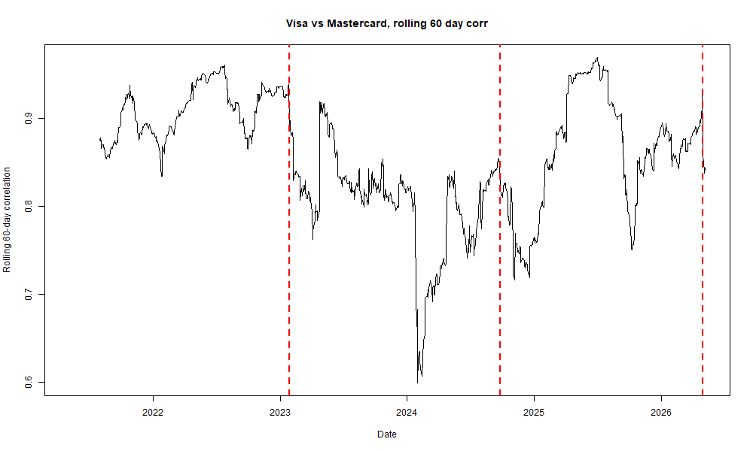
2024-09-24: Visa fell 5.49% versus Mastercard’s 1.96% decline. The reason behind Visa’s performance was Justice Department suing Visa for monopolizing debit markets. Since Mastercard is in the same sector, its decline is related to Visa’s.

Correlation
The 60-day correlation is Corr (V, MA) = Cov (V, MA) / (SD(V) * SD(MA)).
Date | Corr with | Corr without | Cov with | Cov without | SD V with | SD V without | SD MA with | SD MA without
2026-04-29 | 0.870 | 0.925 | 0.000224 | 0.000176 | 1.68% | 1.29% | 1.53% | 1.47%
2023-01-27 | 0.891 | 0.933 | 0.000278 | 0.000288 | 1.66% | 1.63% | 1.88% | 1.89%
2024-09-24 | 0.821 | 0.851 | 0.000141 | 0.000122 | 1.37% | 1.17% | 1.25% | 1.23%

All outlier days reduced the 60-day correlation. Because of the above-mentioned lawsuit Visa’s SD jumped from 1.17% to 1.37%, while Mastercard’s barely changed.

Part 2: Rolling Beta
For the 10-year beta analysis, NVIDIA and SP500 were chosen. Rolling beta was computed over 252 days, where Beta = Cov (NVDA, SP500) / Var SP500).
Measure | Before | After | Change
Correlation rho | 0.728 | 0.823 | 0.094
NVDA daily SD | 2.27% | 3.51% | 1.23%
SP500 daily SD | 0.74% | 1.96% | 1.22%
Volatility ratio | 3.055 | 1.785 | -1.270
Beta | 2.225 | 1.469 | -0.756
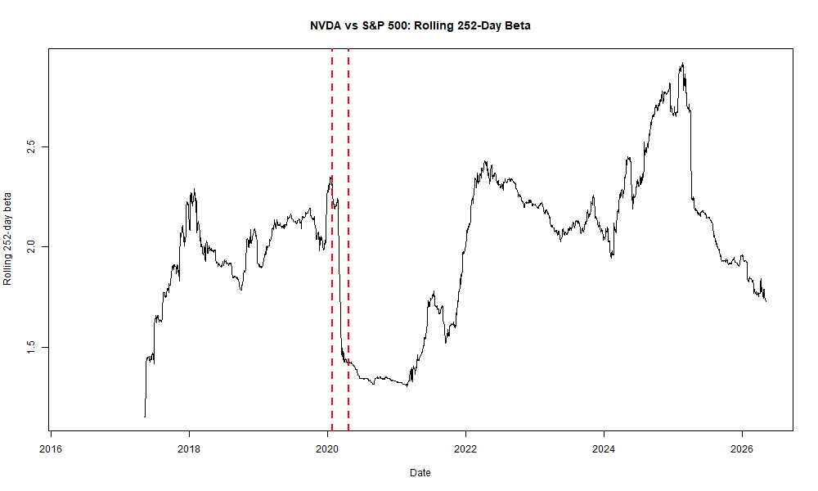

The regime’s starting and ending point was identified using the following chart (the red lines represent the chosen period between 2020-01-28 and 2020-04-23). That period lines up with the COVID-19 crash.
Beta fell even though correlation rose. The main driver was the volatility ratio: market volatility increased sharply during the COVID crash, so NVIDIA's volatility relative to the market fell from 3.081 to 1.732.

Part 3: Normal VaR
SPY’s normal 99% daily VaR was calculated using the mean and standard deviation of daily returns over the 10-year window.
Measure | Value
Index | SPY
Start date | 2016-05-09
End date | 2026-05-05
Observations | 2512
Normal 99% daily VaR | 2.57%
Actual breach count | 49
Actual breach rate | 1.95%

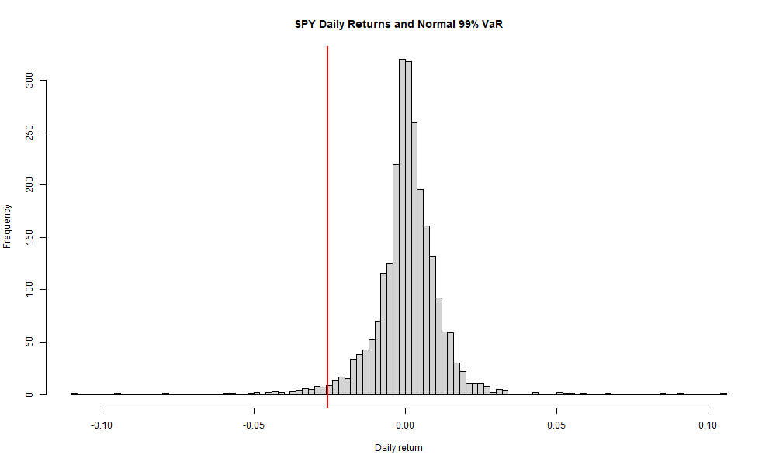

https://www.fool.com/investing/2026/04/29/why-visa-stock-is-up-today/
https://investor.visa.com/news/news-details/2023/Visa-Inc.-Fiscal-First-Quarter-2023-Financial-Results/default.aspx
https://www.investing.com/news/stock-market-news/mastercard-shares-fall-as-credit-card-giant-q1-revenue-outlook-misses-estimates-2989068
https://www.justice.gov/archives/opa/pr/justice-department-sues-visa-monopolizing-debit-markets
https://www.federalreserve.gov/econres/notes/feds-notes/banks-backtesting-exceptions-during-the-covid-19-crash-causes-and-consequences-accessible-20210708.htm

