**Could Self-Interacting Dark Matter halos foster blue Globular Cluster Formation?**

**Summary of CDM findings:**

* Creasey et. al. did Cold Dark Matter simulations for globular cluster formation during reionization and found that ~20% of these clusters have a dark matter halo (subject to van den bosch 2018)
  + This was deduced using analytical calculations and NFW profile, which only works for CDM. SIDM profiles are nowhere near as well developed.
* There is no evidence that metal-poor globular clusters have dark matter (Moore 2018, Peebles 1984)
* The main mechanism for dark matter stripping in Creasey et. al. is tidal forces and eccentric orbits. Since SIDM gives a less drastic density curve, this stripping mechanism might be more effective.

**Questions to answer**

* How do globular clusters form during reionization?
  + *DM haloes created enough over-density to hit jeans mass*.
    - I feel like this would require a DM halo that’s moving at a constant velocity for long enough that the stars can form, then the halo accelerates (maybe bc of an eccentric orbit) and puts the stars in motion
  + *Something else creates the density and then DM haloes swoop in and put the stars in motion.*
    - Would definitely be easier to simulate than the first one
  + Another thing we would need to know is what kind of stellar motion is necessary to create globular clusters?
* How do those GCs evolve, do they stick with their halos? Do they survive?
* How do those GCs stack up to observations?

**What has to be done**

* Similar to the Creasey et. al. paper, the simulation will be an N-Body simulation will be a DM-only simulation run from z = 127 to 0. At z = ztag ≈ 8.65, we run a cluster-finding algorithm to tag candidate DM haloes
* 10 Mpc “zoom-in” box with 5123 particles with mass of 2.95 × 105 M⊙ each (i.e. ≈340 particles for a 108 M⊙ halo) (as per Creasey et. al.)
* Analysis:
  + Get the DM simulation to the tagging redshift
  + Run an algorithm which identifies subhaloes which are good candidates for globular cluster incubation. Tag the most bound particle.
  + Track the most bound particles to z=0

**Tools**

* Initial Condition Code:
  + Needs to create initial conditions and output a .GADGET file, which can then be input into GIZMO
  + Not sure if CDM generators work for SIDM.
* Evolution Code: GIZMO
  + Evolves SIDM particles
  + Has a cluster finder, SUBFIND (which is also used in Creasey et. al.)
  + Must establish the correct parameters to use for both the SUBFIND algorithm as well as the SIDM evolution.

**Time Estimations**

* Difficult to judge the computational timing for this project. GIZMO documentation has one example which has full hydrodynamics, cooling, star formation etc. So this example is definitely an upper limit to what this project requires.

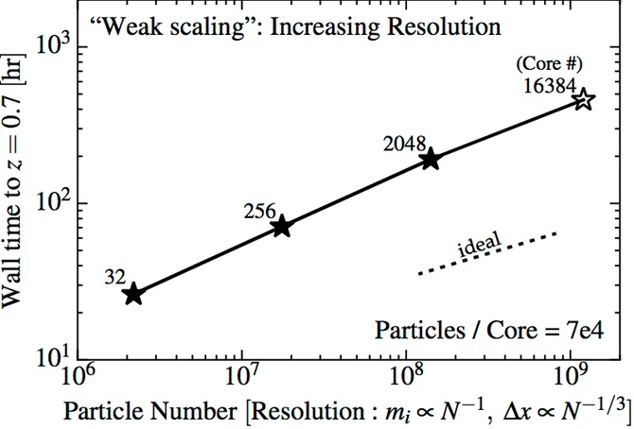

* For this case, we need to simulate ~75% of the age of the universe with ~1 million DM particles.
  + For 1.5 hours of processing time → ~2,000 cores