Documentation

1. Features

The images are not preprocessed. They are being fit to the model as they are. The labels are transformed into categorical labels. Instead of using 0 and 1 as classes [1, 0] and [0, 1] are used.

1. Model Description

The model contains 10 layers as follows:

1. First layer is a Convolutional 2D layer and has 128 filters with a kernel size of (7, 7) and the activation function of the layer is “Relu”. For this layer a Batch Normalization is being done and also a Max Pooling 2D with the default pool size of size (2, 2)
2. Second layer is a Convolutional 2D layer and has 64 filters with a kernel size of (6, 6) and the activation function of the layer is “Relu”. For this layer a Batch Normalization is being done and also a Max Pooling 2D with the default pool size of size (2, 2)
3. Third layer is a Convolutional 2D layer and has 32 filters with a kernel size of (5, 5) and the activation function of the layer is “Relu”. For this layer a Batch Normalization is being done and also a Max Pooling 2D with the default pool size of size (2, 2)
4. Fourth layer is a Convolutional 2D layer and has 16 filters with a kernel size of (4, 4) and the activation function of the layer is “Relu”. For this layer a Batch Normalization is being done and also a Max Pooling 2D with the default pool size of size (2, 2)
5. Fifth layer flattens the data
6. Sixth layer is a Dense layer with 512 units and the activation function of the layer is “Relu”. For this layer a Batch Normalization is being done
7. Seventh layer is a Dense layer with 256 units and the activation function of the layer is “Relu”. For this layer a Batch Normalization is being done
8. Eighth layer is a Dense layer with 256 units and the activation function of the layer is “Sigmoid”. For this layer a Batch Normalization is being done
9. Ninth layer is a Dense layer with 128 units and the activation function of the layer is “Relu”. For this layer a Batch Normalization is being done
10. The last layer is a Dense layer with 2 units (the categorical label) and activation function of the layer is “Softmax”

The model has a learning rate of 0.0001 and the optimizer used is “Adam” optimizer.

1. 3-fold-cross-validation results

The results for the 3-fold-cross-validation are the following:

* **85.83%** accuracy with 0.3964 loss

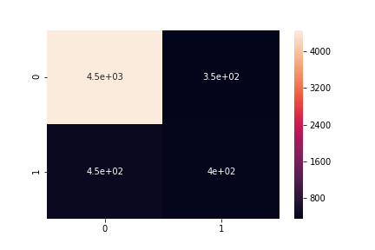

* **87.25%** accuracy with 0.3864 loss

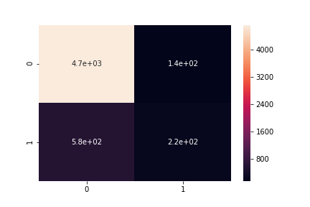

* **86.23%** accuracy with 0.4466 loss

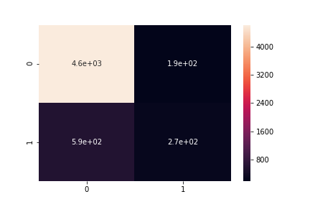

The mean accuracy resulted is: **86.43%**