APPENDIX C

development OF THE DHW NETWORK DATASET
DHW NETWORK DATASET
Billing data obtained from fuel suppliers and utility companies were available for a subset of 3,341 households in the 1993 SHEU database. As shown in Appendix B, a total of 3,298 bills from 2,749 households were considered reliable. Out of these 2,749 households, there are 2,050 households with electricity bills, 1,012 households with natural gas bills, and 236 households with oil bills. The screening processes used in the selection of the households with the billing data for the development of the DHW network dataset are presented in the following sections.

1. Households with Electricity Bills
There are 2,050 households with electricity bills. The distribution of these households based on their end-use electricity consumption is given in Table B.2 of Appendix B. As seen in Table B.2 of Appendix B, there are 506 households using electricity for ALC and DHW heating, and 531 households using electricity for ALC, DHW, and SH.
The electricity consumption data for the 506 households using electricity for ALC and DHW heating were screened as follows:
- The ALC electricity consumption estimated by the ALC NN model was deducted from the annual electricity consumption of the 506 households, and 94 households were found to have negative values. This shows that these households consumed less energy for ALC and DHW heating than the estimated values. This could be due to the vacancy of the dwellings for long periods of time or an error associated with the billing data. Thus, these 94 households were excluded from the analysis.
- The minimum likely annual electricity consumption, Q_{min} (MJ/yr), of a household for DHW heating was estimated using Equation C.1 assuming that:
- the household has one occupant,
- DHW heating system efficiency is 0.96,
- average annual ground temperature is 12 ºC (285K).
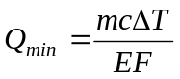 (C.1)
where m : annual DHW consumption, kg/yr
c : 4.184 10⁻³ MJ/kgK
ΔT: [318 K – Average annual ground temperature, K]
EF: efficiency of the DHW heating system
The annual DHW consumption (m) of a household can be estimated from Equation C.2 (NRCan, 1996).
m (kg/d) = [85 l/d + (35 l/d-people * no. people)] * 365 d/yr * 0.997 kg/l (C.2)
Using Equations C.1 and C.2, the minimum likely annual electricity consumption of a household for DHW heating was calculated as 6,280.7 MJ/yr ≈ 1,745 kWh/yr. There were 71 households with DHW heating consumption values less than 1,745 kWh. These 71 households were therefore excluded from the analysis.
Thus, the number of households with electricity bills and using electricity for ALC and DHW heating was reduced to 341 after excluding the 165 (= 94 + 71) households as shown above.
There are 531 households using electricity for ALC, and DHW and SH in the billing dataset. The ALC electricity consumption of these households was estimated by the ALC NN model. To include these households in the dataset used for the development of the DHW network, the amount of electricity consumed for SH by these households should be estimated.
Assuming that the monthly ALC electricity consumption of these households was constant throughout the year, the annual ALC electricity consumption estimated by the ALC NN model for these households was divided by twelve and deducted from the monthly electricity consumption. Therefore, the remaining monthly electricity consumption of these households accounted for DHW and SH electricity consumption.
It was assumed that during summer months (i.e. June, July, and August), the electricity consumption of these households accounted only for DHW heating, and there was not any electricity consumption for SH. The minimum monthly electricity consumption in these summer months can be taken as the household’s monthly DHW heating electricity consumption. Therefore, the annual DHW heating electricity consumption can be calculated by multiplying this monthly electricity consumption by 12. This method is termed as “Summer Months Method (SMM)”.
It was assumed that the monthly DHW consumption is constant throughout the year. Thus, the month-to-month variation in the DHW heating energy consumption would be due to the month-to-month change in the average ground temperature. It was also assumed that the DHW temperature is maintained at 318 K (45ºC). For example, the DHW heating energy consumption (Q) of a household in January and in August would be:
Q_{JAN} = m[kg] * c[MJ/kgK] * (318 - GT_{JAN}[K])
Q_{AUG} = m[kg] * c[MJ/kgK] * (318 - GT_{AUG}[K])
where GT is the average annual ground temperature in K. The ratio of the DHW heating energy consumption in January to that in August is:
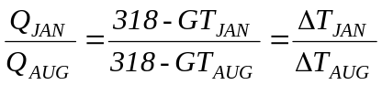
If the household’s electricity consumption in August was the minimum monthly electricity consumption within summer months, i.e. there was no electricity consumption for SH in August, and electricity consumption in this month accounted for ALC and DHW heating. Then, the DHW heating energy consumption in January can be calculated applying the SMM as:
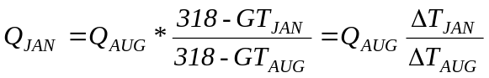
Therefore, the SMM can be formulized as:
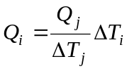 (C.3)
where Q is the monthly electricity consumption, ΔT is the temperature difference (i.e. 318 – GT ), i represents the months other than the month with the minimum electricity consumption, and j represents the month with the minimum electricity consumption.
The monthly electricity consumption information of the 531 households was required to apply the SMM. Out of 531 households, 525 of them had monthly electricity bills as given in Table B.3 of Appendix B. The average monthly ground temperatures were available only for 22 cities in 1993 from Environment Canada (Environment Canada, 1999). The cities, in which these 525 households with monthly electricity bills were located, were matched with the closest cities with the average monthly ground temperature data.
The electricity consumption data of the 525 households using electricity for DHW and SH were screened before applying the SMM.
- There were 75 households with A/C units in the set of 525 households with monthly electricity bills. The A/C unit increases the electricity consumption in the summer months, therefore these 75 households were excluded from the analysis.
- The monthly electricity consumption values of each of the remaining 450 (=525-75) households were plotted to check if the minimum electricity consumption occurred in one of the three summer months and if the household had a “reasonable” annual electricity consumption pattern. An electricity consumption pattern was deemed reasonable if the peak consumption occurs in winter months and the minimum occurs in summer months. The monthly electricity consumption of a sample household using electricity for ALC, and DHW and SH with a “reasonable” annual electricity consumption pattern, and the monthly average ground temperature at the region the household was located are given in Figure C.1. As seen in Figure C.1, the household had a “reasonable” annual electricity consumption pattern, which gradually increases in winter months and decreases in summer months. It was found that 294 households did not have “reasonable” electricity consumption patterns; such as minimum electricity consumption occurring in one of the winter months, or maximum electricity consumption occurring in one of the summer months, or sudden increase or decrease in consumption occurring in-between seasons. Thus, these 294 households were excluded from the analysis.
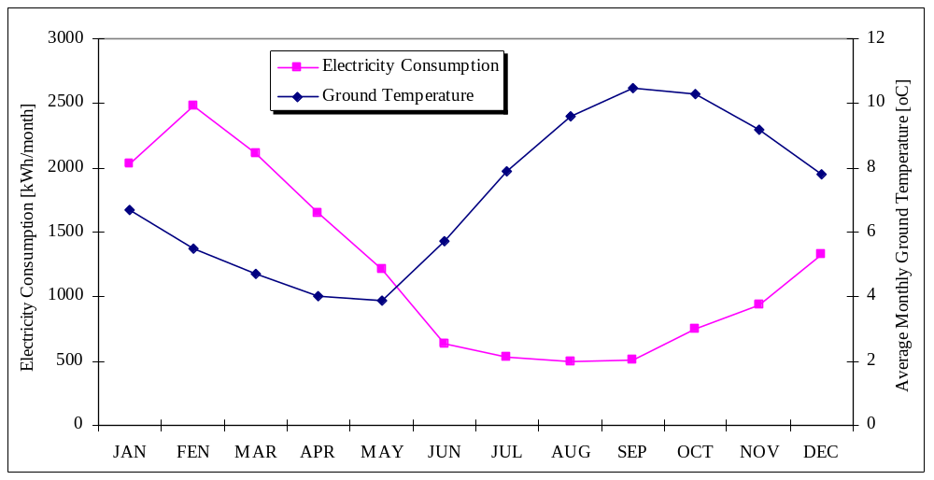
Figure C.1. Monthly electricity consumption and average monthly ground temperature of a sample household using electricity for DHW and SH
The annual ALC electricity consumption estimated by the ALC NN model for these households was divided by twelve and deducted from each month’s electricity consumption of the remaining 156 (= 450-294) households. Then, the SMM was applied to the each of 156 households as follows:
- Electricity consumption of each month was divided by the monthly temperature difference of that month, i.e. ΔT in Equation C.3 (= 318 – monthly GT).
- The monthly electricity consumption with the minimum 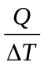 value was taken as the month in which there was no electricity consumption for SH, and the household electricity consumption accounted only for DHW heating. This value was then multiplied by the monthly temperature difference of each of the remaining eleven months.
- The summation of computed Q values of the eleven months and the electricity consumption of the month with minimum value represented the annual DHW heating electricity consumption.
The annual DHW heating electricity consumption values of the 156 households estimated by the SMM were analyzed, and it was found that:
- There were 40 households with negative DHW heating electricity consumption values. Thus, these 40 households were excluded from the analysis.
- There were also 26 households with DHW heating consumption values less than 1,745 kWh. These 26 households were excluded from the analysis.
Thus, the number of households with electricity bills and using electricity for ALC, and space and DHW heating reduced to 90 after excluding the 66 (= 40 + 26) households as given above.
As a total, 431 (= 341 + 90) households with electricity bills remained in the dataset. An additional screening process was applied to the remaining 436 households by examining their daily DHW consumption values.
As the number of occupants increases, the daily DHW consumption increases. The household with the maximum number of occupants in the 1993 SHEU database have eleven occupants. Therefore, this household would likely have the maximum daily DHW consumption amongst the households in the 1993 SHEU database. Using Equation C.2, it was found that the daily DHW consumption of this household was 470 l/day.
The maximum number of weekly dishwasher and clothes washer loads reported in the 1993 SHEU database was 15 loads per week. It was stated by Tomlimson and Rizy (1998) that average clothes washer DHW consumption was 25 liters per load in a study covering 103 households in USA. The average dishwasher DHW consumption was reported in EnerGuide- 1994 (NRCan, 1994) as 40 liters for one load. Therefore, daily dishwasher and clothes washer DHW consumption of a household with 15 loads per week would be about 140 liters.
Thus, the maximum likely daily DHW consumption for the households in the 1993 SHEU database would be 610 l/day. Therefore, the daily DHW consumption values of the remaining 431 households with electricity bills should be lower than this value.
The DHW consumption values of the remaining 431 households were calculated using Equation C.4.
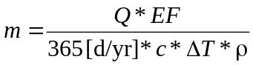 (C.4)
where m : daily DHW consumption, L/day
Q : DHW heating energy consumption, MJ/yr
EF : efficiency (0.96 for tankless systems and 0.824 for systems with tanks)
c : 4.184 10⁻³ MJ/kgK
ΔT : 318 K – Average annual ground temperature, K
ρ : water density, kg/L = 0.997 kg/L
It was found that there were 43 households with DHW consumption values higher than 610 L/day. These 43 households were excluded from the analysis, and the remaining 388 (= 431 – 43) households with electricity bills were deemed to have reliable electricity consumption data to be used in the dataset for the development of the DHW network.

2. Households with Natural Gas Bills
There are 1,012 households with natural gas bills. The distribution of these households based on their end-use natural gas consumption is given in Table B.4 of Appendix B. As seen in Table B.4 of Appendix B, there are 27 households using natural gas only for DHW heating, and 915 households using natural gas for DHW and SH. There are seven households with natural gas bills, but the data indicate that they do not use natural gas fueled space or DHW heating equipment, or any other natural gas fueled appliances.
Out of 915 households using natural gas for space and DHW heating, 745 of them had monthly natural gas bills as given in Table B.5 of Appendix B. Therefore, the annual DHW heating natural gas consumption of these 745 households with monthly natural gas bills could be estimated using the SMM. Before applying the SMM, some screening processes were applied to these 745 households:
- The monthly natural gas consumption of each of the 745 households was examined if the minimum monthly natural gas consumption occurred in the summer months (i.e. June, July, and August). It was found that 488 households had minimum monthly natural gas consumption in January, February, March, April, May, September, October, November, or December. Thus, these 488 households were excluded from the analysis.
- The minimum likely annual DHW heating natural gas consumption was calculated using Equation C.1 and C.2, and assuming that:
- the household has one occupant,
- DHW heating system efficiency is 0.80,
- average annual ground temperature is 12 ºC (285K).
With these assumptions, the minimum likely annual DHW heating natural gas consumption was calculated as 7,536.8 MJ/yr ≈ 202 m³/yr ≈ 17 m³/month. There were three households with monthly DHW heating consumption values less than 17 m³. These three households were excluded from the analysis.
- There might be other sources of natural gas consumption in the households other than the natural gas fueled space and DHW heating systems. The natural gas fueled appliances reported in the 1993 SHEU database that would contribute to the natural gas consumption of a household are:
- Oven/stove
- Dryer
- Pool heater
- Fire place
- Supplementary heater
There were 59 households with monthly natural gas bills using one or more of the above natural gas fueled appliances. Thus, these 59 households were excluded from the analysis.
- The monthly natural gas consumption values of each of the remaining 195 (= 745 – 488 – 3 – 59) households were plotted to check if the household had a “reasonable” annual natural gas consumption pattern, which gradually increases in winter months and decreases in summer months. It was found that 26 households did not have “reasonable” monthly natural gas consumption patterns. Thus, these 26 households were excluded from the analysis.
Thus, the number of households with monthly natural gas bills reduced to 169 after excluding the 576 (488+3+59+26) households as given above. The SMM was applied to these remaining 169 households, and their annual DHW heating natural gas consumption was estimated.
There were 27 households using natural gas only for DHW heating, 19 of these households had natural gas consumption values either less than 200 m³ or more than 2000 m³. Thus, 19 households with unacceptable DHW heating energy consumption values were excluded from the analysis. Therefore, only eight of these 27 households were deemed to have acceptable natural gas DHW heating consumption values.
As a total, 177 (= 169 + 8) households with natural gas bills were left in the analysis. An additional screening process was applied to the remaining 177 households by examining their daily DHW consumption values. The daily DHW consumption values of these 177 households were calculated using Equation C.4. Two households with daily DHW consumption values higher than 610 L/day were excluded from the analysis. Finally, remaining 175 (= 177 – 2) households with natural bills were deemed to have reliable natural gas consumption data used to be used in the dataset for the development of the DHW network.

3. Households with Oil Bills
There are 236 households with oil bills. The distribution of these households based on their end-use consumption is given in Table B.6 of Appendix B. As seen in Table B.6 of Appendix B, there are three households using oil only for DHW heating and 137 households using oil for DHW and SH. There are six households with oil bills, but the data indicate that they do not use oil fueled space or DHW heating equipment, or any other oil fueled appliances.
The billing data of the 230 households with oil bills were all in the annual form. Since there was no household with monthly oil bills, the SMM could not be applied to the households with oil bills and using oil for space and DHW heating.
There were three households with oil bills and using oil only for DHW heating. The annual oil consumption values of these three households were all higher than 2700 L. The maximum likely annual oil consumption for DHW heating was calculated using Equation C.1 and C.2, and assuming that:
- the household has eleven occupants (maximum number of occupants reported in the 1993 SHEU database),
- DHW heating system efficiency is 0.50,
- average annual ground temperature is 5 ºC (278K, minimum average annual ground temperature in Canada in 1993).
With these assumptions, the maximum likely annual DHW heating oil consumption was calculated as 57,250 MJ/yr ≈ 1500 L/yr. Therefore, the DHW heating oil consumption values of these three households were found unacceptably high. Thus, none of the 230 households oil bills were found reliable to be used in the dataset for the development of the DHW network.

It was assumed that the DHW was distributed at 45ºC (318K) in the households. Therefore, ΔT used in Equation C.1 is 318K- 285K = 33K.

