APPENDIX E

CONFIGURATION OF THE NN MODEL
1. ALC NN MODEL
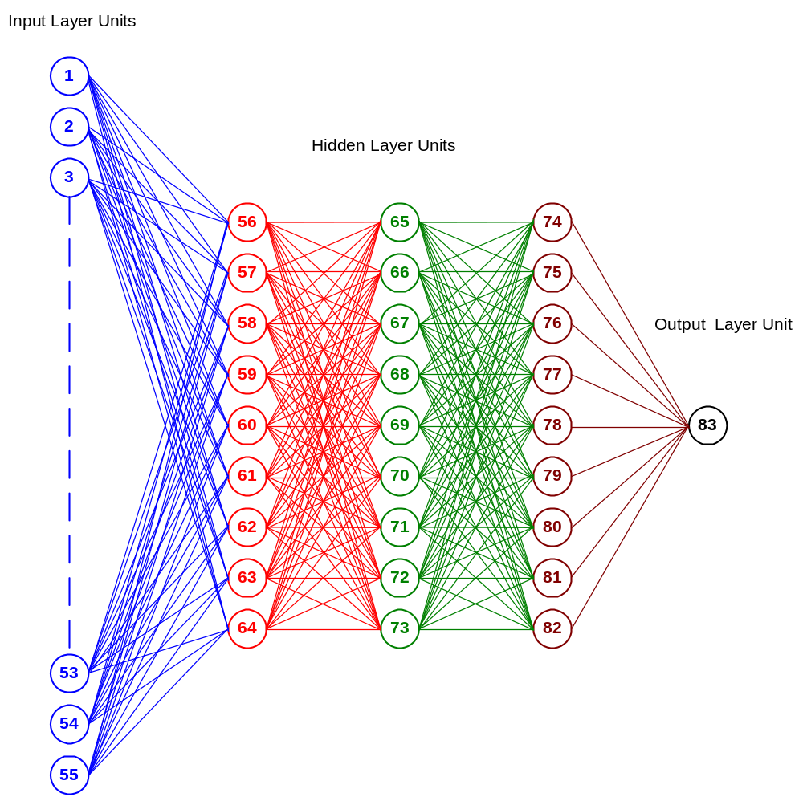
The NN model developed to estimate the ALC energy consumption has 55 input layer units, nine units in each of the three hidden layers, and one output layer unit. As shown in Figure E.1, the units from one to 55 represent the input layer units, units from 56 to 82 represent the hidden layer units, and units 83 is the output layer unit.
Figure E.1. Architectural configuration of the ALC NN Model

The unit definition section of the SNNS output for the ALC NN Model is given in Figure E.2. The bias values of the hidden and output layer units are given in the third column.

No. | Name | Bias | Type | Activation F.|
----|--------------------|----------|--------|--------------|
1 | Main Refrigerator | | input | |
2 | Secondary Refri. | | input | |
3 | Stove | | input | |
4 | Dishwasher | | input | |
5 | Main Freezer | | input | |
6 | Secondary Freezer | | input | |
7 | Clothes Washer | | input | |
8 | Clothes Dryer | | input | |
9 | Microwave | | input | |
10 | Color TV | | input | |
11 | BW TV | | input | |
12 | Furnace Fan | | input | |
13 | Boiler Pump | | input | |
14 | Supplementary Ht. | | input | |
15 | VCR | | input | |
16 | CD Player | | input | |
17 | Stereo | | input | |
18 | Computer | | input | |
19 | Electric Blanket | | input | |
20 | Water Bed | | input | |
21 | Humidifier | | input | |
22 | Dehumidifier | | input | |
23 | Car Block | | input | |
24 | Car Warmer | | input | |
25 | Water Cooler | | input | |
26 | Fish Tank | | input | |
27 | Bath. Exh. Fan | | input | |
28 | Kitch. Exh. Fan | | input | |
29 | Central Air Filter | | input | |
30 | Central Humidifi. | | input | |
31 | Central Dehumidif. | | input | |
32 | Central Air Exch. | | input | |
33 | HRV | | input | |
34 | Central Vacuum | | input | |
35 | Sump Pump | | input | |
36 | Water Softener | | input | |
37 | Jacuzzi | | input | |
38 | Sauna | | input | |
39 | Ceiling Fan | | input | |
40 | Portable Fan | | input | |
41 | Central A/C | | input | |
42 | Window A/C | | input | |
43 | Halogen | | input | |
44 | Fluorescent | | input | |
45 | Incandescent | | input | |
46 | HDD | | input | |
47 | CDD | | input | |
48 | Area | | input | |
49 | Income | | input | |
50 | Dwelling Type | | input | |

Figure E.2. Unit definition of the ALC NN Model

51 | Ownership | | input | |
52 | Population | | input | |
53 | No. of Children | | input | |
54 | No. of Adults | | input | |
55 | Employment Ratio | | input | |
56 | | -0.03352 | hidden | Logistic |
57 | | 0.43477 | hidden | Logistic |
58 | | 0.54654 | hidden | Logistic |
59 | | -0.14504 | hidden | Logistic |
60 | | -0.58060 | hidden | Logistic |
61 | | -0.99884 | hidden | Logistic |
62 | | 0.98134 | hidden | Logistic |
63 | | -0.89134 | hidden | Logistic |
64 | | -1.36429 | hidden | Logistic |
65 | | -0.77716 | hidden | Logistic |
66 | | 0.10899 | hidden | Logistic |
67 | | -0.62399 | hidden | Logistic |
68 | | 0.85723 | hidden | Logistic |
69 | | 0.93863 | hidden | Logistic |
70 | | 0.09220 | hidden | Logistic |
71 | | -0.59255 | hidden | Logistic |
72 | | -0.74478 | hidden | Logistic |
73 | | -1.17445 | hidden | Logistic |
74 | | -0.77444 | hidden | Logistic |
75 | | -0.07289 | hidden | Logistic |
76 | | 0.28001 | hidden | Logistic |
77 | | 0.03338 | hidden | Logistic |
78 | | -0.24248 | hidden | Logistic |
79 | | 0.00637 | hidden | Logistic |
80 | | -0.53576 | hidden | Logistic |
81 | | -0.72210 | hidden | Logistic |
82 | | -0.59786 | hidden | Logistic |
83 | | -0.29669 | output | Identity |
----|--------------------|----------|--------|--------------|

Figure E.2. (continued) Unit definition of the ALC NN Model

The values of the weights between the units of the ALC NN Model are given in Figure E.3.

The output of the ALC NN Model can be calculated by applying Equations E.1 to E.4. Since the hidden layer activation function was chosen to be the logistic function (Equation 2.2), the outputs of the hidden layer units are calculated using the logistic function. Identity function (Equation 2.4) was chosen for the output layer unit, thus the output of the unit at the output layer is calculated using the identity function.
The output of each first hidden layer unit is calculated as follows:
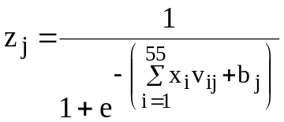 (E.1)
Similarly, the outputs of each second and third hidden layer units are calculated using Equations E.2 and E.3, respectively.
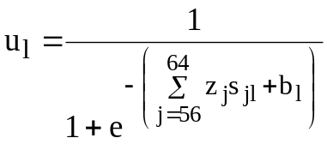 (E.2)
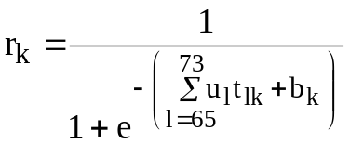 (E.3)
The output of the network is calculated as follows:
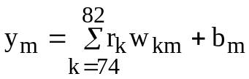 (E.4)
where,
x_{i}: input to the first hidden layer unit j from input layer unit i
z_{j}: output of the first hidden layer unit j / input to the second hidden layer unit l from first hidden layer unit j
u_{l}: output of the second hidden layer unit l / input to the third hidden layer unit k from second hidden layer unit l
r_{k}: output of the third hidden layer unit k / input to the output layer unit m from third hidden layer unit k
v_{ij}: weight between the input layer unit i and first hidden layer unit j
s_{jl}: weight between the first hidden layer unit j and second hidden layer unit l
t_{lk}: weight between the second hidden layer unit l and third hidden layer unit k
w_{km}: weight between the third hidden layer unit k and output layer unit m
b_{j}: bias of the first hidden layer unit j
b_{l}: bias of the second hidden layer unit l
b_{k}: bias of the third hidden layer unit k
b_{m}: bias of the output layer unit m
i: number of input layer units (1 to 55)
j: number of first hidden layer units (56 to 64)
l: number of second hidden layer units (65 to 73)
k: number of third hidden layer units (74 to 82)
m: output layer unit (83)

2. DHW NN MODEL
The NN model developed to estimate the DHW heating energy consumption has 18 input layer units, 29 hidden layer, and one output layer unit. As shown in Figure E.4, the units from one to 18 represent the input layer units, units from 19 to 47 represent the hidden layer units, and units 48 is the output layer unit.
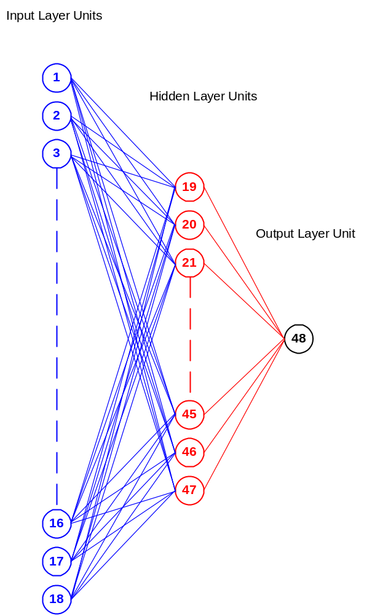
Figure E.4. Architectural configuration of the DHW NN Model
The unit definition section of the SNNS output for the DHW NN Model is given in Figure E.5. The bias values of the hidden and output layer units are given in the third column.

No. | Name | Bias | Type | Activation F.|
----|----------------------|----------|--------|--------------|
1 | Shared System | | input | |
2 | No. of Tanks | | input | |
3 | Tank Age | | input | |
4 | Tank Size | | input | |
5 | Tank Blanket | | input | |
6 | Pipe Insulation | | input | |
7 | Low Flow Showers | | input | |
8 | Aerators | | input | |
9 | System Efficiency | | input | |
10 | Ground Temp. | | input | |
11 | Clothes Washer Loads | | input | |
12 | Dishwasher Loads | | input | |
13 | No. of Children | | input | |
14 | No. of Adults | | input | |
15 | Income | | input | |
16 | Dwelling type | | input | |
17 | Ownership | | input | |
18 | Population | | input | |
19 | | 0.43783 | hidden | Logistic |
20 | | -0.19880 | hidden | Logistic |
21 | | 0.47309 | hidden | Logistic |
22 | | 0.26038 | hidden | Logistic |
23 | | -0.54827 | hidden | Logistic |
24 | | 0.45152 | hidden | Logistic |
25 | | 0.53175 | hidden | Logistic |
26 | | -0.27679 | hidden | Logistic |
27 | | 0.34231 | hidden | Logistic |
28 | | 0.46766 | hidden | Logistic |
29 | | 0.87066 | hidden | Logistic |
30 | | 0.56837 | hidden | Logistic |
31 | | 0.06767 | hidden | Logistic |
32 | | 0.27738 | hidden | Logistic |
33 | | 0.06953 | hidden | Logistic |
34 | | -0.50163 | hidden | Logistic |
35 | | 0.14777 | hidden | Logistic |
36 | | 0.76758 | hidden | Logistic |
37 | | -0.75195 | hidden | Logistic |
38 | | -0.62799 | hidden | Logistic |
39 | | -0.81846 | hidden | Logistic |
40 | | -0.18931 | hidden | Logistic |
41 | | 0.19161 | hidden | Logistic |
42 | | 0.65300 | hidden | Logistic |
43 | | 0.50905 | hidden | Logistic |
44 | | 0.76856 | hidden | Logistic |
45 | | 0.53077 | hidden | Logistic |
46 | | -0.83590 | hidden | Logistic |
47 | | -0.42768 | hidden | Logistic |
48 | | 0.08354 | output | Logistic |
----|----------------------|----------|--------|--------------|
Figure E.5. Unit definition of the DHW NN Model
The values of the weights between the units of the DHW NN Model are given in Figure E.6.

The output of the DHW NN Model can be calculated by applying Equations E.5 and E.6. Since the hidden and output layer activation functions were chosen to be the logistic function (Equation 2.2), the outputs of the hidden and output layer units are calculated using the logistic function.
The output of each hidden layer unit is calculated as follows:
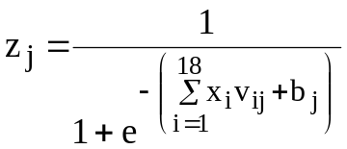 (E.5)
The output of the network is calculated as follows:
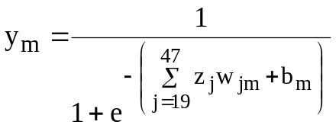 (E.6)
where,
x_{i}: input to the hidden layer unit j from input layer unit i
z_{j}: output of the hidden layer unit j / input to the output layer unit m from hidden layer unit j
v_{ij}: weight between the input layer unit i and hidden layer unit j
w_{km}: weight between the hidden layer unit j and output layer unit m
b_{j}: bias of the hidden layer unit j
b_{m}: bias of the output layer unit m
i: number of input layer units (1 to 18)
j: number of hidden layer units (19 to 47)
m: output layer unit (48)

3. SH NN MODEL
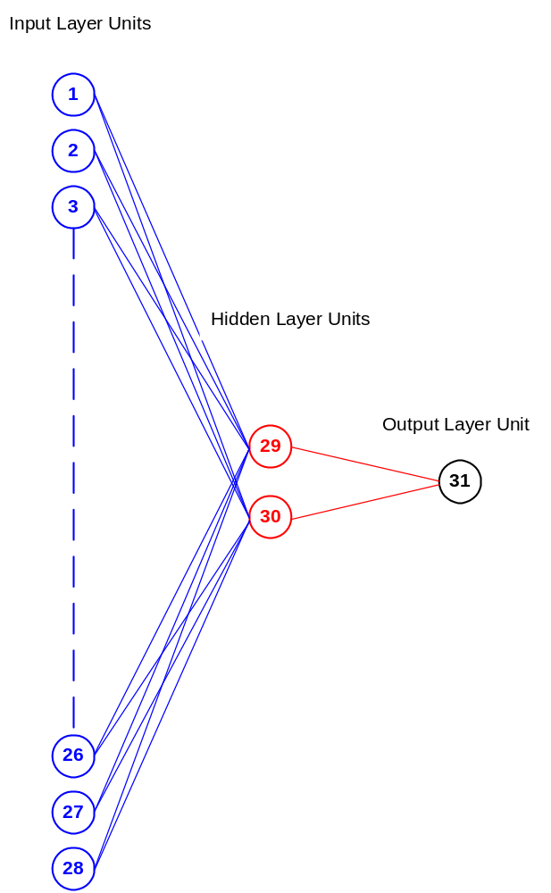
The NN model developed to estimate the SH energy consumption has 28 input layer units, two hidden layer, and one output layer unit. As shown in Figure E.4, the units from one to 28 represent the input layer units, units from 29 and 30 are the hidden layer units, and units 31 is the output layer unit.

Figure E.7. Architectural configuration of the SH NN Model
The unit definition section of the SNNS output for the SH NN Model is given in Figure E.8. The bias values of the hidden and output layer units are given in the third column.
No. | Name | Bias | Type | Activation F. |
----|-------------------------|----------|--------|---------------|
1 | Dwelling Type | 0.20707 | input | |
2 | No. of Doors | -0.68097 | input | |
3 | No. of Triple Windows | 0.29333 | input | |
4 | No. of Double Windows | 0.10683 | input | |
5 | No. of Single Windows | 0.36261 | input | |
6 | Main Wall Area | -0.77286 | input | |
7 | Floor Area | 0.96883 | input | |
8 | Basement Wall Area | -0.16818 | input | |
9 | Basement Floor Area | 0.68126 | input | |
10 | Roof Area | 0.23257 | input | |
11 | Heated Basement | -0.38201 | input | |
12 | Heated Garage | 0.88228 | input | |
13 | Dwelling Age Cat. | -0.79971 | input | |
14 | Wall Age Cat. | 0.67291 | input | |
15 | Roof Age Cat. | 0.68186 | input | |
16 | Basement Wall Age Cat. | -0.06613 | input | |
17 | Basement Floor Age Cat. | -0.20829 | input | |
18 | System Efficiency | -0.16540 | input | |
19 | HRV | 0.46006 | input | |
20 | Thermostats | 0.21904 | input | |
21 | Indoor Temperature | 0.41320 | input | |
22 | HDD | -0.48475 | input | |
23 | Owner | 0.40295 | input | |
24 | Income | 0.84892 | input | |
25 | No. of Children | 0.19003 | input | |
26 | No. of Adults | -0.71476 | input | |
27 | Daytime Occupancy | -0.88394 | input | |
28 | Population | -0.32566 | input | |
29 | | -0.56311 | hidden | Identity |
30 | | 0.89065 | hidden | Identity |
31 | | 0.08948 | output | Logistic |
----|-------------------------|----------|--------|---------------|

Figure E.8. Unit definition of the SH NN Model

The values of the weights between the units of the SH NN Model are given in Figure E.9.

The output of the SH NN Model can be calculated by applying Equations E.7 and E.8. Since the hidden layer activation function was chosen to be the identity function (Equation 2.4), the outputs of the hidden layer units are calculated using the identity function. Logistic function (Equation 2.2) was chosen for the output layer unit, thus the output of the unit at the output layer is calculated using the logistic function.
The output of each hidden layer unit is calculated as follows:
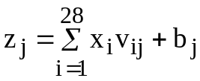 (E.7)
The output of the network is calculated as follows:
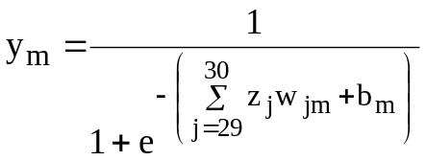 (E.8)
where,
x_{i}: input to the hidden layer unit j from input layer unit i
z_{j}: output of the hidden layer unit j / input to the output layer unit m from hidden layer unit j
v_{ij}: weight between the input layer unit i and hidden layer unit j
w_{km}: weight between the hidden layer unit j and output layer unit m
b_{j}: bias of the hidden layer unit j
b_{m}: bias of the output layer unit m
i: number of input layer units (1 to 28)
j: number of hidden layer units (29 to 30)
m: output layer unit (31)

